Report
- server info
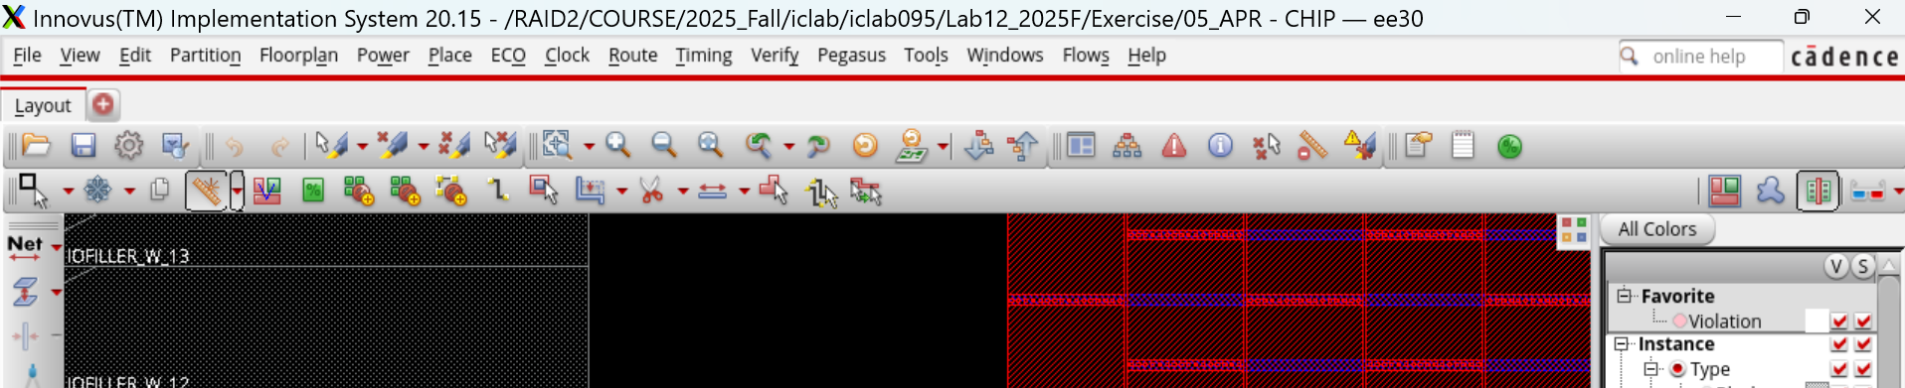
- server info
- server info
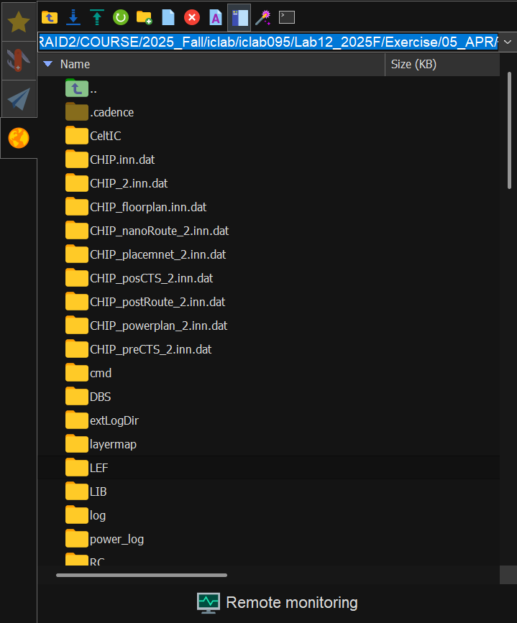
- Chip Layout View
Instructions: After completing the final layout, capture a screenshot of the entire chip layout.
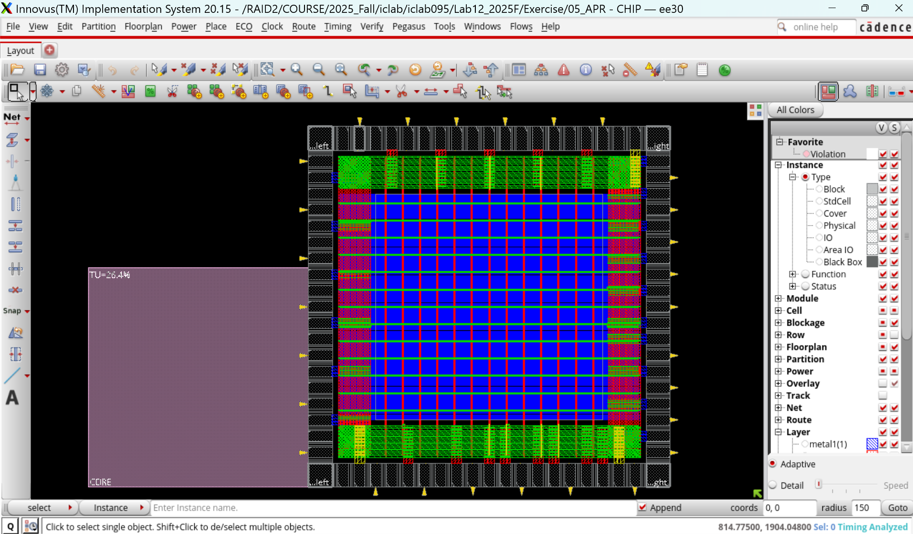
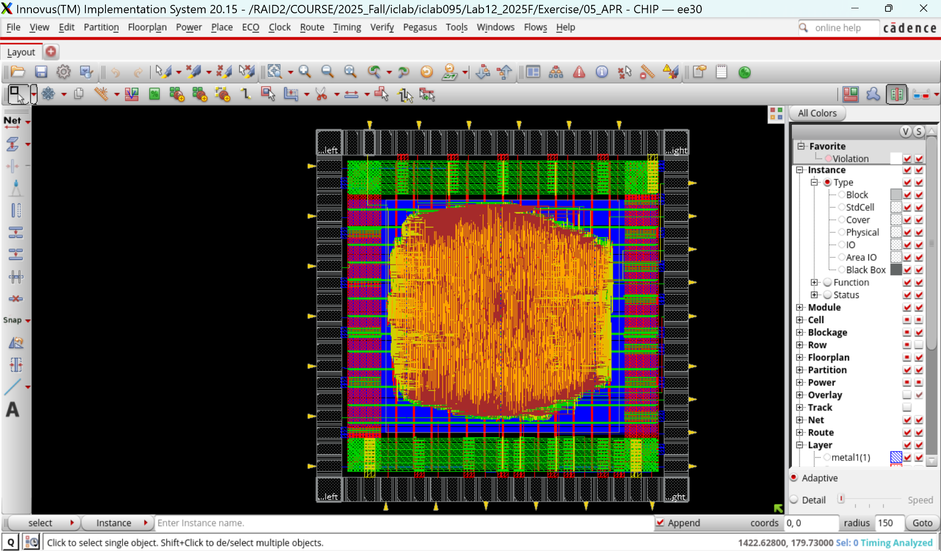
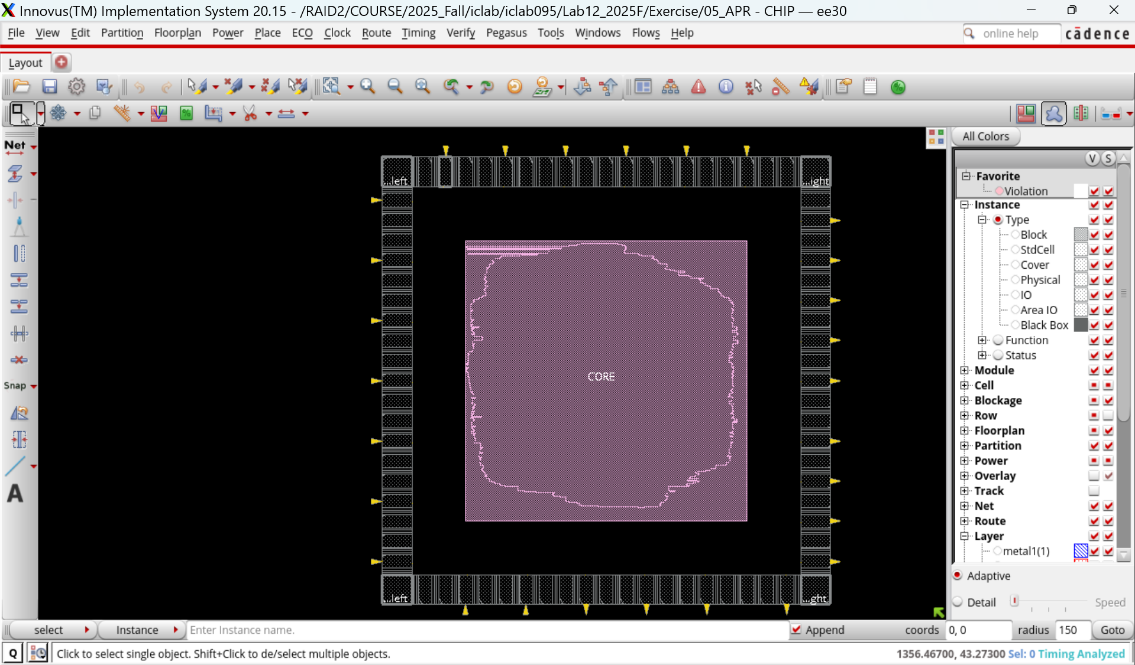

- Core to IO boundary
Instructions: After completing the final layout, open Floorplan -> Specify Floorplan, and capture a screenshot.

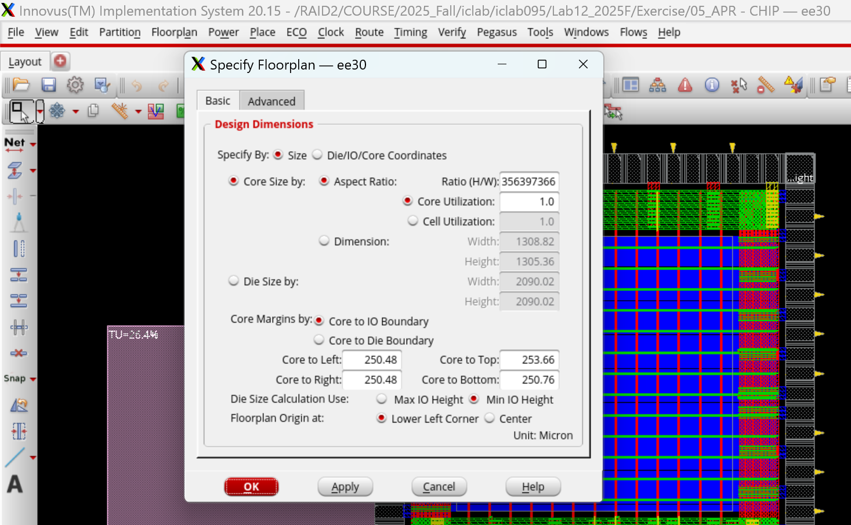

- Core Ring
Instructions: After completing the final layout, zoom in on the Power section (ensuring the entire power ring is visible), and use the K key to measure the width of a single power line.

Overall Power Ring

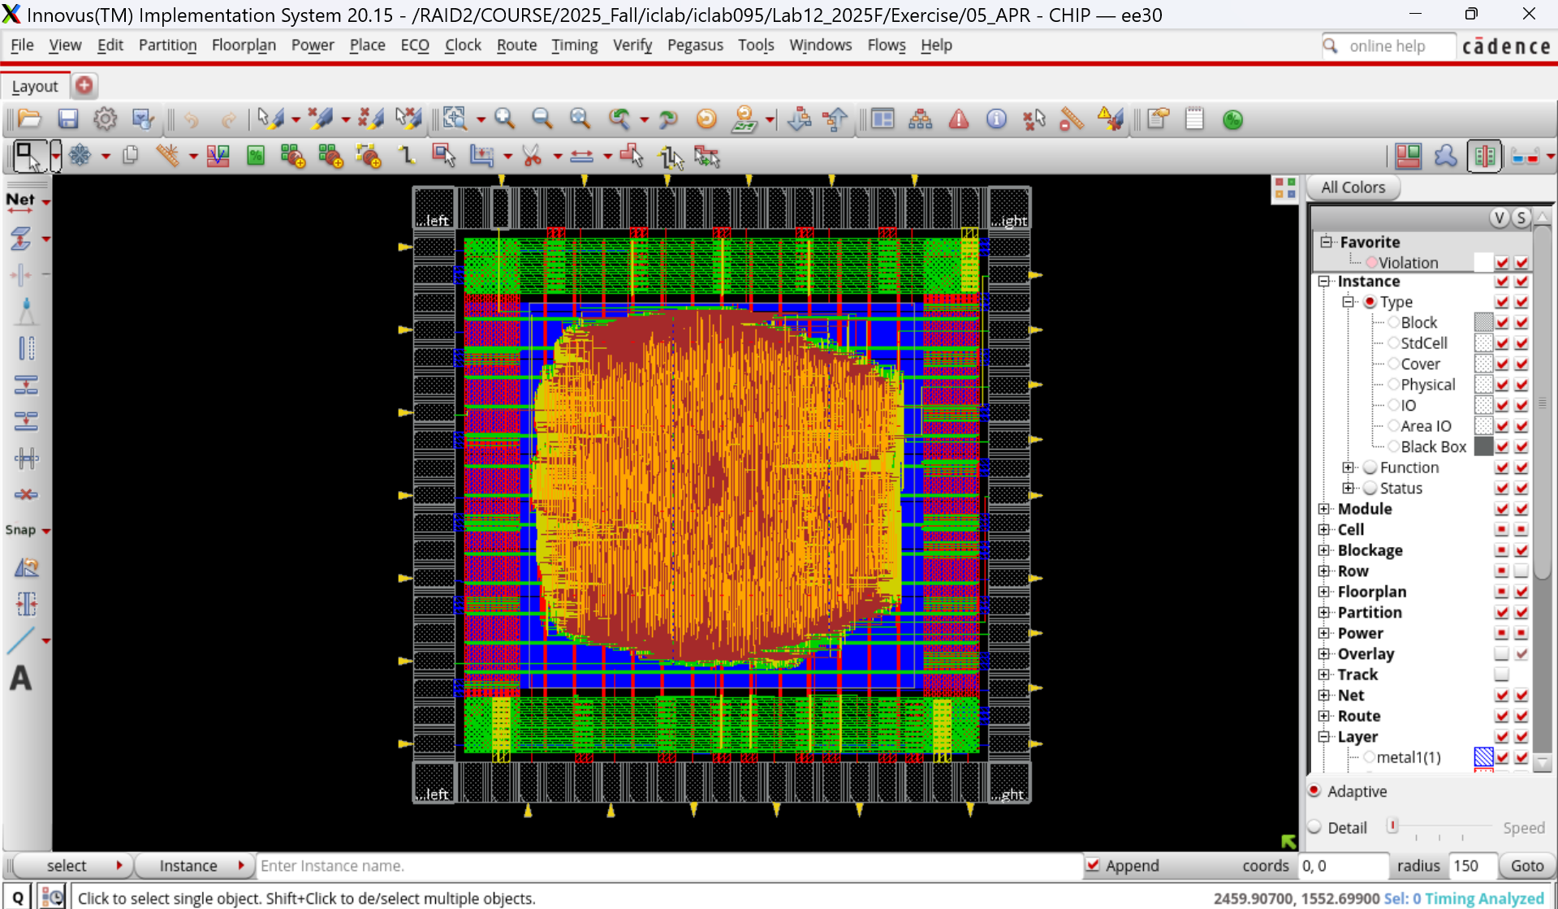

Overall Power Ring: wire group, interleaving, 10 pairs, width 9.

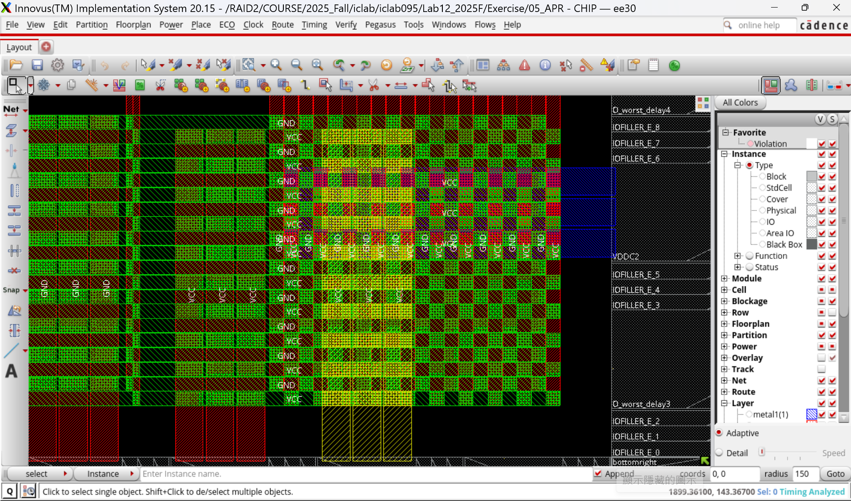

Top Power Ring: width=9

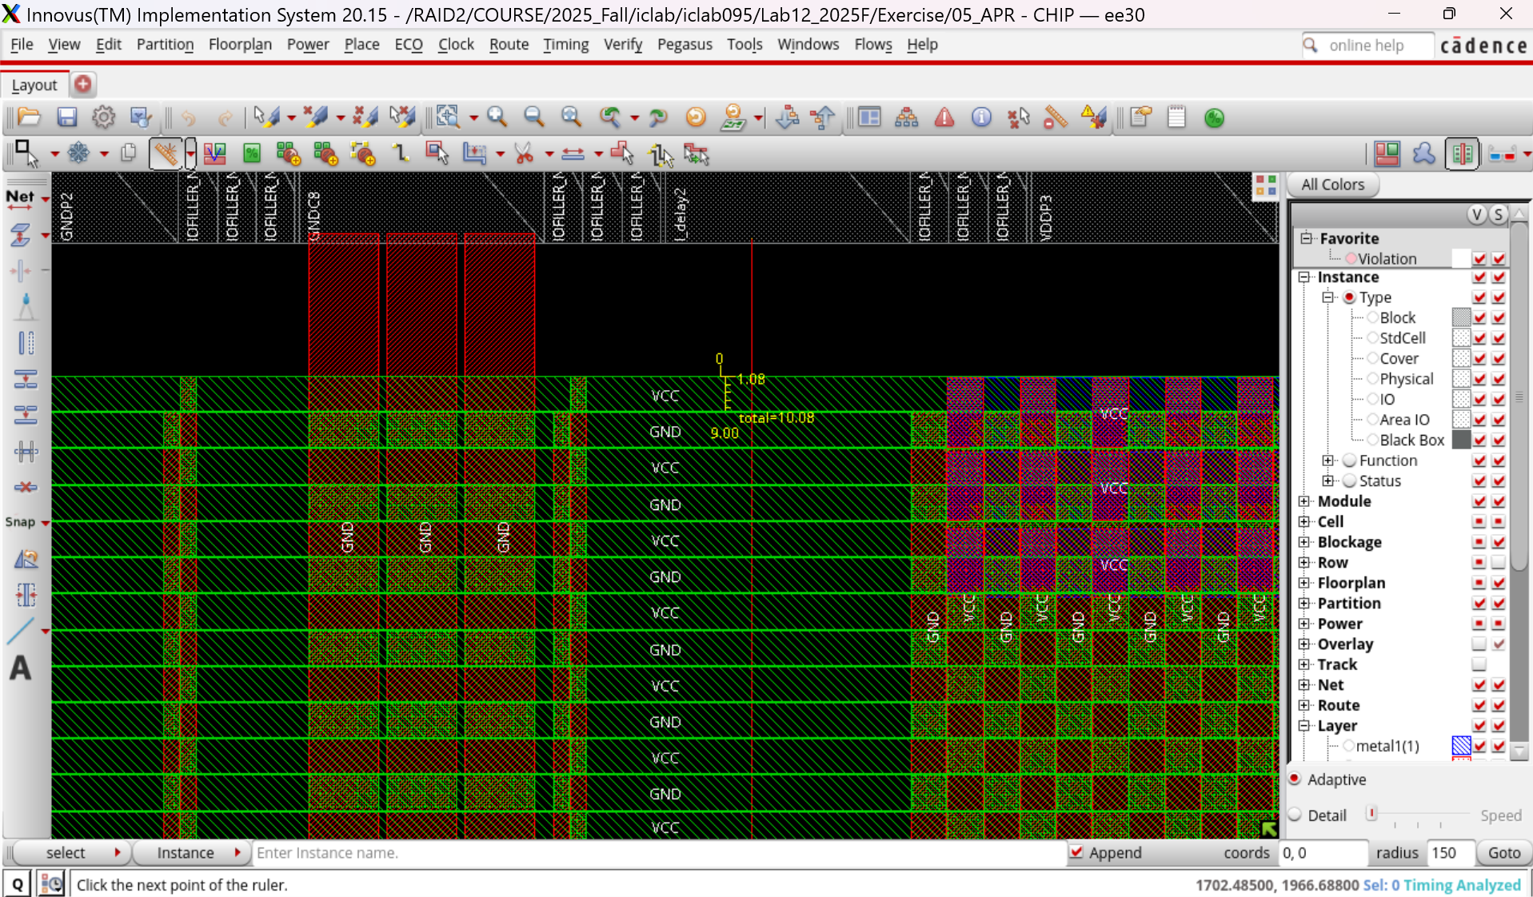

Right Power Ring: width=9
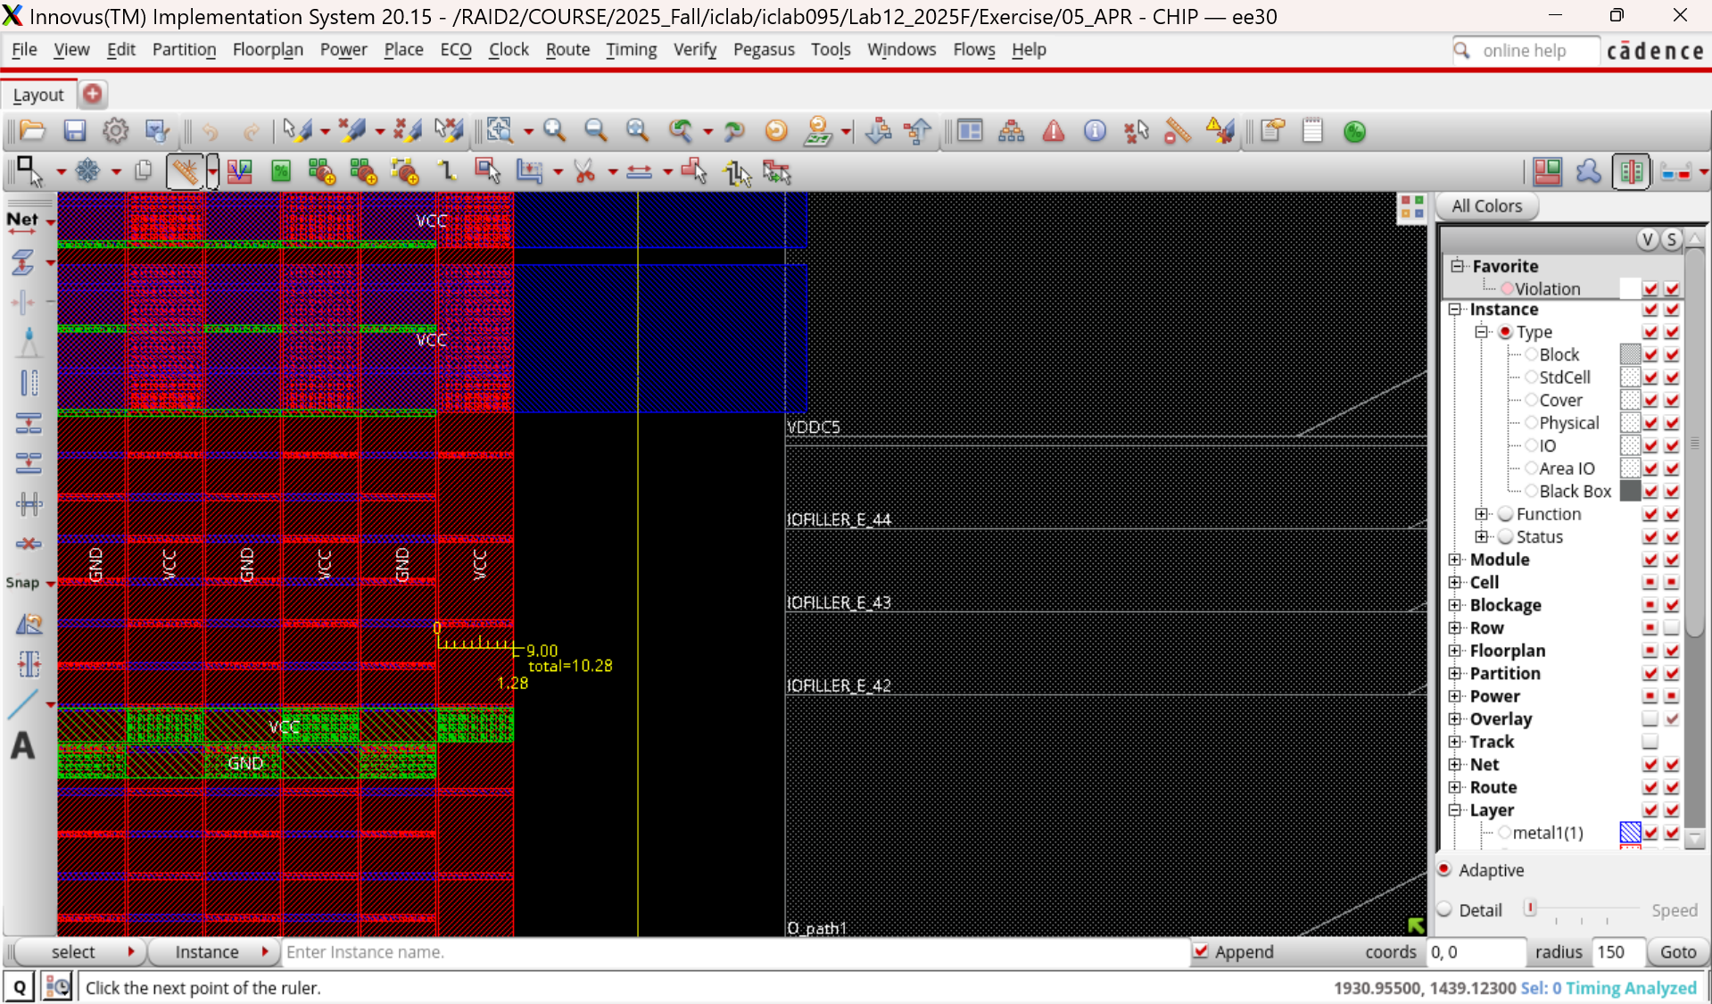

Bottom Power Ring: width=9
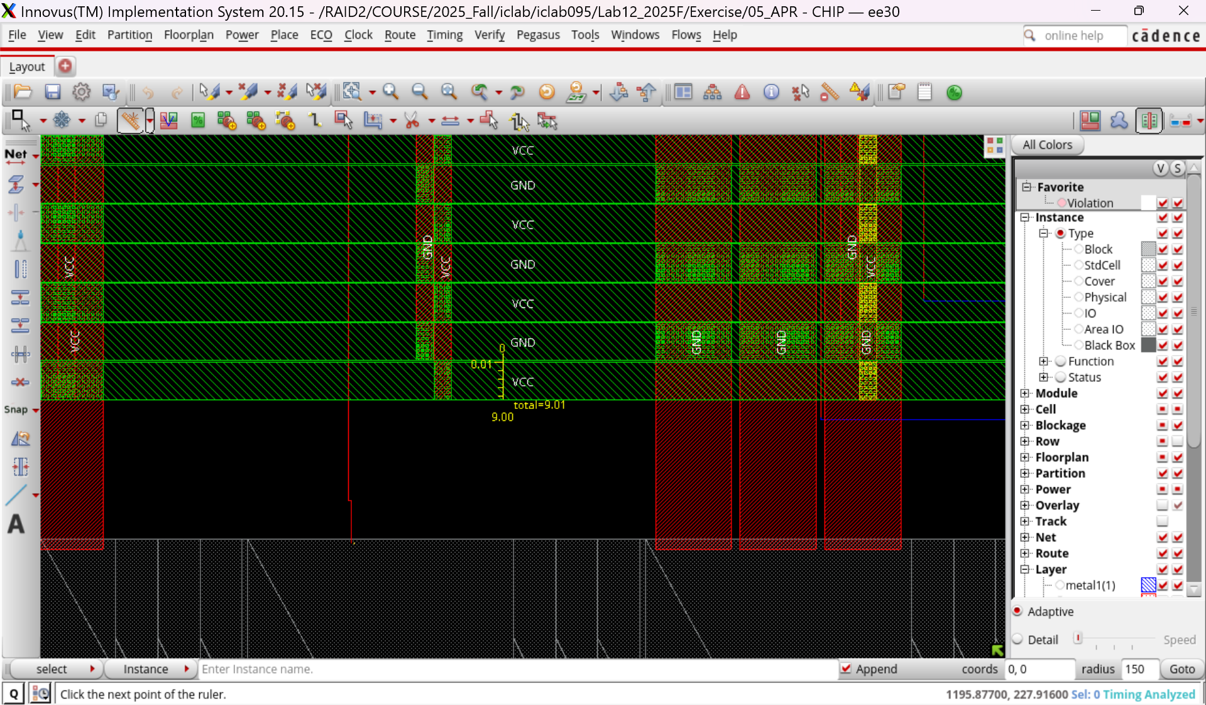

Left Power Ring: width=9
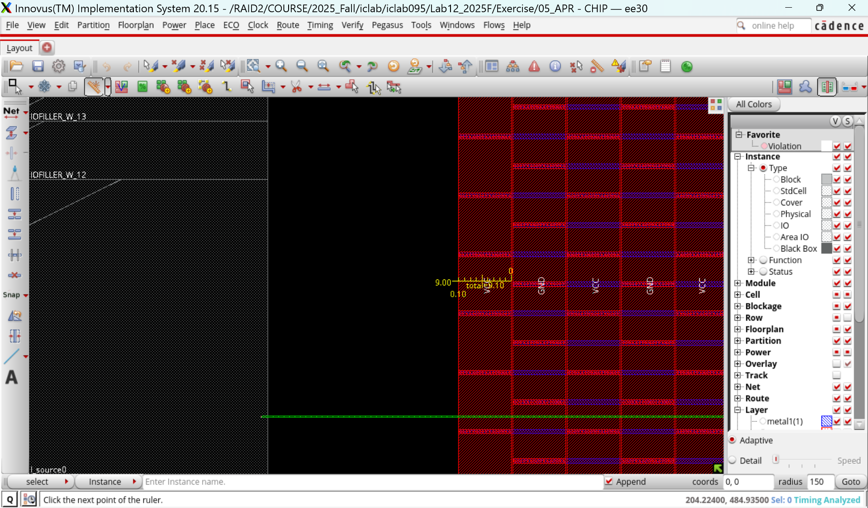
( Width settings are all 9 )

- Post-Route setup time analysis :
Instructions: After completing the analysis, capture a screenshot of the results displayed in the terminal (including the timeDesign Summary).
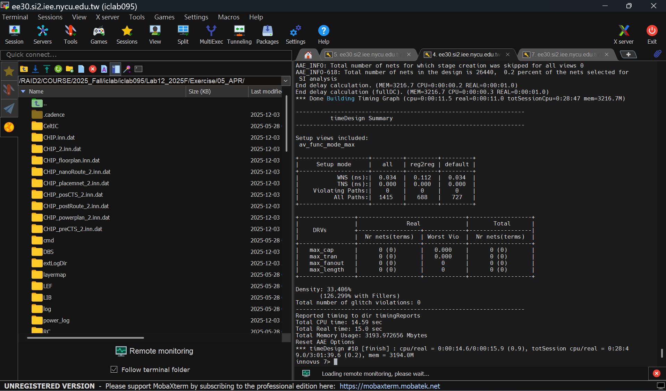
- Post-Route hold time analysis
Instructions: After completing the analysis, capture a screenshot of the results displayed in the terminal (including the timeDesign Summary).
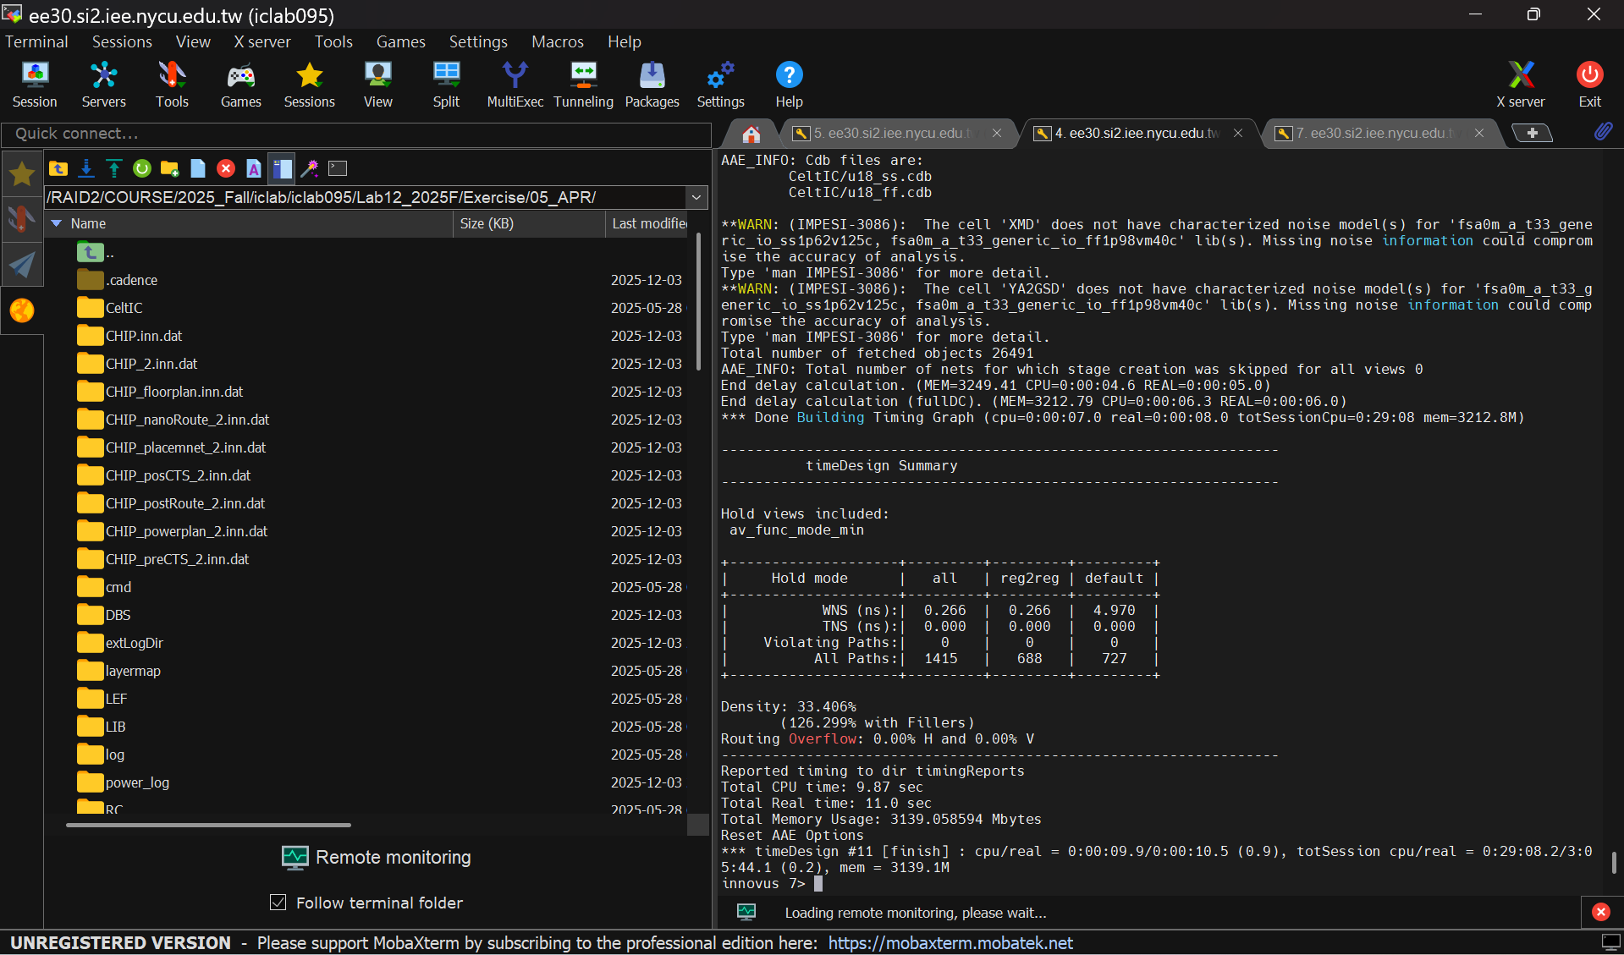
- DRC result
Instructions: After completing the final layout, run the analysis and capture a screenshot of the results displayed in the terminal (including the number of violations).
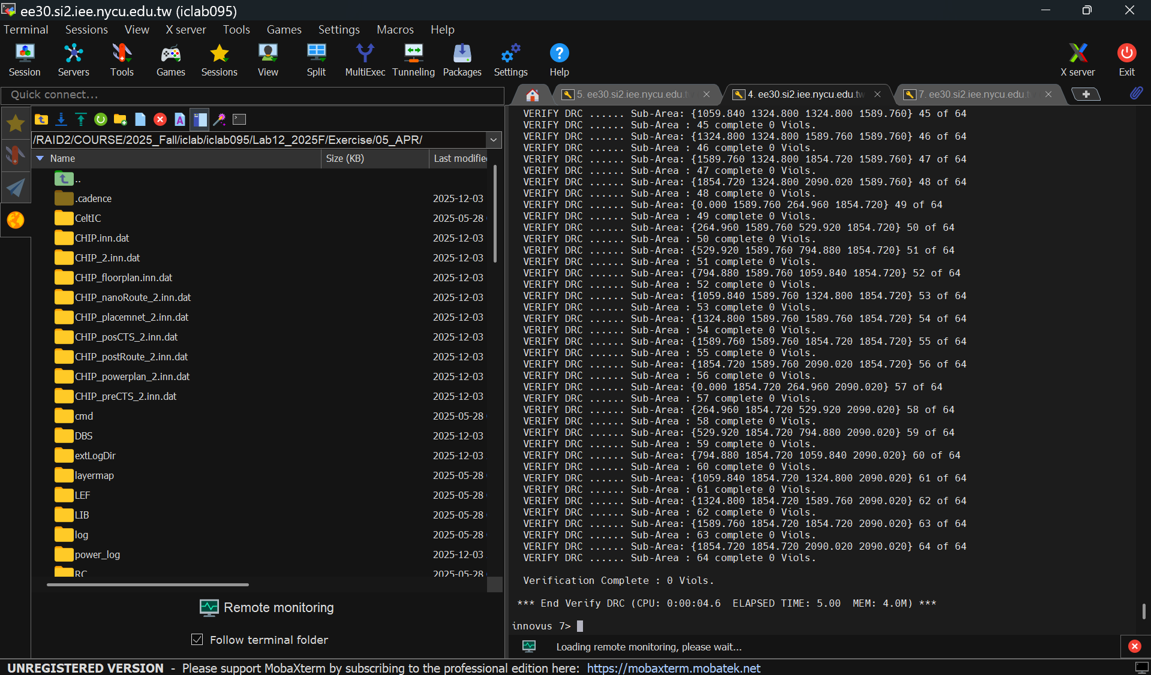
- LVS result
Instructions: After completing the final layout, run the analysis and capture a screenshot of the results displayed in the terminal (including the number of violations).
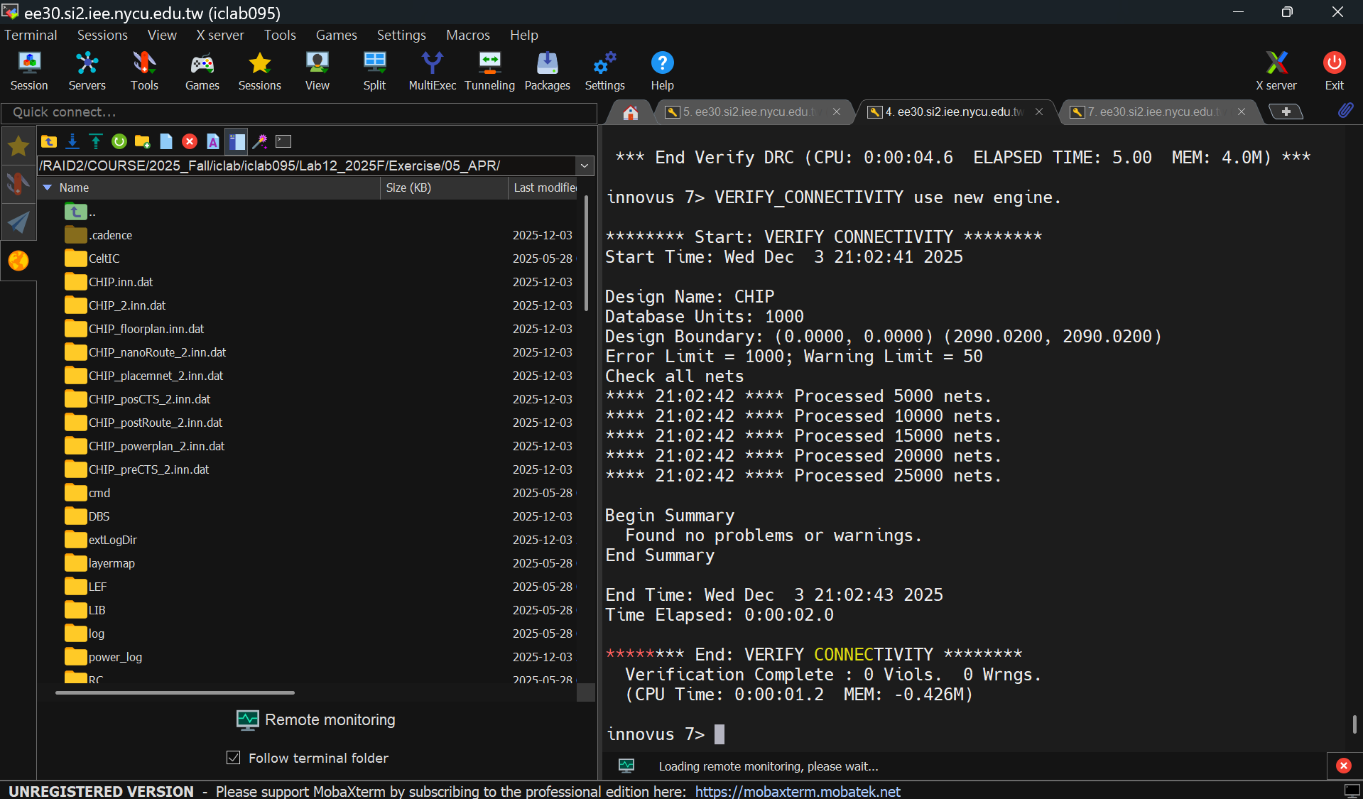

- Post Layout simulation result
Instructions: After completing the final layout, run the post-simulation in 06_POST and capture a screenshot of the results displayed in the terminal
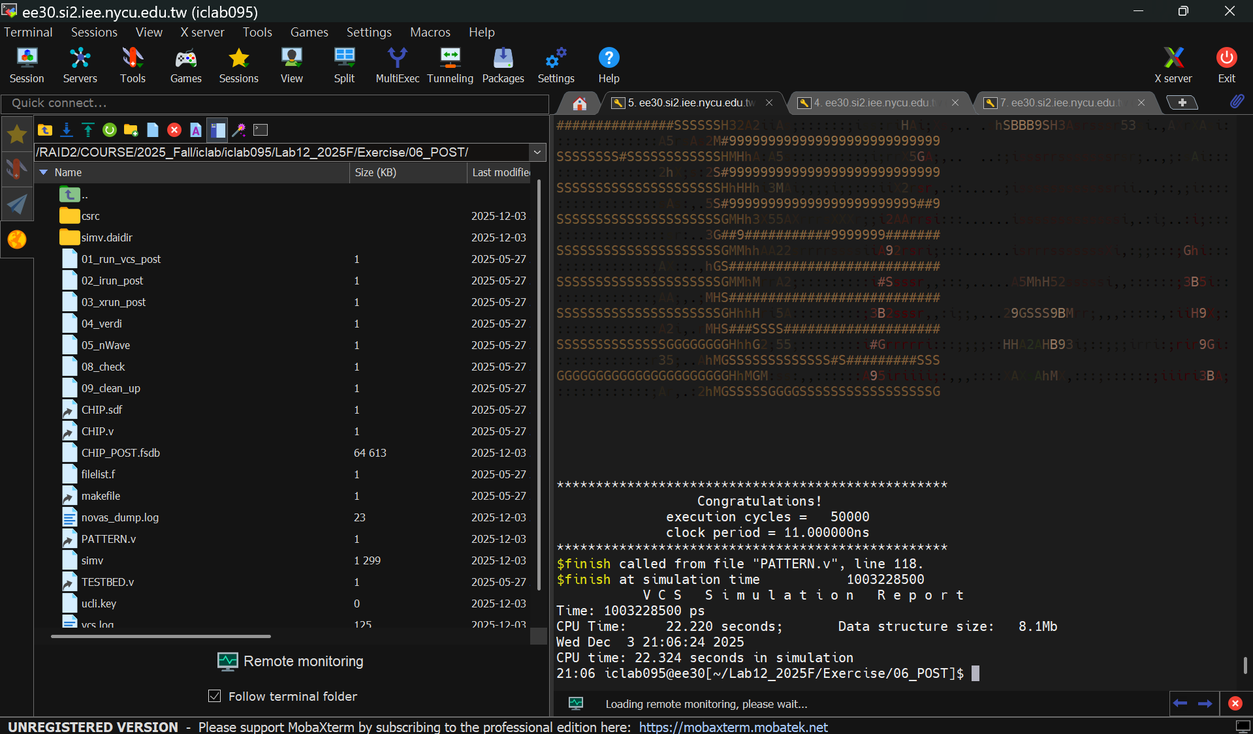
- Power result
After running the analysis, capture a screenshot of the results in the terminal (including Total Power).
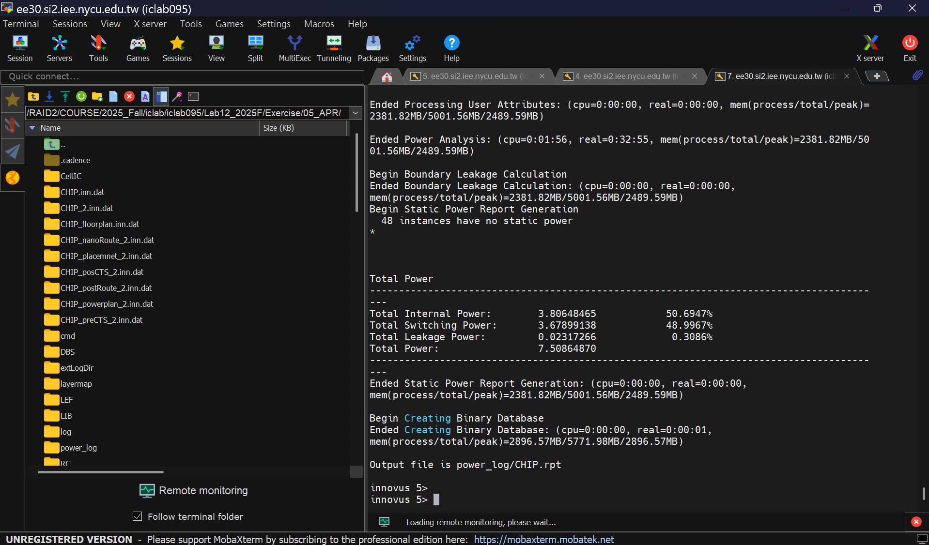
- IR Drop Results :
Instructions: After completing the analysis, capture a screenshot of the results in Innovus. Highlight the maximum value of the IR drop and provide a brief explanation of the method you used to mitigate the IR drop issue.
maximum value of the IR drop: 0.58401mV
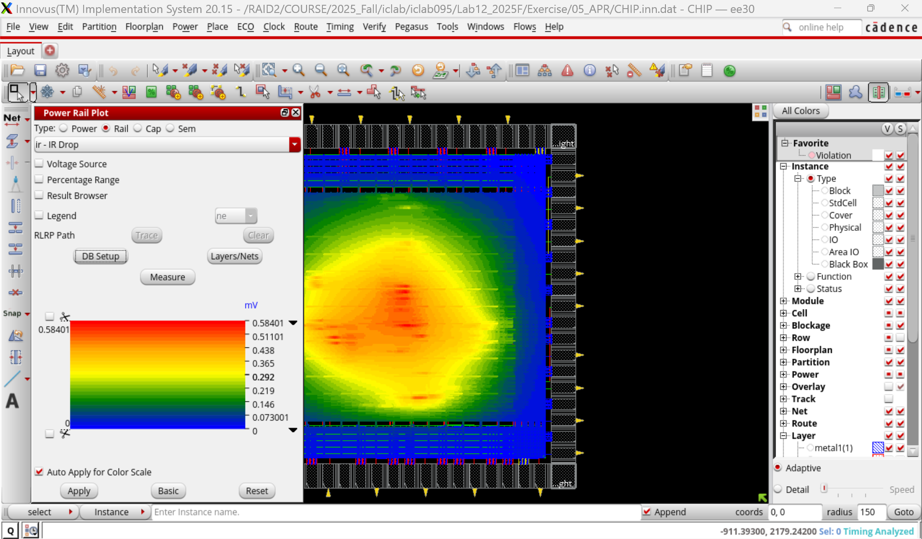
maximum value of the IR drop: 0.58401mV
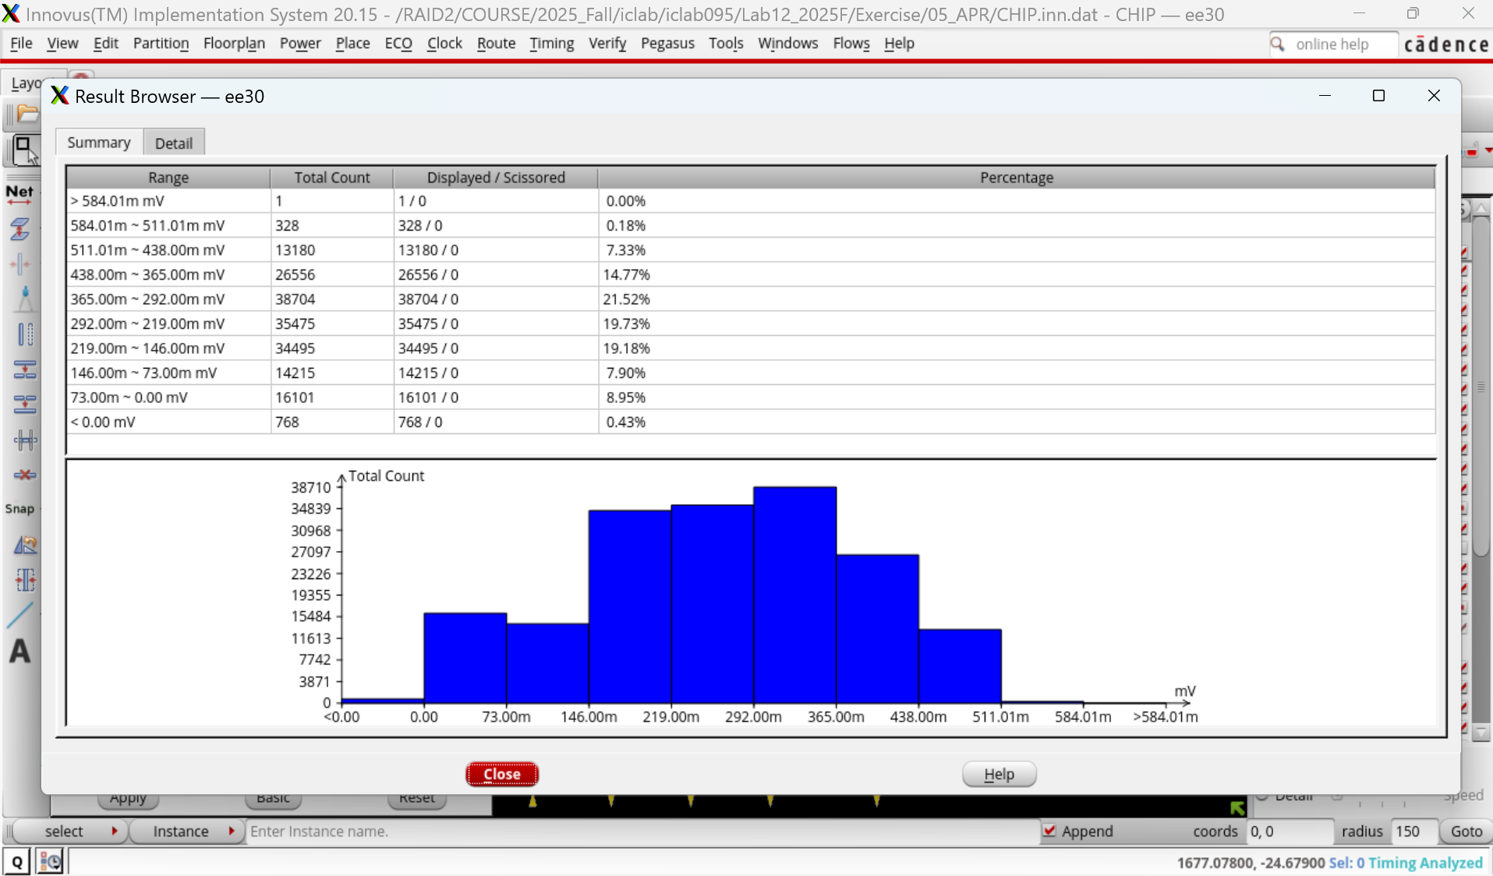

Explanation:
目前的作法是依照助教的建議，增加 Core PowerPad 與 IO PowerPad 的數量。其中，IO PowerPad 共配置 8 組，而 Core PowerPad 則配置 16 組。

在 PowerPad 的擺放上，我也盡量依助教所述，避免將 PowerPad 集中於晶片的單一邊，而是盡可能均勻分佈於四周，以避免造成某些區域的邏輯閘因電源距離過遠而產生不利影響。

此外，目前的 power stripe 寬度設定為 4。本來有考慮將 stripe 與 stripe 之間的間距（原為 100）再縮小，但由於目前的 IR Drop 檢查已通過，因此暫時尚未調整。

若後續需要再優化，則會考慮進一步增加 PowerPad 數量，或縮小 stripe 間距，不過此部分仍需視 DRC 是否能通過而定。

