人工智慧之應用

用人工智慧處理工具機之顫振效應

程式介紹:

import numpy as np

import matplotlib.pyplot as plt

from os import walk

from sklearn.preprocessing import MinMaxScaler

from sklearn.neural_network import MLPClassifier

from sklearn.model_selection import LeaveOneOut

from sklearn.model_selection import cross_val_predict

from sklearn.metrics import confusion_matrix

from numpy import genfromtxt

train_input=[]

train_input_std=[]

train_output=[]

folder_name=['stable','unstable']

i = 0;

for folder in folder_name:

path = 'Data/'+str(folder)+'/'

for root,dirs,files in walk(path):

for f in files:

filename = path + f

print(filename)

acc = genfromtxt(filename, delimiter=',')

acc = acc[:,1].tolist()

train_input.append(acc[60000:80000])

train_input_std.append(np.std(acc))

if folder == 'unstable':

train_output.append(1)

title = 'Original Signal With Chatter #'

saved_file_name = 'Fig/Original/unstable_'

if folder == 'stable':

train_output.append(0)

title = 'Original Signal Without Chatter #'

saved_file_name = 'Fig/Original/stable_'

plt.figure(figsize=(7,4))

plt.plot(acc,'b-',lw=1)

plt.title(title + str(i+1))

plt.xlabel('Samples')

plt.ylabel('Acceleration')

plt.savefig(saved_file_name + str(i+1) + '.png')

plt.show()

i = i + 1

train_input = np.array(train_input_std)

train_output = np.array(train_output)

scaler = MinMaxScaler(feature_range=(0,1))

train_input=scaler.fit_transform(train_input.reshape(-1,1))

loo = LeaveOneOut()

model = MLPClassifier(max_iter=500, batch_size=1, solver='adam')

y_pred = cross_val_predict(model, train_input, train_output, cv=loo)

y_true = train_output

print('Prediction: \t', y_pred)

print('Ground Truth: \t',y_true)

cf_m = confusion_matrix(y_true, y_pred)

print('Confusion Matrix: \n', cf_m)

tn, fp, fn, tp = cf_m.ravel()

accuracy = (tn+tp)/(tn+fp+fn+tp)

print('Accuracy: ', accuracy)

實驗過程:

利用郭秉寰教授的影片中的程式，但因助教給的數據為csv檔，和影片中的mat檔不同，所以做了變化，用了 genfromtxt來拿出數據，其餘和郭教授的程式一樣，且助教的數據為x,y,z方向的，也有各用過，而x,y,z方向切換用 acc = acc[:,1].tolist()這一行的數字切換就行，x:0，y:1，z:2。

訓練模型:

train_input = np.array(train_input_std)

train_output = np.array(train_output)

scaler = MinMaxScaler(feature_range=(0,1))

train_input=scaler.fit_transform(train_input.reshape(-1,1))

loo = LeaveOneOut()

model = MLPClassifier(max_iter=500, batch_size=1, solver='adam')

y_pred = cross_val_predict(model, train_input, train_output, cv=loo)

y_true = train_output

成果:

X方向:

unstable的其中一張圖

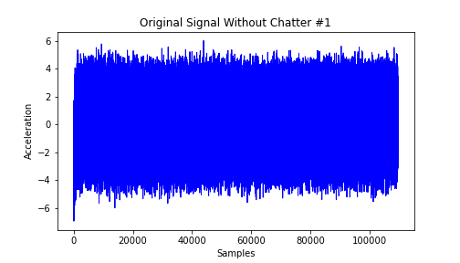

stable的其中一張圖



前面看得出兩張圖幾乎沒差，所以測試出的成果準確率也很低，以下是60000~80000的成果，這算準了，有些區間準確度甚至是0

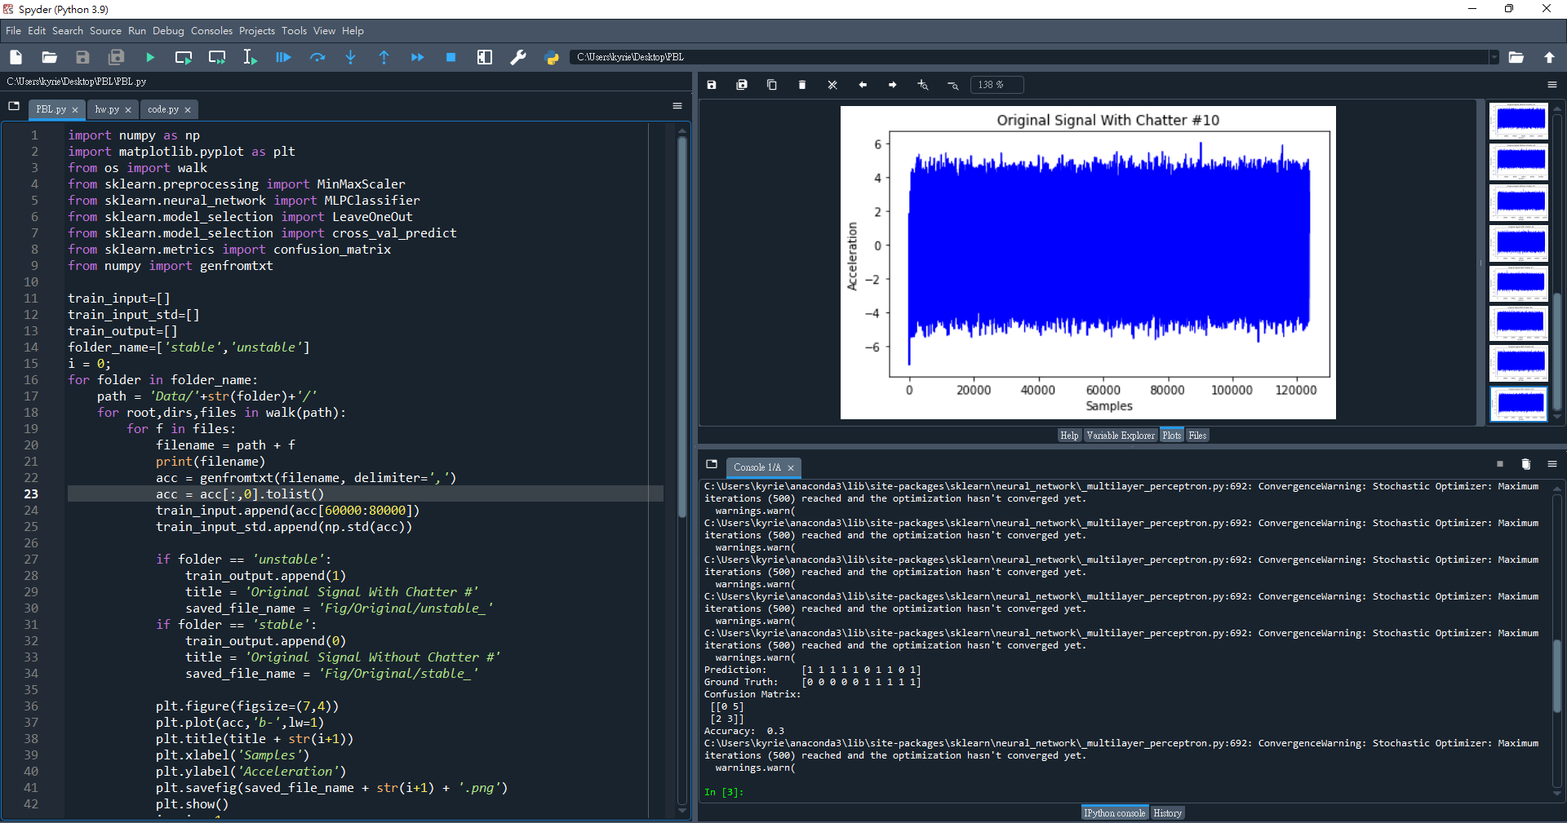

Y方向:

stable的其中一張圖

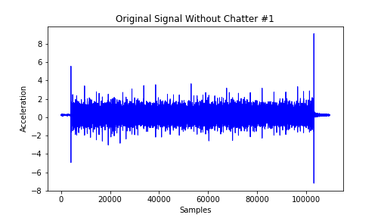

unstable的其中一張圖

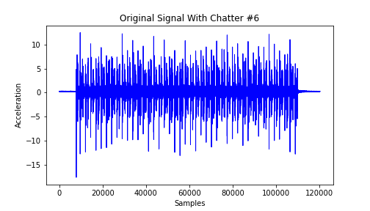

前面看得出兩張圖的差距，而測出的數據也都準確度為1，相當成功

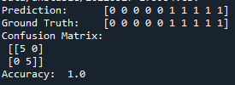

Z方向因和Y一樣準，所以就沒放上來

由實驗成果得知，X方向訊號做為有無顫振的判斷相當失敗，而YZ方向則準確度皆為1，用來判斷顫振依據是相當成功的，可以信任。