**系統程式設計**

**Lab7 setjmp/longjmp**

**學號:408420001**

**姓名:王宇軒**

1. **Where are the errors located?**

**Email: spta@embedded.cs.ccu.edu.tw**

**@ found at 5**

**valid email address!**

**------------------------------------------------**

**Email: twetrewt.terthbbb.com.tw**

**Email format error: at least one @**

**------------------------------------------------**

**Email: spta@embed@ded.cs.cc@u.edu.tw**

**@ found at 5**

**@ found at 11**

**@ found at 21**

**Email format error: more than one @**

**------------------------------------------------**

**Email: pv#pig@hot#mail.com**

**@ found at 7**

**# found at 3(error occur)**

**# found at 11(error occur)**

**Email format error: cant't exist #**

**------------------------------------------------**

**Email: pvpig@hot*mail.com**

**@ found at 6**

**\* found at 10(error occur)**

**Email format error: cant't exist \***

**------------------------------------------------**

**Email: aaawww@ccu.cs..edu.tw**

**@ found at 7**

**.. found at 14(error occur)**

**Email format error: cant exist ..**

**------------------------------------------------**

**Email: EA.EA@ccucsedutw**

**@ found at 6**

**Email format: at least one . behind the @**

**What is the error message format?  
(you must not print any message after you print error message)**

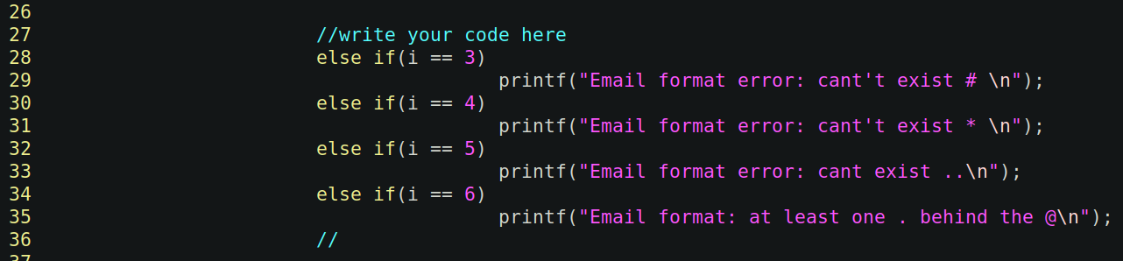**in the main function to react to the longjmp return value**

1. **How did you use the setjmp/longjmp function?**

**A:  
setjmp for each situation in the main function and longjmp when counter error format:**

**compare (@,#,*,..,@__.__) if one has been checked in error format, then longjmp to main and print error message.**

1. **Final result.  
   Please attach screenshot !**

