**系統程式設計**

**Lab4 File Attributes**

**學號:408420001**

**姓名:王宇軒**

1. **How do you modify fig4_22.c?**

A : read permission is not enough, the user also need execute permission to change directory

1. 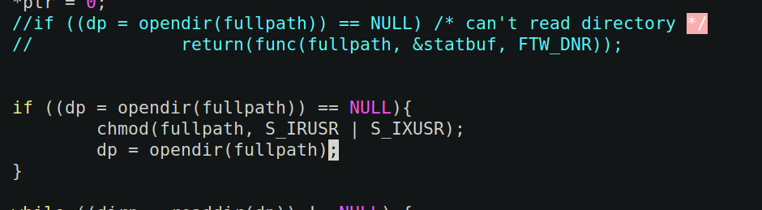**The count of the various types of files?**

**Ex: File type = Count, Percentage**

A:

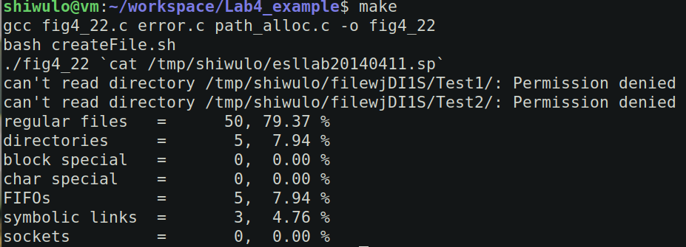without permission : 50 + 5 + 0 + 0 + 5 + 3 + 0 = 63

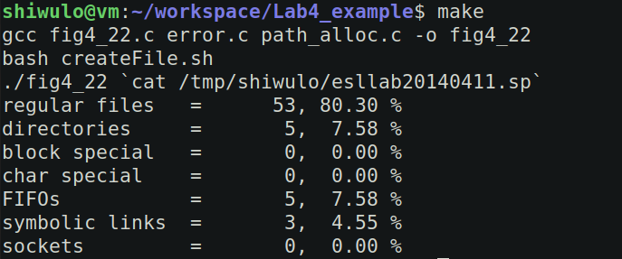with permission : “53” + 5 + 0 + 0 + 5 + 3 = 66

1. **The count of total files size?**

**Ex: Total size = Size**

A : declare global off_t total_size = 0, sum by using statptr->st_size in myfunc, then print out in main

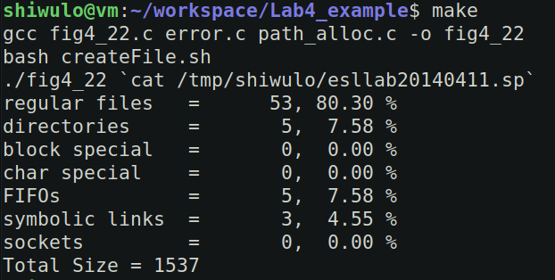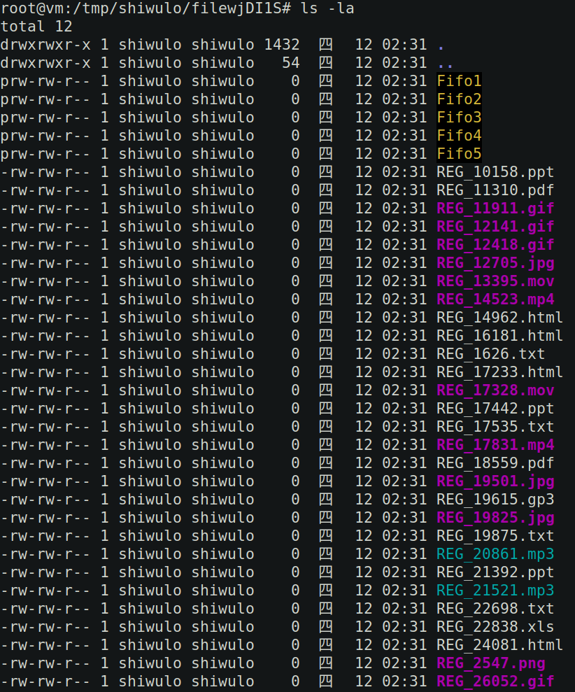

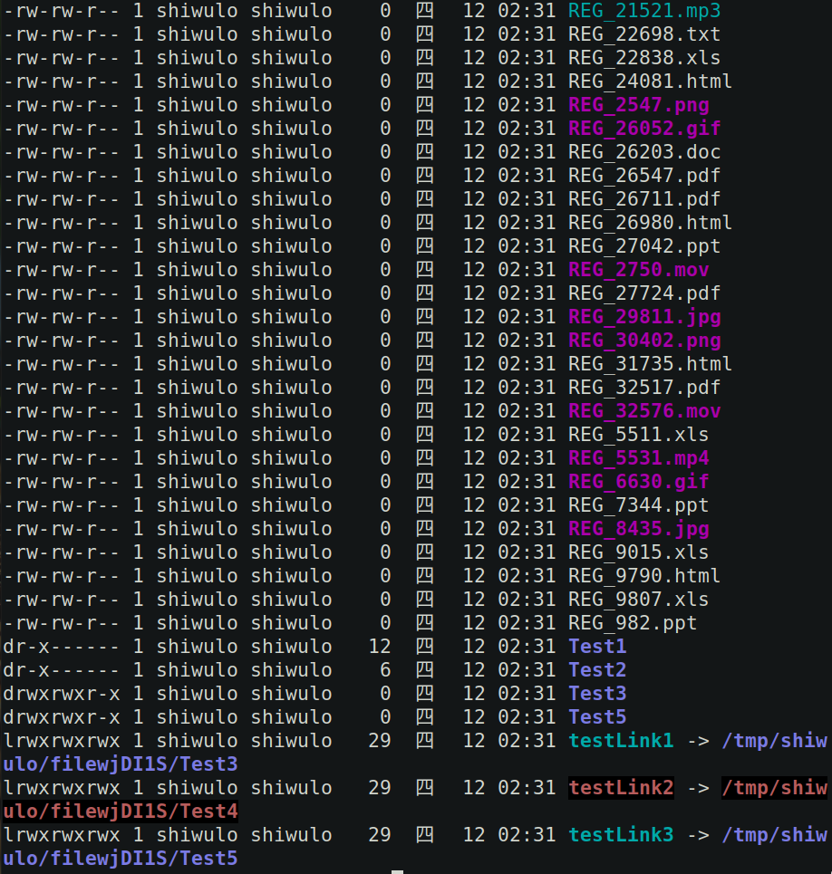**(Bonus) The count of valid and invalid link?**

**Ex:**

**Valid link = Count**

**Invalid link = Count**

A : use access()

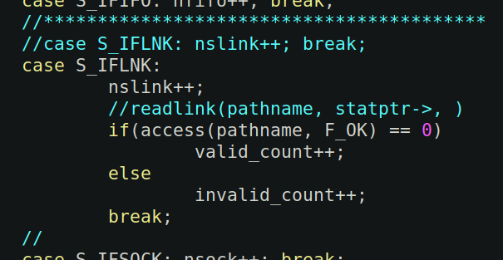

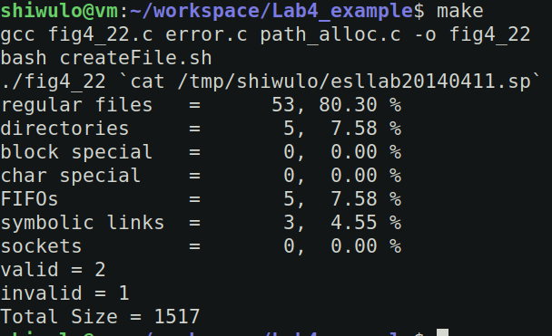***total_size changes because the directory “.” is different size every time i “make”