

*Texas A&M University*

**ECEN-719 Lab3 Report**

**NAME: Hai-Ming, Hsu**

**UID: 433004106**

**Section: 602**

**Department of Electrical & Computer Engineering**

1. *Screenshots of the waveform with analysis*

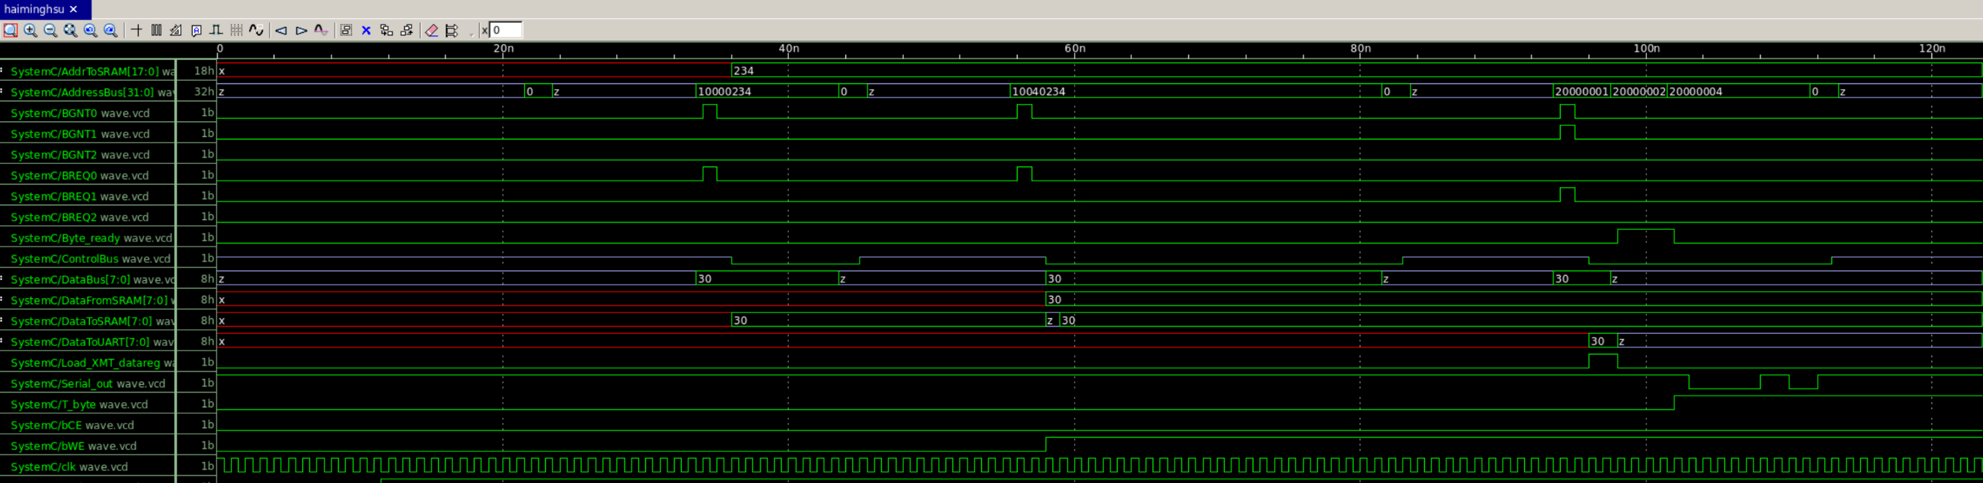

This time’s lab we connect what we built before with some new stuffs all together.

SRAM, UART Transmitter, Decoders for both, Bus and an Arbiter

From the waveform, it works functionally as what we expect from the Testbench.

After the reset, Tb writes data 30 to SRAM 0x00234( the last 18 bits from Address bus)

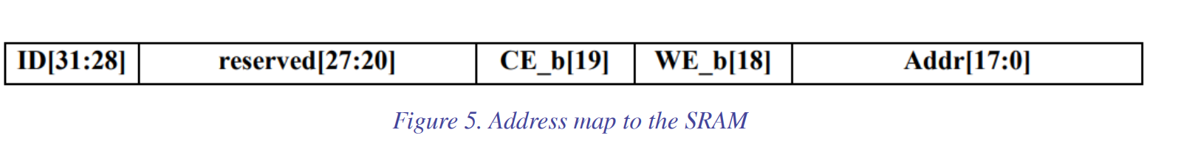

We can also see there is a Bus request and grant between the sram and arbiter.

Then, Tb read data 30 from SRAM 0x00234.

The last operation is to transmit data which is read from SRAM through UART. The control signals are set in the last three bits from Address bus.

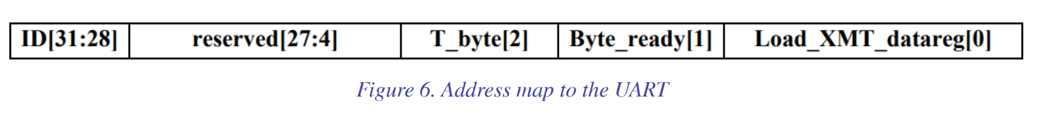

1. *Screenshots of the simulation output in Vista*

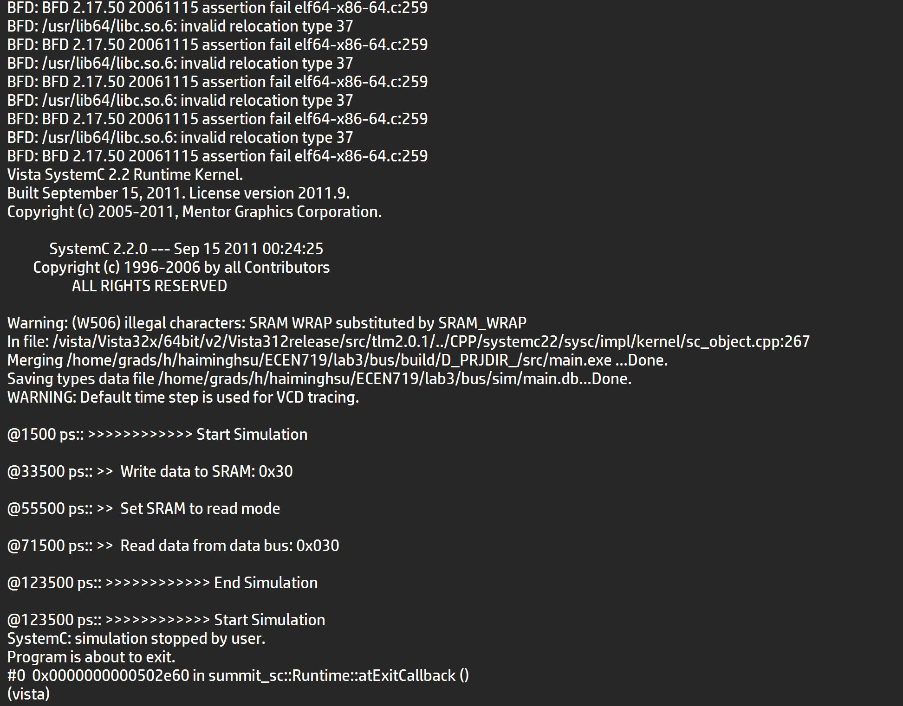

1. *Screenshots of your code in this design with reasonable comments*

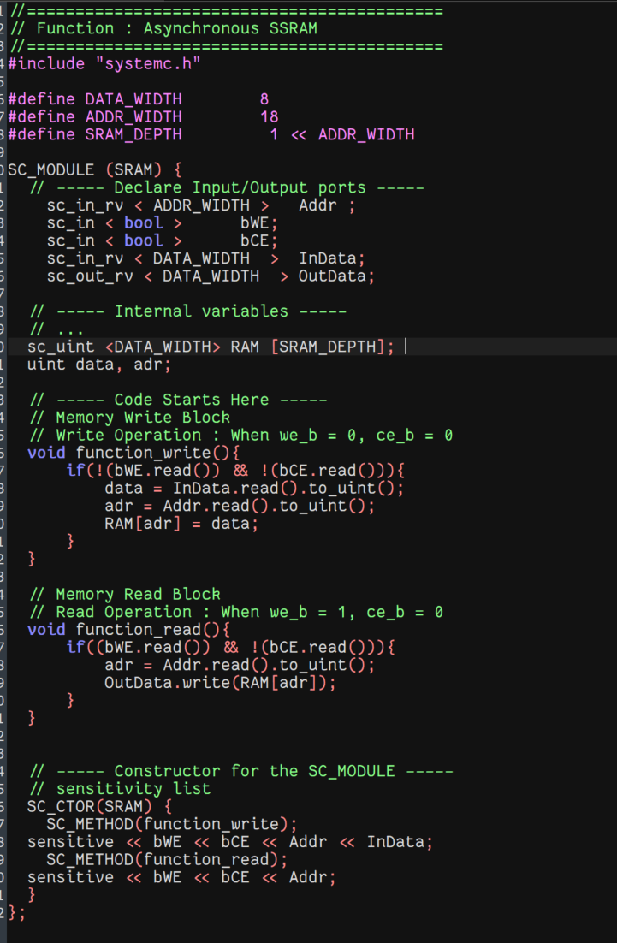

**SRAM**

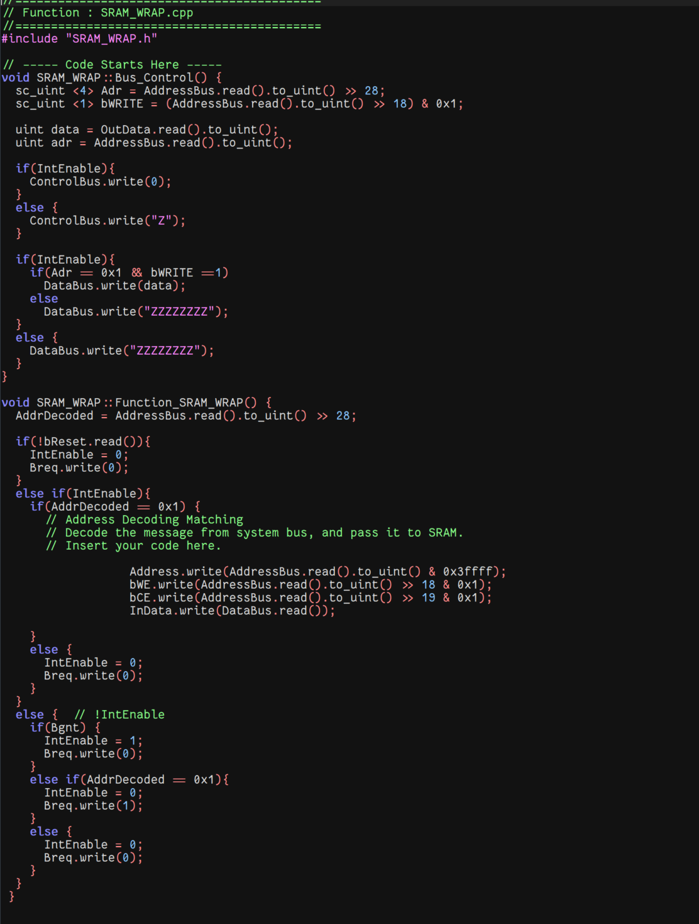

**SRAM decoder**

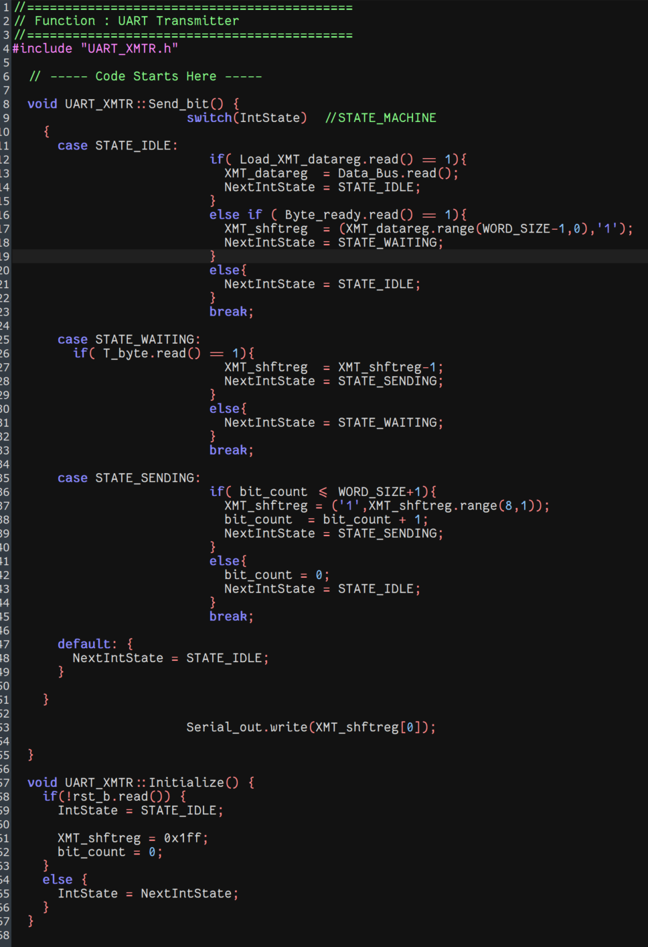

**UART**

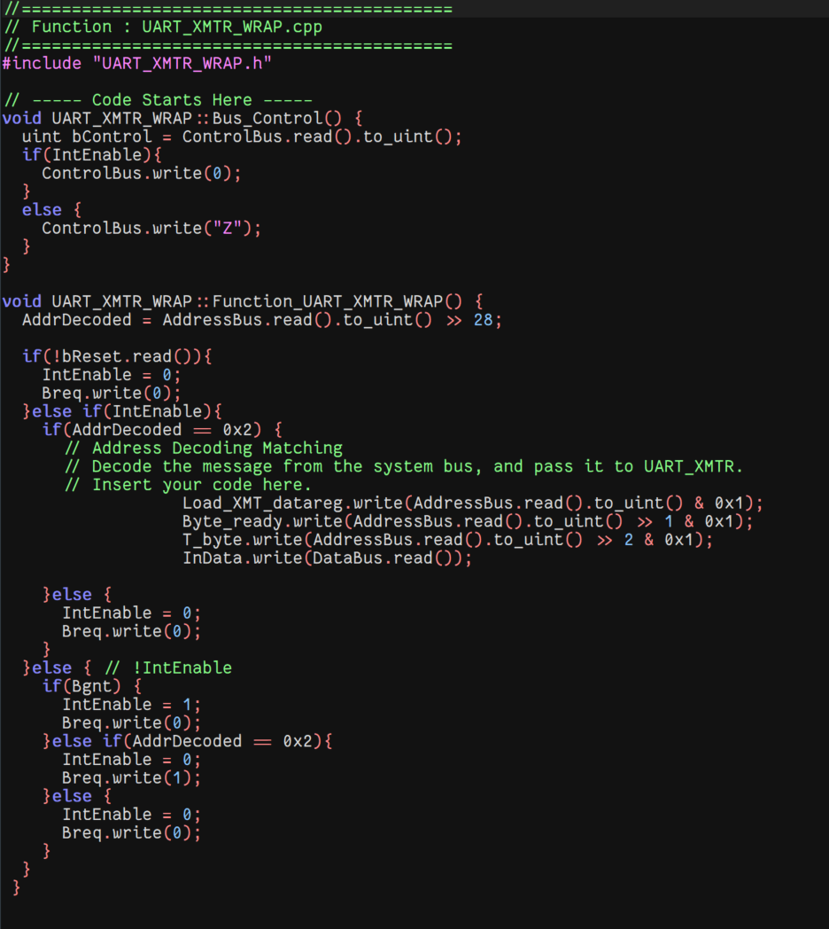

**UART decoider**

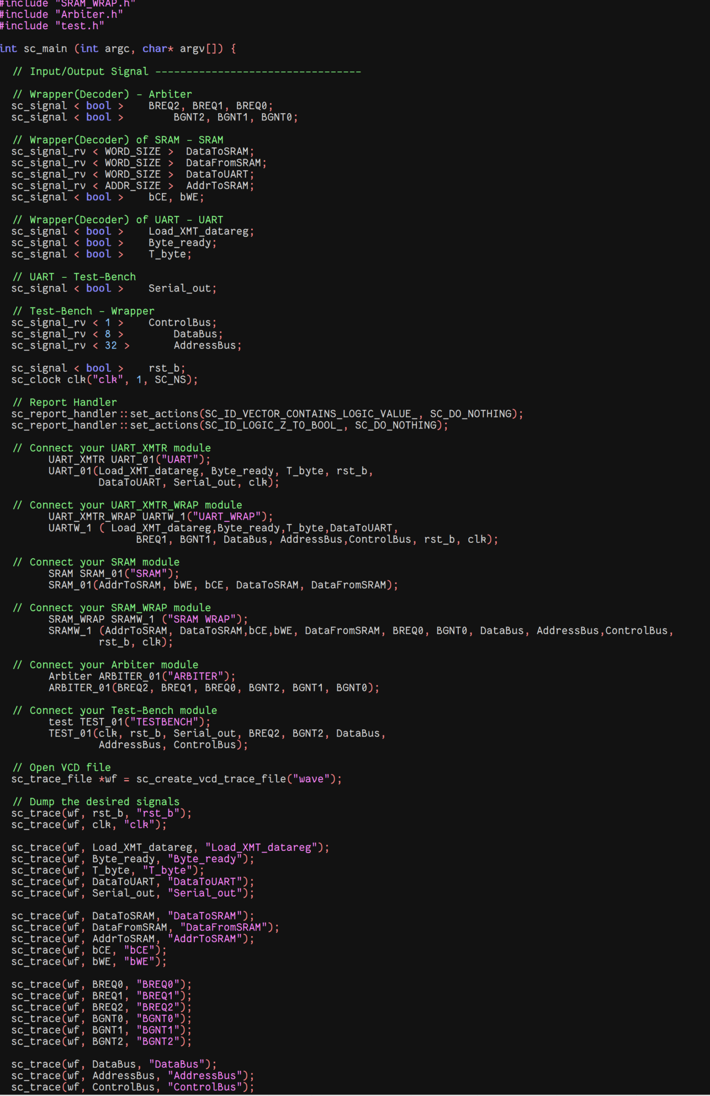

**Mod connection**

1. *Question:*

*Suppose we have three devices (A, B, C) connected to the Arbiter on ports (2, 1, 0) in “Arbiter.h”, please list the order of the priorities of the three devices from high to low.*

*Solution:*

The order of the priorities of these three devices from high to low should be ACB . We may tell it from the sequence if-else sentences defined in the arbiter.

if(BREQ2.read()) IntGrant = 4; // 100

else if(BREQ0.read()) IntGrant = 1; // 001

else if(BREQ1.read()) IntGrant = 2; // 010

We may jump to the branch of the first matching condition.

So the priorities are ranged as Port 2 (A) > Port 0 (C) > Port 1 (B)