

*Texas A&M University*

**ECEN-719 Lab5 Report**

**NAME: Hai-Ming, Hsu**

**UID: 433004106**

**Section: 602**

**Department of Electrical & Computer Engineering**

1. *Screenshots of the output images with analysis*

Just the same as last lab

|  |  |
| --- | --- |
|  |  |
|  |  |
|  |  |
| *OutputOrigin* | *OutputGauss* |
| *OutputGradient* | *OutputAngle* |
| *OutputNMS* | *OutputThres* |

1. *Screenshots of the simulation output in Vista*

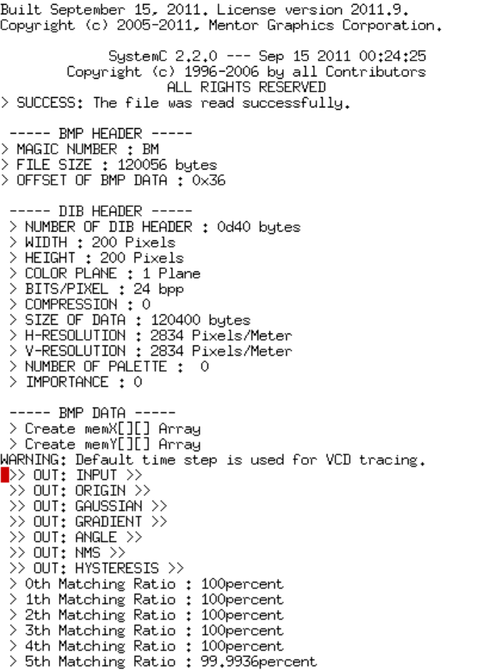

1. *Screenshots of your code in this design with reasonable comments*

Canny edge wrap

