

*Texas A&M University*

**ECEN-719 Lab6 Report**

**NAME: Hai-Ming, Hsu**

**UID: 433004106**

**Section: 602**

**Department of Electrical & Computer Engineering**

1. *Screenshots of the waveform with analysis*

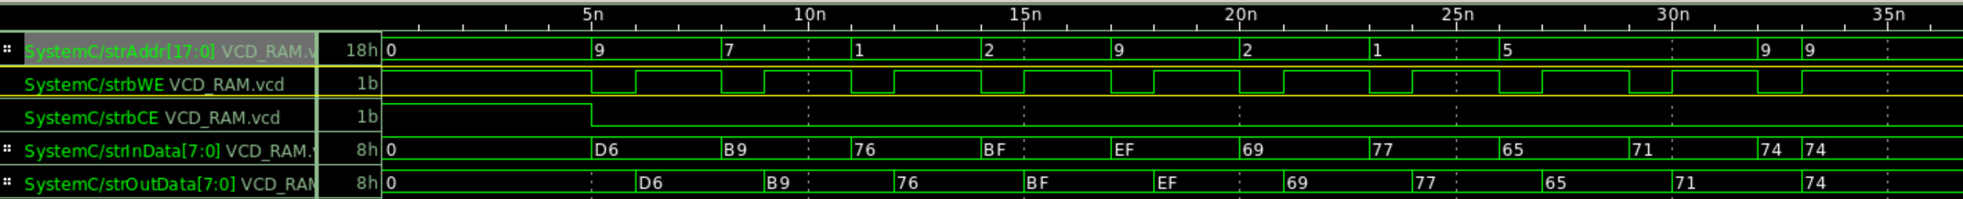

Part 5ns to 20ns is Verification 1, Addr & InData is randomized as required.

Addr & InData is reloaded per test cycle.

Addrs are constrained between 0 to 10. InData >80.

Part 20ns to 35ns is Verification 2, Addr & InData is randomized as required.

Indata are constrained between 100 to 120 with the weight of 5% / 95%.

1. *Screenshots of the simulation output in Vista*

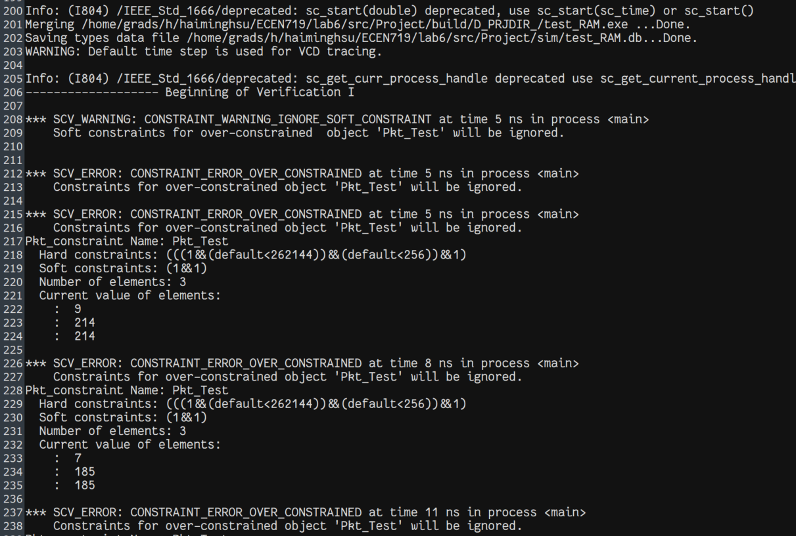

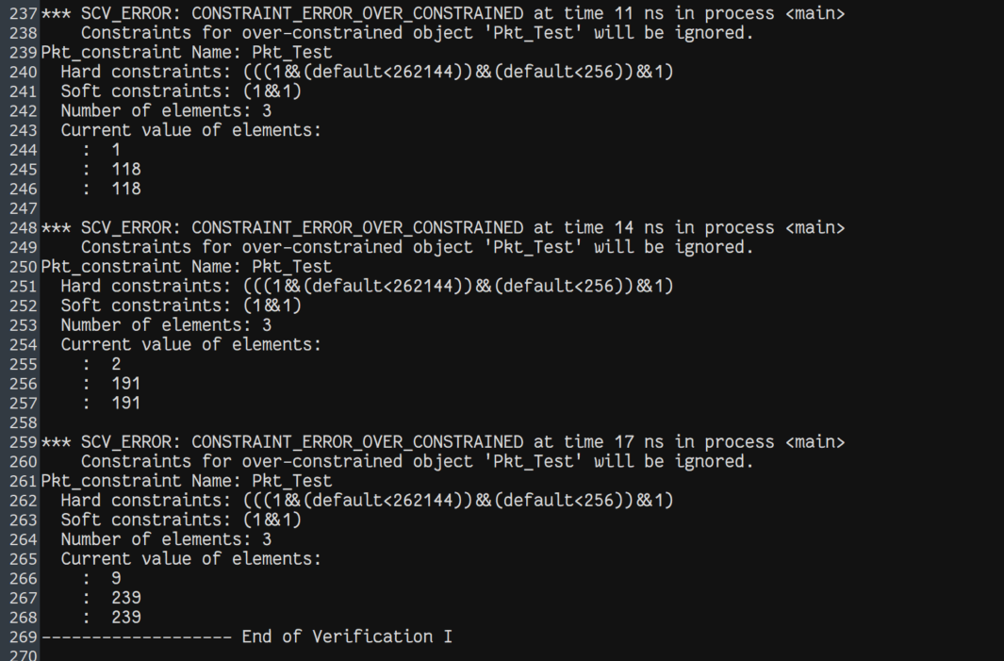

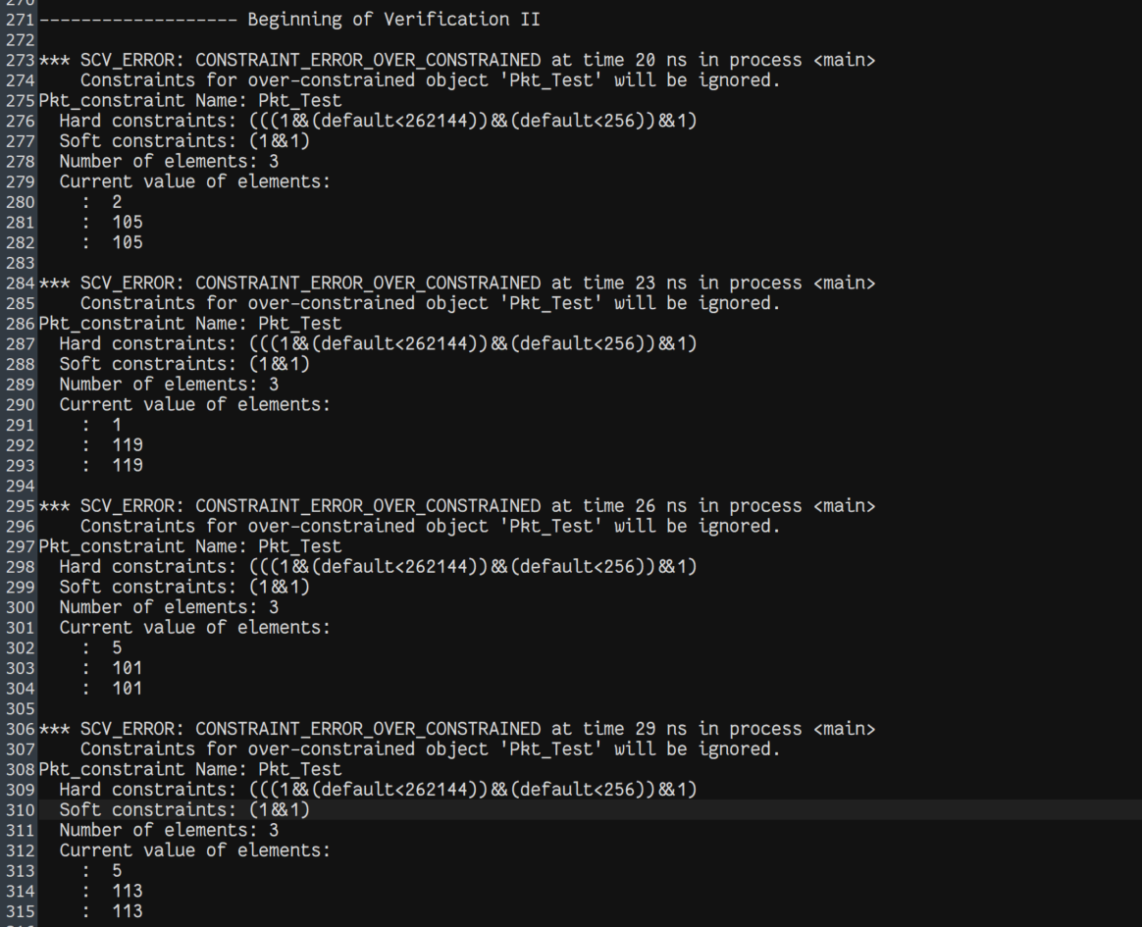

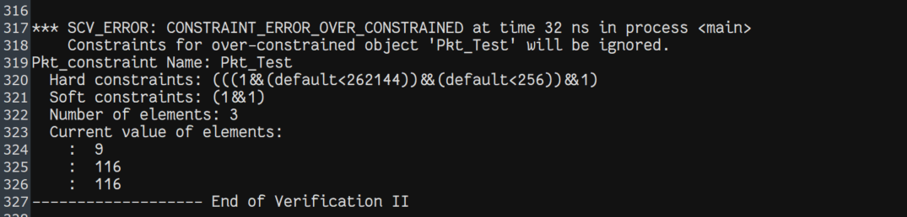

1. *Screenshots of your code in this design with reasonable comments*

