**校园网搭建**

### 一、网络拓扑结构图

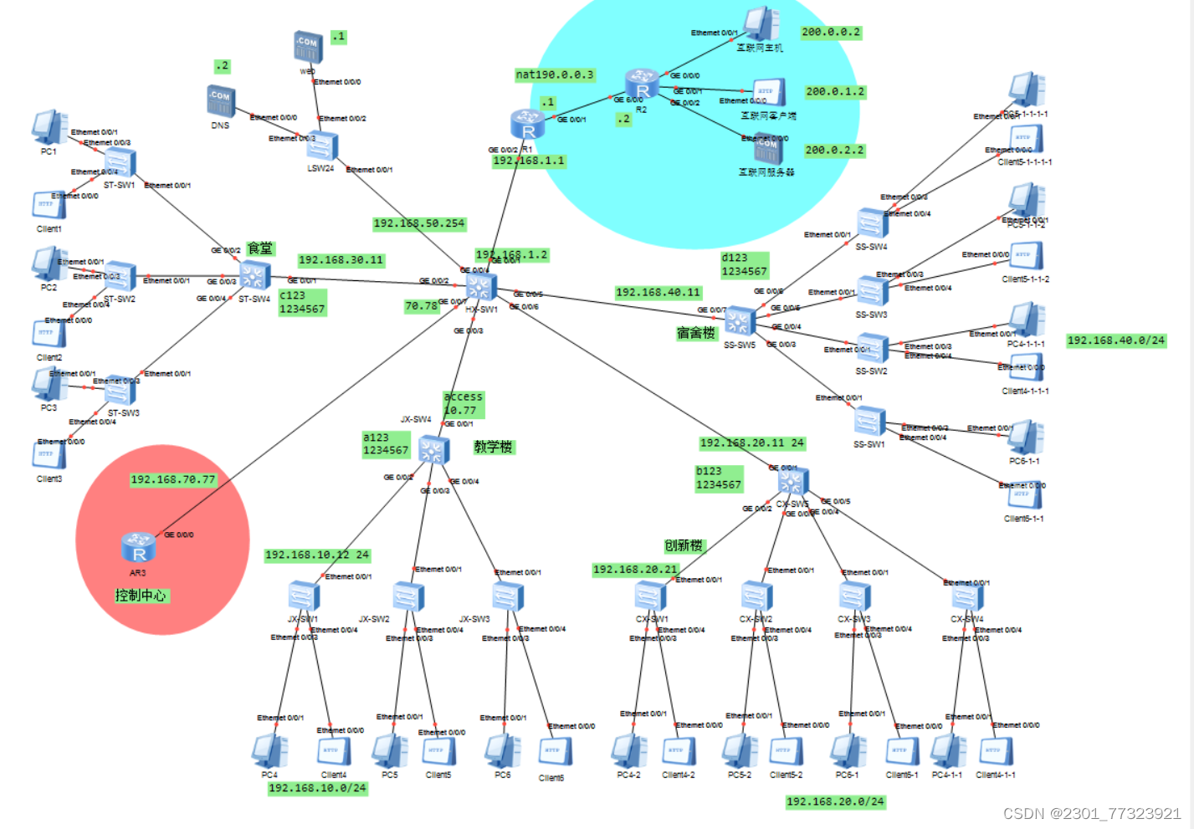

图 1 网络拓扑结构图

### 二、IP地址分配与子网划分方案

表 1 IP地址分配与子网划分方案

|  |  |  |  |  |
| --- | --- | --- | --- | --- |
| 部门名称 | VLAN名称 | VLAN ID | IP地址取值范围 | VLAN SVI ip 地址 |
| 教学楼 | JX-SW | 10 | 192.168.10.1-192.168.10.254 | 192.168.10.254 |
| 创新楼 | CX-SW | 20 | 192.168.20.1-192.168.20.254 | 192.168.20.254 |
| 食堂 | S-SW | 30 | 192.168.30.1-192.168.30.254 | 192.168.30.254 |
| 宿舍楼 | SS-SW | 40 | 192.168.40.1-192.168.40.254 | 192.168.40.254 |
| Web和DNS | WebDns | 50 | 192.168.50.1-192.168.50.254 | 192.168.50.254 |
| 外网 | R1R2 | 60 | 192.168.60.1-192.168.60.254 | 192.168.60.254 |
| 控制中心 | R3 | 70 | 192.168.70.1-192.168.70.254 | 192.168.70.254 |

### **三、所有命令**

dis ip interface brief

教学楼

JX-SW1

sys

sysname JX-SW1

un in en

vlan 10

int e0/0/1

port link-type trunk

port trunk allow vlan all

int e0/0/3

port link-type access

port default vlan 10

int e0/0/4

port link-type access

port default vlan 10

sys

int vlan 10

ip add 192.168.10.11 24

sys

user-interface maximum-vty 15

user-interface vty 0 14

user privilege level 15

protocol inbound telnet

authentication-mode aaa

quit

aaa

local-user aa123 password cipher 1234567

local-user aa123 service-type telnet

JX-SW2

sys

sysname JX-SW2

un in en

vlan 10

int e0/0/1

port link-type trunk

port trunk allow vlan all

int e0/0/3

port link-type access

port default vlan 10

int e0/0/4

port link-type access

port default vlan 10

JX-SW3

sys

sysname JX-SW3

un in en

vlan 10

int e0/0/1

port link-type trunk

port trunk allow vlan all

int e0/0/3

port link-type access

port default vlan 10

int e0/0/4

port link-type access

port default vlan 10

JX-SW4

sys

sysname JX-SW4

un in en

vlan 10

int g0/0/1

port link-type access

port default vlan 10

int g0/0/2

port link-type trunk

port trunk allow vlan all

int g0/0/3

port link-type trunk

port trunk allow vlan all

int g0/0/4

port link-type trunk

port trunk allow vlan all

ip route-static 0.0.0.0 0 192.168.10.254

sys

user-interface maximum-vty 15

user-interface vty 0 14

user privilege level 15

protocol inbound telnet

authentication-mode aaa

quit

aaa

local-user a123 password cipher 1234567

local-user a123 service-type telnet

创新楼

CX-SW1

sys

sysname CX-SW1

un in en

vlan 20

int e0/0/1

port link-type trunk

port trunk allow vlan all

int e0/0/3

port link-type access

port default vlan 20

int e0/0/4

port link-type access

port default vlan 20

远程控制

sys

int vlan 20

ip add 192.168.20.21 24

quit

user-interface maximum-vty 15

user-interface vty 0 14

user privilege level 15

protocol inbound telnet

authentication-mode aaa

quit

aaa

local-user bb123 password cipher 1234567

local-user bb123 service-type telnet

CX-SW2

sys

sysname CX-SW2

un in en

vlan 120

int e0/0/1

port link-type trunk

port trunk allow vlan all

int e0/0/3

port link-type access

port default vlan 20

int e0/0/4

port link-type access

port default vlan 20

CX-SW3

sys

sysname CX-SW3

un in en

vlan 20

int e0/0/1

port link-type trunk

port trunk allow vlan all

int e0/0/3

port link-type access

port default vlan 20

int e0/0/4

port link-type access

port default vlan 20

CX-SW4

sys

sysname CX-SW4

un in en

vlan 20

int e0/0/1

port link-type trunk

port trunk allow vlan all

int e0/0/3

port link-type access

port default vlan 20

int e0/0/4

port link-type access

port default vlan 20

CX-SW5

sys

sysname CX-SW5

un in en

vlan 20

int g0/0/1

port link-type trunk

port trunk allow vlan all

int g0/0/2

port link-type trunk

port trunk allow vlan all

int g0/0/3

port link-type trunk

port trunk allow vlan all

int g0/0/4

port link-type trunk

port trunk allow vlan all

int g0/0/5

port link-type trunk

port trunk allow vlan all

ip route-static 0.0.0.0 0 192.168.20.254

ip route-static 192.168.70.0 24 192.168.20.254

sys

user-interface maximum-vty 15

user-interface vty 0 14

user privilege level 15

protocol inbound telnet

authentication-mode aaa

quit

aaa

local-user b123 password cipher 1234567

local-user b123 service-type telnet

宿舍楼

SS-SW1

sys

sysname SS-SW1

un in en

vlan 40

int e0/0/1

port link-type trunk

port trunk allow vlan all

int e0/0/3

port link-type access

port default vlan 40

int e0/0/4

port link-type access

port default vlan 40

SS-SW2

sys

sysname SS-SW2

un in en

vlan 40

int e0/0/1

port link-type trunk

port trunk allow vlan all

int e0/0/3

port link-type access

port default vlan 40

int e0/0/4

port link-type access

port default vlan 40

SS-SW3

sys

sysname SS-SW3

un in en

vlan 40

int e0/0/1

port link-type trunk

port trunk allow vlan all

int e0/0/3

port link-type access

port default vlan 40

int e0/0/4

port link-type access

port default vlan 40

SS-SW4

sys

sysname SS-SW4

un in en

vlan 40

int e0/0/1

port link-type trunk

port trunk allow vlan all

int e0/0/3

port link-type access

port default vlan 40

int e0/0/4

port link-type access

port default vlan 40

SS-SW5

sys

sysname SS-SW5

un in en

vlan 40

int g0/0/3

port link-type trunk

port trunk allow vlan all

int g0/0/4

port link-type trunk

port trunk allow vlan all

int g0/0/5

port link-type trunk

port trunk allow vlan all

int g0/0/6

port link-type trunk

port trunk allow vlan all

int g0/0/7

port link-type trunk

port trunk allow vlan all

ip route-static 0.0.0.0 0 192.168.40.0

ip route-static 192.168.70.0 24 192.168.40.254

sys

int vlan 40

ip add 192.168.40.11 24

quit

user-interface maximum-vty 15

user-interface vty 0 14

user privilege level 15

protocol inbound telnet

authentication-mode aaa

quit

aaa

local-user d123 password cipher 1234567

local-user d123 service-type telnet

食堂

ST-SW1

sys

sysname ST-SW1

un in en

vlan 30

int e0/0/1

port link-type trunk

port trunk allow vlan all

int e0/0/3

port link-type access

port default vlan 30

int e0/0/4

port link-type access

port default vlan 30

ST-SW2

sys

sysname ST-SW2

un in en

vlan 30

int e0/0/1

port link-type trunk

port trunk allow vlan all

int e0/0/3

port link-type access

port default vlan 30

int e0/0/4

port link-type access

port default vlan 30

ST-SW3

sys

sysname ST-SW3

un in en

vlan 30

int e0/0/1

port link-type trunk

port trunk allow vlan all

int e0/0/3

port link-type access

port default vlan 30

int e0/0/4

port link-type access

port default vlan 30

ST-SW4

sys

sysname ST-SW4

un in en

vlan 30

int G0/0/1

port link-type trunk

port trunk allow vlan all

int G0/0/2

port link-type trunk

port trunk allow vlan all

int G0/0/3

port link-type trunk

port trunk allow vlan all

int G0/0/4

port link-type trunk

port trunk allow vlan all

ip route-static 0.0.0.0 0 192.168.30.0

sys

int vlan 30

ip add 192.168.30.11 24

ip route-static 192.168.70.0 24 192.168.30.254

远程

user-interface maximum-vty 15

user-interface vty 0 14

user privilege level 15

protocol inbound telnet

authentication-mode aaa

quit

aaa

local-user c123 password cipher 1234567

local-user c123 service-type telnet

中间的核心层

HX-SW1

sys

sysname HX-SW1

vlan batch 10 20 30 40 50

int g0/0/2

port link-type trunk

port trunk allow vlan all

int g0/0/3

port link-type access

port default valn 10

int g0/0/5

port link-type trunk

port trunk allow vlan all

int g0/0/6

port link-type trunk

port trunk allow vlan all

int g0/0/7

port link-type access

port default valn 10

int vlan 10

ip add 192.168.10.254 24

int vlan 20

ip add 192.168.20.254 24

int vlan 30

ip add 192.168.30.254 24

int vlan 40

ip add 192.168.40.254 24

int vlan 50

ip add 192.168.50.254 24

[HX-SW1]ip route-static 192.168.70.0 24 192.168.10.77

[HX-SW1]ip route-static 192.168.10.0 24 192.168.70.77

[HX-SW1]ospf

[HX-SW1-ospf-1]a

[HX-SW1-ospf-1]area 0

[HX-SW1-ospf-1-area-0.0.0.0]network 192.168.70.0 0.0.0.255

[HX-SW1-ospf-1-area-0.0.0.0]network 192.168.10.0 0.0.0.255

dhcp enable

int vlan 10

dhcp select global

q

ip pool p1

network 192.168.10.0 mask 24

gateway-list 192.168.10.254

dns-list 192.168.50.1

quit

int vlan 20

dhcp select global

q

ip pool p2

network 192.168.20.0 mask 24

gateway-list 192.168.20.254

dns-list 192.168.50.1

quit

int vlan 30

dhcp select global

q

ip pool p3

network 192.168.30.0 mask 24

gateway-list 192.168.30.254

dns-list 192.168.50.1

quit

int vlan 40

dhcp select global

q

ip pool p4

network 192.168.40.0 mask 24

gateway-list 192.168.40.254

dns-list 192.168.50.1

quit

[Huawei]vlan 60

[Huawei-vlan60]q

[Huawei]int vlan 60

[Huawei-Vlanif60]ip add 192.168.1.2 24

int g0/0/1

port link-type access

port default vlan 60

ip route-static 0.0.0.0 0 192.168.1.1

telnet的配置

sys

user-interface maximum-vty 15

user-interface vty 0 14

user privilege level 15

protocol inbound telnet

authentication-mode aaa

quit

aaa

local-user 123321 password cipher 1234567

local-user 123321 service-type telnet

R1

sys

un in en

sysname R1

int g0/0/2

ip add 192.168.1.1 24

int g0/0/1

ip add 190.0.0.1 24

ip route-static 0.0.0.0 0 190.0.0.2

ip route-static 0.0.0.0 0 192.168.1.2

nat address-group 1 190.0.0.3 190.0.0.3

acl 2000

rule 5 permit source 192.168.10.0 0.0.0.255

int g0/0/1

nat outbound 2000 address-group 1

ip route-static 192.168.10.0 24 192.168.1.2

ip route-static 192.168.20.0 24 192.168.1.2

ip route-static 192.168.30.0 24 192.168.1.2

ip route-static 192.168.40.0 24 192.168.1.2

ip route-static 200.0.0.0 24 190.0.0.2

sys

telnet server enable

user-interface maximum-vty 15

user-interface vty 0 14

user privilege level 15

protocol inbound telnet

authentication-mode aaa

quit

aaa

local-user R122 password cipher 1234567

local-user R122 service-type telnet

R2

sys

un in en

sysname R2

int g6/0/0

ip add 190.0.0.2 24

int g0/0/0

ip add 200.0.0.1 24

int g0/0/1

ip add 200.0.1.1 24

int g0/0/2

ip add 200.0.2.1 24

ip route-static 0.0.0.0 0 190.0.0.3

ip route-static 192.168.10.254 24 190.0.0.3

R3

sys

un in en

int g0/0/0

ip add 192.168.70.77 24

ip route-static 0.0.0.0 0 192.168.70.78