Dataset Selection and Preparation

The data for this project was sourced from Kaggle, which contained 100,000 records and an initial 54 columns. To optimize this raw data for our specific hybrid data model and subsequent machine learning (ML) tasks, we deleted several rows. We filtered out redundant or non-essential columns (such as detailed procedural counts) to curate a focused dataset of 35 key columns. These retained features perfectly align with the project's conceptual model, covering all essential domains: Personal & Demographic (e.g., `age`, `income`), Biometrics & Risk Factors (e.g., `bmi`, `systolic_bp`, `smoker`), Policy & Pricing (e.g., `plan_type`, `deductible`, `annual_premium`), Chronic Conditions (10 flags, e.g., `diabetes`, `cardiovascular_disease`), and core Business Metrics (e.g., `total_claims_paid`, `annual_medical_cost`). This finalized 35-column dataset (`medical_insurance_final.csv`) served as the structured source, which was then transformed into a "ML-analysis" document schema and loaded into our MongoDB Atlas cluster, hosted on AWS, for analysis via PyMongo.

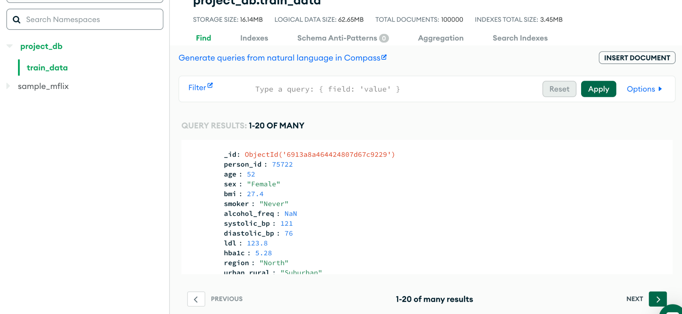

Our schema builds upon the structure introduced in Part 1. It is designed to comprehensively represent the core data of an insurance company. The database consists of four main components. For insured customers, it records demographic information, lifestyle details, and healthcare histories to support risk assessment. Billing information is also maintained, with each bill individually documented. Policyholders—either individuals or companies—are stored in separate tables, and associates responsible for contract execution are recorded as well. Moreover, the design accounts for group contracts that cover multiple insured customers under a single agreement. This structure enables the company to efficiently retrieve data for daily operations, track billing within policy periods, and, most importantly, evaluate risk levels and provide plan recommendations.

