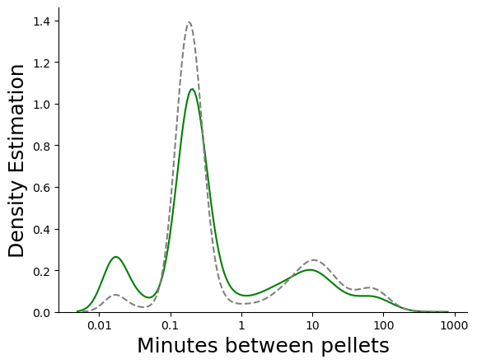NRPR Grain Green and NR grey

PRNR Grain Green and NR gret

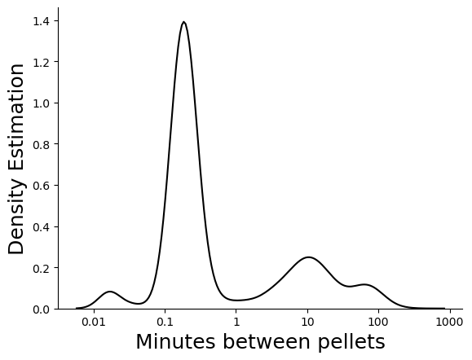NR pellets NRPR

Most of the pellets are taken with 25ish sec gap.

