Dynamics of intake ( All pellet taken throughout the course of experiment)

Repeated measures ANOVA with Diet and Day as within subjests factors and Sex and Order as between subjests factors revealed: a main effect of Day (F(3.4,64.8) = 13.127, P<0.001) but no main effect of Diet, Sex and Order. In addition, there was significant interactions between Diet x Day x Sex x Order, Diet x Day x Order , Diet x Day , Day x Sex (P< 0.05 for all)

#### Descriptives plots

##### Sex: F

##### Sex: M

For further analysis we devided data by Sex and by Order of diet presentation and conducted two-way ANOVA with Diet and Day as factors.

Males NRPR: two-way repeated measures ANOVA with Diet and Day as within subject factors revealed a main effect of Day(F(6,30)= 5.308, P < 0.001) , no main effect of Diet F((1,5)= 0.007, P= 0.938) , but a Diet by Day interaction (F(6,30)= 2.985, P = 0.021)

**Descriptives plots**

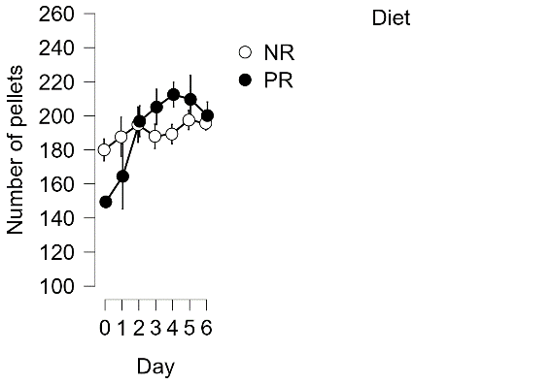

One-way ANOVA on the non-restricted phase revealed no main effect of Day F((6,30)= 0.954, P=0.47). Thus, consumption was stable while mice had access to a non-restricted diet.

### However, one-way ANOVA on the restricted phase did show a main effect of Day F((6,30)= 5.376, P<0.001). Thus, these animals’ consumption increased over the course of access to protein restricted diet.

Males PRNR: two-way repeated measures ANOVA with Diet and Day as within subject factors revealed a main effect of Day(F(6,30)= 5.488, P < 0.001) , no main effect of Diet F((1,5)= 3.894, P= 0.105) , but a Diet by Day interaction (F(6,30)= 15.180, P < 0.001)

**Descriptives plots**

One-way ANOVA on the protein-restrcited phase shows a main effect of Day (F(6,30)= 16.018, P <0.001 ) and post-hoc test shows that consumption increased over time such that the amount of consumption on the last three days was greater that the first three days.

One-Way ANOVA on the non-restricted phase show a main effect of Day (F(6,30)= 6.14, P<0.001 )and Post-hoc tests revealed that consumption decreased from the first day on non-restricted diet versus later days.

Females NRPR: two-way repeated measures ANOVA with Diet and Day as within subject factors revealed a main effect of Day(F(6,24)= 6.932, P < 0.001) , no main effect of Diet F((1,4)= 0.403, P= 0.560) , and no Diet by Day interaction (F(6,24)= 1.924, P = 0.118)

**Descriptives plots**

One-way ANOVA on the non-restricted phase revealed a main effect of Day F((6,24)= 3.922, P=0.007). Thus, consumption was increased while mice had access to a non-restricted diet.

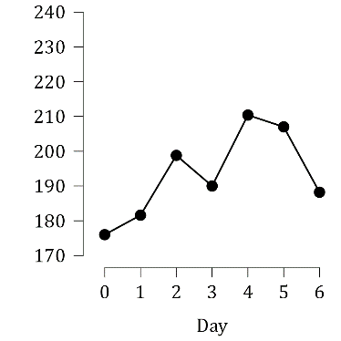

### Also, one-way ANOVA on the restricted phase did show a main effect of Day F((6,24)= 3.592, P=0.011). Thus, these animals’ consumption increased over the course of access to protein restricted diet.

Females PRNR: two-way repeated measures ANOVA with Diet and Day as within subject factors revealed a main effect of Day(F(6,30)= 3.625, P = 0.008) , no main effect of Diet F((1,5)= 0.534, P= 0.498) , but a Diet by Day interaction (F(6,30)= 4.723, P = 0.002)

**Descriptives plots**

### Also, one-way ANOVA on the restricted phase did show a main effect of Day F((6.30)= 6.329, P<0.001). Thus, these animals’ consumption increased over the course of access to protein restricted diet.

One-way ANOVA on the non-restricted phase revealed a main effect of Day F((6,30)= 2.592, P=0.038). Thus, consumption was decreased while mice had access to a non-restricted diet.

Food intake increases during the restricted phase, however on non-restricted diet finding are more variable and are dependent on order of diet presentation and sex of the animals

Overall intake ( Average all pellets taken )

Repeated measures ANOVA with Diet as within subjests factors and Sex and Order as between subjests factors did not reveal any interaction between the parameters among the two cohorts. Thus the avreage of overall pellet intake at each phase of experiment for each group did not statistically differ.

NRPR Male:

One-way ANOVA with Diet as within subjects factor revealed no main effect of diet F((1,5)= 1.750e-4, P=0.990). Thus, avreage pellet intake was not significantely altered across each phase of access to different diets.

NRPR Female:

One-way ANOVA with Diet as within subjects factor revealed no main effect of diet F((1,4)= 0.546, P=0.501). Thus, avreage pellet intake was not significantely altered across each phase of access to different diets.

PRNR Male:

One-way ANOVA with Diet as within subjects factor revealed no main effect of diet F((1,5)= 3.769, P=0.110). Thus, avreage pellet intake was not significantely altered across each phase of access to different diets.

PRNR Female:

One-way ANOVA with Diet as within subjects factor revealed no main effect of diet F((1,5)= 0.577, P=0.482). Thus, avreage pellet intake was not significantely altered across each phase of access to different diets.

Dynamics of bodyweight

Repeated measures ANOVA with Diet and Day as within subjests factors and Sex and Order as between subjests factors revealed : a main effect of Diet (F(1,19) = 4.679, P=0.043) plus a main effect of Day(F(2.9,55.296)= 3.794, P= 0.016). In addition, there was significant interaction between Diet x Order(F(1,19)= 9.734, P = 0.006), Diet x Day(F(2.08,39.58 = 4.900, P = 0.012))and Diet x Day x Order (F(2.08,39.58) = 10.798, P < 0.001).

The between subjects effects showed a significant difference between males and females (F(1,19)= 75.692, P=0.001).

#### Descriptives plots

##### Sex: F

##### Sex: M

For further analysis we devided data by Order of diet presentation and conducted two-way ANOVA with Diet and Day as factors.

TOWWAY= NRPR males Diet and Day as within subject factors shows no effect and mice have constant weight during the two phases

**Descriptives plots**

TOWWAY= PRNR males Diet and Day as within subject factors shows an effect of Diet (F(1,5)= 0.21, P= 0.02), Day(F(6,30)= 4.17, P= 0.004) and an interaction between Diet and Day (F(6,30)= 17.66, P= 0.001)

TOWWAY= NRPR Females Diet and Day as within subject factors shows no effect and interaction of diet and day, weight is constant during the two phases.

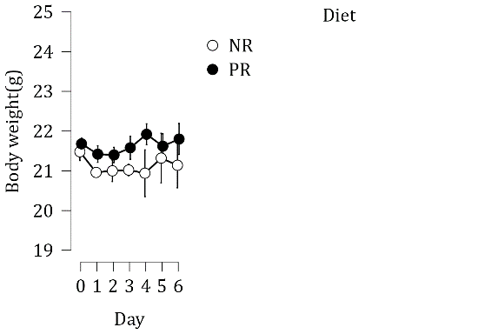

TOWWAY= PRNR Females Diet and Day as within subject factors shows an effect of Diet (F(1,5)=11.4, P= 0.02), Day(F(6,30)= 3.89, P= 0.005) and an interaction between Diet and Day (F(6,30)= 7.87, P= 0.001). The mice lose weight during PR phase and gain weight during NR phase.

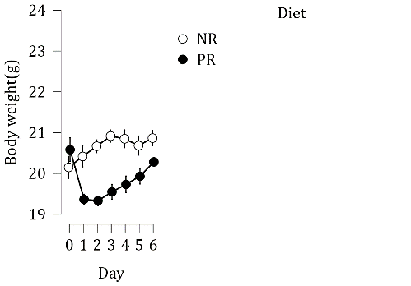

Just NRPR – two way ANOVA

Two-way repeated measures ANOVA with Diet and Day as within subject factors revealed a main effect of Day(F(6,2.3)= 6.932, P < 0.001) , no main effect of Diet F((1,4)= 0.403, P= 0.560) , and no Diet by Day interaction (F(6,24)= 1.924, P = 0.118)

PRNR- two way anova—followed by one way anova and posthocs for NR and PR phase

Meal size ( Average of meal size )

Repeated measures ANOVA with Diet as within subjests factors and Sex and Order as between subjests factors revealed : a main effect of Diet (F(1,19) = 79.071, P<0.001) but no main effect of Diet x Sex and Diet x Sex x Order. In addition, there was significant interactions between Diet x Order (F(1,19)= 20.674 P< 0.001) – consider combining sexes in case there is no difference

#### Descriptives plots

##### Order: NRPR

##### Order: PRNR

#### Raincloud plots

##### Pellets/meal: Order: NRPR

##### Pellets/meal: Order: PRNR

Just add the Two-way ANOVA resuts

Intermeal interval

Repeated measures ANOVA with Diet as within subjests factors and Sex and Order as between subjests factors revealed a main effect of Diet (F(1,19) = 41.62, P<0.001) and an interaction between Diet x Order (F(1,19) = 4.83, P<0.04) but no main effect of Diet x Sex and Diet x Sex x Order.

#### Descriptives plots

##### Order: NRPR

##### Order: PRNR

#### Raincloud plots

##### Time (h): Order: NRPR

##### Time (h): Order: PRNR

