**Real-Time Weather Monitoring & Forecasting**

**Aman Kumar Dassa, Himanshua, Saurabh Chaudharya**

*“Netaji Subhas University of Technology, Dwarka, New Delhi, india”*

1. **Abstract**

Weather forecasting is an application of engineering to determine the current environment for a particular region on Earth. monitoring of the atmosphere or the weather.Forecasting is a crucial undertaking because it aids in knowing what to expect from the climate in the future. Every person or organisation can benefit from this forecasting so they can carry out their plans in accordance with the weather conditions. Weather forecasts are made by experts who study and practise meteorology based on the present weather. They greatly benefit from other methods, such as air balloons, satellites, ocean buoys, radar, etc., which greatly simplifies their task.This paper proposes a machine learning-based real-time weather monitoring and forecasting system that utilises advanced algorithms and statistical models to gather, process, and analyse weather data in real-time. The system collects data from various sources such as weather stations, satellites, and radars to generate accurate and reliable weather forecasts for different geographical regions. The system can provide hourly, daily, or weekly forecasts and can also issue alerts and warnings for severe weather events. The proposed system is essential for various industries that rely on weather forecasts, including agriculture, aviation, transportation, and emergency management. Accurate and timely weather forecasts can help these industries make informed decisions, minimise risks, and improve overall efficiency. Overall, the proposed system is a powerful tool for predicting and managing weather conditions, providing valuable information to help individuals and businesses plan for the future.

1. **Introduction**

Weather forecasting has always been a critical application of engineering, as it helps predict the state of the climate for a specific location across the globe. The ability to forecast the weather is essential for various industries, including agriculture, transportation, and energy. Meteorologists and other professionals in the field of weather forecasting use various data sources, such as satellites, weather stations, and meteorological models, to make predictions for temperature, humidity, precipitation, air quality index, and other weather-related variables.A machine learning-based real-time weather monitoring and forecasting system is a software application that uses advanced algorithms and statistical models to gather, process, and analyse weather data in real-time to provide accurate and reliable weather forecasts. The system leverages machine learning techniques such as neural networks, decision trees, and random forests to make predictions based on historical data and current observations.

The system collects data from various sources such as weather stations, satellites, and radars to generate accurate and reliable weather forecasts. It can predict weather conditions for different geographical regions and can provide hourly, daily, or weekly forecasts. The system can also provide alerts and warnings for severe weather events such as hurricanes, tornadoes, and thunderstorms.This type of system is essential for various industries that rely on weather forecasts, including agriculture, aviation, transportation, and emergency management. Accurate and timely weather forecasts can help these industries make informed decisions, minimise risks, and improve overall efficiency.Overall, a machine learning-based real-time weather monitoring and forecasting system is a powerful tool for predicting and managing weather conditions, providing valuable information to help individuals and businesses plan for the future.

1. **Literature Work**

In paper **[1]**, the authors describe a real-time weather forecasting system that uses machine learning algorithms and data from multiple predictor locations to generate accurate weather predictions. The system employs a collaborative approach that allows multiple users to contribute data and update the models in real-time. The paper first provides an overview of traditional weather forecasting methods and their limitations. It then introduces the concept of collaborative machine learning and explains how it can be applied to weather forecasting. The author also discusses the advantages of using multiple predictor locations to improve the accuracy of weather forecasts.

The system described in the paper is built using a combination of machine learning algorithms and data from multiple weather stations. The system is designed to update its predictions in real-time based on new data, allowing it to respond quickly to changes in weather conditions. The author presents the results of an experiment that demonstrates the effectiveness of the system. The experiment uses data from multiple weather stations and shows that the collaborative machine learning approach improves the accuracy of weather forecasts compared to traditional methods.

In conclusion, the paper highlights the potential of machine learning and collaborative approaches for weather forecasting. The author recommends further research in this area to explore the full potential of these techniques and improve the accuracy of weather predictions. The proposed system has the potential to provide valuable information to a variety of stakeholders, including farmers, transportation companies, and emergency services.

In paper **[2]**, the author focuses on the use of machine learning techniques for forecasting future events or trends. The paper provides an overview of the traditional forecasting methods and the limitations associated with them. It then delves into the use of machine learning algorithms for forecasting, which involves training models on historical data to identify patterns and make predictions about future events. The paper discusses several popular machine learning algorithms used for forecasting, including linear regression, time-series analysis, and artificial neural networks. The author also covers various performance metrics used to evaluate the accuracy of the forecasts generated by these algorithms.

The paper includes a case study that demonstrates the effectiveness of machine learning in forecasting. The author uses a dataset of historical sales data for a retail store and applies machine learning techniques to predict future sales. The results show that machine learning algorithms outperform traditional forecasting methods in terms of accuracy.

In conclusion, the paper highlights the potential of machine learning for forecasting and the advantages it offers over traditional methods. The author recommends further research in this area to explore the full potential of machine learning for forecasting.

In paper **[3]**, it presents a system that uses city buses equipped with sensors to collect real-time weather data and machine learning algorithms to predict future weather conditions. The system aims to improve the accuracy of weather predictions by using data from a large number of sensors distributed across a city. The paper first describes the design of the system, which involves equipping city buses with sensors to collect data on temperature, humidity, and other weather-related variables. The data is then transmitted in real-time to a central server, where it is processed using machine learning algorithms to generate weather predictions.

The paper describes the machine learning algorithms used in the system, which include neural networks and support vector machines. The algorithms are trained on historical weather data and then used to predict future weather conditions based on real-time data collected by the sensors on the city buses. The author presents the results of an experiment that demonstrates the effectiveness of the system. The experiment uses data collected from city buses in a real-world setting and shows that the system can accurately predict future weather conditions.

In conclusion, the paper highlights the potential of using city buses and machine learning for real-time weather monitoring and prediction. The author recommends further research in this area to explore the full potential of these techniques and to develop more advanced algorithms for weather prediction. The proposed system has the potential to provide valuable information to a variety of stakeholders, including transportation companies, emergency services, and city planners.

In paper **[4]**, it presents a deep learning-based weather forecasting model that aims to improve the accuracy of fine-grained weather predictions. The model uses a convolutional neural network (CNN) to extract features from weather data and a long short-term memory (LSTM) network to predict future weather conditions. The paper first describes the design of the model, which involves preprocessing weather data to extract features that are relevant to weather forecasting. The CNN is used to extract high-level features from the preprocessed data, and the LSTM network is used to generate predictions based on the extracted features.

The paper discusses the advantages of using deep learning for weather forecasting, including the ability to learn complex patterns in weather data and the ability to handle large datasets. The author also compares the proposed model with other existing weather forecasting models and shows that the deep learning-based model outperforms these models in terms of accuracy. The author presents the results of an experiment that demonstrates the effectiveness of the model. The experiment uses data from multiple weather stations and shows that the deep learning-based model can accurately predict fine-grained weather conditions, including temperature, humidity, and wind speed.

In conclusion, the paper highlights the potential of deep learning for weather forecasting and the advantages it offers over traditional forecasting methods. The author recommends further research in this area to explore the full potential of deep learning for weather prediction. The proposed model has the potential to provide valuable information to a variety of stakeholders, including farmers, transportation companies, and emergency services.

In paper **[5],** the authors propose a novel deep learning-based approach to forecast different types of convective weather such as thunderstorms, hail, and tornadoes. The proposed model combines convolutional neural networks (CNNs) and long short-term memory (LSTM) networks to extract and predict relevant features from weather data. The paper discusses the advantages of using deep learning for convective weather forecasting, including the ability to capture complex spatial and temporal relationships in weather data. The author compares the proposed model with other existing weather forecasting models and shows that the deep learning-based model outperforms these models in terms of accuracy.

The paper describes the design of the model, which involves preprocessing weather data to extract features that are relevant to convective weather forecasting. The CNN is used to extract spatial features from the preprocessed data, and the LSTM network is used to capture the temporal dynamics of convective weather. The proposed approach is evaluated using data from multiple weather stations and the results demonstrate the effectiveness of the model in accurately forecasting different types of convective weather.

In conclusion, the paper highlights the potential of deep learning for convective weather forecasting and the advantages it offers over traditional forecasting methods. The proposed model has the potential to provide valuable information to a variety of stakeholders, including transportation companies, emergency services, and city planners. Further research in this area is recommended to explore the full potential of deep learning for convective weather prediction.

1. **Methodology**

The dataset utilised in this has been gathered from Kaggle which is “Historical Weather Data for Indian Cities” from which we have chosen the data for “Delhi City”. The dataset was created by keeping in mind the necessity of such historical weather data in the community. The datasets for the top 8 Indian cities as per the population. The datasets contain hourly weather data from 01-01-2009 to 01-01-2020. The data of each city is for more than 10 years. This data can be used to visualise the change in data due to global warming or can be used to predict the weather for upcoming days, weeks, months, seasons, etc.

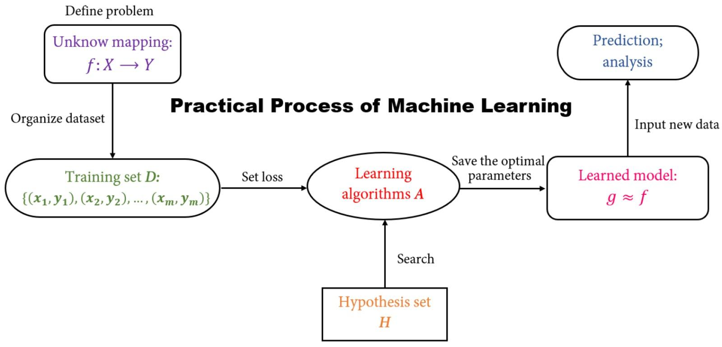

**Fig. 1 : Process of Machine Learning**

We are concentrating on the temperature prediction of Delhi city with the help of various machine learning algorithms and various regressions. By applying various regressions on the historical weather dataset of Delhi city we are predicting the temperature like first we are applying Multiple Linear regression, then Decision Tree regression, and after that, we are applying Random Forest Regression

**4.1 Flow Diagram**

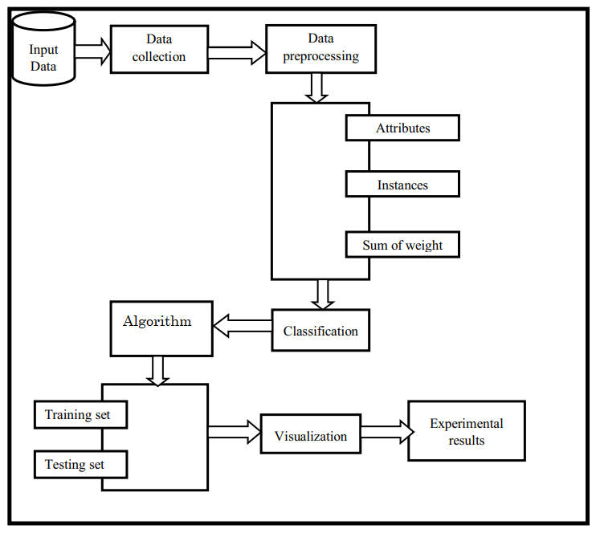

**4.2 Multiple Linear Regression**

Multiple Linear Regression is a supervised learning algorithm used to predict a continuous output variable based on multiple input variables.It assumes a linear relationship between the input variables and the output variable, and tries to find the best linear equation that describes the relationship.

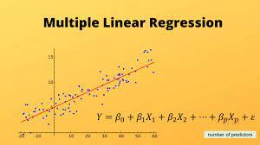

**Fig. 2 : Equation formed in MLR**

The algorithm uses a training dataset to estimate the coefficients that minimise the sum of the squared differences between the predicted and actual values.The estimation is done using techniques like Ordinary Least Squares (OLS) or Gradient Descent.

The equation takes the form:

**Y = b0 + b1X1 + b2X2 + ... + bn*Xn,**

Here, Y is the output variable, X1 to Xn are the input variables, and b0 to bn are the coefficients that determine the strength and direction of the relationship between the variables.

**4. Decision Tree Regression**

Decision Tree is a supervised learning algorithm used for both classification and regression tasks.It works by recursively splitting the data into smaller subsets based on the most significant attribute/feature that best separates the data into classes. The goal of the algorithm is to create a tree-like structure where each internal node represents a test on an attribute, each branch represents the outcome of the test, and each leaf node represents a class label.

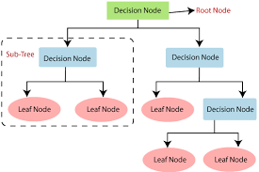

**Fig 3 : Structure of Decision Tree**

The algorithm selects the attribute to split the data based on measures like entropy, information gain, or Gini index to maximise the separation of the classes.

**4.4 Random Forest Regression**

Random Forest is a supervised learning algorithm used for both classification and regression tasks.It is an ensemble learning method that combines multiple decision trees to improve the model's performance and reduce overfitting.

The algorithm works by creating a set of decision trees on random subsets of the training data (bootstrap samples) and random subsets of the input features (feature bagging).Each decision tree in the forest is trained using a subset of the data and features, and makes predictions on new data by averaging the predictions of all the trees in the forest (for regression) or using a majority vote (for classification).

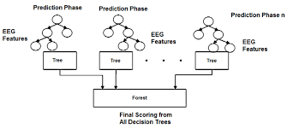

Fig. 4 : Random Forest structure

The number of trees in the forest, the maximum depth of each tree, and the number of features to consider at each split are hyperparameters that can be tuned to optimise the performance of the model.

1. **Result**

* Dataset Preprocessing and visualisation

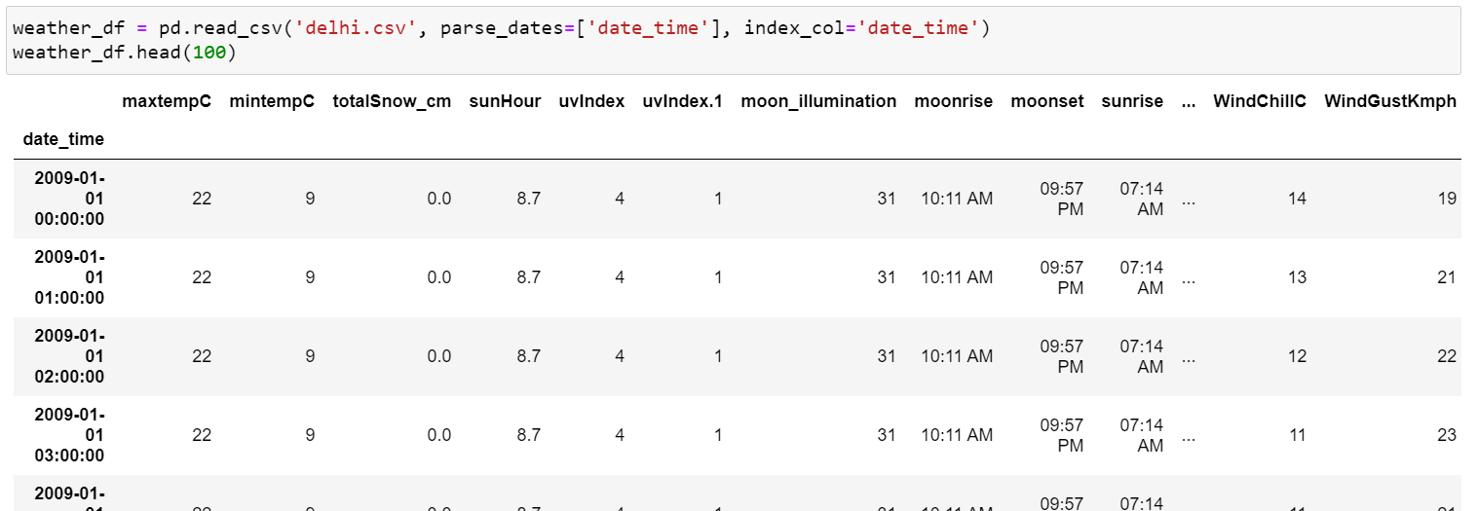

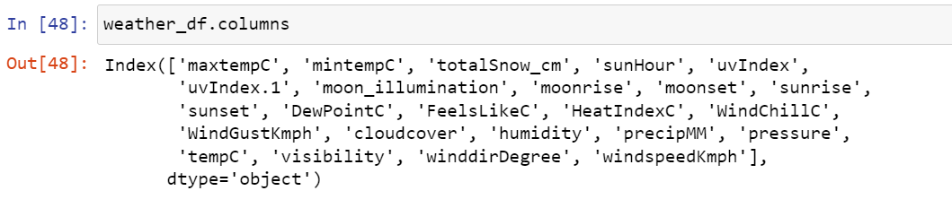

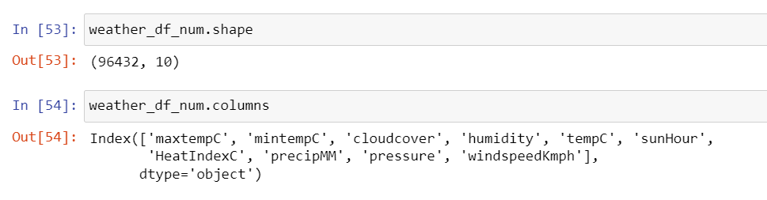

* Multiple Linear Regression

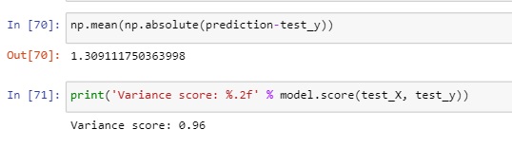

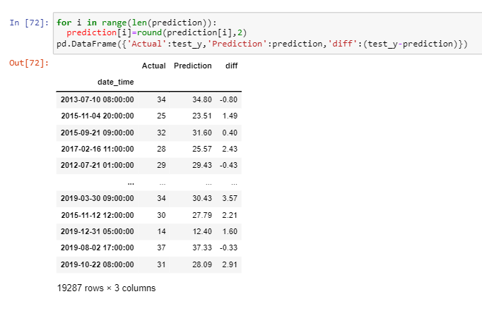

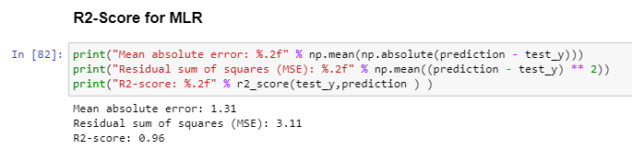

* Decision Tree Regression

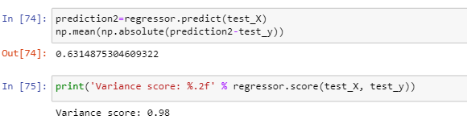

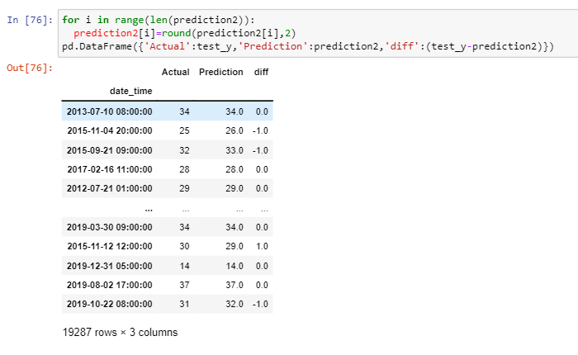

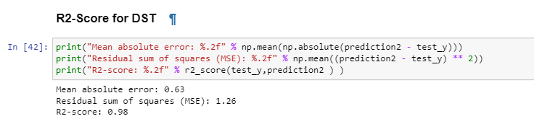

* Random Forest Regression

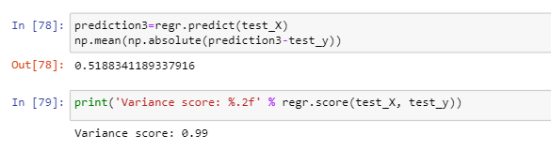

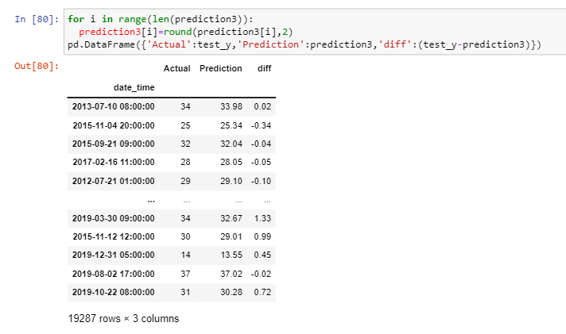

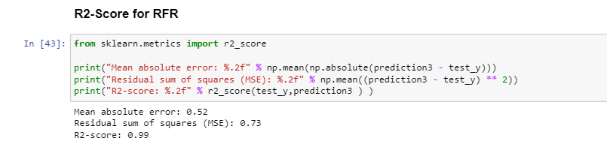

1. **Conclusion**

Linear regression is naturally a high difference model as it is unsteady to outliers, so one approach to improve the linear regression model is by gathering more information. Practical regression, however, was high predisposition, demonstrating that the decision of the model was poor and that its predictions can't be improved by the further accumulation of information. This predisposition could be expected to the structure decision to estimate temperature dependent on the climate of the previous two days, which might be too short to even think about capturing slants in a climate that practical regression requires. On the off chance that the figure was rather founded on the climate of the past four or five days, the predisposition of the practical regression model could probably be decreased. In any case, this would require significantly more calculation time alongside retraining of the weight vector w, so this will be conceded to future work.

Talking about Random Forest Regression, it proves to be the most accurate regression model. Likely so, it is the most popular regression model used, since it is highly accurate and versatile. Below is a snapshot of the implementation of Random Forest in the project.Weather Forecasting has a major test of foreseeing the precise outcomes which are utilised in numerous ongoing frameworks like power offices, air terminals, the travel industry focuses, and so forth. The trouble of this determination is the mind-boggling nature of parameters. Every parameter has an alternate arrangement of scopes of qualities.

1. **References**

[1] Fowdur, T. P., & Ibn, R. M. N. U. D. (2022). A real-time collaborative machine learning based weather forecasting system with multiple predictor locations. Array, 14, 100153.

[2] Amit Kumar Agarwal, Manish Shrimali, Sukanya Saxena, Ankur Sirohi, Anmol Jain, Forecasting using Machine Learning, “ International Journal of Recent Technology and Engineering (IJRTE)”, ISSN: 2277-3878, Volume-7 Issue-6C, April 2019.

[3] Huang, Z. Q., Chen, Y. C., & Wen, C. Y. (2020). Real-time weather monitoring and prediction using city buses and machine learning. Sensors, 20(18), 5173.

[4] Hewage, P., Trovati, M., Pereira, E., & Behera, A. (2021). Deep learning-based effective fine-grained weather forecasting model. Pattern Analysis and Applications, 24(1), 343-366.

[5]Zhou, K., Zheng, Y., Li, B., Dong, W., & Zhang, X. (2019). Forecasting different types of convective weather: A deep learning approach. Journal of Meteorological Research, 33, 797-809.