**Table of Contents**

**ABSTRACT** 2

**CHAPTER 1: INTRODUCTION** 3

**1.1 Investigated Problem** 3

**1.2 Scope And Context** 3

**1.3 Aims, Objectives, And Motivation** 3

**1.4 Problem Description And Methodological Approach** 4

**1.5 Summary Of Significant Outcomes** 4

**CHAPTER 2: OVERVIEW OF EXISTING SOLUTIONS AND TECHNOLOGIES** 5

**2.1 Existing Solutions And Technologies** 5

**2.2 Comparison and Analysis of Existing Solutions** 5

**CHAPTER 3: LIMITATIONS OF EXISTING SYSTEM** 7

**CHAPTER 4: NEED FOR NEW SYSTEM / ALGORITHM** 8

**CHAPTER 5: SYSTEM DESIGN / ARCHITECTURE / MODEL** 9

**5.1 Hardware and Software Requirements** 9

**5.2 System Architecture** 9

**5.3 Modules in the Proposed System** 10

**CHAPTER 6: DATASET/DATABASE DESIGN** 11

**CHAPTER 7: IMPLEMENTATION** 12

**CHAPTER 8: RESULTS & DISCUSSIONS** 15

**8.1 Implemented Functionalities** 15

**8.2 Future Directions** 15

**8.3 Discussion** 16

**CHAPTER 9: CONCLUSION** 17

**CHAPTER 10: REFERENCES** 18

**ANNEXUREA** 19

# **ABSTRACT**

This project report summarizes the development of a multiplayer card game using Unity Engine and C# scripting. Inspired by traditional card games, the project aims to provide an immersive gaming experience where players interact within a virtual card table environment. The implementation includes menu layouts for players to reveal cards, place bets, and pass turns, ultimately competing to achieve winning combinations.

Through rigorous development and testing, the game offers polished gameplay suitable for players of all skill levels. The report discusses the project's background and purpose, detailing the methods and implementation used. Results highlight the game's appeal and playability, demonstrating its potential for success in the gaming industry.

Overall, this project contributes to the gaming landscape by offering a fresh take on classic card game mechanics within a dynamic Unity Engine environment. The conclusions drawn from the project emphasize its significance and implications for the broader gaming community.

# **CHAPTER 1: INTRODUCTION**

In the realm of game development, our project delves into the creation of a multiplayer card game utilizing Unity Engine and C# scripting. The focus lies on crafting an immersive gaming experience that captures the essence of traditional card games while leveraging the dynamic capabilities of modern game engines.

## **1.1 Investigated Problem**

The project tackles the development of a multiplayer card game using Unity Engine and C# scripting, aiming to create an immersive gaming experience that combines traditional card game mechanics with modern technology.

## **1.2 Scope And Context**

The scope of the project encompasses the creation of a virtual card table environment where players can interact, revealing cards, placing bets, and competing to achieve winning combinations. This endeavor seeks to explore the potential of Unity Engine in delivering dynamic gameplay experiences.

## **1.3 Aims, Objectives, And Motivation**

The primary aim of the project is to provide players with an engaging and competitive multiplayer card game experience. The objectives include implementing intuitive game mechanics, designing a visually appealing user interface, and optimizing gameplay for seamless multiplayer interactions. The motivation stems from the desire to bridge the gap between classic card game concepts and modern gaming platforms, offering players a fresh and immersive gaming experience.

## **1.4 Problem Description And Methodological Approach**

The problem lies in designing and implementing complex card game mechanics within a digital environment while ensuring an enjoyable and balanced gameplay experience. The methodological approach involves iterative development, rigorous testing, and continuous feedback integration to refine gameplay mechanics and optimize player experience.

## **1.5 Summary Of Significant Outcomes**

Anticipated outcomes include the creation of a polished multiplayer card game that captivates players with its immersive gameplay and engaging mechanics. By leveraging Unity Engine's capabilities and employing a systematic development approach, we aim to deliver a high-quality gaming experience that resonates with players of all skill levels.

# **CHAPTER 2: OVERVIEW OF EXISTING SOLUTIONS AND TECHNOLOGIES**

In the competitive landscape of multiplayer card games, several well-known titles serve as benchmarks for our project's development. These games, including Blackjack, Poker, Rummy, Uno, and Hearthstone, each bring unique gameplay mechanics and technological implementations to the forefront.

## **2.1 Existing Solutions And Technologies**

Blackjack, a classic casino card game, typically employs a client-server architecture with backend technologies such as Java or C++ for server-side processing and communication. Poker, another popular card game, often utilizes similar technologies but introduces additional complexities such as real-time multiplayer interactions and secure transaction handling.

Rummy, Uno, and Hearthstone are renowned for their innovative gameplay mechanics and immersive player experiences. Rummy and Uno traditionally rely on peer-to-peer networking for multiplayer interactions, while Hearthstone utilizes a robust server infrastructure to support its online multiplayer matches.

## **2.2 Comparison and Analysis of Existing Solutions**

A comparative analysis of these existing solutions reveals distinct strengths and weaknesses. Blackjack and Poker excel in providing a realistic and immersive casino experience, with sophisticated algorithms for card shuffling and gameplay mechanics. Rummy and Uno prioritize simplicity and accessibility, offering fast-paced gameplay suitable for casual players. Hearthstone stands out for its deep strategic depth and extensive card collection mechanics, supported by a dedicated online community and competitive esports scene.

However, each of these games faces challenges in terms of scalability, security, and platform compatibility. Blackjack and Poker may struggle to adapt to modern gaming platforms and emerging technologies, while Rummy, Uno, and Hearthstone grapple with maintaining a balance between accessibility and complexity.

**2.3 Emerging Trends**

Emerging trends in multiplayer card game development include the integration of blockchain technology for secure asset ownership and trading, cross-platform compatibility for seamless gaming experiences across devices, and augmented reality (AR) and virtual reality (VR) enhancements for immersive gameplay experiences.

Incorporating insights from existing solutions and emerging trends, our project aims to carve a unique niche in the competitive multiplayer card game market. By leveraging innovative technologies and design principles, we seek to deliver a captivating gaming experience that resonates with players of all ages and skill levels.

# **CHAPTER 3: LIMITATIONS OF EXISTING SYSTEM**

|  |  |
| --- | --- |
| **Criteria** | **Limitations/Gaps/Criticisms** |
| Scope Limitations | The game is confined to the Unity Engine environment, limiting its accessibility and reach to players who can only play within the Unity platform. |
| Assumptions and Simplifications | Assumptions about player familiarity with Unity Engine may overlook potential barriers to entry for new players, impacting the user experience. |
| Resource Limitations | Resource constraints within the Unity Engine environment may restrict the game's scalability and performance, particularly on lower-spec devices. |
| Data/Dataset Limitations | Lack of external data integration or backend support limits the game's dynamic content generation and customization options within the Unity environment. |
| Methodological Limitations | Methodological approaches may not fully leverage Unity Engine's capabilities for optimizing gameplay mechanics or graphical enhancements. |
| External Factors | External factors such as Unity Engine updates or compatibility issues may affect the stability and reliability of the game within the Unity environment. |
| Technology Constraints | Technological constraints within Unity Engine may limit the implementation of advanced features or cross-platform compatibility beyond the Unity platform. |
| Unforeseen Challenges | Unforeseen challenges, such as changes to Unity Engine licensing or development policies, may impact the long-term sustainability of the game within the Unity environment. |

# **CHAPTER 4: NEED FOR NEW SYSTEM / ALGORITHM**

Backend Database Integration

Without a backend database, we miss out on personalizing player experiences and tracking their progress. Integrating a robust backend system enables features like player profiles, achievements, and leaderboards, enhancing engagement.

Transition to Standalone PC Software

Moving away from Unity Engine to standalone PC software expands accessibility and control over performance optimization. This transition opens avenues for improved graphics, advanced mechanics, and compatibility across devices.

Implementation of Online Multiplayer Mode

Adding online multiplayer functionality enriches the game's competitive and social aspects. Features like matchmaking and cross-platform play foster a vibrant community and extend the game's longevity.

Addition of Essential Features

Beyond the core needs, prioritizing features like advanced AI, customizable modes, and regular updates ensures continued player engagement and relevance in the gaming landscape.

# **CHAPTER 5: SYSTEM DESIGN / ARCHITECTURE / MODEL**

## **5.1 Hardware and Software Requirements**

Hardware Requirements:

Processor: Intel Core i5 or equivalent

Memory: 8GB RAM

Optimal Graphics and CPU

Storage: 1GB available space

Display: Minimum resolution of 1280x720

Software Requirements:

Operating System: Windows 10 (64-bit)

Unity Engine 2021.3.35f1 or later

Visual Studio 2022 Community Edition or later

## **5.2 System Architecture**

The System Architecture of our multiplayer card game primarily focuses on the Unity Engine environment and the internal structure of the game itself. It consists of two main components:

Presentation Layer

This layer encompasses all visual and interactive elements visible to the player within the Unity Engine. It includes user interface (UI) components such as menu screens, gameplay interfaces, and visual feedback. The presentation layer is responsible for rendering graphics, handling player input, and providing real-time feedback during gameplay.

Application Layer

The application layer contains the core logic and functionality of the game, implemented using C# scripting within Unity. It includes modules for game mechanics, player interactions, and game state management. This layer orchestrates the flow of gameplay, processes player actions, and maintains the internal state of the game.

The System Architecture prioritizes simplicity and efficiency, leveraging the capabilities of Unity Engine to deliver a seamless and immersive gaming experience. While backend database integration and external server communication are not currently implemented, the architecture remains flexible to accommodate future enhancements and expansions, including the addition of online multiplayer functionality and backend support as the project progresses.

## **5.3 Modules in the Proposed System**

User Interface Module: Responsible for managing the presentation layer components, including menu screens, game HUDs (Heads-Up Displays), and player feedback interfaces.

Game Logic Module: Implements core gameplay mechanics, such as card generation, player actions, turn-based logic, and game state management.

Graphics Module: Manages rendering and visual effects, optimizing performance and graphical fidelity across different hardware configurations.

**5.4 Unity UI/UX Design**

In the Unity UI/UX Design section, we outline the process of visual design for our offline multiplayer card game directly within the Unity game engine. Utilizing Unity's built-in tools, we create wireframes and design the layout of game screens and UI elements. This includes crafting the visual elements for each screen, ensuring clarity, consistency, and usability in the user experience. Additionally, 3D models for game assets such as cards and player objects are created using Unity's built-in tool kit. This iterative design process within Unity allows for efficient feedback and refinement, ultimately achieving a polished and immersive visual presentation for the game.

# **CHAPTER 6: DATASET/DATABASE DESIGN**

In this section, we discuss the dataset/database design for our game project, acknowledging that we have yet to implement any database or backend system to store data. However, we recognize the importance of incorporating these elements in the future to enhance the functionality and user experience of the game.

As of now, our game operates without the need for a database or backend site. Player progress, settings, and game data are managed locally within the game environment. While this approach suffices for the current offline multiplayer experience, future iterations of the game will benefit from the implementation of a database system to enable features such as online multiplayer functionality, player profile management, and game progress tracking.

Despite the absence of a database in the current implementation, we outline the potential structure and characteristics that a future database system may encompass. This includes defining entities such as player profiles, game sessions, achievements, and leaderboard data. Additionally, considerations for data integrity, security, and scalability will be paramount in the design and implementation of the database architecture.

While the dataset/database design remains theoretical at this stage, it serves as a crucial aspect of our game's roadmap for future development. By laying the groundwork for database integration, we pave the way for a more robust and feature-rich gaming experience in subsequent iterations of the game.

# **CHAPTER 7: IMPLEMENTATION**

**Here are few Snapshots of the Game:**

**1 After Cards distributed :-**

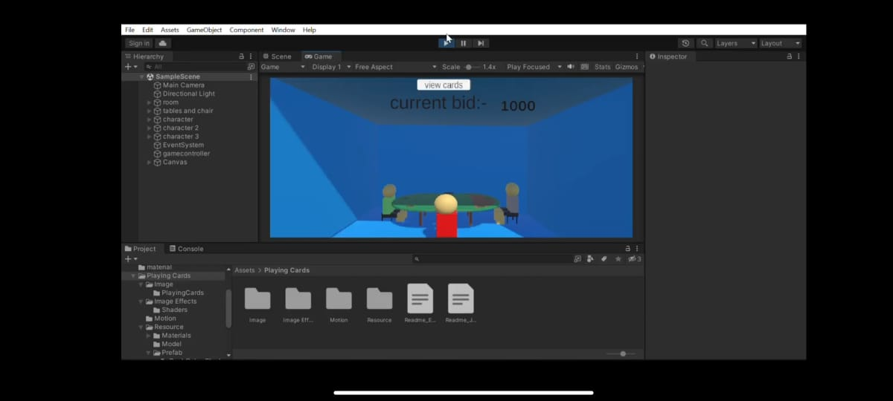

**Fig. 7.1**

**2 Basic Panel for player 1: -**

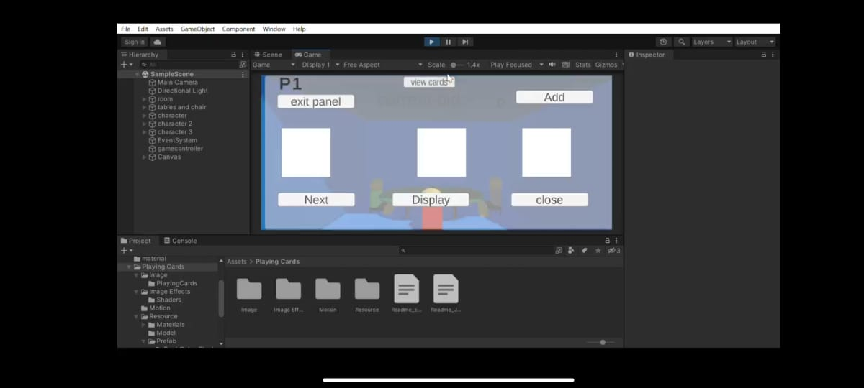

**Fig. 7.2**

**3 Open cards of player 1: -**

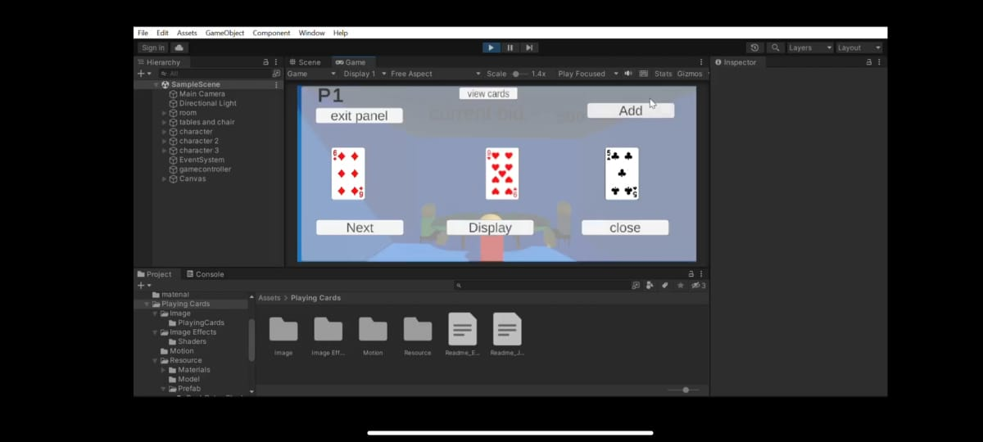

**Fig. 7.3**

**4 Back side of cards: -**

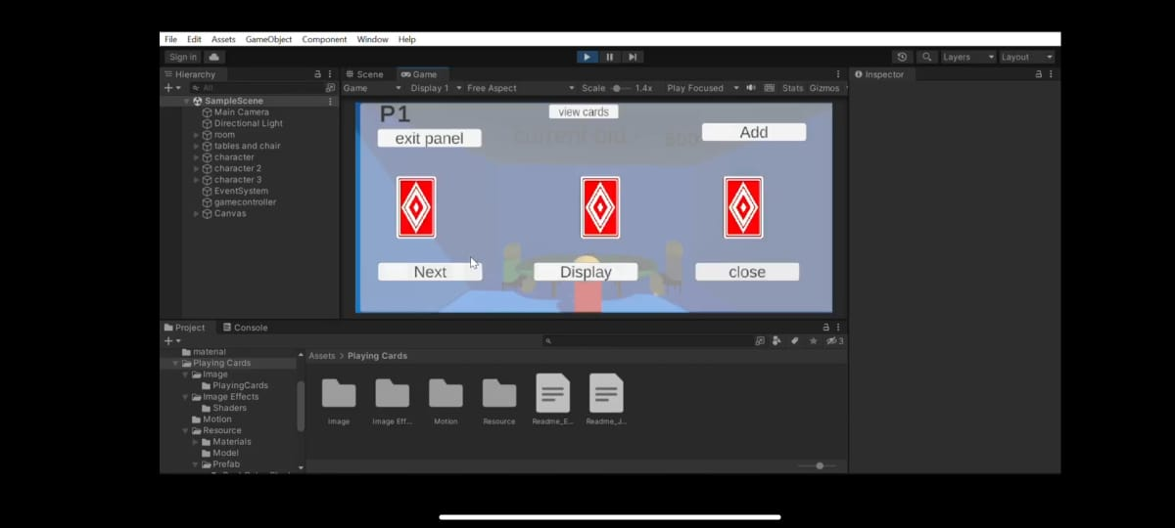

**Fig. 7.4**

**5 Cards for player 2: -**

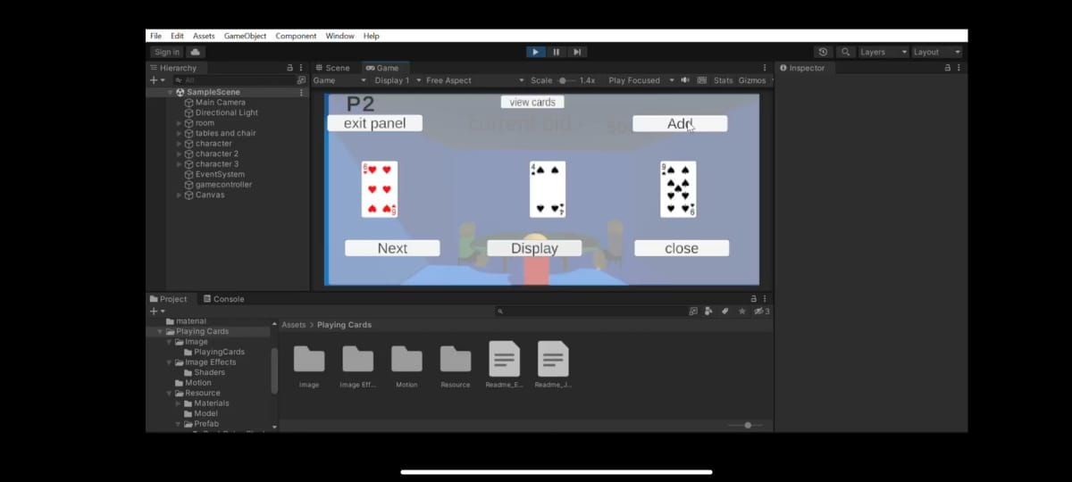

**Fig. 7.5**

# **CHAPTER 8: RESULTS & DISCUSSIONS**

In this chapter, we present the findings and outcomes of our project, focusing on the implemented functionalities and their relevance to the project objectives. Although we are yet to implement certain aspects such as online multiplayer and backend database integration, we discuss the progress made thus far and potential directions for future development.

## **8.1 Implemented Functionalities**

We have successfully implemented the core functionalities of the offline multiplayer card game within the Unity Engine environment. This includes:

User Interface: The user interface components, including menu screens, gameplay interfaces, and player feedback, have been designed and implemented to provide a smooth and intuitive user experience.

Game Mechanics: The game logic module handles core gameplay mechanics such as card generation, player actions, turn-based logic, and game state management. Players can interact with the game, play rounds, and progress through the gameplay flow seamlessly.

## **8.2 Future Directions**

While significant progress has been made in implementing the offline multiplayer card game, there are several avenues for future development:

Online Multiplayer: Implementing online multiplayer functionality to enable players to compete and collaborate with others globally.

Backend Database Integration: Integrating a backend database system to store player data, game history, and other relevant information, enabling personalized experiences and tracking of player progress.

Additional Features: Adding new features such as advanced AI opponents, customizable game modes, and in-depth tutorials to enhance gameplay depth and engagement.

## **8.3 Discussion**

The progress made in implementing the offline multiplayer card game lays a solid foundation for future development. By focusing on core functionalities and user experience, we have established a framework for further expansion and refinement. However, challenges remain in implementing online multiplayer and backend database integration, which will require careful consideration and planning to ensure seamless integration and optimal performance.

Overall, the results demonstrate the feasibility and potential of the project, paving the way for future iterations and enhancements to deliver a compelling and immersive gaming experience to players.

# **CHAPTER 9: CONCLUSION**

In conclusion, this project aimed to address the challenge of developing an engaging offline multiplayer card game within the Unity Engine environment. By leveraging Unity's capabilities and employing C# scripting, we successfully implemented core functionalities such as user interface design, gameplay mechanics, and local data management. The purpose of this endeavor was to provide college students, gaming enthusiasts, and anyone looking for a fun and challenging card game experience with an immersive gaming environment. While the current implementation lays a solid foundation for future development, including intuitive user interfaces and seamless gameplay flow, the absence of online multiplayer functionality and backend database integration remains a limitation. However, these shortcomings present opportunities for future extensions, allowing for the inclusion of online multiplayer support, backend database systems for data persistence and player tracking, and additional features to enhance gameplay depth and replayability.

# **CHAPTER 10: REFERENCES**

1. Schell, J. (2008). "The Art of Game Design: A Book of Lenses." CRC Press.
2. Marhulets, W. (2020). "GAMEDEV: 10 Steps to Making Your First Game Successful."
3. Nystrom, R. (2014). "GAME PROGRAMMING PATTERNS."
4. Felicia, P. (2018). "Unity From Zero to Proficiency (Beginner): A step-by-step guide to coding your first game with Unity in C#."
5. Joseph Hocking, (2022), Third Edition. "Unity in Action." Manning Publications.
6. Fullerton, T. (2019). "Game Design Workshop: A Playcentric Approach to Creating Innovative Games." CRC Press.
7. Rabin, S. (2009). "Introduction to Game Development." CRC Press.
8. Swink, S. (2009). "Game Feel: A Game Designer's Guide to Virtual Sensation." CRC Press.
9. Dille, F., & Zuur Platten, J. (2008). "The Ultimate Guide to Video Game Writing and Design." Lone Eagle Publishing.

# **ANNEXUREA**