**Software testing assignment**

**Module – 4 (Defect Management)**

**Q-1 : Difference between Priority and Severity**

**Ans :**

|  |  |  |
| --- | --- | --- |
| **Parameters** | **Severity in Testing** | **Priority in Testing** |
| Definition | Severity is a term that denotes how severely a defect can affect the functionality of the software. | Priority is a term that defines how fast we need to fix a defect. |
| Parameter | Severity is basically a parameter that denotes the total impact of a given defect on any software. | Priority is basically a parameter that decides the order in which we should fix the defects. |
| Relation | Severity relates to the standards of quality. | Priority relates to the scheduling of defects to resolve them in software. |
| Value | The value of severity is objective. | The value of priority is subjective. |
| Change of Value | The value of Severity changes continually from time to time. | The value of Priority changes from time to time. |
| Who Decides the Defect | The testing engineer basically decides a defect’s severity level. | The product manager basically decides a defect’s priority level. |
| Types | There are 5 types of Severities: Cosmetic, Minor, Moderate, Major, and Critical. | There are 3 types of Priorities: High, Medium, and Low. |

**Q-2 : What is Bug Life Cycle?**

**Ans :** A computer bug is an error, flaw, mistake, failure, or fault in a computer program that prevents it from working correctly or produces an incorrect result. Bugs arise from mistakes and

Errors, made by people, in either a program’s source code or its design.

* The duration or time span between the first time defects is found and the time that it is closed successfully, rejected, postponed or deferred is called as ‘Defect Life Cycle

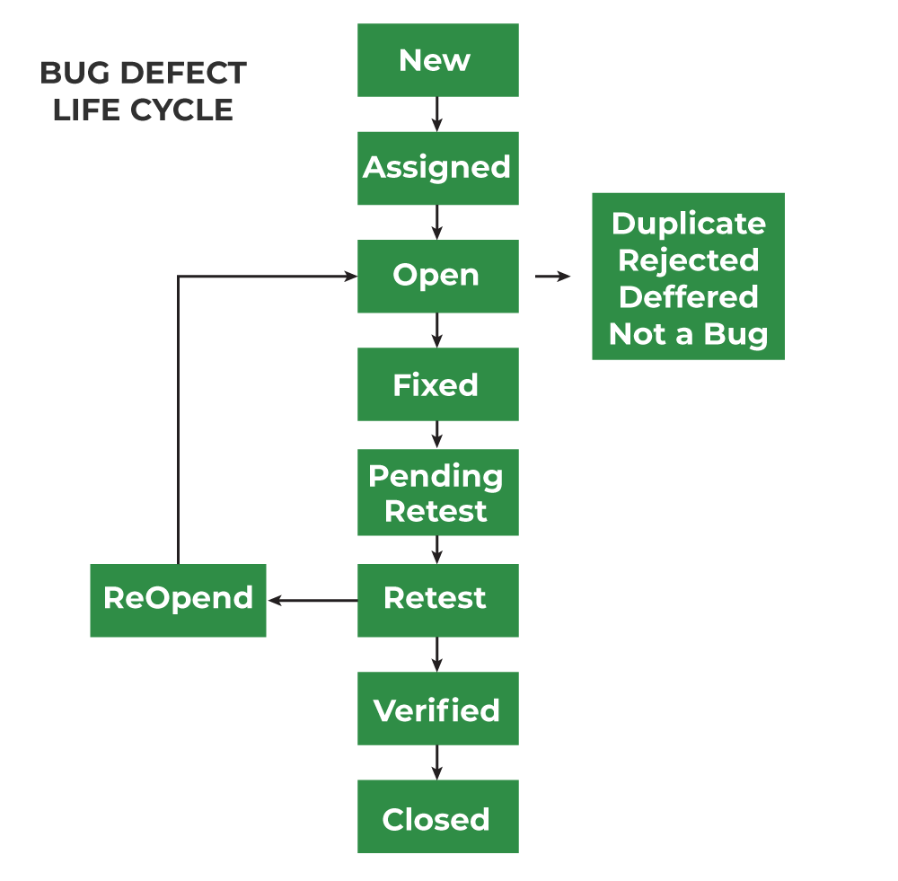

**Q-3 :** **What is priority?**

**Ans :** Priority in software testing refers to the order in which defects should be addressed, fixed, and tested based on their importance and impact on the project's goals. Priority levels are typically categorized into several levels, such as Immediate, High, Medium, and Low.

**Q-4 : What is severity?**

**Ans :** Severity is defined as the extent to which a particular defect can create an impact on the software. Severity is a parameter to denote the implication and the impact of the defect on the functionality of the software.

* A higher effect of the bug on system functionality will lead to a higher severity level.
* A QA engineer determines the severity level of a bug.

**Q-5 : Bug categories are…**

**Ans :** There are different types of software bugs:

1. Functional Bugs
2. Performance Bugs
3. Security Bugs
4. Unit-level bugs
5. Usability Bugs
6. Syntax Errors
7. Compatibility Errors
8. Logic Bugs

**Q-6 : Advantage of Bugzila .**

**Ans :**

* it is an open-source widely used bug tracker;
* it is easy in usage and its user interface is understandable for people without technical knowledge;
* it easily integrates with test management instruments;
* it integrates with an e-mailing system;
* it automates documentation**.**
* Best for small companies who wants to start up with less budget.
* Main benefit of this software is its open source architecture. It carries virtually no cost and very good community support which provides guidance on virtually every aspect.