CENTRAL TOOL ROOM & TRAINING CENTER
B-36, CHANDAKA INDUSTRIAL AREA, NEAR INFOCITY, BBSR,(O.D) 751024
Department Of PGDTD & CC

CERTIFICATE

Certified that Major Project Work entitled “Healthcare Management Dashboard” is a Bonafide work carried out by Data Analytics June Batch in particular fulfillment of the requirements for the award of MASTER CERTIFICATE COURSE IN DATA ANALYTICS from CENTRAL TOOL ROOM & TRAINING CENTER, Bhubaneswar, during the month June-july. It is certified that all the correction/suggestion indicated for internal assessment have been incorporated in the report. The major project report has been approved as is satisfied the academic requirements in the respect of project work prescribed for PGDTD & CC, CTTC, Bhubaneswar (O.D).
…………………………………..  Workshop  In-Charge  (Dept. Of MCCAI) | ……………………………………  Course  Coordinator  (Dept. Of MCCAI) | …………………………………..  Examiner

ACKNOWLEDGEMENT
It is our proud privilege and duty to acknowledge the kind of help and guidance received from several people in preparation for this report. It would not have been possible to prepare this report in this form without their valuable help, cooperation, and guidance.
First and foremost, we wish to record our sincere gratitude to Management of this Training Center and to our beloved Principal, Mr. L. Rajasekhar, and Sr. Manager, Mr. Rajan K.M, CTTC, Bhubaneswar. For his constant support and encouragement in preparation of this report and for making the available library and laboratory facilities available needed to prepare this report. Our sincere thanks to Sr. Engineer Mrs. Ritu Maity, CTTC, BBSR. For his valuable suggestions and guidance throughout the period of this report. We express our sincere gratitude to our supervisor Er. Md Shamaun Alam, Er. Ashutosh Pati & Er. Aldrin Kerketta, Department of MCCAI, CTTC, Bhubaneswar for guiding us in investigations for this major project and in carrying out experimental work. Our numerous discussions with him were extremely helpful. We hold him in esteem for guidance, encouragement, and inspiration received from his.
The project on " HEALTHCARE MANAGEMENT DASHBOARD " was very helpful for us in giving the necessary background information and inspiration in choosing this Project. Our sincere thanks to Mrs. Gitanjali, for having supported the work related to this project. Their contributions and technical support in preparing this report are greatly acknowledged. Last but not the least, we wish to thank our parents for ﬁnancing our studies in this college as well as for constantly encouraging us to learn to engineer. Their personal sacriﬁce in providing this opportunity to learn engineering is gratefully acknowledged.

Place: Bhubaneswar Data Analytics

DECLARATION

We the batch of June Data Analytics successfully completed Internship of Duration of 1month At CTTC (Central Tool Room & Training Center), Bhubaneswar, hereby declare that this major project work entitled “Healthcare Management Dashboard” which is being submitted by us .CTTC, Bhubaneswar is an authentic record carried out during the Training duration(Jun 25-July 25), under the supervision of Mrs. Gitanjali, Department of CSE, CTTC, Bhubaneswar.

MCCAI 2nd BATCH

ABSTRACT

Healthcare management plays a crucial role in improving patient outcomes and optimizing the operational efficiency of hospitals and clinics. Traditional methods of managing patient records, appointments, and treatment workflows are often time-consuming, error-prone, and lack real-time analytics. This project proposes the development of a Healthcare Management Dashboard that provides an interactive and visual representation of critical healthcare data including patient details, doctor performance, appointment status, treatment cost analysis, and billing summaries.

The dashboard is built using data analytics tools and supports advanced features such as data filtering, KPI tracking, and performance monitoring, enabling hospital administrators and staff to make informed decisions. Using datasets like patient demographics, doctor specialization, treatment procedures, and billing data, the system integrates and visualizes information in a user-friendly interface. This not only improves decision-making but also enhances service delivery and patient satisfaction.

The dashboard is implemented using Microsoft Excel and Tableau, offering flexibility for both exploratory and explanatory data analysis. By transforming raw healthcare data into meaningful insights, the dashboard contributes to efficient healthcare management and aligns with the digital transformation goals of modern medical institutions.

Key Words:
Healthcare ,Dashboard, Excel, Tableau, Patient, Appointment, Billing, Data Visualization, KPI, Analytics, Doctor Performance

INDEX
S. No. | Contents
CERTIFICATE

ACKNOWLEDGEMENT

DECLARATION

ABSTRACT

INDEX

Introduction

Workflow

System Architecture

ML Model of Healthcare Management System

INTRODUCTION

As we have seen in many hospitals and healthcare institutions, administrators and staff face numerous challenges in managing patient data, tracking appointments, recording treatment histories, and maintaining billing details on a daily basis. Traditionally, most of this data is recorded manually or stored in fragmented systems, making it time-consuming and prone to errors. To simplify and streamline these tasks, various technologies have emerged in the field of healthcare data management.Manual Attendance System (MAS)

With the growing demand for accurate, real-time, and actionable healthcare information, data visualization tools like Excel and Tableau offer powerful solutions for building interactive dashboards. These dashboards help healthcare professionals access critical insights related to patient care, doctor performance, treatment costs, revenue generation, and appointment analytics — all in one place.

Healthcare dashboards make use of data analytics and visual representation techniques to automatically process large datasets and present them in an intuitive format. These tools assist hospitals in performance monitoring, resource allocation, and strategic planning. The rise of business intelligence in healthcare has significantly improved the quality and speed of decision-making across departments.

In general, healthcare data can be managed and visualized through various systems, namely:
• Manual Record Keeping Systems
• Electronic Health Record (EHR) Systems
• Hospital Management Systems (HMS)
• Excel-based Data Trackers
• Power BI / Tableau-based Dashboards
• Automated Healthcare Analytics Platforms

Manual Record Keeping Systems:-
These are the traditional paper-based systems used by hospitals and clinics to document patient information, appointments, treatments, and billing. Data is recorded in registers or files and physically stored.
Limitations: Prone to human error, time-consuming, difficult to retrieve and Analyse, and vulnerable to damage or loss.

Electronic Health Record (EHR) Systems:-
EHR systems are digital versions of a patient’s paper chart. They contain comprehensive patient histories, including diagnoses, medications, treatment plans, immunization dates, and test results. EHRs are accessible across multiple departments and even between different healthcare providers.
Advantages: Real-time updates, improved accuracy, remote access, better patient care coordination, and enhanced data security.

Hospital Management Systems (HMS):-
An HMS is a comprehensive, integrated system that manages all aspects of hospital operations, including patient registration, appointment scheduling, billing, inventory, lab reports, and staff management.
Benefits: Automation of administrative tasks, centralized data handling, improved patient care, and operational efficiency.

Excel-based Data Trackers:-
Excel is commonly used for manually entering, organizing, and analyzing healthcare data such as patient logs, revenue tracking, treatment cost comparison, and appointment records. With pivot tables, charts, and formulas, users can create simple dashboards and reports.
Strengths: Easy to use, flexible, supports basic visualization and analytics without requiring programming knowledge.
Limitations: Lacks automation and scalability for large data; prone to manual errors.

WORK FLOW:
The System Architecture of a Healthcare Management Dashboard using a relational data model. It includes five main entities (tables): Patient_pvt, Doctor_pvt, Appoint_pvt, Treatment_pvt, and Bill_pvt, each connected by primary and foreign key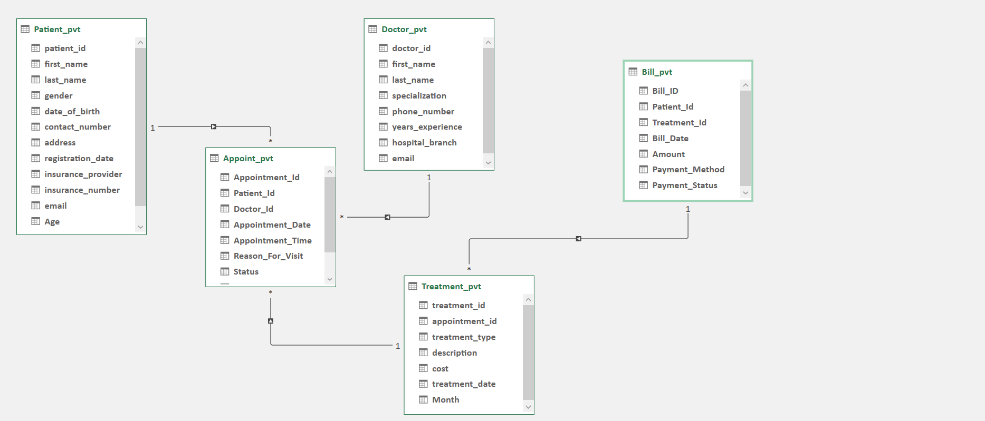

. Patient_pvt Table
- Primary Key: patient_id
- Stores all patient-related details like:
  - Name, Gender, DOB, Contact Info
  - Insurance info and email
  - Registration date and Age
- Relationship: One patient can have multiple appointments (1-to-many with Appoint_pvt).

Doctor_pvt Table:-
- Primary Key: doctor_id
- Contains doctor information:
  - Name, Specialization
  - Phone number, Experience, Email
  - Hospital branch
- Relationship: One doctor can handle multiple appointments (1-to-many with Appoint_pvt

Appoint_pvt Table:-
- Primary Key: Appointment_Id
- Foreign Keys: Patient_Id, Doctor_Id
- Records appointment data:
  - Date, Time, Reason for Visit, Status
- Relationship:
  - Linked to both Patient_pvt and Doctor_pvt
  - One appointment can result in multiple treatments (1-to-many with Treatment_pvt)

Treatment_pvt Table:-
- Primary Key: treatment_id
- Foreign Key: appointment_id
- Stores treatment-related information:
  - Type of treatment, Description, Cost
  - Treatment date and Month
- Relationship:
  - Connected to Appoint_pvt
  - Each treatment may be billed (1-to-1 or 1-to-many with Bill_pvt)

5. Bill_pvt Table:-

- Primary Key: Bill_ID
- Foreign Keys: Patient_Id, Treatment_Id
- Captures billing details:
  - Bill date, Amount
  - Payment method (e.g., Cash, Card)
  - Payment status (e.g., Paid, Pending)
- Relationship:
  - Linked to both Patient_pvt and Treatment_pvt

SYSTEM ARCHITECHTURE:-
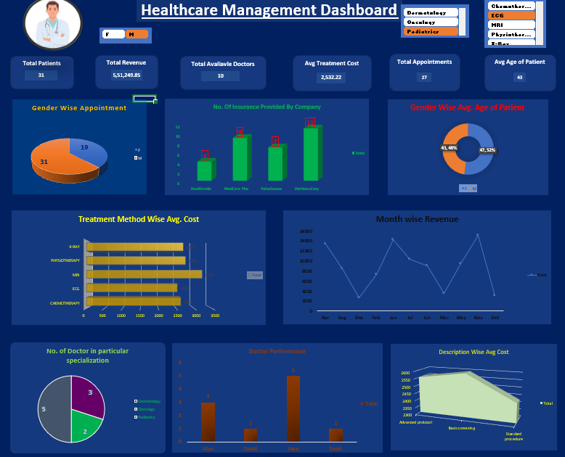

The Healthcare Management Dashboard is the front-end data visualization layer that sits on top of the relational database system, transforming raw data from multiple interconnected tables into insightful and interactive visuals. It is designed using tools like Microsoft Excel , which are directly linked to the backend data model (consisting of tables such as Patient_pvt, Doctor_pvt, Appoint_pvt, Treatment_pvt, and Bill_pvt).
This dashboard provides a consolidated view of key healthcare KPIs (Key Performance Indicators), making it easier for hospital administrators and staff to:

Dashboard Components and Their Data Sources:-
Total Patients ,Revenue ,Doctors,Appointments ,Avg. Treatment Cost ,Avg. Age
- Data Source: Aggregated from Patient_pvt, Doctor_pvt, Treatment_pvt, and Bill_pvt.

• Gender-wise Appointments
- Data Source: Patient_pvt joined with Appoint_pvt.
• Insurance Provided by Company
- Data Source: Grouped data from Patient_pvt (insurance_provider).
• Gender-wise Avg. Age of Patient
- Data Source: Calculated from Patient_pvt using gender and date_of_birth.
• Treatment Method-wise Avg. Cost
- Data Source: Treatment_pvt grouped by treatment_type and cost.
• Month-wise Revenue
- Data Source: Bill_pvt using Bill_Date and Amount.
• Doctor Performance
Data Source: Count of appointments per doctor from Appoint_pvt.
• Number of Doctors per Specialization
- Data Source: Doctor_pvt grouped by specialization.
• Description-wise Avg. Treatment Cost
- Data Source: Treatment_pvt using description and cost.

ML MODEL OF HEALTHCARE MANAGEMENT SYSTEM:

Objective:
The objective of this is to analyse the Health Management System dataset and build a predictive model to estimate treatment costs based on various features such as treatment type and specialization.

Steps for building model:
1. Data Preparation
1.1 Importing Required Libraries
To begin the analysis, the following Python libraries were imported:
- ‘Pandas’ : for data manipulation and analysis
- ‘Numpy’ : for numerical operations
- ‘matplotlib’ and ‘seaborn’ : for data visualization
- ‘sklearn’ : for machine learning algorithms and model evaluation
1.2 Loading and Merging Datasets
The datasets related to the Health Management System were loaded and merged into a final dataset using their unique value columns.
1.3 Data Cleaning
Although the dataset was already cleaned, the following checks were performed:
- Checked for null values in the dataset
- Verified the data types of each column to ensure they were appropriate for analysis

2. Data Analysis
2.1 Exploratory Data Analysis (EDA)
Data analysis was conducted to visualize the relationships between:
- Treatment type
- Specialization
- Treatment cost
Graphs were plotted to illustrate these relationships, providing insights into how different factors influence treatment costs.
3. Data Preprocessing
3.1 Encoding Categorical Variables
Since the output column (treatment cost) is numerical, label encoding was applied to:
- Output column
- All input columns containing string values
This conversion transformed categorical values into numerical values suitable for modeling.
3.2 Dropping Unused Columns
Columns that were not relevant to the predictive model were dropped to streamline the dataset.
3.3 Defining Features and Target Variable
The feature variables (input) and the target variable (output) were defined for the modeling process.
3.4 Splitting the Dataset
The dataset was split into training and testing sets to evaluate the model's performance effectively.
4. Model Building and Training
4.1 Model Selection
Given that the output column is a continuous variable, a Random Forest Regression model was selected for this analysis.
4.2 Training the Model
The model was trained using the training dataset, allowing it to learn the relationships between the features and the target variable.
5. Predictions and Evaluation
5.1 Making Predictions
Predictions were made on the testing dataset using the trained Random Forest Regression model.
5.2 Evaluating the Model
The model's performance was evaluated by comparing the actual vs. predicted values. Various metrics such as Mean Absolute Error (MAE), Mean Squared Error (MSE), and R-squared were calculated to assess the accuracy of the predictions.
5.3 Visualization of Results
A plot was created to visualize the actual vs. predicted values, providing a clear representation of the model's performance.

