Responsibilities of a software project manager

Software project managers take the overall responsibility of steering a project to success. The job responsibility of a project manager ranges from invisible activities like building up team morale to highly visible customer presentations. Most managers take responsibility for project proposal writing, project cost estimation, scheduling, project staffing, software process tailoring, project monitoring and control, software configuration management, risk management, interfacing with clients, managerial report writing and
presentations, etc. These activities are certainly numerous, varied and difficult to enumerate, but these activities can be broadly classified into project planning, and project monitoring and control activities. The project planning activity is undertaken before the development starts to plan the activities to be undertaken during development. The project monitoring and control activities are undertaken once the development activities start with the aim of ensuring that the
development proceeds as per plan and changing the plan whenever required to cope up with the situation.

Skills necessary for software project management

A theoretical knowledge of different project management techniques is certainly
necessary to become a successful project manager. However, effective software
project management frequently calls for good qualitative judgment and decision
taking capabilities. In addition to having a good grasp of the latest software
project management techniques such as cost estimation, risk management,
configuration management, project managers need good communication skills
and the ability get work done. However, some skills such as tracking and controlling the progress of the project, customer interaction, managerial
presentations, and team building are largely acquired through experience.

Project planning

Once a project is found to be feasible, software project managers undertake
project planning. Project planning is undertaken and completed even before any
development activity starts. Project planning consists of the following essential
activities:

• Estimating the following attributes of the project:

Project size: What will be problem complexity in terms of the effort and time required to develop the product?
Cost: How much is it going to cost to develop the project?
Duration: How long is it going to take to complete development?
Effort: How much effort would be required?

Software Project Management Plan (SPMP)

Once project planning is complete, project managers document their plans in a
Software Project Management Plan (SPMP) document. The SPMP document
should discuss a list of different items that have been discussed below. This list
can be used as a possible organization of the SPMP document.
Organization of the Software Project Management Plan (SPMP) Document

1. Introduction
(a) Objectives
(b) Major Functions
(c) Performance Issues
(d) Management and Technical Constraints

2. Project Estimates
(a) Historical Data Used
(b) Estimation Techniques Used
(c) Effort, Resource, Cost, and Project Duration Estimates

3. Schedule
(a) Work Breakdown Structure
(b) Task Network Representation
(c) Gantt Chart Representation
(d) PERT Chart Representation

4. Project Resources
(a) People
(b) Hardware and Software
(c) Special Resources

5. Staff Organization
(a) Team Structure
(b) Management Reporting

6. Risk Management Plan

(a) Risk Analysis
(b) Risk Identification
(c) Risk Estimation
(d) Risk Abatement (to become less intense) Procedures

7. Project Tracking and Control Plan

8. Miscellaneous Plans
(a) Process Tailoring
(b) Quality Assurance Plan
(c) Configuration Management Plan
(d) Validation and Verification
(e) System Testing Plan
(f) Delivery, Installation, and Maintenance Plan

Metrics for software project size estimation

Accurate estimation of the problem size is fundamental to satisfactory estimation
of effort, time duration and cost of a software project. In order to be able to
accurately estimate the project size, some important metrics should be defined in
terms of which the project size can be expressed. The size of a problem is
obviously not the number of bytes that the source code occupies. It is neither the
byte size of the executable code.
The project size is a measure of the problem complexity in terms of the effort and time required to develop the product. Currently two metrics are popularly being used widely to estimate size: lines of code (LOC) and function point (FP). The usage of each of these metrics in project size estimation has its own advantages and disadvantages.

Lines of Code (LOC)

LOC is the simplest among all metrics available to estimate project size. This
metric is very popular because it is the simplest to use. Using this metric, the
project size is estimated by counting the number of source instructions in the
developed program. Obviously, while counting the number of source instructions,
lines used for commenting the code and the header lines should be ignored.
Determining the LOC count at the end of a project is a very simple job.
However, accurate estimation of the LOC count at the beginning of a project is
very difficult. In order to estimate the LOC count at the beginning of a project,
project managers usually divide the problem into modules, and each module into
submodules and so on, until the sizes of the different leaf-level modules can be
approximately predicted. By using the estimation of the lowest level modules,
project managers arrive at the total size estimation.

Function point (FP)

Function point metric was proposed by Albrecht [1983]. This metric overcomes
many of the shortcomings of the LOC metric. Since its inception in late 1970s,
function point metric has been slowly gaining popularity. One of the important
advantages of using the function point metric is that it can be used to easily
estimate the size of a software product directly from the problem specification.
This is in contrast to the LOC metric, where the size can be accurately
determined only after the product has fully been developed.

The conceptual idea behind the function point metric is that the size of a
software product is directly dependent on the number of different functions or
features it supports. A software product supporting many features would certainly
be of larger size than a product with less number of features. Each function when
invoked reads some input data and transforms it to the corresponding output
data. For example, the issue book feature (as shown in fig. 11.2) of a Library
Automation Software takes the name of the book as input and displays its
location and the number of copies available. Thus, a computation of the number
of input and the output data values to a system gives some indication of the
number of functions supported by the system. Albrecht postulated that in addition
to the number of basic functions that a software performs, the size is also
dependent on the number of files and the number of interfaces.

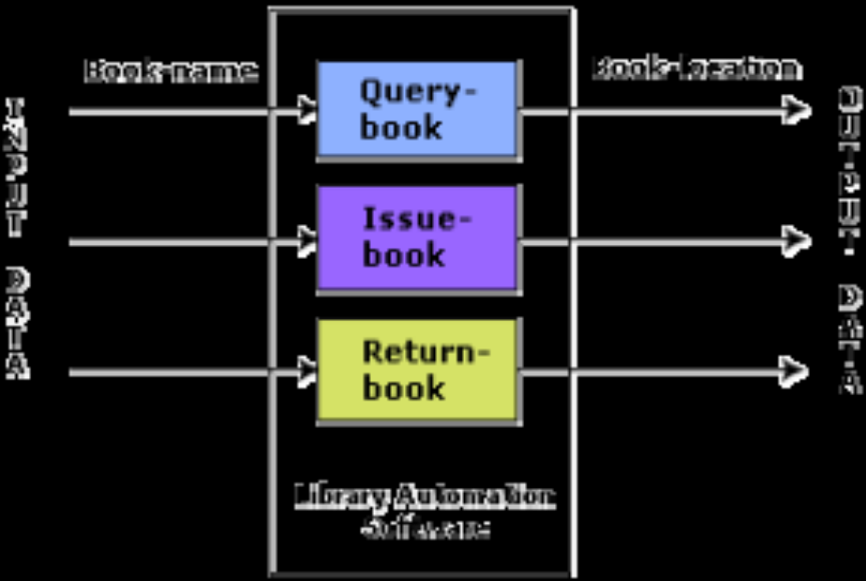

Fig. System function as a map of input data to output data

Project Estimation techniques
Estimation of various project parameters is a basic project planning activity. The
important project parameters that are estimated include: project size, effort
required to develop the software, project duration, and cost. These estimates not
only help in quoting the project cost to the customer, but are also useful in
resource planning and scheduling. There are three broad categories of
estimation techniques:
• Empirical estimation techniques
• Heuristic techniques
• Analytical estimation techniques

Empirical Estimation Techniques

Empirical (on observation or experiment, not on theory) estimation techniques are based on making an educated guess of the project parameters. While using this technique, prior experience with development of similar products is helpful. Although empirical estimation techniques are based on common sense, different activities involved in estimation have been formalized over the years. Two popular empirical estimation techniques are: Expert judgment technique and Delphi cost estimation.

Expert Judgment Technique

Expert judgment is one of the most widely used estimation
techniques. In this approach, an expert makes an educated guess of the
problem size after analyzing the problem thoroughly. Usually, the expert
estimates the cost of the different components (i.e. modules or
subsystems) of the system and then combines them to arrive at the overall
estimate. However, this technique is subject to human errors and
individual bias. Also, it is possible that the expert may overlook some
factors inadvertently (not done intentionally). Further, an expert making an estimate may not have experience and knowledge of all aspects of a project. For example, he may be conversant (having knowledge of sth) with the database and user interface parts but may not be very knowledgeable about the computer communication part.

A more refined form of expert judgment is the estimation made by group of experts. Estimation by a group of experts minimizes factors such as individual oversight, lack of familiarity with a particular aspect of a
project, personal bias, and the desire to win contract through overly
optimistic estimates. However, the estimate made by a group of experts
may still exhibit bias on issues where the entire group of experts may be
biased due to reasons such as political considerations. Also, the decision
made by the group may be dominated by overly assertive (showing a strong personality) members.

Delphi cost estimation
Delphi cost estimation approach tries to overcome some of the shortcomings of the expert judgment approach. Delphi estimation is carried out by a team comprising of a group of experts and a coordinator.
In this approach, the coordinator provides each estimator with a copy of the software requirements specification (SRS) document and a form for recording his cost estimate. Estimators complete their individual estimates anonymously and submit to the coordinator. In their estimates, the estimators mention any unusual characteristic of the product which has influenced his estimation. The coordinator prepares and distributes the summary of the responses of all the estimators, and includes any unusual rationale (the principles or reasons on which sth is based) noted by any of the estimators. Based on this summary, the estimators re-estimate. This process is iterated for several rounds.
However, no discussion among the estimators is allowed during the entire estimation process. The idea behind this is that if any discussion is allowed among the estimators, then many estimators may easily get influenced by the rationale of an estimator who may be more experienced or senior. After the completion of several iterations of estimations, the
coordinator takes the responsibility of compiling the results and preparing the final estimate.

Heuristic Techniques

Heuristic techniques assume that the relationships among the different project parameters can be modeled using suitable mathematical expressions. Once the basic (independent) parameters are known, the other (dependent) parameters can be easily determined by substituting the value of the basic parameters in the mathematical expression. Different heuristic estimation models can be divided into the following two classes: single variable model and the multi variable model.

Single variable estimation models provide a means to estimate the desired characteristics of a problem, using some previously estimated basic (independent) characteristic of the software product such as its size. A single variable estimation model takes the following form:
Estimated Parameter = c1 * e^{d1}
In the above expression, e is the characteristic of the software which has already been estimated (independent variable). Estimated Parameter is the dependent parameter to be estimated. The dependent parameter to be estimated
could be effort, project duration, staff size, etc. c1 and d1 are constants. The values of the constants c1 and d1 are usually determined using data collected from past projects (historical data).

The basic COCOMO model is an example of
single variable cost estimation model.
A multivariable cost estimation model takes the following form:
Estimated Resource = c1*e1^{d1} + c2*e2^{d2} + ...
Where e1, e2, … are the basic (independent) characteristics of the software already estimated, and c1, c2, d1, d2, … are constants. Multivariable estimation models are expected to give more accurate estimates compared to the single variable models, since a project parameter is typically influenced by several independent parameters. The independent parameters influence the dependent parameter to different extents. This is modeled by the constants c1, c2, d1, d2, … . Values of these constants are usually etermined from historical data. The intermediate COCOMO model can be considered to be an example of a multivariable estimation model.

Analytical Estimation Techniques
Analytical estimation techniques derive the required results starting with basic assumptions regarding the project. Thus, unlike empirical and heuristic techniques, analytical techniques do have scientific basis. Halstead’s software
science is an example of an analytical technique. Halstead’s software science can be used to derive some interesting results starting with a few simple assumptions. Halstead’s software science is especially useful for estimating
software maintenance efforts. In fact, it outperforms both empirical and heuristic techniques when used for predicting software maintenance efforts.

Halstead’s Software Science – An Analytical Technique

Halstead’s software science is an analytical technique to measure size, development effort, and development cost of software products. Halstead used a few primitive program parameters to develop the expressions forover all program length, potential minimum value, actual volume, effort,
and development time.
For a given program, let:
η1 be the number of unique operators used in the program,
η2 be the number of unique operands used in the program,
N1 be the total number of operators used in the program,
N2 be the total number of operands used in the program.

Length and Vocabulary
The length of a program as defined by Halstead, quantifies total usage of all operators and operands in the program. Thus, length N = N1 +N2. Halstead’s definition of the length of the program as the total number of operators and operands roughly agrees with the intuitive notation of the program length as the total number of tokens used in the program. The program vocabulary is the number of unique operators and operands used in the program. Thus, program vocabulary η = η1 + η2.

Project scheduling
Project-task scheduling is an important project planning activity. It involves deciding which tasks would be taken up when. In order to schedule the project activities, a software project manager needs to do the following:
1. Identify all the tasks needed to complete the project.
2. Break down large tasks into small activities.
3. Determine the dependency among different activities.
4. Establish the most likely estimates for the time durations necessary to complete the activities.
5. Allocate resources to activities.
6. Plan the starting and ending dates for various activities.
7. Determine the critical path. A critical path is the chain of activities that determines the duration of the project.

The first step in scheduling a software project involves identifying all the tasks necessary to complete the project. A good knowledge of the intricacies of the project and the development process helps the managers to effectively identify the important tasks of the project. Next, the large tasks are broken down into a logical set of small activities which would be assigned to different engineers. The work breakdown structure formalism helps the manager to breakdown the tasks systematically.

After the project manager has broken down the tasks and created the work breakdown structure, he has to find the dependency among the activities. Dependency among the different activities determines the order in which the different activities would be carried out. If an activity A requires the results of another activity B, then activity A must be scheduled after activity B. In general, the task dependencies define a partial ordering among tasks, i.e. each tasks may precede a subset of other tasks, but some tasks might not have any precedence ordering defined between them (called concurrent task).The dependency among the activities are represented in the form of an activity network.

Once the activity network representation has been worked out, resources are allocated to each activity. Resource allocation is typically done using a Gantt chart. After resource allocation is done, a PERT chart representation is developed. The PERT chart representation is suitable for program monitoring and control. For task scheduling, the project manager needs to decompose the project tasks into a set of activities. The time frame when each activity is to be
performed is to be determined. The end of each activity is called milestone (a very important stage in the development so sth). The project manager tracks the progress of a project by monitoring the timely completion of the milestones. If he observes that the milestones start getting delayed, then he has to carefully control the activities, so that the overall deadline can still be met.

Organization structure

Usually every software development organization handles several projects at any time. Software organizations assign different teams of engineers to handle different software projects. Each type of organization structure has its own advantages and disadvantages so the issue “how is the organization as a whole structured?” must be taken into consideration so that each software project can be finished before its deadline.

Functional format vs. project format

There are essentially two broad ways in which a software development organization can be structured: functional format and project format. In the project format, the project development staff are divided based on the project for which they work (as shown in fig. 12.1). In the functional format, the development staff are divided based on the functional group to which they belong. The different projects borrow engineers from the required functional groups for specific phases to be undertaken in the project and return them to the functional group upon the completion of the phase.

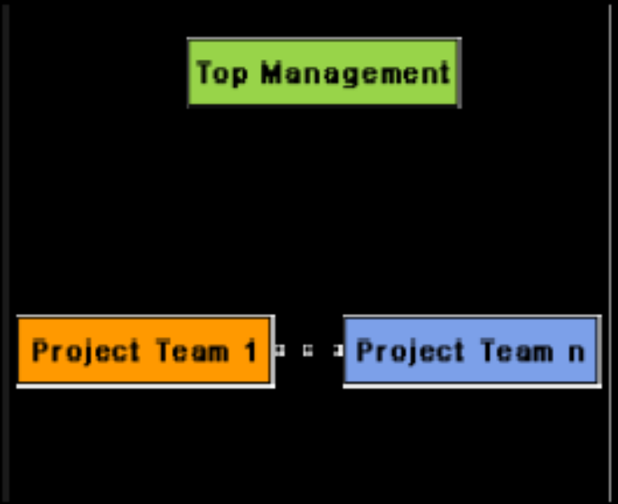

(a) Project Organization

(b) Functional Organization

Fig. 12.1: Schematic representation of the functional and project organization

In the functional format, different teams of programmers perform different phases of a project. For example, one team might do the requirements specification, another do the design, and so on. The partially completed product passes from one team to another as the project evolves. Therefore, the functional format requires considerable communication among the different teams because the work of one team must be clearly understood by the subsequent teams working on the project. This requires good quality documentation to be produced after every activity.

In the project format, a set of engineers is assigned to the project at the start of the project and they remain with the project till the completion of the project. Thus, the same team carries out all the life cycle activities. Obviously, the functional format requires more communication among teams than the project format, because one team must understand the work done by the previous teams

Team structures

Team structure addresses the issue of organization of the individual project teams. There are some possible ways in which the individual project teams can be organized. There are mainly three formal team structures: chief programmer, democratic, and the mixed team organizations although several other variations to these structures are possible. Problems of different complexities and sizes often require different team structures for chief solution.

Chief Programmer Team
In this team organization, a senior engineer provides the technical leadership and is designated as the chief programmer. The chief programmer partitions the task into small activities and assigns them to the team members. He also verifies and integrates the products developed by different team members. The structure of the chief programmer team is shown in fig. 12.2. The chief programmer provides an authority, and this structure is arguably more efficient than the democratic team for well-understood problems. However, the chief programmer team leads to lower team morale (the amount of confidence a group has at a particular time), since team-members work under the constant supervision of the chief programmer. This also inhibits (to make sb nervous from doing sth) their original thinking. The chief programmer team is subject to single point failure since too much responsibility and authority is assigned to the chief programmer.

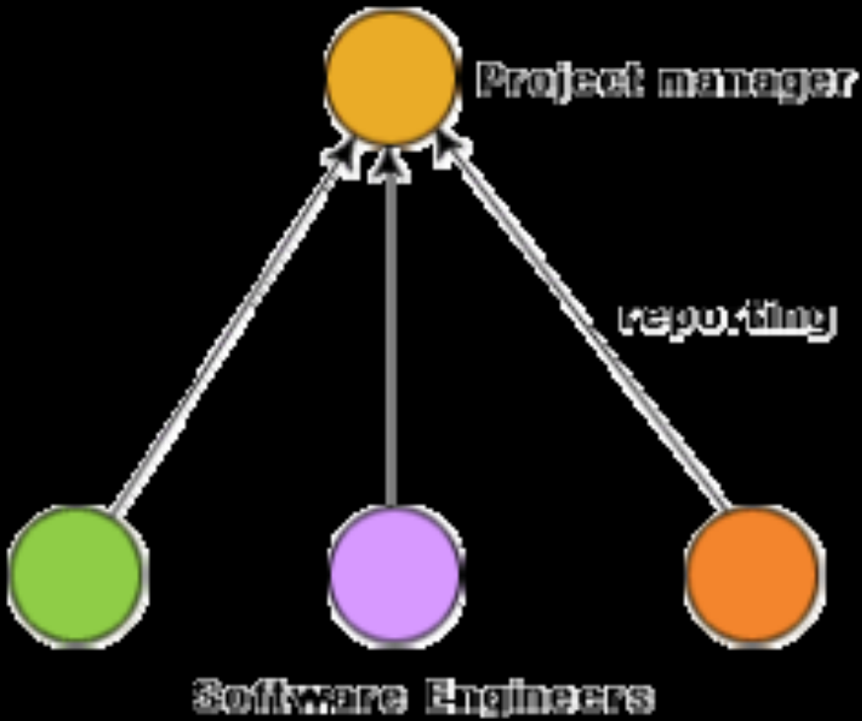

Fig. 12.2: Chief programmer team structure

Democratic Team
The democratic team structure, as the name implies, does not enforce any formal team hierarchy (as shown in fig. 12.3). Typically, a manager provides the administrative leadership. At different times, different members of the group
provide technical leadership.



The democratic organization leads to higher morale and job satisfaction. Consequently, it suffers from less man-power turnover. Also, democratic team structure is appropriate for less understood problems, since a group of engineers can invent better solutions than a single individual as in a chief programmer team. A democratic team structure is suitable for projects requiring less than five or six engineers and for research-oriented projects. For large sized projects, a pure democratic organization tends to become chaotic (complete confusion). The democratic team organization encourages egoless programming as programmers can share and review one another’s work.

Mixed Control Team Organization
The mixed team organization, as the name implies, draws upon the ideas from both the democratic organization and the chief-programmer organization. The mixed control team organization is shown pictorially in fig. 12.4. This team organization incorporates both hierarchical reporting and democratic set up. In fig. 12.4, the democratic connections are shown as dashed lines and the reporting structure is shown using solid arrows. The mixed control team organization is suitable for large team sizes. The democratic arrangement at the senior engineers level is used to decompose the problem into small parts. Each democratic setup at the programmer level attempts solution to a single part. Thus, this team organization is eminently suited to handle large and complex programs. This team structure is extremely popular and is being used in many software development companies.

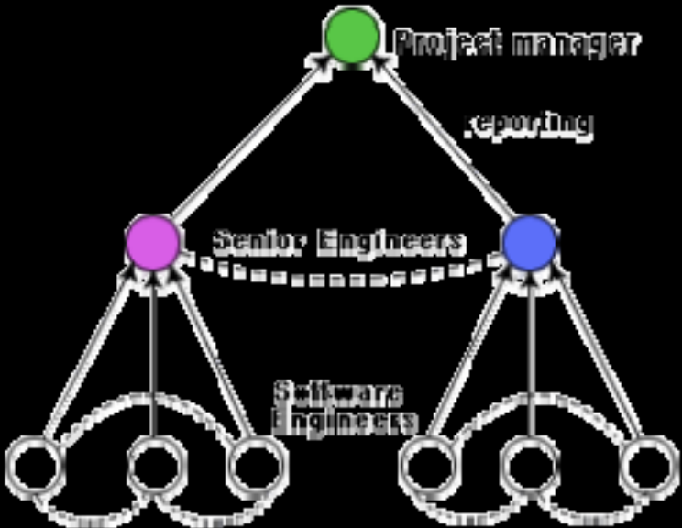
Fig. 12.4: Mixed team structure

Qualities of a good software engineer

The attributes that good software engineers should posses are as follows:
• Exposure to systematic techniques, i.e. familiarity with software engineering principles.
• Good technical knowledge of the project areas (Domain knowledge).
• Good programming abilities.
• Good communication skills. These skills comprise of oral, written, and interpersonal skills.
• High motivation.
• Sound knowledge of fundamentals of computer science.
• Intelligence.
• Ability to work in a team.
• Discipline, etc.

Risk management
A software project can be affected by a large variety of risks. In order to be able to systematically identify the important risks which might affect a software project, it is necessary to categorize risks into different classes. The project manager can then examine which risks from each class are relevant to the project. There are three main categories of risks which can affect a software project:

Project risks
Project risks concern varies forms of budgetary, schedule, personnel, resource, and customer-related problems. An important project risk is schedule slippage. Since, software is intangible, it is very difficult to monitor and control a software project. It is very difficult to control something which cannot be seen. For any manufacturing project, such as manufacturing of cars, the project manager can see the product taking shape. He can for instance, see that the engine is fitted, after that the doors are fitted, the car is getting painted, etc. Thus he can easily assess the progress of the work and control it. The invisibility of the product being developed is an important reason why many software projects suffer from the risk of schedule slippage.

Technical risks
Technical risks concern potential design, implementation, interfacing, testing, and maintenance problems. Technical risks also include ambiguous specification, incomplete specification, changing specification, technical uncertainty, and technical obsolescence (going out of use). Most technical risks occur due to the development team’s insufficient knowledge about the project.

Business risks
This type of risks include risks of building an excellent product that no one wants, losing budgetary or personnel commitments, etc.

Risk assessment
The objective of risk assessment is to rank the risks in terms of their damage causing potential. For risk assessment, first each risk should be rated in two ways:
• The likelihood of a risk coming true (denoted as r).
• The consequence of the problems associated with that risk (denoted as s).
Based on these two factors, the priority of each risk can be computed:
p = r * s
Where, p is the priority with which the risk must be handled, r is the probability of the risk becoming true, and s is the severity of damage caused due to the risk becoming true. If all identified risks are prioritized, then the most likely and damaging risks can be handled first and more comprehensive risk abatement (to become less intense) procedures can be designed for these risks.

Risk containment (the keeping of sth within limits, so that it cannot spread in a harmful way)
After all the identified risks of a project are assessed, plans must be made to contain the most damaging and the most likely risks. Different risks require different containment procedures. In fact, most risks require ingenuity (for solving problems in a cleaver original way) on the part of the project manager in tackling the risk. There are three main strategies to plan for risk containment:

Avoid the risk: This may take several forms such as discussing with the customer to change the requirements to reduce the scope of the work, giving incentives (a thing that encourages sb to do sth) to the engineers to avoid the risk of manpower turnover, etc.

Transfer the risk: This strategy involves getting the risky component developed by a third party, buying insurance cover, etc.

Risk reduction: This involves planning ways to contain the damage due to a risk. For example, if there is risk that some key personnel might leave, new recruitment may be planned.

Software configuration management
The results (also called as the deliverables) of a large software development effort typically consist of a large number of objects, e.g. source code, design document, SRS document, test document, user’s manual, etc. These objects are usually referred to and modified by a number of software engineers through out the life cycle of the software. The state of all these objects at any point of time is called the configuration of the software product. The state of each deliverable object changes as development progresses and also as bugs are detected and fixed.

Release vs. Version vs. Revision
A new version of a software is created when there is a significant change in functionality, technology, or the hardware it runs on, etc. On the other hand a new revision of a software refers to minor bug fix in that software. A new release is created if there is only a bug fix, minor enhancements to the functionality, usability, etc.

Necessity of software configuration management
There are several reasons for putting an object under configuration management. But, possibly the most important reason for configuration management is to control the access to the different deliverable objects. Unless strict discipline is enforced regarding updation and storage of different objects, several problems appear. The following are some of the important problems that appear if configuration management is not used.
Inconsistency problem when the objects are replicated. A scenario can be considered where every software engineer has a personal copy of an object (e.g. source code). As each engineer makes changes to his local copy, he is expected to intimate (to make sth known to sb) them to other engineers, so that the changes in interfaces are uniformly changed across all modules. However, many times an engineer makes changes to the interfaces in his local copies and forgets to intimate other teammates about the changes. This makes the different copies of the object inconsistent. Finally, when the product is integrated, it does not work. Therefore, when several team members work on developing an object, it is necessary for them to work on a single copy of the object, otherwise inconsistency may arise.
Problems associated with concurrent access. Suppose there is a single copy of a problem module, and several engineers are working on it. Two engineers may simultaneously carry out changes to different portions of the same module, and while saving overwrite each other. Though the problem associated with concurrent access to program code has been explained, similar problems occur for any other deliverable object.
Providing a stable development environment. When a project is underway, the team members need a stable environment to make progress. Suppose somebody is trying to integrate module A, with the modules B and C, he cannot
make progress if developer of module C keeps changing C; this can be especially frustrating if a change to module C forces him to recompile A. When an effective configuration management is in place, the manager freezes the objects to form a base line. When anyone needs any of the objects under configuration control, he is provided with a copy of the base line item. The requester makes changes to his private copy. Only after the requester is through with all modifications to his private copy, the configuration is updated and a new base line gets formed instantly. This establishes a baseline for others to use and depend on. Also, configuration may be frozen periodically. Freezing a configuration may involve archiving everything needed to rebuild it. (Archiving means copying to a safe place such as a magnetic tape).
System accounting and maintaining status information. System accounting keeps track of who made a particular change and when the change was made.
Handling variants. Existence of variants of a software product causes some peculiar problems. Suppose somebody has several variants of the same module, and finds a bug in one of them. Then, it has to be fixed in all versions and revisions. To do it efficiently, he should not have to fix it in each and every version and revision of the software separately.

Software configuration management activities
Normally, a project manager performs the configuration management activity by using an automated configuration management tool. A configuration management tool provides automated support for overcoming all the problems
mentioned above. In addition, a configuration management tool helps to keep track of various deliverable objects, so that the project manager can quickly and unambiguously determine the current state of the project. The configuration management tool enables the engineers to change the various components in a controlled manner.

Configuration management is carried out through two principal activities:
• Configuration identification involves deciding which parts of the system should be kept track of.
• Configuration control ensures that changes to a system happen smoothly.

Configuration identification
The project manager normally classifies the objects associated with a software development effort into three main categories: controlled, pre-controlled, and uncontrolled. Controlled objects are those which are already put under configuration control. One must follow some formal procedures to change them. Pre-controlled objects are not yet under configuration control, but will eventually be under configuration control. Uncontrolled objects are not and will not be subjected to configuration control. Controllable objects include both controlled and pre-controlled objects.

Typical controllable objects include:
• Requirements specification document
• Design documents
• Tools used to build the system, such as compilers, linkers, lexical (words of a language) analyzers, parsers (breaker of inputs in chunks), etc.
• Source code for each module
• Test cases
• Problem reports

The configuration management plan is written during the project planning phase and it lists all controlled objects. The managers who develop the plan must strike a balance between controlling too much, and controlling too little. If too much is controlled, overheads (high expenses) due to configuration management increase to unreasonably high levels. On the other hand, controlling too little might lead to confusion when something changes.

Configuration control
Configuration control is the process of managing changes to controlled objects. Configuration control is the part of a configuration management system that most directly affects the day-to-day operations of developers. The configuration control system prevents unauthorized changes to any controlled objects. In order to change a controlled object such as a module, a developer can get a private copy of the module by a reserve operation as shown in fig. 12.5. Configuration management tools allow only one person to reserve a module at a time. Once an object is reserved, it does not allow any one else to reserve this module until the reserved module is restored as shown in fig. 12.5. Thus, by preventing more than one engineer to simultaneously reserve a module, the problems associated with concurrent access are solved.

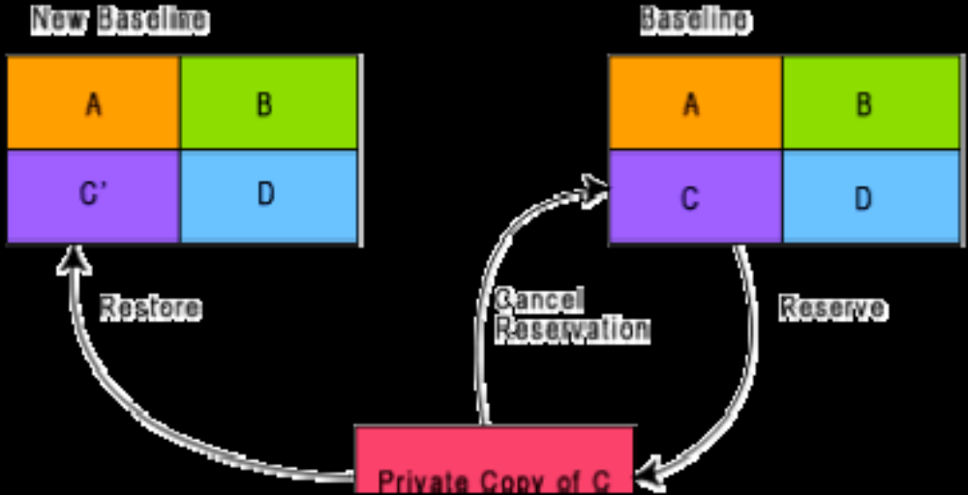

Fig. 12.5: Reserve and restore operation in configuration control

It can be shown how the changes to any object that is under configuration control can be achieved. The engineer needing to change a module first obtains a private copy of the module through a reserve operation. Then, he carries out all
necessary changes on this private copy. However, restoring the changed module to the system configuration requires the permission of a change control board (CCB). The CCB is usually constituted from among the development team members. For every change that needs to be carried out, the CCB reviews the changes made to the controlled object and certifies several things about the change:
1. Change is well-motivated.
2. Developer has considered and documented the effects of the change.
3. Changes interact well with the changes made by other developers.
4. Appropriate people (CCB) have validated the change, e.g. someone has tested the changed code, and has verified that the change is consistent with the requirement.

Configuration management tools
SCCS and RCS are two popular configuration management tools available on most UNIX systems. SCCS or RCS can be used for controlling and managing different versions of text files. SCCS and RCS do not handle binary files (i.e. executable files, documents, files containing diagrams, etc.) SCCS and RCS provide an efficient way of storing versions that minimizes the amount of occupied disk space. Suppose, a module MOD is present in three versions MOD1.1, MOD1.2, and MOD1.3. Then, SCCS and RCS stores the original module MOD1.1 together with changes needed to transform MOD1.1 into MOD1.2 and MOD1.2 to MOD1.3. The changes needed to transform each base lined file to the next version are stored and are called deltas. The main reason behind storing the deltas rather than storing the full version files is to save disk space.

The change control facilities provided by SCCS and RCS include the ability to incorporate restrictions on the set of individuals who can create new versions, and facilities for checking components in and out (i.e. reserve and restore operations). Individual developers check out components and modify them. After they have made all necessary changes to a module and after the changes have been reviewed, they check in the changed module into SCCS or RCS. Revisions are denoted by numbers in ascending order, e.g., 1.1, 1.2, 1.3 etc. It is also possible to create variants or revisions of a component by creating a fork in the development history.

8.Emerging Trends

Client-server software
A client is basically a consumer of services and server is a provider of services as shown in figure. A client requests some services from the server and the server provides the required services to the client. Client and server are usually software components running on independent machines. Even a single machine can sometimes acts as a client and at other times a server depending on the situations. Thus, client and server are mere (nothing more than) roles.

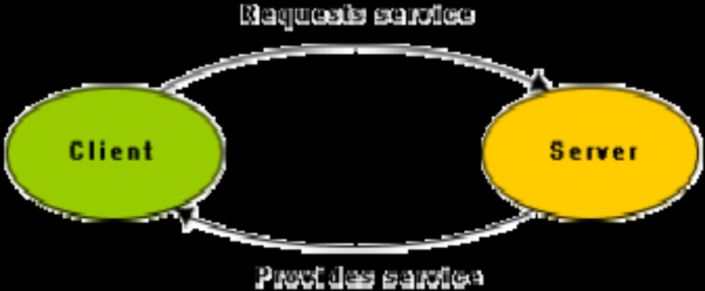

Example:
A man was visiting his friend’s town in his car. The man had a handheld computer (client). He knew his friend’s name but he didn’t know his friend’s address. So he sent a wireless message (request) to the nearest “address server” by his handheld computer to enquire his friend’s address. The message first came to the base station. The base station forwarded that message through landline to local area network where the server is located. After some processing,
LAN sent back that friend’s address (service) to the man.

Advantages of client-server software
The client-server software architecture is a versatile, message-based and modular infrastructure that is intended to improve usability, flexibility, interoperability and scalability as compared to centralized, mainframe, time sharing computing.

Popular middleware standards
Two popular middleware standards are:
• CORBA (Common Object Request Broker Architecture)
• COM/DCOM

Common Object Request Broker Architecture (CORBA)
The Common Object Request Broker Architecture (CORBA) is a specification of a standard architecture for middleware.
Using a CORBA implementation, a client can transparently invoke a method on a server object, which can be on the same machine or across a network. The middleware takes the call, and is responsible for finding an object that can implement the request, passing it the parameters, invoking its method, and returning the results of the invocation. The client does not have to be aware of where the object is located, its programming language, its operating system or any other aspects that are not part of an object’s interface.

Component Object Model (COM)
The main idea in the Component Object Model (COM) is that:
• Different vendors can sell binary components.
• Application can be developed by integrating off-the-shelf (ready to use, packaged) and proprietary (sth that is privately owned) components.

COM is a specification developed by Microsoft for building software components that can be assembled into programs or adds functionality to existing programs running on Microsoft Windows platforms.
COM runs on a single computer. The concepts used are very similar to CORBA. The components are known as binary objects. These can be generated using languages such as Visual Basic, Visual C++ etc. These languages have the necessary features to create COM components. COM components are binary objects and they exist in the form of .exe or .dll (dynamic link library).

Distributed Component Object Model (DCOM)
Distributed Component Object Model (DCOM) is the extension of the Component Object Model (COM). The restriction that clients and servers reside in the same computer is released here. So, DCOM and CORBA both operate on networked computers.

Here development is much easier as compared to CORBA development. Many of the things are transparent to the programmer such as proxy generation, service invocation etc.

Service-Oriented Architecture (SOA)
Service-oriented architecture (SOA) is a software design and software architecture design pattern based on distinct pieces of software providing application functionality as services to other applications. This is known as service-orientation. It is independent of any vendor, product or technology.
A service is a self-contained unit of functionality, such as retrieving an online bank statement. Services can be combined by other software applications to provide the complete functionality of a large software application. SOA makes it easy for computers connected over a network to cooperate. Every computer can run an arbitrary number of services, and each service is built in a way that ensures that the service can exchange information with any other service in the network without human interaction and without the need to make changes to the underlying program itself.
A service-oriented architecture is essentially a collection of services. These services communicate with each other. The communication can involve either simple data passing or it could involve two or more services coordinating some activity. Some means of connecting services to each other is needed.
Software as a Service (SaaS):
Software as a Service (SaaS) is a software distribution model in which applications are hosted by a vendor or service provider and made available to customers over a network, typically the Internet.
Short for Software as a Service, SaaS is a software delivery method that provides access to software and its functions remotely as a Web-based service. Software as a Service allows organizations to access business functionality at a cost typically less than paying for licensed applications since SaaS pricing is based on a monthly fee. Also, because the software is hosted remotely, users don't need to invest in additional hardware. Software as a Service removes the need for organizations to handle the installation, set-up and often daily upkeep and maintenance. Software as a Service may also be referred to as simply hosted applications.
Short for Storage as a Service, SaaS is a term used to describe a storage model where a business or organization (the client) rents or leases storage space from a third-party provider. Data is transferred from the client to the service provider via the Internet and the client would then access their stored data using software provided by the storage provider. The software is used to perform common tasks related to storage, such as data backups and data transfers.
Benefits of the SaaS model include:
- easier administration
- automatic updates and patch management
- compatibility: All users will have the same version of software.
- easier collaboration, for the same reason
- global accessibility.

The traditional model of software distribution, in which software is purchased for and installed on personal computers, is sometimes referred to as software as a product.

