PROCEDURE FOR ONLINE REGISTRATION

1. **Type the address** <http://banner.gre.ac.uk/pls/prod/hwzkilog.P_DispLoginNon>

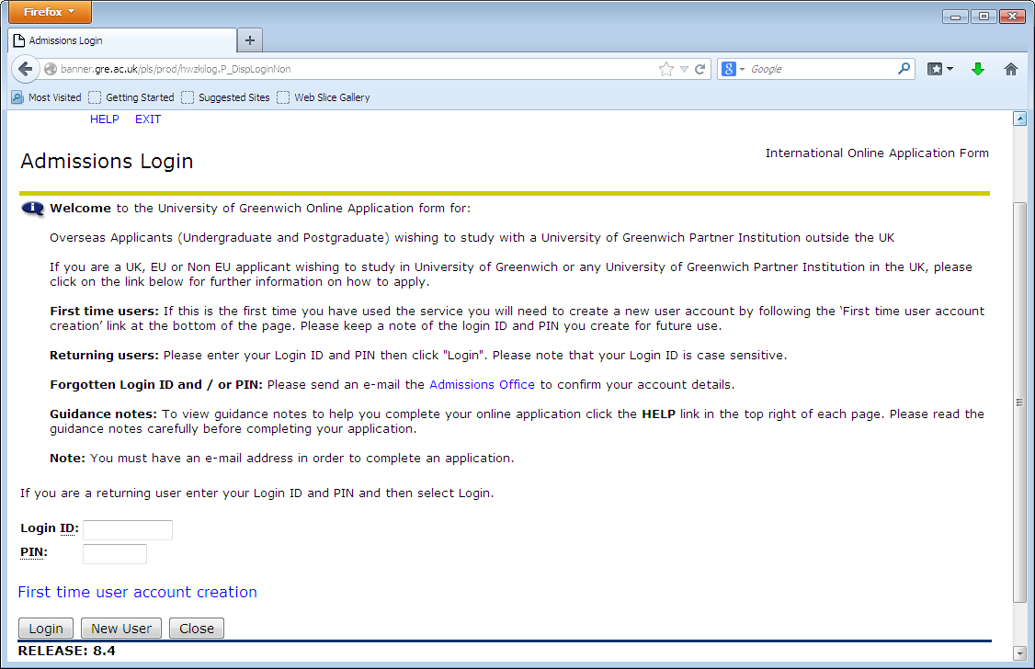

1. **Click the First Time User Account Creation. Fill the Institution Information and click login button.**

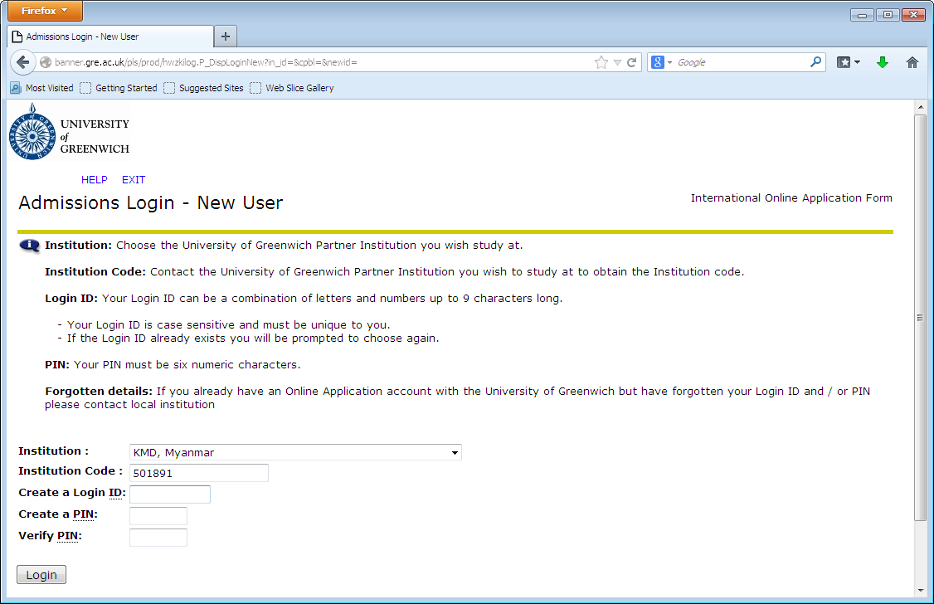

**Institution Code: 236946**

Login ID : Your Name

PIN: Your Short Date of Birth

1. **Click the First Time User Account Creation. Fill the Institution Information and click login button.**

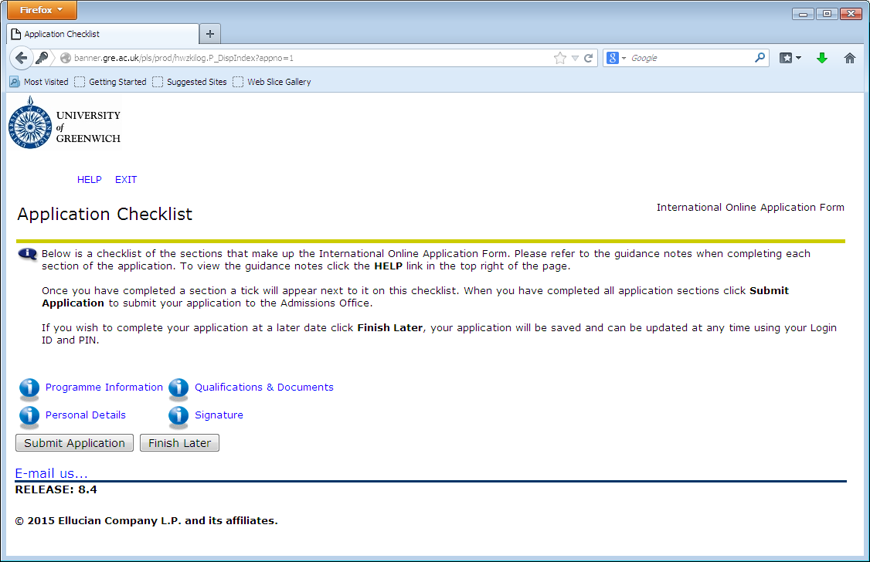

1. **Click the program Information and fill data. Then click continue button.**

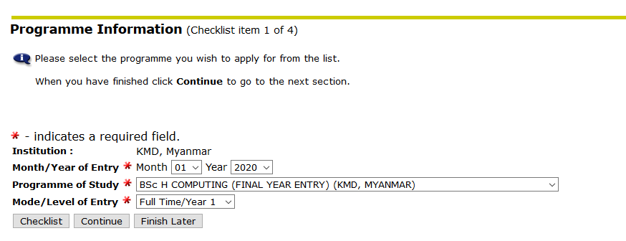

Month : 01

Year : 2025

1. **Fill the Personal Information.**

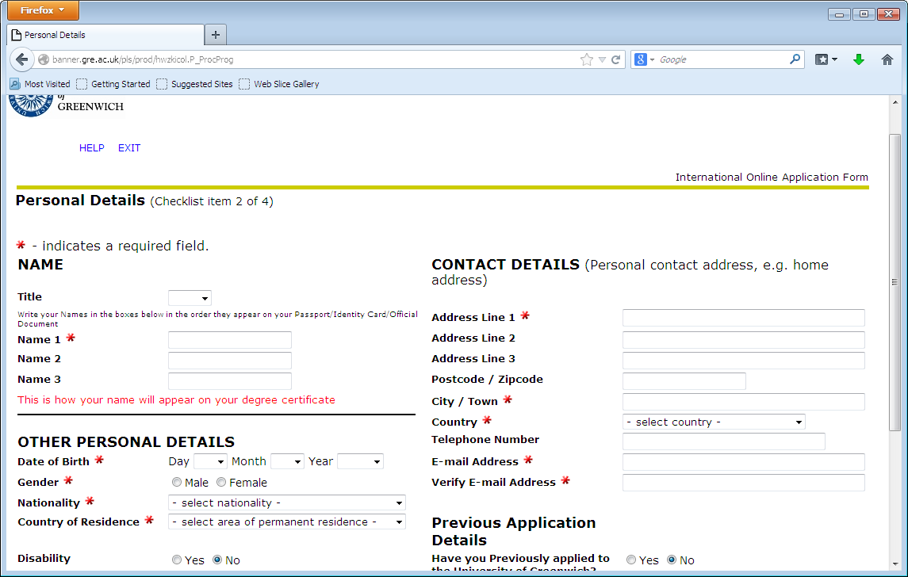

1. Fill Qualifications and Documents.

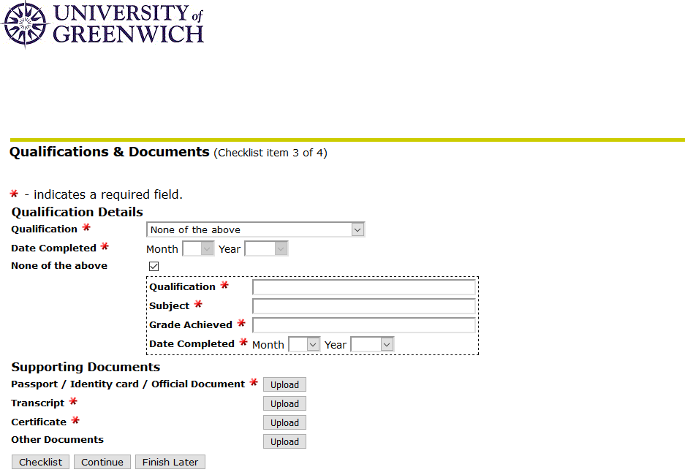

1. Click the signature and select the all check box.
2. Click Submit Application button.