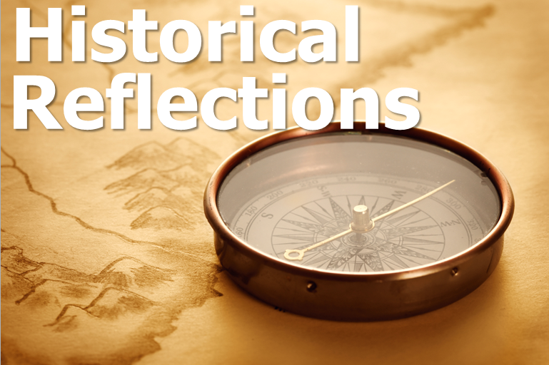

**Articles: Reflecting on Historical Events**

In reflective articles on historical events, the aim is to provide a deeper understanding of how pivotal moments in history continue to shape our world today. These articles analyze the significance of major milestones, such as the Industrial Revolution, world wars, or social movements, offering fresh perspectives on their lasting effects on society, politics, and culture.

1. **Impact of the Industrial Revolution**

The Industrial Revolution was a turning point in human history, marking the shift from agrarian economies to industrialized societies. Articles exploring this event delve into how it transformed economies, altered social structures, and sparked technological advancements that continue to shape industries today. These writings often examine the rise of factory work, urbanization, and the creation of global trade networks, discussing both the positive and negative consequences on workers, families, and the environment. By analyzing this period, readers understand how industrialization laid the foundation for modern capitalism and shaped the global economy.

1. **The Legacy of World Leaders**

Reflective articles often focus on the enduring legacies of influential figures such as Winston Churchill, Nelson Mandela, or Mahatma Gandhi. These pieces provide a nuanced look at their roles in shaping national identities, human rights, and international relations. Through a mix of historical context, critical analysis, and personal anecdotes, the articles uncover how these leaders influenced social justice, governance, and the course of major global conflicts. Understanding their legacy allows readers to connect their leadership styles, philosophies, and achievements to contemporary political and social movements.

1. **Social Changes Sparked by Pivotal Moments in Time**

Key historical events, such as the American Civil Rights Movement, the fall of the Berlin Wall, or the women's suffrage movement, continue to inspire social change in the present. Articles reflecting on these moments analyze the transformative effects they had on public consciousness and the shifts in societal values, including the fight for equality, freedom, and justice. By examining the causes and outcomes of these movements, readers gain insight into the ongoing struggles for civil rights, freedom of expression, and human dignity. These articles bridge the past with the present, encouraging readers to reflect on ongoing social challenges and how historical movements serve as a catalyst for change today.

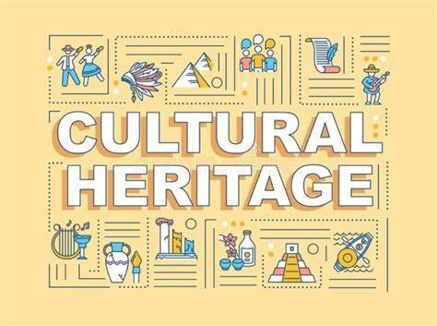

### ****Articles: Understanding Cultural Heritage****

Articles on cultural heritage explore how traditions, customs, and artistic expressions from the past are preserved and adapted over time. These writings shed light on how cultural heritage impacts modern identities, global relations, and societal values.

1. **Preserving Ancient Traditions in a Modern World**

This article explores the challenges and strategies for preserving ancient customs and traditions. It highlights efforts to protect endangered languages, traditional dances, and culinary practices. Readers learn about how communities and organizations work to keep their cultural heritage alive in the face of globalization, digital media, and changing societal norms.

1. **Architecture as a Window to the Past**

Historic architecture provides a tangible connection to the past, showcasing how societies lived and expressed their identities. This article examines iconic architectural sites such as the Great Wall of China, the Parthenon, and Gothic cathedrals, revealing the stories behind their construction and cultural significance. It discusses how modern architects draw inspiration from historic designs while balancing preservation with urban development.

1. **The Role of Festivals in Cultural Identity**

Cultural festivals, such as the Day of the Dead in Mexico, Diwali in India, or Carnival in Brazil, reflect the rich history and collective identity of communities. Articles in this category highlight how these celebrations evolved, the symbolic meaning behind rituals, and their role in strengthening cultural bonds. Readers are encouraged to appreciate how festivals help preserve history and foster cross-cultural understanding.

## **The Rise and Fall of the Roman Empire: A Legacy of Power**

### **Introduction**

The Roman Empire was one of the greatest civilizations in history, dominating Europe, North Africa, and parts of Asia for over a thousand years. Its impact on law, architecture, governance, and culture is still evident today.

### **Key Factors in the Rise of Rome**

* **Military Strength**: The Roman legions were highly trained and well-equipped.
* **Political Organization**: The Senate and Republic system provided structured governance.
* **Engineering and Innovation**: Roads, aqueducts, and monumental structures like the Colosseum.

### **Causes of the Fall**

* **Political Corruption**: Weak leadership and internal conflicts.
* **Economic Decline**: Heavy taxation and reliance on slave labor weakened the economy.
* **Invasions by Barbarian Tribes**: The empire struggled against attacks from the Visigoths and Vandals.

### **Conclusion**

Although the empire fell in **476 AD**, its influence on **law, language, and architecture** continues to shape the modern world.

## **The Industrial Revolution: A New Era of Progress**

### **Introduction**

The **Industrial Revolution (1750–1900)** marked a turning point in history, transforming agriculture, manufacturing, and transportation. This period saw rapid technological advancements that reshaped societies.

### **Key Inventions**

* **The Steam Engine** (James Watt): Powered factories and locomotives.
* **The Spinning Jenny** (James Hargreaves): Revolutionized textile production.
* **The Telegraph** (Samuel Morse): Improved long-distance communication.

### **Impact on Society**

* **Urbanization**: People moved to cities for work, leading to overcrowding.
* **Child Labor**: Harsh working conditions in factories.
* **Economic Growth**: Increased production and global trade.

### **Conclusion**

While the **Industrial Revolution** improved technology and infrastructure, it also led to **social inequalities**. However, it laid the foundation for modern economic development.