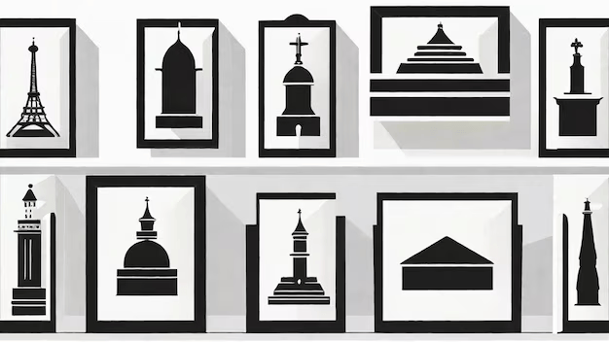

**Research or Knowledge: Unveiling Historical Discoveries**

Research and knowledge-based articles offer in-depth examinations of historical topics, often focusing on newly discovered facts, archaeological findings, or historical reinterpretations. These explorations provide a deeper understanding of human history, revealing lost narratives, and offering unique insights into past civilizations.

1. **Archaeological Findings**  
   In-depth research into archaeology uncovers forgotten stories from ancient civilizations, bringing to light artifacts, structures, and documents that reshape our understanding of history. Articles on these discoveries dive into the importance of archaeological sites like Pompeii, the tomb of Tutankhamun, or the ruins of the Indus Valley, providing detailed accounts of the methods used by archaeologists to uncover these treasures. Readers are introduced to the history of forgotten cultures, the significance of ancient rituals, and the daily life of people from thousands of years ago. These discoveries challenge our historical narratives, revealing how much of the past is still hidden beneath the earth’s surface.
2. **The Evolution of Societies**  
   Articles exploring the evolution of societies focus on the development of human cultures, from early hunter-gatherer groups to advanced urban civilizations. Research in this area examines how societies evolved politically, economically, and socially over time. Through studies of ancient texts, artifacts, and genetic research, readers learn how early communities developed systems of governance, trade, religion, and law. These articles also explore how innovations such as writing, agriculture, and metallurgy led to the rise of complex civilizations, helping readers connect the past with present-day societal structures and challenges.
3. **Detailed Analyses of Historical Texts**  
   Research-based articles often focus on historical documents, such as the Magna Carta, the works of ancient philosophers, or letters from war veterans. These texts provide firsthand accounts of history, offering insights into the thoughts, beliefs, and experiences of people from different eras. By analyzing these documents, scholars uncover new interpretations of historical events and offer fresh perspectives on key moments in time. Articles may delve into the language, context, and impact of these writings, examining how they shaped philosophical thought, legal systems, and global politics. These articles provide readers with a deeper understanding of how written records can reflect cultural, political, and intellectual shifts.
4. **Hidden Stories of Past Civilizations**  
   Research articles that unveil hidden or lesser-known stories of past civilizations focus on uncovering the often-overlooked aspects of history. These narratives might focus on marginalized groups, forgotten inventions, or alternative historical accounts that challenge the mainstream understanding of the past. Articles exploring the history of indigenous peoples, lesser-known empires, or forgotten technological advancements offer a more inclusive view of history. These discoveries reveal the complexity of human societies and the many layers of history that continue to shape modern cultures.

Through detailed research and analysis, these articles uncover the intricacies of historical events and discoveries, helping readers develop a more nuanced understanding of the world’s past and its implications for the future.

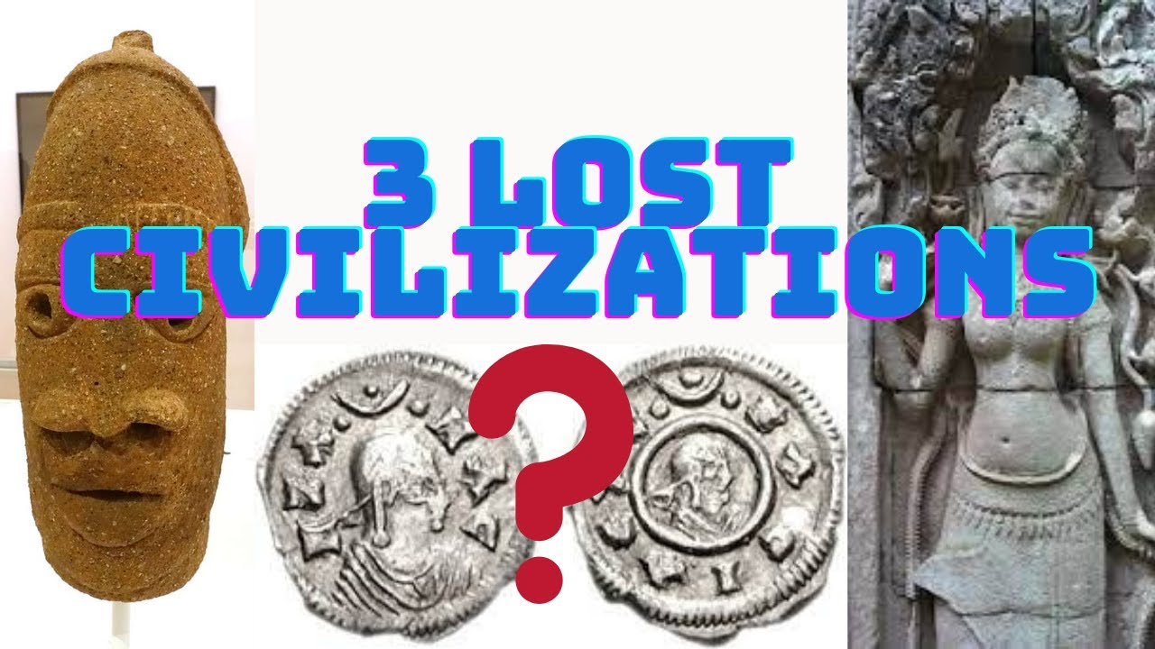

**Research or Knowledge: Rediscovering Lost Civilizations**

Research articles focused on lost civilizations explore how new discoveries help reshape our understanding of human history and provide insight into forgotten cultures.

1. **Exploring the Mystery of the Lost City of Atlantis**  
   This research article discusses the myths and theories surrounding Atlantis, examining historical references and modern interpretations. By analyzing ancient texts and archaeological evidence, scholars attempt to determine whether the lost city was based on reality or purely a creation of ancient imagination.
2. **The Rediscovery of the Mayan Civilization**  
   Recent advancements in satellite imagery and 3D mapping have led to the discovery of hidden Mayan cities and trade routes in Central America. This research delves into how these technologies have transformed our understanding of Mayan society, including their advanced knowledge of astronomy, mathematics, and urban planning.
3. **Uncovering the Secrets of Ancient Mesopotamia**  
   Mesopotamia, often referred to as the "Cradle of Civilization," was home to many innovations, including writing and legal codes. Research articles explore how new findings, such as ancient tablets and city ruins, provide deeper insight into the region’s political, economic, and religious life. By examining these discoveries, readers gain a greater appreciation for how Mesopotamian advancements influenced later civilizations.
4. **The Influence of Trade Routes on Ancient Empires**  
   This research focuses on how trade routes like the Silk Road and the Trans-Saharan trade shaped cultural exchange and economic prosperity in ancient empires. By studying artifacts and historical accounts, readers learn how the movement of goods, ideas, and religions connected distant societies and influenced the development of global civilizations.

## **The Impact of the Silk Road on Global Trade and Cultural Exchange**

### **Introduction**

The **Silk Road**, spanning from China to Europe, was one of the most significant trade routes in history. It not only facilitated the exchange of goods but also promoted cultural, religious, and technological exchanges between civilizations.

### **Key Research Areas**

* **Trade Goods**: Silk, spices, precious metals, and paper.
* **Cultural Exchange**: Spread of Buddhism, Islam, and Christianity.
* **Technological Transfers**: Innovations like paper-making and gunpowder traveled westward.

### **Impact**

* Strengthened economic ties between Asia, the Middle East, and Europe.
* Encouraged urban growth in major trade cities.
* Spread of the Black Plague due to increased movement of people and goods.

### **Conclusion**

The Silk Road shaped **globalization, economic systems, and cultural interactions**, influencing world history for centuries.

## **The Fall of the Roman Empire: Causes and Consequences**

### **Introduction**

The **Roman Empire** was one of the most powerful civilizations, but by **476 AD**, it had collapsed. Historians debate the reasons behind its decline and the long-term effects on Europe.

### **Key Research Areas**

* **Economic Decline**: High taxation and reliance on slave labor.
* **Military Weakness**: Mercenary armies and defeats against barbarian tribes.
* **Political Corruption**: Civil wars and weak leadership.

### **Impact**

* Led to the **Middle Ages**, a period of feudalism and economic stagnation.
* The Eastern Roman Empire (Byzantium) continued for another 1,000 years.
* Influenced modern governance and legal systems.

### **Conclusion**

The fall of Rome changed the **political, economic, and cultural landscape of Europe**, shaping medieval history.

## **The Influence of the Renaissance on Modern Science and Art**

### **Introduction**

The **Renaissance (14th–17th century)** was a cultural revival that led to advancements in **art, literature, and science**. It marked the transition from medieval thinking to modern innovation.

### **Key Research Areas**

* **Scientific Discoveries**: Galileo’s heliocentric theory, Newton’s physics.
* **Artistic Achievements**: Michelangelo’s sculptures, Da Vinci’s inventions.
* **Printing Press (Johannes Gutenberg)**: Spread knowledge across Europe.

### **Impact**

* Inspired the **Scientific Revolution**, leading to modern physics and biology.
* Changed artistic techniques with perspective and realism.
* Encouraged humanism, focusing on individual potential and reason.

### **Conclusion**

The Renaissance **transformed European thought**, influencing both artistic expression and scientific discovery.