**A World in verse**

Through love’s embrace, the heart takes flight,  
In tender whispers, day turns bright.  
A gentle touch, a lover’s gaze,  
Ignites the soul, sets hearts ablaze.

Beneath the skies, where nature reigns,  
The mountains echo, the rivers wane.  
A single bloom, with colors bold,  
Tells tales of life and stories old.

Society’s pulse, a rhythm deep,  
In cities vast, where dreams don’t sleep.  
We rise and fall, with hope we strive,  
In every soul, a world alive.

In verse we find, our spirits free,  
A world of wonder, harmony.  
Where love and life, in words we weave,  
And beauty lingers, hearts believe.

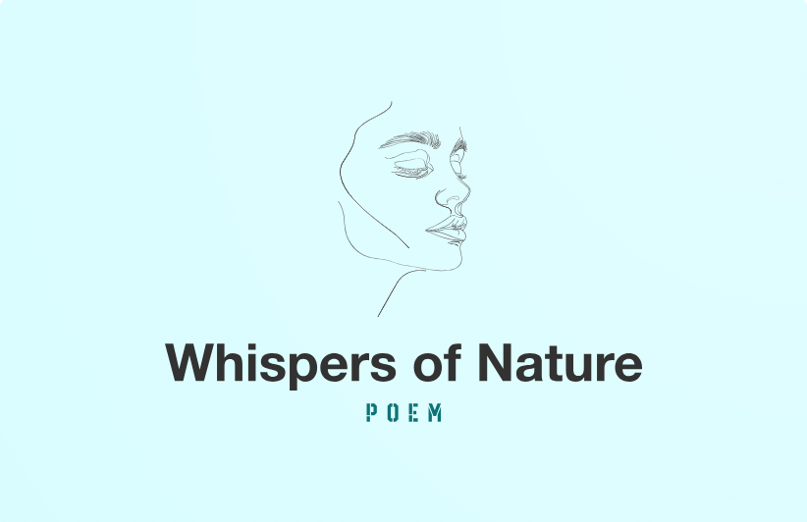

**Whispers of Nature**

In dawn’s soft glow, the world awakes,  
The river hums, the forest shakes.  
A breeze caresses leaf and stone,  
A song of life, through earth and bone.

The mountains rise, with crowns of white,  
Guardians bold, in morning light.  
Each peak a tale, of ages past,  
Unyielding, timeless, standing fast.

A meadow blooms, with colors vast,  
Where seasons kiss, as shadows cast.  
Petals dance in wind’s embrace,  
A fleeting joy, a tender grace.

Through nature’s eyes, we find our peace,  
In every rustle, wonders cease.  
A poet’s dream, the earth’s soft voice,  
A place of stillness, hearts rejoice.

### **The Weaver of Tales**

A tale is spun like golden thread,  
 It binds the hearts of those long dead.  
 It shapes the past, it paints the new,  
 It turns to dreams, it shifts the view.

A tale is sung, a tale is cried,  
 It tells of love, it speaks of pride.  
 It bends the truth, it shows the lie,  
 It makes us laugh, it makes us sigh.

And though the teller fades from sight,  
 His words will dance within the night.  
 For stories live, they breathe, they grow,  
 They stay with us, they shape what’s known.

And when the world forgets the name,  
 The tale itself will light the flame.  
 For history writes with fleeting hands,  
 But stories last—they take their stand.

### **The Eternal Tapestry of Words**

In the hush of dawn, where silence wakes,  
 A poet stirs and his soul takes  
 A journey deep through time untold,  
 Through books and tales both new and old.

Upon his desk, a candle burns,  
 Its flickering light as the pages turn.  
 Each word he writes, each verse he weaves,  
 Carries the echoes of those who grieve.

A sonnet soft, a ballad bright,  
 A tragic tale of love and light.  
 The ink flows fast, the quill moves free,  
 Tracing the past, shaping destiny.

Oh, language vast, a boundless sea,  
 A bridge of thought, eternally.  
 From Shakespeare’s stage to Dickens’ lore,  
 To modern tales we all adore.

Each novel spun, each play performed,  
 Carries hearts that once were warmed.  
 The laughter bright, the teardrops cold,  
 All emotions stories hold.

A library grand, where whispers call,  
 A thousand lives within each hall.  
 Heroes rise and villains scheme,  
 In written lines, in spoken dreams.

For words outlive the fleeting years,  
 They carry love, they echo fears.  
 No blade nor war, no rust nor rain,  
 Can steal the power stories gain.

So let us write, let voices grow,  
 Through poetry’s fire and fiction’s glow.  
 For in the ink, we carve our name,  
 And in the words, we live again.

### **The Ink That Never Fades**

Upon the parchment, ink is cast,  
 A bridge between the present and past.  
 Through every tale, through every rhyme,  
 A whisper echoes beyond all time.

The poet’s hand, both firm and free,  
 Shapes the rhythm of destiny.  
 With every stroke, with every line,  
 A world is formed, both fierce and fine.

Words are rivers, flowing wide,  
 They carve the hills, they shift the tide.  
 They breathe, they burn, they mend, they mold,  
 Turning silence into gold.

No empire stands beyond decay,  
 No king can rule without dismay.  
 But words endure through dust and stone,  
 A voice eternal, yet unknown.

### **The Library of Dreams**

Beyond the doors of quiet halls,  
 Lie towers lined with ancient calls.  
 Leather-bound and paper-thin,  
 A thousand worlds are stored within.

In whispered tones, the pages speak,  
 To scholars wise and dreamers meek.  
 Each spine a vessel, each tale a key,  
 Unlocking doors to mystery.

Here lies love and battles bold,  
 Here lies truths the wise foretold.  
 Here are voices, lost yet strong,  
 Singing stories all along.

So tread with care, oh wandering mind,  
 For in these books, the past you’ll find.  
 And when your tale is set in stone,  
 It too shall join the endless tome.

### **The Eternal Library**

Between the shelves where silence hums,  
 Where time is caught in leathered sums,  
 Where voices whisper in the dust,  
 And knowledge reigns—eternal, just.

The books, they sleep, yet dream so loud,  
 Their pages vast as shifting cloud.  
 A single touch, a story wakes,  
 A journey formed with every page.

A hero rides through ancient lands,  
 A scholar writes with steady hands.  
 A love once lost, a war once fought,  
 In ink and verse, all tales are caught.

No fire can burn them, none erase,  
 The words are bound in time and space.  
 For when the reader comes to find,  
 The book gives birth inside their mind.

### **The Heart of a Poet**

A poet’s heart is not his own,  
 It beats through echoes yet unknown.  
 It aches for beauty, grieves for pain,  
 It seeks the stars, it loves the rain.

A single phrase, a fleeting thought,  
 Becomes the poem never sought.  
 A burning sun, a frozen sea,  
 A moment caged in poetry.

Through every war, through every peace,  
 Through whispered love and lost release,  
 A poet writes with trembling hand,  
 Yet leaves a mark that long will stand.

The words outlive the fleeting years,  
 They hold the joys, they catch the tears.  
 And though the poet turns to dust,  
 His verses breathe—his words, they trust.

### **The Kingdom of Words**

O language bright, O tongue so vast,  
 A kingdom built from ages past.  
 Through spoken breath, through written lore,  
 The voice of men forever soars.

Each letter laid in perfect rhyme,  
 A map of thoughts across all time.  
 From bardic song to scholar’s pen,  
 The words endure beyond all men.

A speech that once a king declared,  
 A plea that once a mother shared,  
 A vow, a tale, a sermon cried,  
 A love confessed, a hope denied.

Within these lines, the world is spun,  
 Its meaning shifts, yet never done.  
 For even when the tongue is still,  
 The words remain—forever will.

### **The Poet’s Curse**

A poet sees where others glance,  
 A poet feels a world’s expanse.  
 A fleeting moment, soft and brief,  
 Becomes a wound, becomes a grief.

No simple thing escapes his view,  
 No shadow fades without its hue.  
 A sunrise bends, a twilight sings,  
 A storm is more than wind and wings.

He hears the words within the rain,  
 He knows that love is born from pain.  
 He dreams too loud, he thinks too deep,  
 He writes the world he cannot keep.

For poets walk a lonely shore,  
 They see the less, they feel the more.  
 Yet though they ache, yet though they burn,  
 They gift us all what we must learn.