STA2201-lab1

Kerry Hu

## # Lab Exercises

1. Plot the ratio of male to female mortality rates over time for ages 10,20,30 and 40 (different color for each age) and change the theme.

library(tidyverse)

── Attaching packages ─────────────────────────────────────── tidyverse 1.3.2 ──  
✔ ggplot2 3.4.0 ✔ purrr 0.3.4   
✔ tibble 3.1.8 ✔ dplyr 1.0.10  
✔ tidyr 1.2.1 ✔ stringr 1.5.0   
✔ readr 2.1.3 ✔ forcats 0.5.2   
── Conflicts ────────────────────────────────────────── tidyverse_conflicts() ──  
✖ dplyr::filter() masks stats::filter()  
✖ dplyr::lag() masks stats::lag()

dm <- read_table("https://www.prdh.umontreal.ca/BDLC/data/ont/Mx_1x1.txt", skip = 2, col_types = "dcddd")

Warning: 494 parsing failures.  
row col expected actual file  
108 Female no trailing characters . 'https://www.prdh.umontreal.ca/BDLC/data/ont/Mx_1x1.txt'  
109 Female no trailing characters . 'https://www.prdh.umontreal.ca/BDLC/data/ont/Mx_1x1.txt'  
110 Female no trailing characters . 'https://www.prdh.umontreal.ca/BDLC/data/ont/Mx_1x1.txt'  
110 Male no trailing characters . 'https://www.prdh.umontreal.ca/BDLC/data/ont/Mx_1x1.txt'  
110 Total no trailing characters . 'https://www.prdh.umontreal.ca/BDLC/data/ont/Mx_1x1.txt'  
... ...... ...................... ...... ........................................................  
See problems(...) for more details.

dp <- dm |>   
 filter(Age==10|Age==20|Age==30|Age==40)|>   
 mutate(mf_ratio = Male/Female)|>select(Year,Age,mf_ratio)  
 dp|> ggplot(aes(x=Year,y=mf_ratio,color = Age))+geom_line()+labs(title = "10,20,30,40 year old MF mortality ratio over time, Ontario")+theme_bw(base_size = 14)

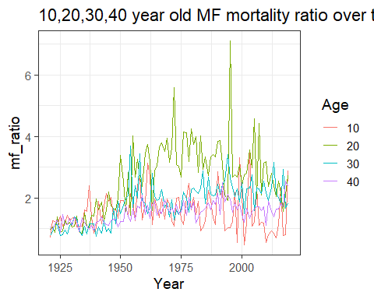

2. Find the age that has the highest female mortality rate each year.

summary_max <- dm |> group_by(Year)|>select(Year,Age,Female)|>  
summarize(max_mortality = max(Female, na.rm = TRUE))  
df_list1 = list(dm,summary_max)  
dmf<- df_list1 |> reduce(left_join, by='Year') |>select(Year,Age,Female,max_mortality)  
dmf <- dmf |>  
 mutate_at(3, ~replace_na(.,0))  
Year=rep(0,200)  
Age=rep(0,200)  
YearAge1<-data.frame(Year,Age)  
  
j=1  
for(i in 1:10989){  
 if(dmf$Female[i]==dmf$max_mortality[i]) {YearAge1$Age[j]<-dmf$Age[i];YearAge1$Year[j]<-dmf$Year[i];j=j+1}  
 }  
YearAge<-head(YearAge1,102)  
YearAge

Year Age  
1 1921 106  
2 1922 98  
3 1923 104  
4 1924 107  
5 1925 98  
6 1926 106  
7 1927 106  
8 1928 104  
9 1929 104  
10 1930 105  
11 1931 104  
12 1932 105  
13 1933 104  
14 1934 106  
15 1935 104  
16 1936 106  
17 1937 105  
18 1938 104  
19 1939 105  
20 1940 104  
21 1941 105  
22 1942 104  
23 1943 105  
24 1944 98  
25 1945 104  
26 1946 105  
27 1947 104  
28 1948 99  
29 1949 102  
30 1950 102  
31 1951 110+  
32 1952 107  
33 1953 106  
34 1954 110+  
35 1955 107  
36 1956 110+  
37 1957 107  
38 1958 110+  
39 1959 108  
40 1960 107  
41 1961 106  
42 1962 108  
43 1963 109  
44 1964 109  
45 1965 109  
46 1966 105  
47 1967 107  
48 1968 97  
49 1969 109  
50 1970 107  
51 1971 107  
52 1972 107  
53 1973 105  
54 1974 107  
55 1974 109  
56 1975 108  
57 1975 110+  
58 1976 106  
59 1976 108  
60 1977 103  
61 1978 109  
62 1979 109  
63 1980 110+  
64 1981 107  
65 1982 109  
66 1983 110+  
67 1984 110+  
68 1985 110+  
69 1986 109  
70 1987 109  
71 1988 108  
72 1989 108  
73 1990 108  
74 1991 103  
75 1992 108  
76 1993 109  
77 1994 109  
78 1995 107  
79 1996 109  
80 1997 107  
81 1998 110+  
82 1999 110+  
83 2000 106  
84 2001 110+  
85 2002 107  
86 2003 109  
87 2004 108  
88 2005 108  
89 2006 110+  
90 2007 107  
91 2008 109  
92 2009 110+  
93 2010 108  
94 2011 110+  
95 2012 109  
96 2013 110+  
97 2014 110+  
98 2015 110+  
99 2016 110+  
100 2017 110+  
101 2018 110+  
102 2019 110+

3. Use the `summarize(across())` syntax to calculate the standard deviation of mortality rates by age for the Male, Female and Total populations.

summary_SD <- dm |> group_by(Age)|>  
 summarize(across(Female:Total, sd))   
summary_SD

# A tibble: 111 × 4  
 Age Female Male Total  
 <chr> <dbl> <dbl> <dbl>  
 1 0 0.0256 0.0330 0.0294   
 2 1 0.00352 0.00396 0.00374   
 3 10 0.000474 0.000561 0.000509  
 4 100 0.0928 0.138 0.0729   
 5 101 0.125 0.158 0.0995   
 6 102 0.143 0.214 0.114   
 7 103 0.252 0.371 0.208   
 8 104 0.449 NA 0.363   
 9 105 NA NA NA   
10 106 NA NA NA   
# … with 101 more rows

4. The Canadian HMD also provides population sizes over time (https://www.prdh.umontreal.ca/BDLC/data/ont/Population.txt). Use these to calculate the population weighted average mortality rate separately for males and females, for every year. Make a nice line plot showing the result (with meaningful labels/titles) and briefly comment on what you see (1 sentence). Hint: `left_join` will probably be useful here.

df <- read_table("https://www.prdh.umontreal.ca/BDLC/data/ont/Population.txt",skip = 2, col_types = "dcddd")  
df_list1 = list(dm,df)   
dmf<- df_list1 |> reduce(left_join, by=c('Year','Age'))  
dmf <-dmf |> mutate(weighed_F=Female.x*Female.y,weighed_M=Male.x*Male.y)|> select(-Total.x,-Total.y)  
dmfsum<- dmf |>group_by(Year) |>summarize(total_F=sum(Female.y, na.rm = TRUE),total_M=sum(Male.y, na.rm = TRUE))  
df_list2 = list(dmf,dmfsum)   
dmf<- df_list2|> reduce(left_join, by='Year')  
dmf

# A tibble: 10,989 × 10  
 Year Age Female.x Male.x Female.y Male.y weighe…¹ weigh…² total_F total_M  
 <dbl> <chr> <dbl> <dbl> <dbl> <dbl> <dbl> <dbl> <dbl> <dbl>  
 1 1921 0 0.0978 0.129 30157. 31530. 2948. 4070. 1.46e6 1.48e6  
 2 1921 1 0.0129 0.0144 30391. 31319. 394. 452. 1.46e6 1.48e6  
 3 1921 2 0.00521 0.00737 30962. 31785. 161. 234. 1.46e6 1.48e6  
 4 1921 3 0.00471 0.00457 31306. 32031. 147. 146. 1.46e6 1.48e6  
 5 1921 4 0.00461 0.00433 31364. 32046. 145. 139. 1.46e6 1.48e6  
 6 1921 5 0.00372 0.00361 31175. 31847. 116. 115. 1.46e6 1.48e6  
 7 1921 6 0.00265 0.00393 30808. 31466. 81.7 124. 1.46e6 1.48e6  
 8 1921 7 0.00295 0.00351 30295. 30922 89.5 108. 1.46e6 1.48e6  
 9 1921 8 0.00237 0.00285 29660. 30270. 70.4 86.4 1.46e6 1.48e6  
10 1921 9 0.00198 0.00255 28923 29494. 57.4 75.3 1.46e6 1.48e6  
# … with 10,979 more rows, and abbreviated variable names ¹​weighed_F,  
# ²​weighed_M

dmf <-dmf |> mutate(weighed_rate_F=Female.x*Female.y/total_F,weighed_rate_M=Male.x*Male.y/total_M)  
  
summary_mean <- dmf |> group_by(Year) |>   
 summarize(mean_mortality_f = mean(weighed_rate_F, na.rm = TRUE),  
 mean_mortality_m = mean(weighed_rate_M, na.rm = TRUE))  
  
summary_mean|> ggplot(aes(x = Year))+geom_line(aes(y=mean_mortality_f),colour ="firebrick4")+geom_line(aes(y=mean_mortality_m),colour ="blue")+  
 labs(title = "Female&Male ave_weighted mortality rates over time, Ontario",  
 y = "Average Weighted Mortality rate") + scale_color_manual("",values = c("Female"="firebrick4","Male"="blue"))+ theme_bw(base_size = 14)

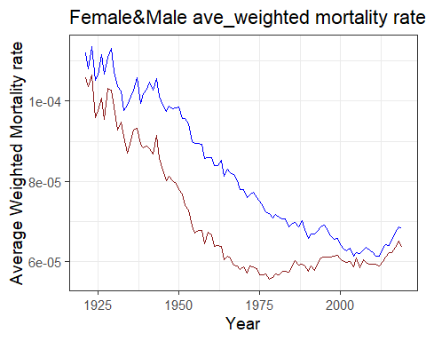

The trend of average weighted mortality rates over time of both gender was going down until 2000 year and after 2000 year,the trend became a little higher and stable.