

**Universidad Tecnológica de Tijuana**



**Alumno:** Alcantara Huerta Angel Josue

**Docente:** Ray Brunett Parra Galaviz.

**Materia:** 4D-Diseño de APPS 2025-1.

**Trabajo:** Mobile Device Architecture.

**Fecha de entrega:** 10 de enero de 2025

**Whats is a movil device architecture?**

Mobile application architecture is essential for developing efficient, scalable, and maintainable applications. Below are the most important aspects:

**Definition of Mobile Architecture**

Mobile architecture refers to the technical structure that guides the main structural elements of an application, including:

**Application Capabilities:** The key functionalities offered through the mobile interface.

**Technical Components:** Approaches such as native, web, or hybrid applications.

**Logical Design Patterns:** Models like MVC (Model-View-Controller), client-server, and offline-first strategies.

**Integration:** Connections with backends, APIs, and services.

**Data Storage:** Strategies for local databases and cache.

**Non-Functional Requirements:** Considerations on user experience, performance, and security.

**Layers of Mobile Application Architecture**

A typical mobile architecture is organized into several layers, each with specific responsibilities:

**Presentation Layer:** Manages the user interface and user interaction.

**Business Logic Layer:** Handles business rules and application logic.

**Data Access Layer:** Responsible for managing and accessing data, including local databases and remote services.

**Integration Layer:** Manages communication with external services and APIs.

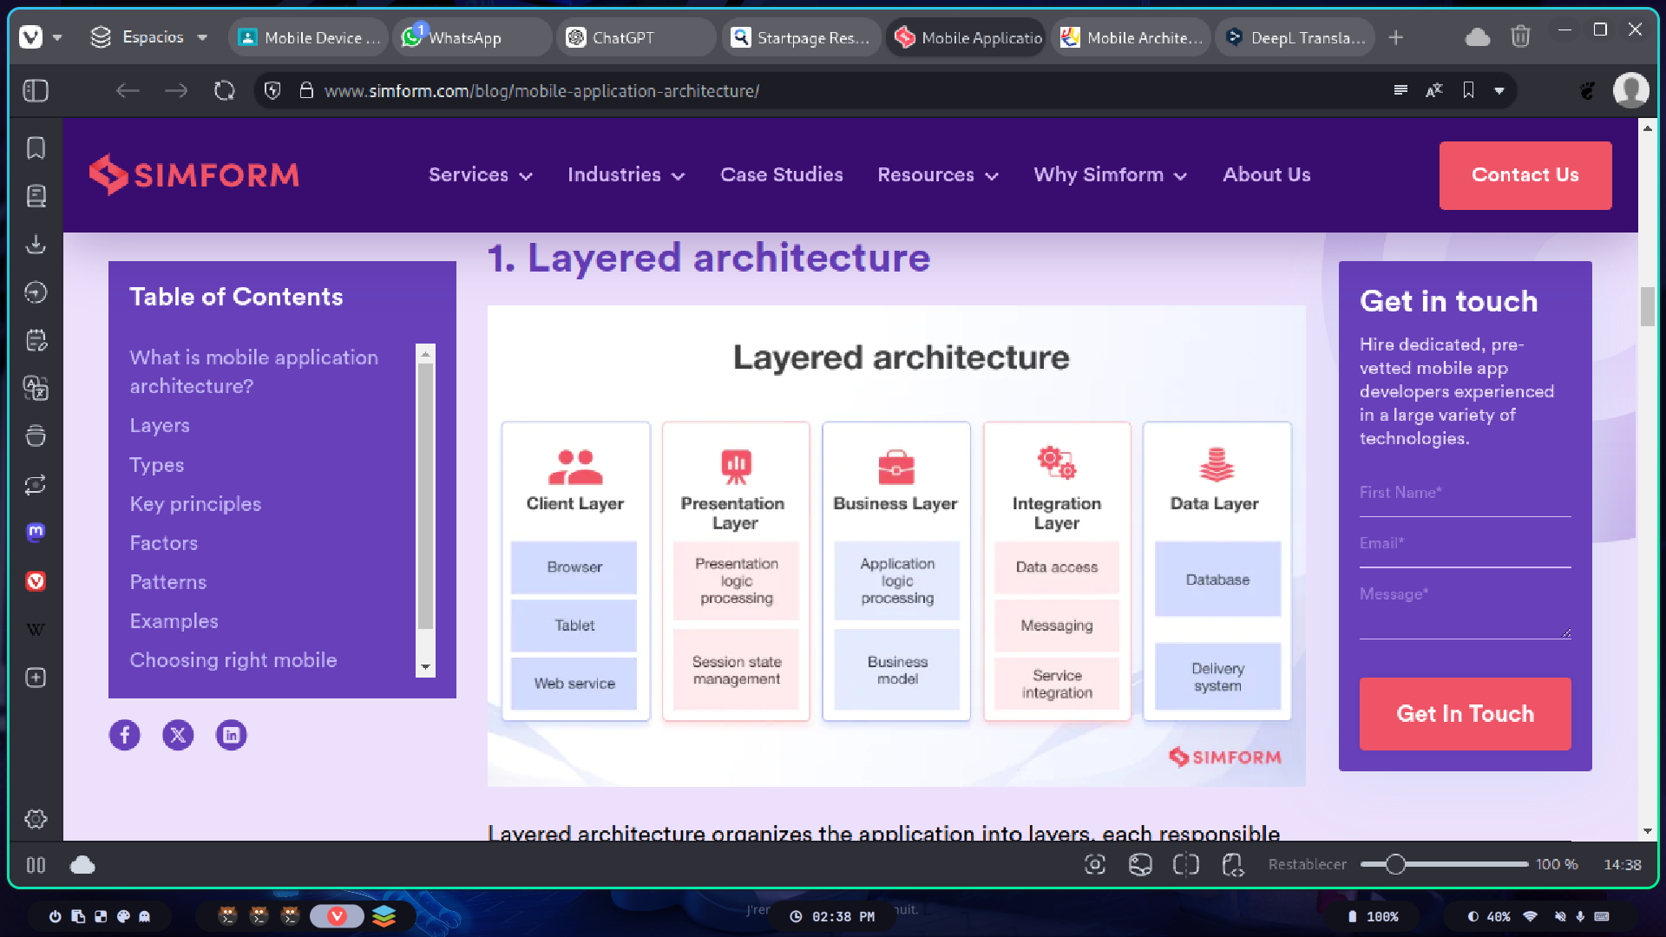

**Types of Mobile Applications**

**Native Applications:** Specifically developed for a platform (iOS, Android) using the native languages and tools of each operating system.

**Web Applications:** Accessible through mobile web browsers, do not require installation, and are usually developed with standard web technologies.

**Hybrid Applications:** Combine elements of both native and web applications, allowing the use of web technologies within a native container.

**Key Principles in Mobile Application Architecture**

**Modularity:** Divide the application into independent modules to facilitate development and maintenance.

**Scalability:** Design the application to handle growth in user base and functionalities.

**Security:** Implement measures to protect user data and ensure application integrity.

**Performance:** Optimize the application to ensure fast response times and efficient use of device resources.

**Factors to Consider in Architecture Design**

**User Experience (UX):** Create intuitive and attractive interfaces that enhance user satisfaction.

**Connectivity:** Properly handle variations in network connectivity, enabling offline functionalities when necessary.

**Compatibility:** Ensure the application works correctly on various devices and operating system versions.

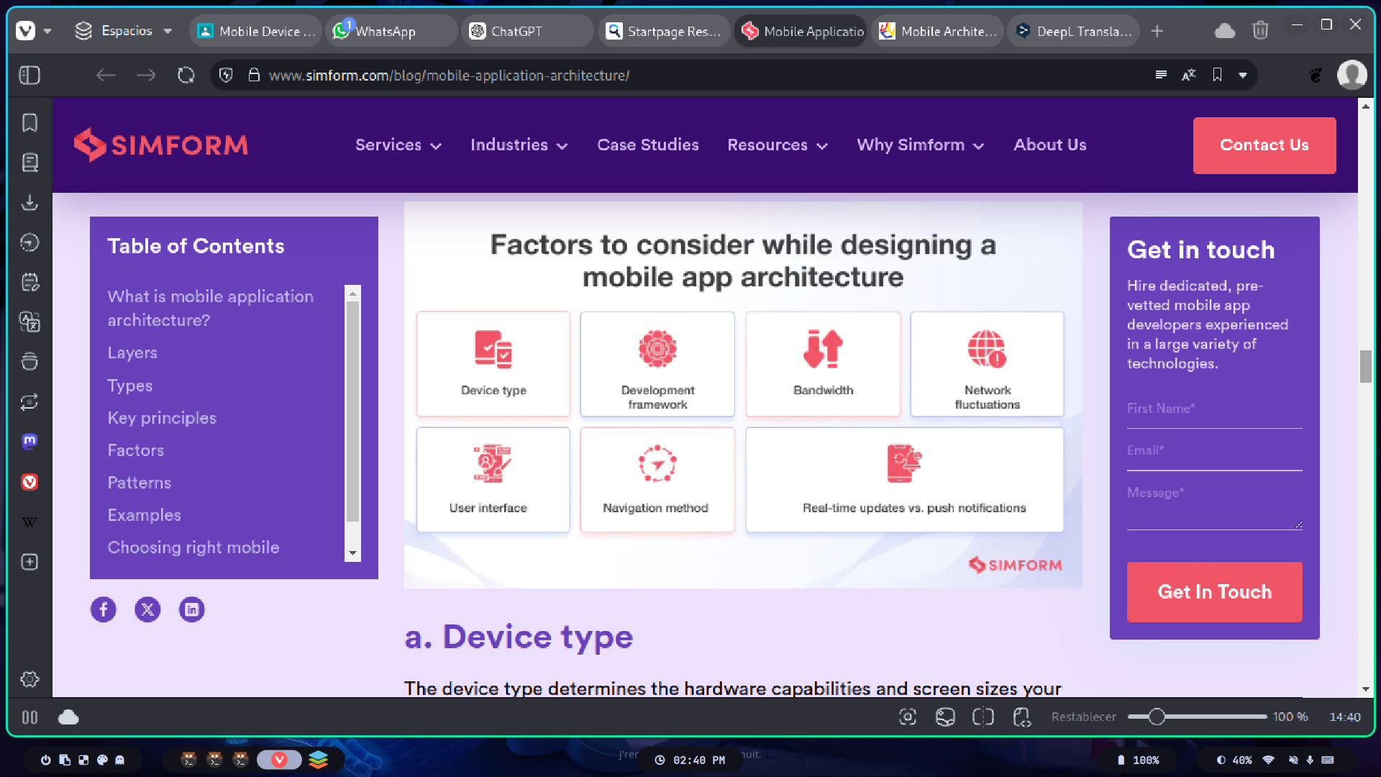

**Common Design Patterns**

**MVC (Model-View-Controller)**: Separates the application into three interconnected components to manage business logic, user interface, and user inputs.

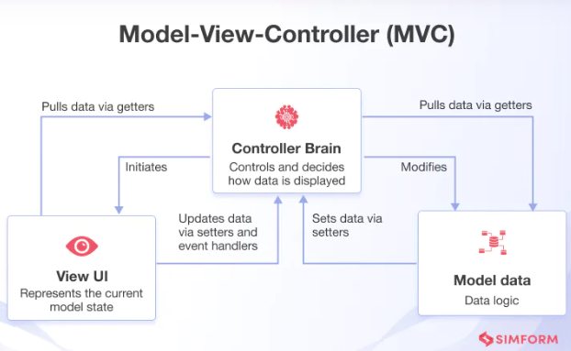

**MVVM (Model-View-ViewModel):** Similar to MVC but introduces the ViewModel to handle presentation logic and facilitate data binding.

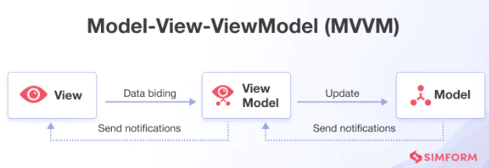

**MVP (Model-View-Presenter):** Divides the application into model, view, and presenter, where the presenter acts as an intermediary between the view and the model.

