

**Universidad Tecnológica de Tijuana**

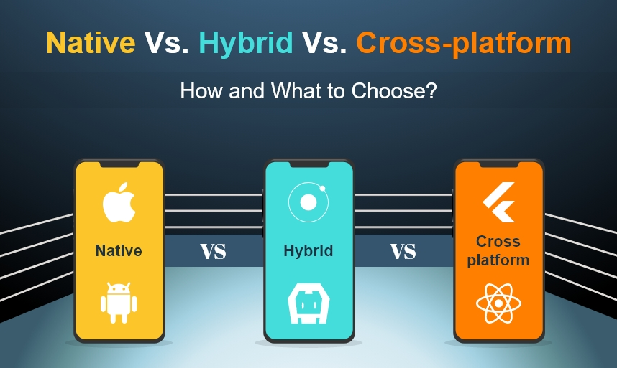

**Alumno:** Alcantara Huerta Angel Josue

**Docente:** Ray Brunett Parra Galaviz.

**Materia:** 4D-Diseño de APPS 2025-1.

**Trabajo:** Mobile design patterns

**Fecha de entrega:** 10 de enero de 2025

**Mobile design patterns**

Mobile interface design patterns are established solutions that solve common challenges in mobile application design, focusing on improving the user experience (UX). These patterns ensure that applications are intuitive, attractive and easy to use, resulting in higher user satisfaction and retention.

**Usability and Interface Design**

Usability in mobile design involves creating interfaces where users can interact easily and efficiently. An application with good usability reduces frustration and improves user satisfaction, crucial in a competitive environment where alternatives abound.

**Common Patterns in Mobile Design**

* **Action Bar:** Generally located at the top, it facilitates navigation and access to essential functions such as “Back” or “Share”.
* Tabbed Navigation: Allows users to switch between different sections by swiping horizontally, ideal for applications with multiple functions.
* **Cards:** Visual elements that combine text and images, often used in social networking and news applications.
* **Sliding Menu:** A panel that slides from one side of the screen, efficiently organizing content and navigation options.
* **Home screens:** The user's first interaction with the application, designed to be attractive and provide an overview of the functionalities.

**Effective Use of Design Patterns**

To apply these patterns successfully, it is essential:

* **Consistency:** Use the same patterns throughout the application to create familiarity.
* **User Testing:** Obtain direct feedback to identify usability improvements.
* **Adaptability:** Design for various devices and screen sizes, ensuring a uniform experience.
* **Simplicity:** Avoid overloading the user with too much information or options.

**Quick access**

There are certain actions that need to be close at hand so that users can achieve their goals quickly, for example, accessing actions associated with items in a list or grid without having to navigate deeply to find them.

In the case of a music app, when you want to add a song to the play queue, it would be a pain to have to go to the detail page to do so. In situations like this, to simplify these repetitive actions it is advisable to use shortcuts.

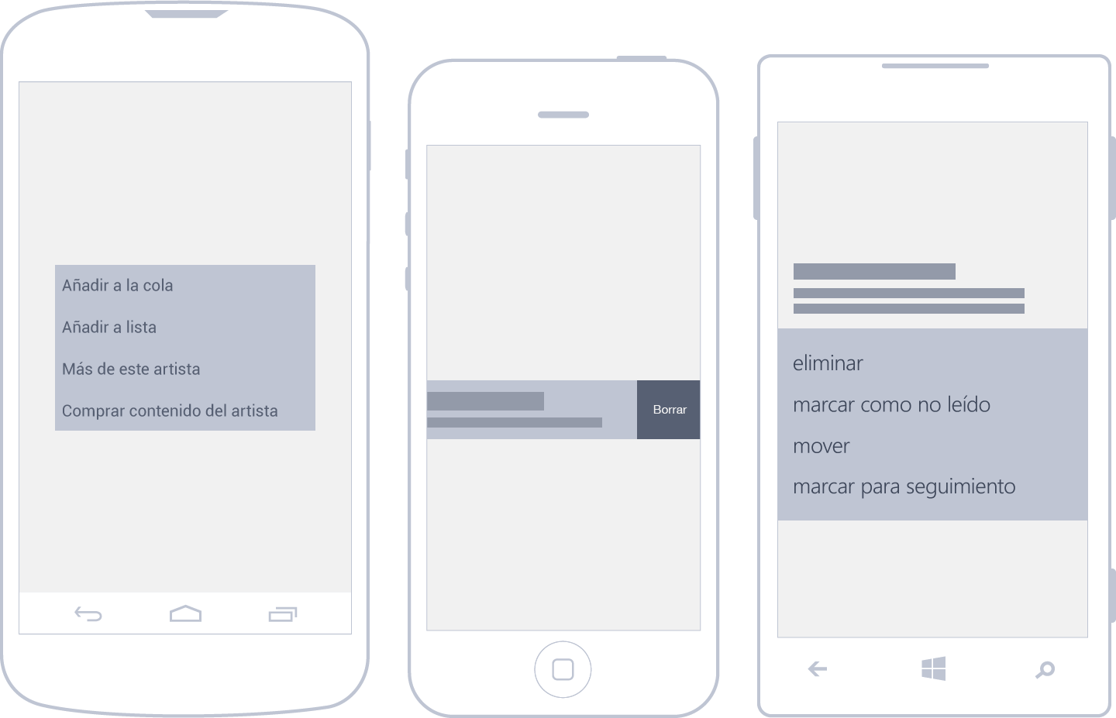

**Share**

It is probably one of the most used actions these days: sharing content with friends, on Facebook, on Twitter, by text message, whatever. Operating systems have also noticed this need and have provided a system-integrated implementation that is very easy to take advantage of.

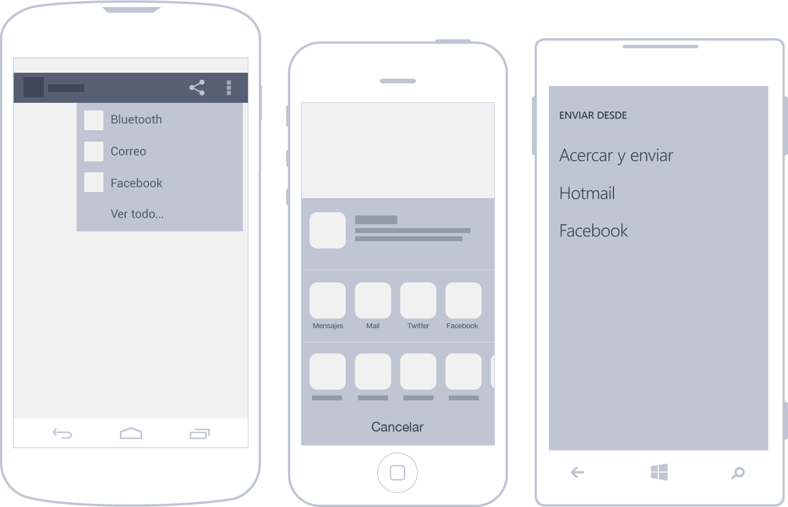

**Search**

Considering that one of the main uses of mobile is the consumption of content, the “search” tool is an essential way to reach it. In apps that display large amounts of data, search may even be the primary function.

Searching can be done by text input - the most common method - or by voice. Whenever possible, it is preferable to display results as the user types to improve the user experience. Ideally, the waiting time between input and result should be no more than one or two seconds.

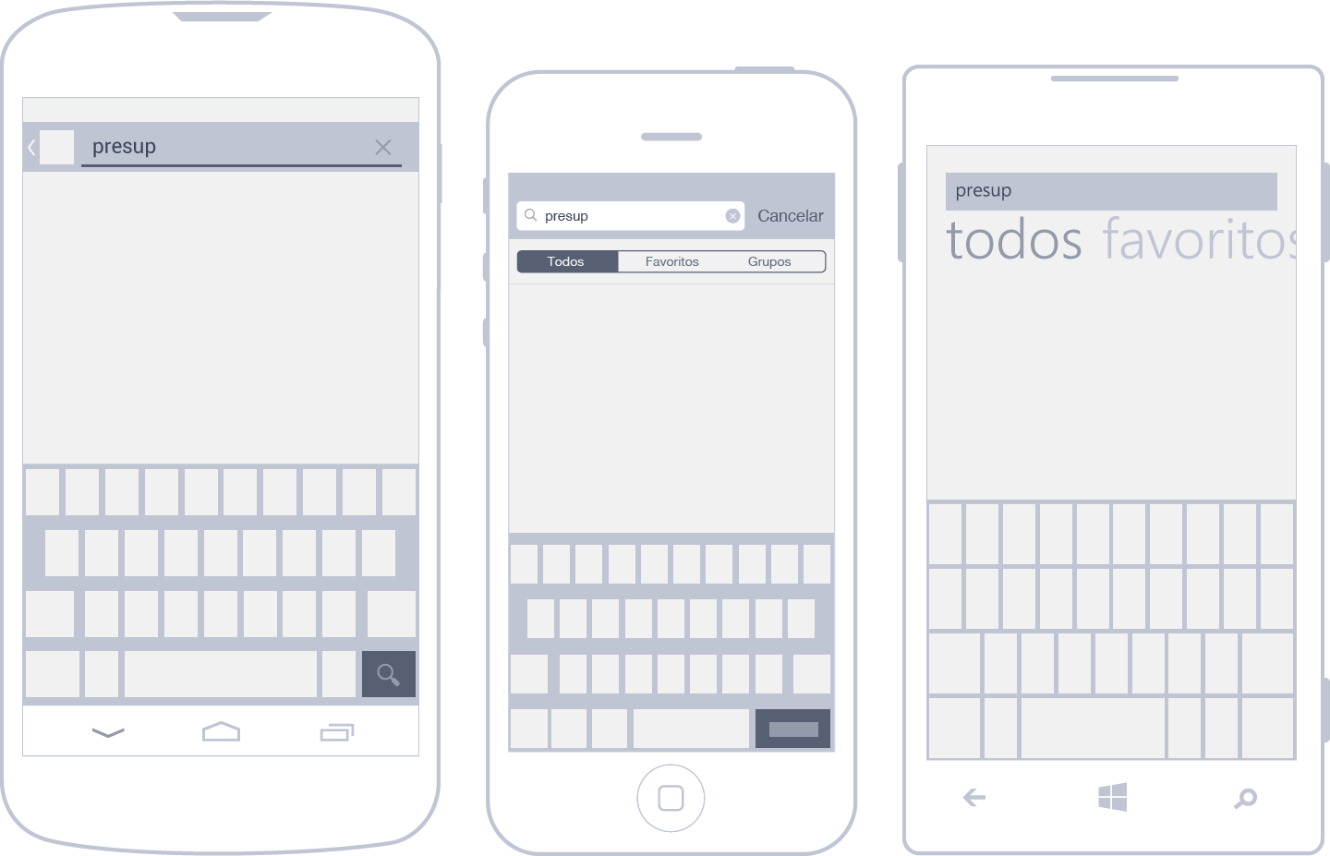

**Editing lists**

The user may need to modify several elements of a list simultaneously. The flow is quite simple: you select the elements you want to act on and then apply the corresponding action.

For example, if in a list of received emails you want to add a label to three of them, you have to check them and apply the desired action. So far, so good.

Now comes the most interesting part: the way to select items in a list varies considerably from one OS to another. Don't panic, we will explain it below.

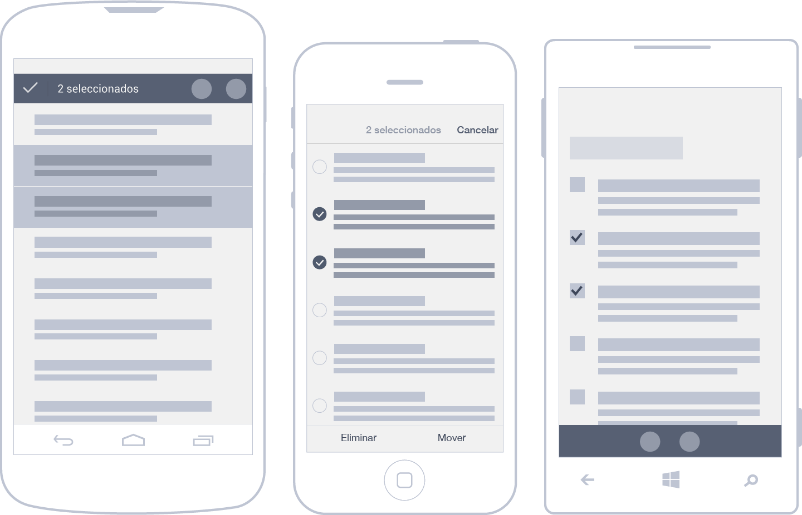

**In-App Notifications**

Notifications in mobile applications inform the user about the status of their actions without interrupting their workflow. On Android, these notifications are presented as “toasts”, small text tablets that disappear after a few seconds. On iOS and Windows Phone, they must be custom programmed, usually using external libraries.

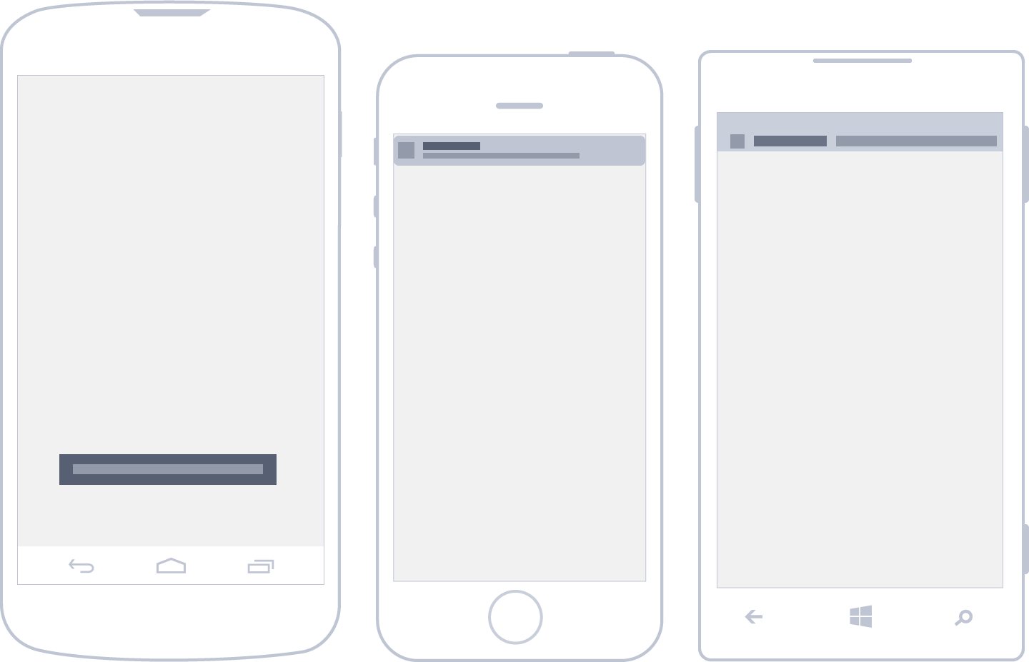

**Data Entry**

Data entry on mobile devices can be optimized using adaptive keyboards depending on the type of data. In addition, alternatives such as sliding menus or hardware sensors (such as microphones or GPS) can be used for more efficient and less tedious data entry.



**Gestures**

The use of simple gestures such as tapping, swiping and dragging is essential in mobile interfaces, as they are intuitive for most users. More complex gestures, while possible, are less common due to their greater difficulty of execution. Each operating system has specific conventions, but there are shared gestures that ensure a more homogeneous experience.

* Touch: Primary action (selection).
* Drag: File or delete items.
* Swipe: Navigate through content.
* Press and hold: Enter edit mode or show tooltips.
* Double tap: Toggle between zoom in and zoom out.
* Zoom in/out: Zoom in or out.
* Rotate: Rotate elements such as images or maps.

