Chapter5 Practice

Configuration for Irvine32.lib

1: Create a new file folder in your hard disk, copy Irvine.zip to your disk and unzip to this folder.

2:

Right-click the project property, select general option from linker menu and input Irvine folder path, such as, c:\irvine in additional library directory.

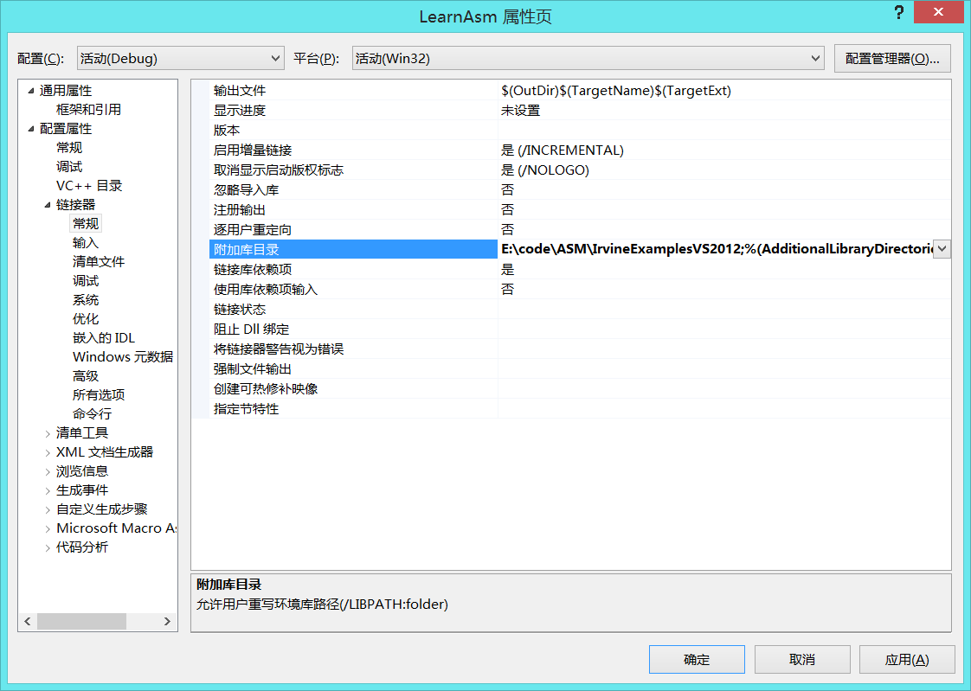

C:\irvine

C

3: Select input from linker menu and input irvine32.lib in additional dependent option, end with ”;”.

4. Select Microsoft macro assembler, select additional lib directory, input c:\irvine

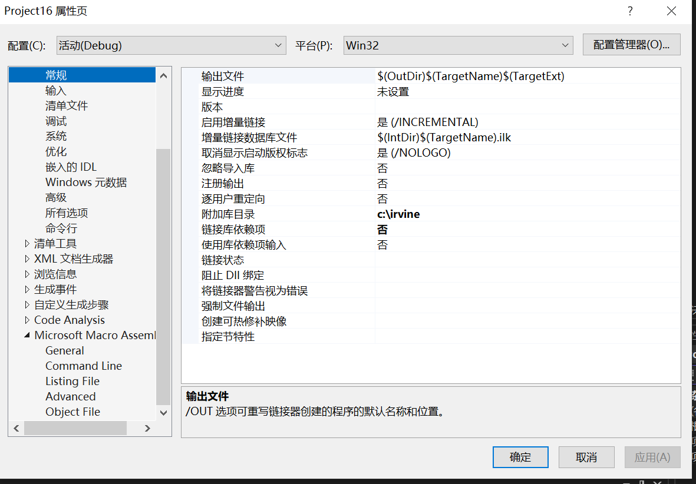

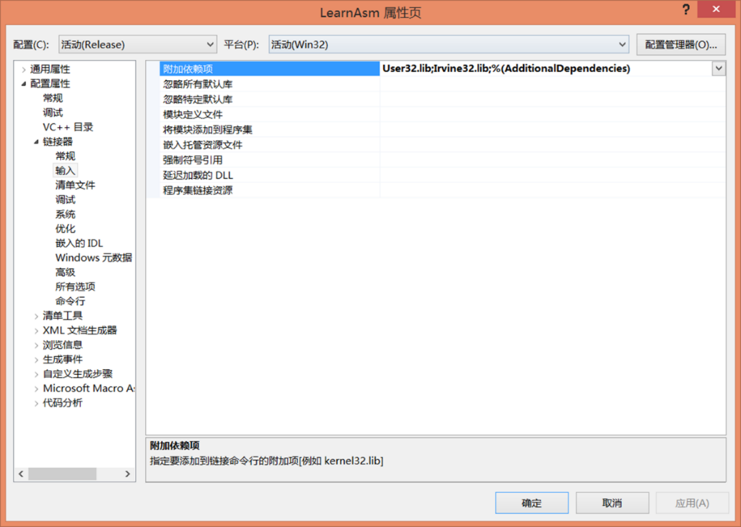

5. Programming Exercises P178

1 ,3, 5, 6, 7