Group 7

Author: Wenlin Zhu

Software Specifications

Elevator System

Table of Contents

System Architecture 2

Software Specifications 3

S1: UI implementation 3

S2: Processor Implementation 10

## System Architecture

The system architecture is shown below:

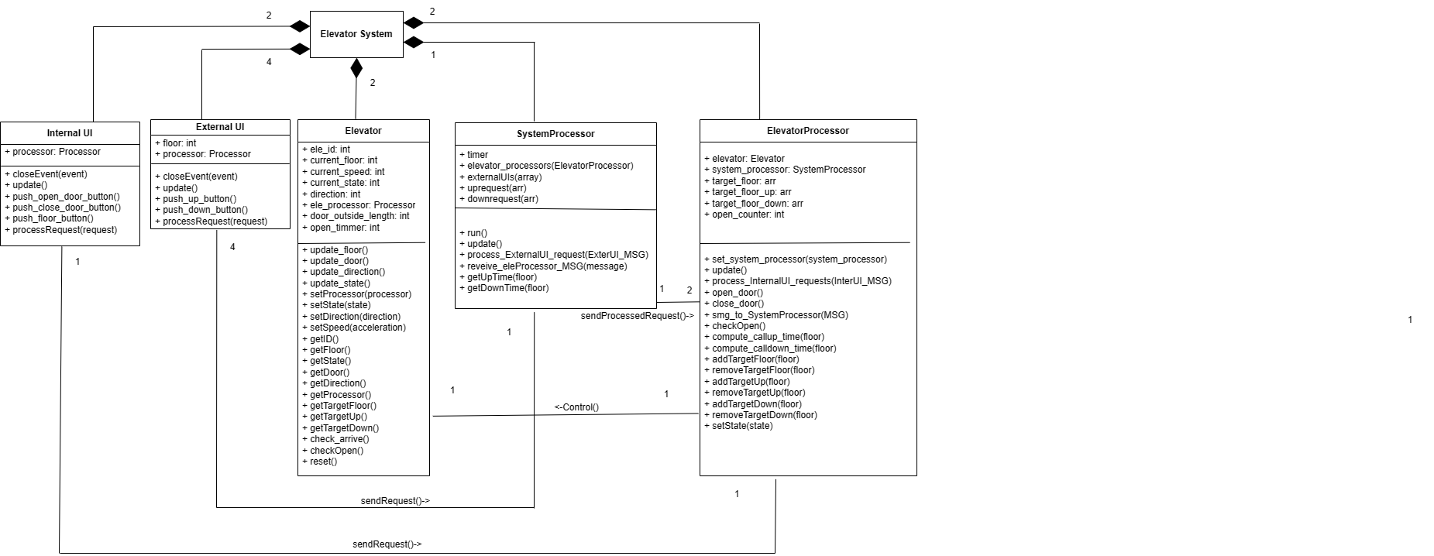

## Software Specifications

### S1: UI implementation

#### S1.1: InternalUI

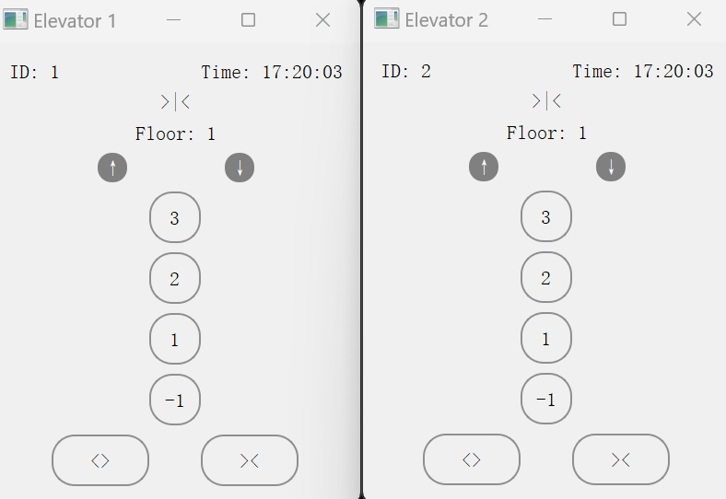

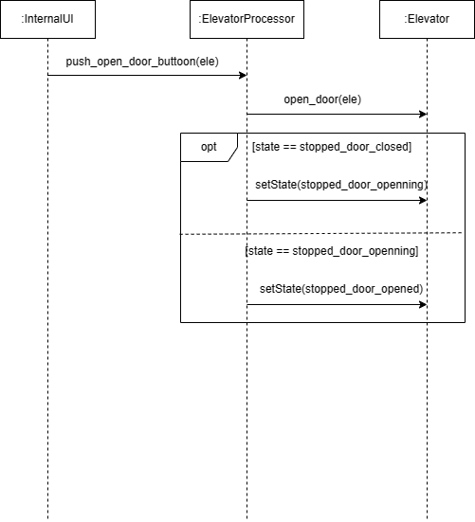

* S1.1.1: Open Door

1. Push <> button
2. Sent “open_door” message to Elevator Processor
3. Check and Set the state
   1. If state == stopped_door_closed, set the state stopped_door_openning
   2. If state == stopped_door_openning, set the state stopped_door_opened

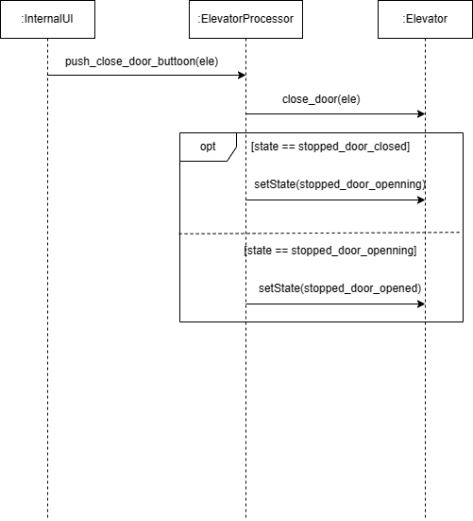

* S1.1.2: Close Door

1. Push >< button
2. Sent “open_door” message to Elevator Processor
3. Check and Set the state
   1. If state == stopped_door_closed, set the state stopped_door_openning
   2. If state == stopped_door_openning, set the state stopped_door_opened

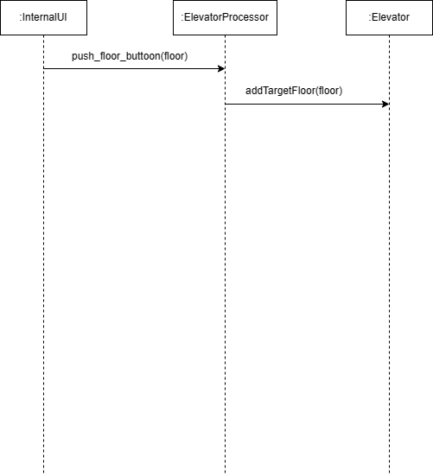

* S1.1.3: Select Floor

1. Push floor button
2. Sent “select_floor@floor#id” message to Elevator Processor
3. Add the floor to TargetFloorList

#### S1.2: EnternalUI

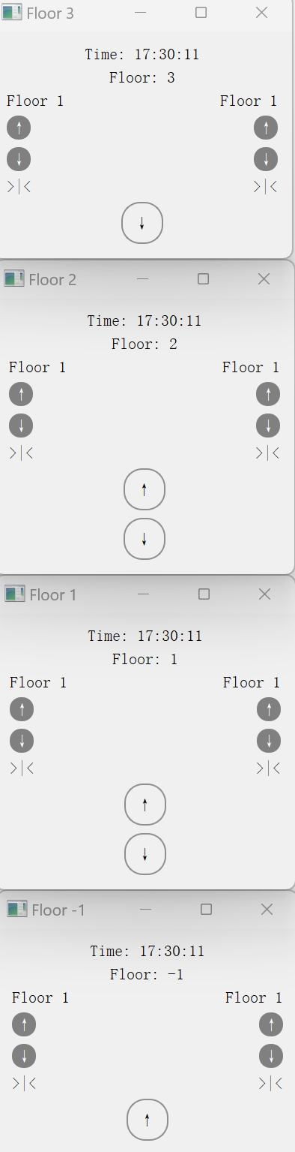

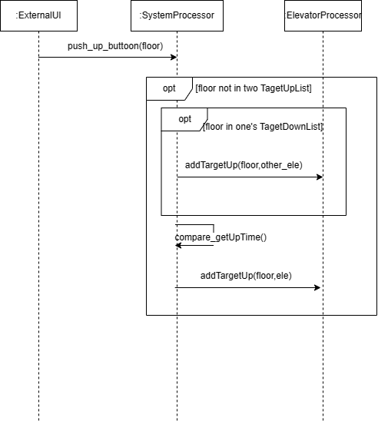

* S1.2.1: Call Up

1. Push ↑ button
2. Sent “call_up@floor” message to System Processor
3. Set the TargetUpList
   1. If the floor is in TargetUpList of two elevators, ignore this MSG
   2. If the floor is in TargetDownList of one elevator, add the floor to TargetUpList of the other elevator
   3. Compare getUp Time of two elevators, add the floor to TargetUpList of the faster one

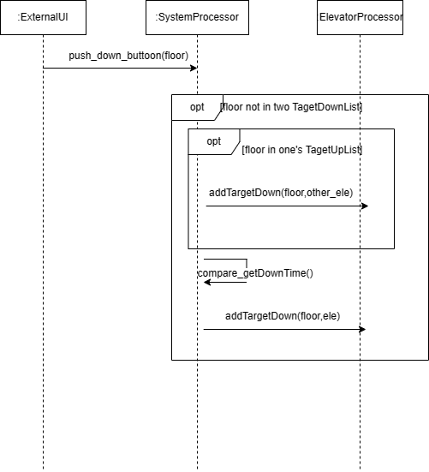

* S1.2.2: Call Down

1. Push ↓button
2. Sent “call_down@floor” message to System Processor
3. Set the TargetDownList
   1. If the floor is in TargetDownList of two elevators, ignore this MSG
   2. If the floor is in TargetUpList of one elevator, add the floor to TargetDownList of the other elevator
   3. Compare getDown Time of two elevators, add the floor to TargetDownList of the faster one

### S2: Processor Implementation

#### S2.1: Open Door upon Arrive

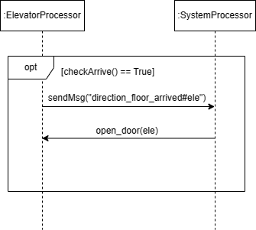

1. Check arrival
   1. If the state is idle, check if the current floor has an up request or a down request, set the request state to False, and set flag to True if it does. Otherwise, continue the procedure.
   2. If the state is up, check if the current floor has an up request, set the request state to False, and set flag to True if it does; otherwise, check for a down request and handle similarly.
   3. If the state is down, check if the current floor has a down request , set the request state to False, and set flag to True if it does; otherwise, check for an up request , and handle similarly.
2. Open Door
   1. If elevator arrives specific floor, its Elevator Processor sends message “direction_floor_arrived#ele” to System Processor, then open elevator’s door

#### S2.2: Update

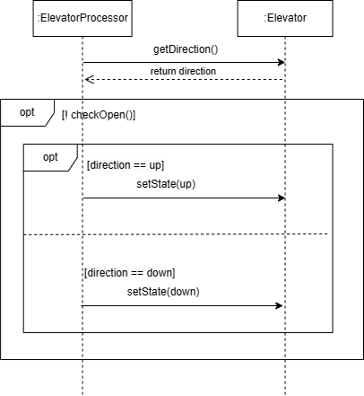

* S2.2.1: Update State

1. If the elevator doors are not open, sets the elevator state to 'up' or 'down' based on the current direction

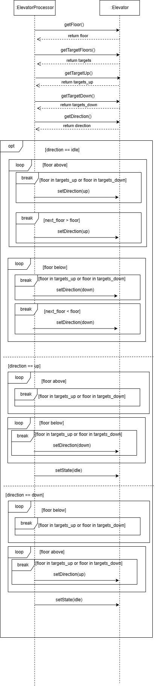

* S2.2.2: Update Direction

1. If direction is idle, checks for any targets above or below the current floor to set direction to up or down. If no targets, sets direction based on nearest target floor
2. If direction is up, continues if targets are above; otherwise, switches to down or idle
3. If direction is down, continues if targets are below; otherwise, switches to up or idle

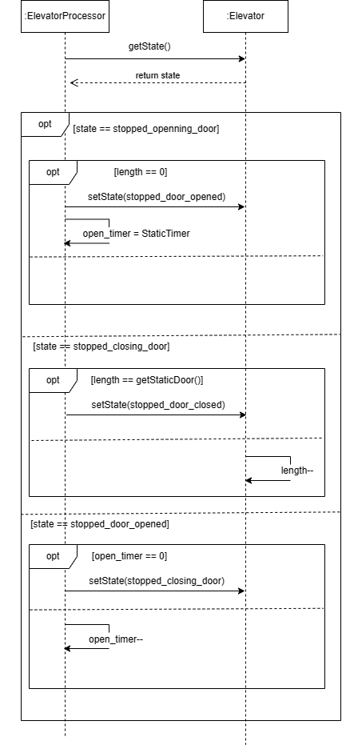

* S2.2.3: Update Door

1. If state is stopped_opening_door, decrements door length until fully open, then sets state to stopped_door_opened and starts the open timer
2. If state is stopped_closing_door, increments door length until fully closed, then sets state to stopped_door_closed
3. If state is stopped_door_opened, decrements open timer until it reaches zero, then sets state to stopped_closing_door

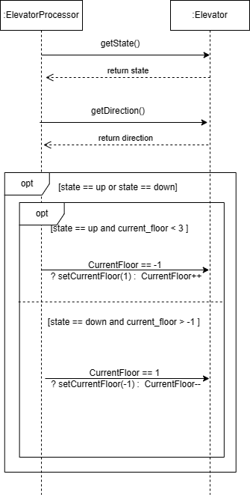

* S2.2.4: Update Floor

1. If the elevator is moving up , when the current floor is below 3, increment the floor by 1 (from -1, set it to 1, make it convenient for calculation)
2. If the elevator is moving down, when the current floor is above -1, decrement the floor by 1 (from 1, set it to -1, make it convenient for calculation)