Group 7

Author: Xinyue Hu

User Manual

Elevator

Table of Contents

System Architecture 2

External UI 2

Internal UI 3

## System Architecture

The system architecture is shown below:

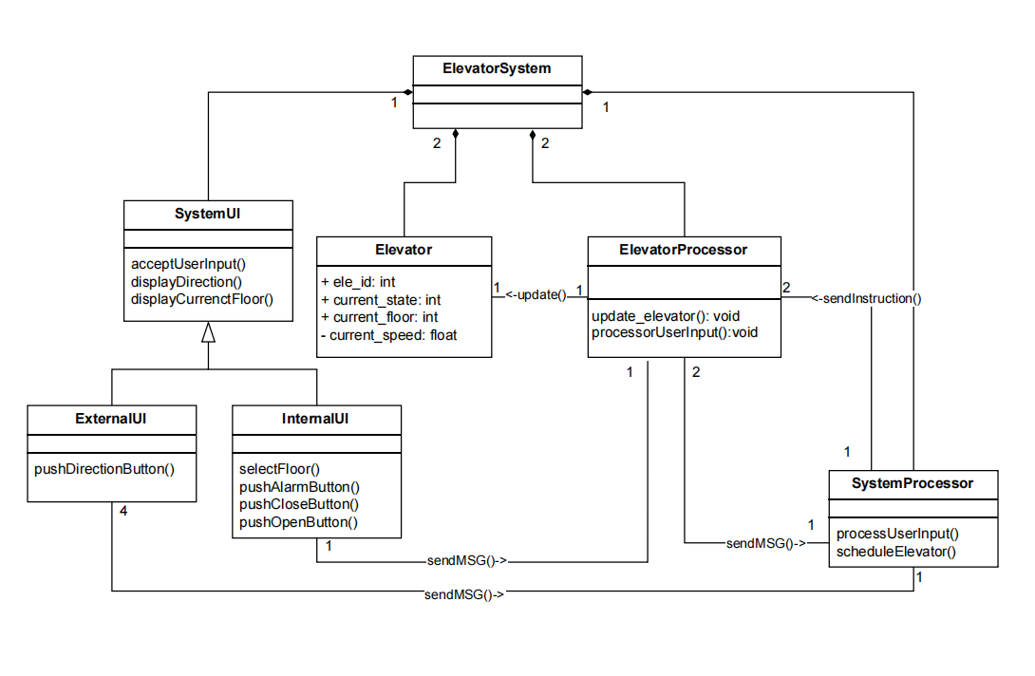

## External UI

There is an External UI on each floor, which is shown below.

➀

➁

➂

➃

➄

➅

➆

➇

➈

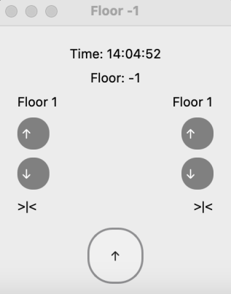 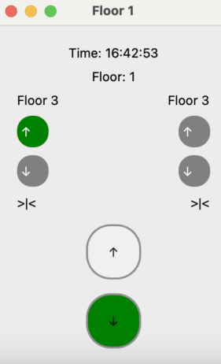 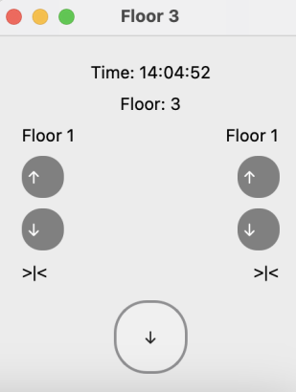

Figure 1

*External UI Components*

➀“Time”. This is the current time.

➁“Floor”. This is the current floor.

➂“Elevator 1’s current floor”. This is the current floor of elevator 1.

➃“Elevator 1’s current direction”. This is the current moving direction of elevator 1. When elevator 1 is moving, the lamp of the corresponding direction is lightened. When elevator 1 is idle, neither of two lamps is lightened.

➄“The current state of elevator 1’s door”. This is the current state of elevator 1’s door, it can be either closed or opened.

➅“Direction Button”.Clicking on this button will lighten the button and let the system know whether the users’ request is to go up or down. When an idle elevator or an elevator with the same moving direction of the direction button arrive on the floor, the button’s light will be off. For the lowest floor，there is only the up button. For the highest floor, there is only the down button.

➆“Elevator 2’s current floor”. This is the current floor of elevator 2.

➇“Elevator 2’s current direction”. This is the current moving direction of elevator 2. When elevator 2 is moving, the lamp of the corresponding direction is lightened. When elevator 2 is idle, neither of two lamps is lightened.

➈“The current state of elevator 2’s door”. This is the current state of elevator 2’s door, it can be either closed or opened.

## Internal UI

There is an Internal UI on each elevator, which is shown below.

➀

➁

➂

➃

➄

➅

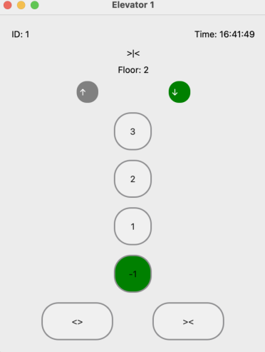

➆

Figure 2

*Internal UI Components*

➀“Time”. This is the current time.

➁“The current state of this elevator’s door”. This is the current state of this elevator’s door, it can be either closed or opened.

➂“This elevator’s current floor”. This is the current floor number of this elevator.

➃“This elevator’s current direction”. This is the current moving direction of this elevator. When this elevator is moving, the lamp of the corresponding direction is lightened. When this elevator is idle, neither of two lamps is lightened.

➄“Floor button”. Clicking on the button will lighten the button and let the processor know the user’s target floor, and will enable the elevator to bring the user to the target floor later.

➅ “Open door”. Pressing on this button will let the processor know the users’ request for opening the door. When the elevator is stopped on a floor, the processor will let the elevator open the door, otherwise, the processor will dismiss the request for the safety concern.

➆ “Close door”. Pressing on this button let the processor know the users’ request for closing the button. When the door is opened, the processor will let the elevator close the door, otherwise it will dismiss the request.