Group 7

Author: Xinyue Hu

Traceability Report

Smart Restaurant System

Table of Contents

System Architecture 2

Software Traceability 2

## System Architecture

The system architecture is shown below:

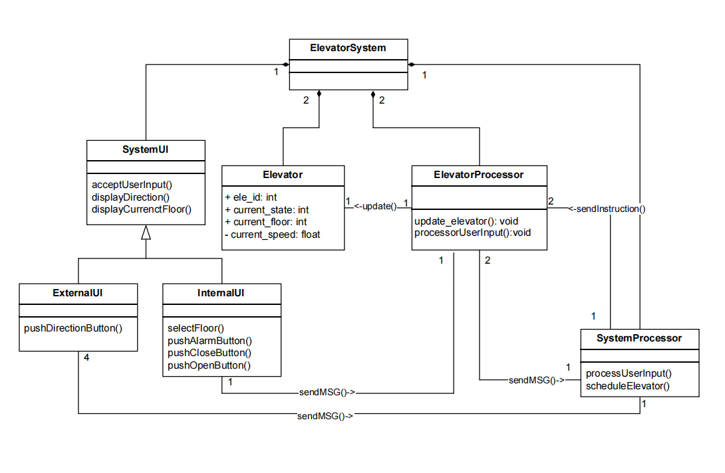

## Software Traceability

|  |  |  |
| --- | --- | --- |
|  | Is implemented by | Is validated by |
| R1(System UI) |  | T2, T3 |
| R1.1(Internal UI) |  | T2.1 - T2.2, T3.1 – T3.6 |
| R1.1.1 |  | T2.1.1 – T2.1.3, T2.2.2, T2.2.3, T2.2.5, T3.1.1, T3.2.1, T3.3.1 – T3.3.3, T3.5.1 |
| R1.1.2 |  | T2.1.1 - T2.1.3, T2.2.1 – T2.2.5, T3.5.2, T3.5.3, T3.5.5 |
| R1.1.3 |  | T2.1.3, T2.2.1 – T2.2.5, T3.3.1 – T3.3.3 |
| R1.1.4 |  | T2.2, T3.1.1, T3.2.1 |
| R1.2(Evternal UI) |  | T2.2, T3.4, T3.5, T3.6 |
| R1.2.1 |  | T2.2.1, T2.2.4, T3.4, T3.5.4, T3.6.1 |
| R1.2.2 |  | T2.1.1 - T2.1.3, T2.2.1 – T2.2.5, T3.5.2, T3.5.3, T3.5.5 |
| R1.2.3 |  | T2.2.1, T2.2.4, T3.4, T3.5.4, T3.6.1 |
| R1.3 |  | T2.1.1 - T2.1.3, T2.2.1 – T2.2.5, T3.5.2, T3.5.3, T3.5.5 |
| R1.4 |  | T1.3.1, T1.3.2, T1.3.3, T1.3.4, T1.3.5, T1.3.6, T1.3.7, T1.3.8, T1.4.7, T1.4.8, T1.4.9, T1.4.10, T1.4.11, T1.4.12 |
| R2(Elevator Processor) |  | T2, T3 |
| R2.1 |  | T2.1, T2.2, T3.1, T3.2, T3.3, T3.4, T3.6 |
| R2.1.1 |  | T2.1.3, T2.2.1 – T2.2.5, T3.1.2, T3.2.2, T3.3.1, T3.3.2, T3.4, T3.6.1, T3.6.2 |
| R2.1.2 |  | T3.1.2, T3.2.2 |
| R2.1.2.1 |  | T3.1.2, T3.2.2 |
| R2.1.2.2 |  | T3.1.2, T3.2.2 |
| R2.2 |  | T3.2, T1.1.3, T1,1,5 |
| R2.2.1 |  | T3.2.2 |
| R2.2.2 |  | T1.1.5 |
| R2.2.3 |  | T1.1.3 |
| R2.3 |  | T3.3, T3.6 |
| R2.3.1 |  | T3.3.1, T3.3.2 |
| R2.3.2 |  | T3.6.1, T3.6.2 |
| R2.3.3 |  | T3.6.1, T3.6.2 |
| R3(System Processor) |  | T2, T3 |
| R3.1 |  | T2.2, T3.4, T3.6 |
| R3.1.1 |  | T1.3.1, T1.3.2, T1.3.3, T1.3.4, T1.3.5, T1.3.6, T1.3.7, T1.3.8, T1.4.7, T1.4.8, T1.4.9, T1.4.10, T1.4.11, T1.4.12 |
| R3.1.2 |  | T2.2.1, T2.2.4, T3.4, T3.6.1, T3.6.2 |
| R3.2 |  | T3.6 |
| R3.2.1 |  | T3.6.1, T3.6.2 |
| R3.2.2 |  | T3.6.1, T3.6.2 |