Group 7

Author: Jintong Luo

Requirement

Banking System

Table of Contents

System Objective 2

Domain Analysis 2

System Architecture 4

Use Cases 4

Software Requirements 5

R1: APPUI 5

R2: ATM UI 5

R3: SystemProcessor 6

R4: SystemDataBase 7

System Objective

In this project, we are developing a software that can manage a banking system correctly and safely. The system would provide a functional interface of both APP and ATM for users, that means our users could access the service both online and with the ATM machines.. Through the interface, users could get services like open & close accounts, deposit & withdraw cash and transfer efficiently.

Domain Analysis

The participants of activities relating to banking system can be categorized into User, APP and ATM. The relationship of them are as follows:

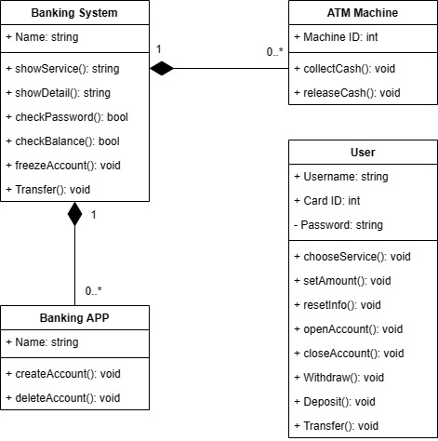

The relationships between the user and the banking system are shown as follows:

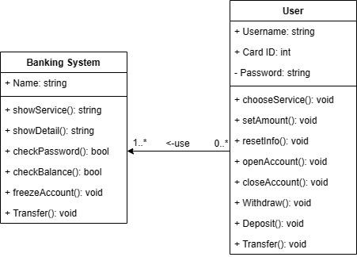

Here is the sequence of events for a user to use banking APP:

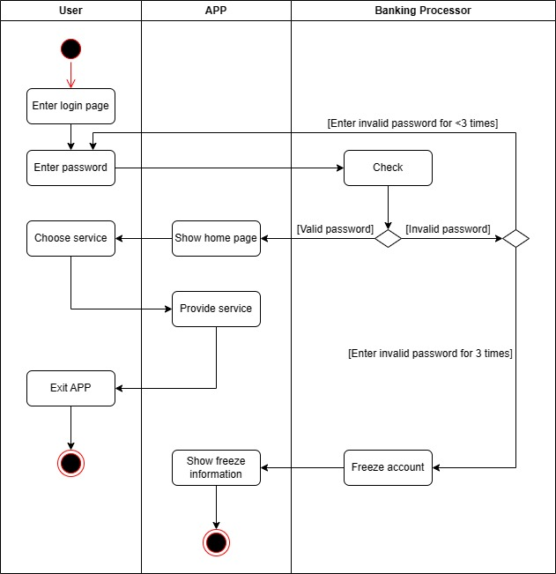

Here is the sequence of events for a user to use an ATM machine:

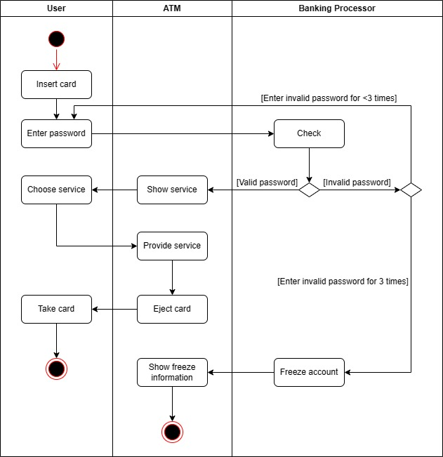

System Architecture

From the information above, we will design a software system that allows the users to use both the banking APP and ATM machine efficiently and safely. The users could choose from variety of services as well. The banking system can satisfy the users’ need and display necessary information. The system architecture is shown below:

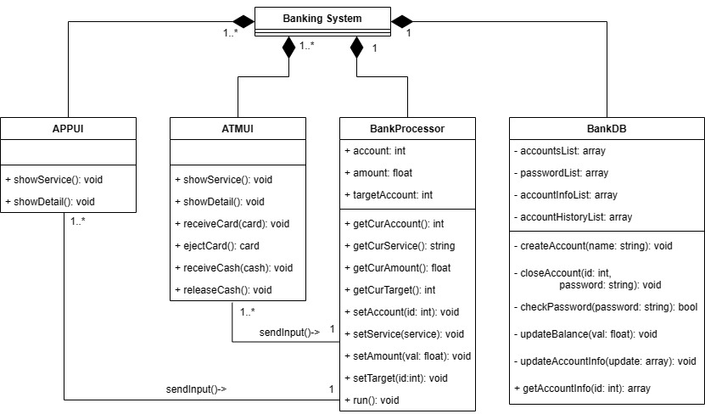

Use Cases

The system can achieve the following use cases from the user’s and the bank’s perspectives:

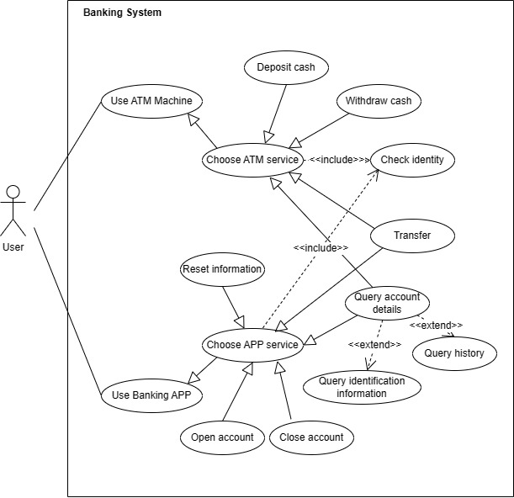

Software Requirements

### R1: APPUI

* R1.1: The APP should have a welcome page.
  + R1.1.1: The user should be able to login at this page.
* R1.2: There should be a page for the users to select services.
  + R1.2.1: The user could choose to transfer.
  + R1.2.2: The user could choose to query account details.
  + R1.2.3: The user could choose to change PIN.
  + R1.2.4: The user could choose to logout.
* R1.3: The depositor should be able to transfer money to other people.
  + R1.3.1: The user should be able to set the amount of money.
  + R1.3.2: The user should be able to set the account to transfer in.
  + R1.3.3: The user should be able to know the amount of commission charge (if there is), and decide whether he wants to pay.
  + R1.3.4: The user should know whether the transfer is successful and the reason for failure.
  + R1.3.5: The user should know the balance after transfer.
  + R1.3.6: The system should ask whether the user needs a bill after successful transfer.
  + R1.3.7: The user should be able cancel the request and return to the main page at any time.
* R1.4: The user should be able to change PIN.
  + R1.4.1: The user should be able to enter the new PIN.
  + R1.4.2: The user should enter the new PIN twice to ensure security.
  + R1.4.3: The user should be able cancel the request and return to the main page at any time.
* R1.5: The user should be able to query account details.
  + R1.5.1: The user should be able to get the card ID.
  + R1.5.2: The user should be able to get balance.
  + R1.5.3: The user should be able to get details for transfer history.
  + R1.5.4: The depositor should be able to get details for deposit & withdraw history.
  + R1.5.5: The user should be able cancel the request and return to the main page at any time.

### R2: ATM UI

* R2.1: There should be an welcome page.
  + R2.1.1: The user could choose to insert card to login or create a new account.
* R2.2: There should be a page for the users to select services.
  + R2.2.1: The user could choose to deposit cash.
  + R2.2.2: The user could choose to withdraw cash.
  + R2.2.3: The user could choose to transfer.
  + R2.2.4: The user could choose to query account details.
  + R2.2.5: The user could choose to change PIN.
  + R2.2.6: The user could choose to close account.
* R2.3: The user should be able to deposit cash.
  + R2.3.1: The user should be able to set the amount.
  + R2.3.2: The user should be able to know the valid amount of money to deposit.
  + R2.3.3: The user should be able to know the balance after depositing.
  + R2.3.4: The system should ask whether the user needs a bill after successful deposit.
  + R2.3.5: The user should be able cancel the request and return to the main page at any time.
* R2.4: The user should be able to withdraw cash.
  + R2.4.1: The user should be able to set the amount.
  + R2.4.2: The user should know the balance if he set a larger amount than his balance.
  + R2.4.3: The user should be able to know the balance after withdrawing.
  + R2.4.4: The system should ask whether the user needs a bill after successful withdraw.
  + R2.4.5: The user should be able cancel the request and return to the main page at any time.
* R2.5: The user should be able to transfer money to other people.
  + R2.5.1: The user should be able to set the amount of money.
  + R2.5.2: The user should be able to set the account to transfer in.
  + R2.5.3: The user should be able to know the amount of commission charge (if there is), and decide whether he wants to pay.
  + R2.5.4: The user should know whether the transfer is successful and the reason for failure.
  + R2.5.5: The user should know the balance after transfer.
  + R2.5.6: The system should ask whether the user needs a bill after successful transfer.
  + R2.5.7: The user should be able cancel the request and return to the main page at any time.
* R2.6: The user should be able to query account details.
  + R2.6.1: The user should be able to get the card ID.
  + R2.6.2: The user should be able to get balance.
  + R2.6.3: The user should be able to get details for transfer history.
  + R2.6.4: The depositor should be able to get details for deposit & withdraw history.
  + R2.6.5: The user should be able cancel the request and return to the main page at any time.
* R2.7: The user should be able to change PIN.
  + R2.7.1: The user should be able to enter the new PIN.
  + R2.7.2: The user should enter the new PIN twice to ensure security.
  + R2.7.3: The user should be able cancel the request and return to the main page at any time.
* R.2.8: The user should be able to get his card back.
  + R2.8.1: The depositor should be able to decide when the ATM machine should release his card.

### R3: SystemProcessor

* R3.1: The system should be able to open a valid account and save the information of the new account.
  + R3.1.1: The system should check the identification card information provided by the user before creating the new account.
  + R3.1.2: The system should tell the user to check the identification card if the card has been occupied, otherwise it could create the new account.
  + R3.1.3: The system should provide the new account ID for the user after creating successfully.
  + R3.1.4: The system should tell the depositor to set basic information like username, login password and payment password.
* R3.2: The system should guarantee the account security.
  + R3.2.1: The system should check the card ID and related login password before logging in.
  + R3.2.2: The system should check the payment password before providing services.
  + R3.2.3: The system should freeze the account and tell the user this message if the user has given invalid passwords for 3 times.
* R3.3: The system should run the deposit procedure correctly.
  + R3.3.1: The system should check the amount of valid money the user has provided and release these fake money back.
  + R3.3.2: The system should tell the user whether the deposit procedure is successful and tell the reason if meeting a failure.
  + R3.3.3: The system should tell the balance after depositing to the user.
* R3.4: The system should run the withdraw procedure correctly.
  + R3.4.1: The system should check whether the balance is larger than the amount that the user has set.
  + R3.4.2: The system should tell the user whether the withdraw procedure is successful and tell the reason if meeting a failure.
  + R3.4.3: The system should tell the balance after withdrawing to the user.
* R3.5: The system should run the transfer procedure correctly.
  + R3.5.1: The system should check whether the account to transfer in is valid.
  + R3.5.2: The system should check whether the balance is larger than the amount that the user has set.
  + R3.5.3: The system should tell the user whether the transfer is successful and tell the reason if meeting a failure.
  + R3.5.4: The system should tell the balance after transfer to the user.
* R3.6: The system should deal with the case that the user uses the APP and ATM at the same time.

### R4: SystemDataBase

* R4.1: The database should be able to save accounts and the related information.
  + R4.1.1: The database should be able to save account and its related passwords.
  + R4.1.2: The database should be able to save balance.
  + R4.1.3: The database should be able to save transfer history.
  + R4.1.4: The database should be able to save deposit & withdraw history.
  + Optional: For safety, the database should use some encryption algorithm.
* R4.2: The database should be able to check accounts.
  + R4.2.1: The database should be able to check whether the current account is valid / frozen.
  + R4.2.2: The database should be able to check whether the passwords for the current account is correct to ensure the account security.
  + R4.2.3: The database should be able to calculate the current balance.