Group 7

Author: Xinyue Hu

Software Specifications

Banking System

Table of Contents

System Architecture 2

Software Specifications 3

S1: ATMUI implementation 3

S1.1: Entry Page 3

S1.2: Select Page 6

S1.3: Transfer Page 10

S1.4: ChangePin Page 12

S1.5: Query Page 14

S1.6: Deposit Cash Page 15

S1.7: Withdraw Cash Page 17

S2: APPUI Implementation 20

S2.1: Log In Page 20

S2.2: Select Page 21

S2.3: Transfer Page 23

S2.4: ChangePin Page 24

S2.5: Query Page 27

## System Architecture

The system architecture is shown below:

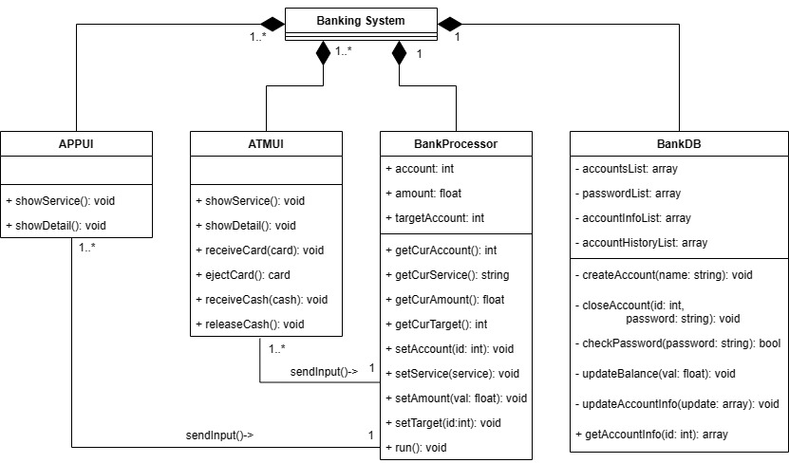

## Software Specifications

### S1: ATMUI implementation

#### S1.1: Entry Page

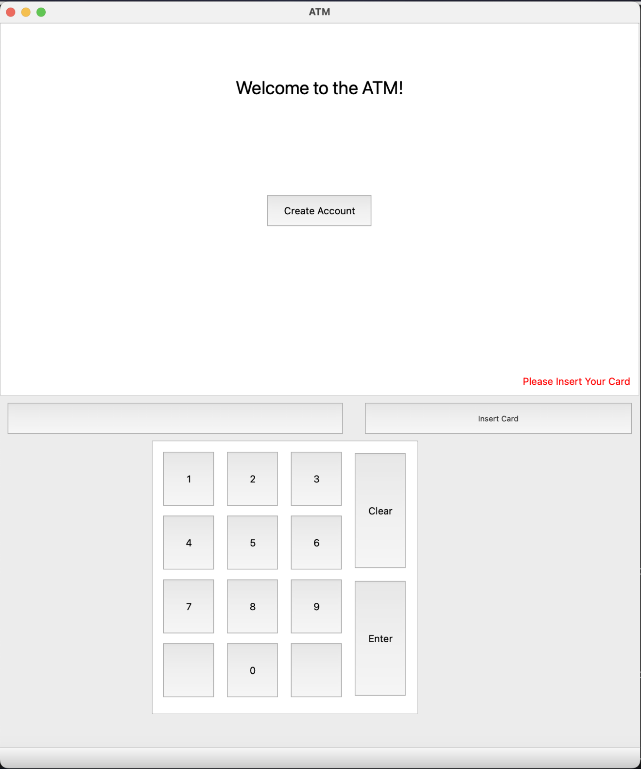

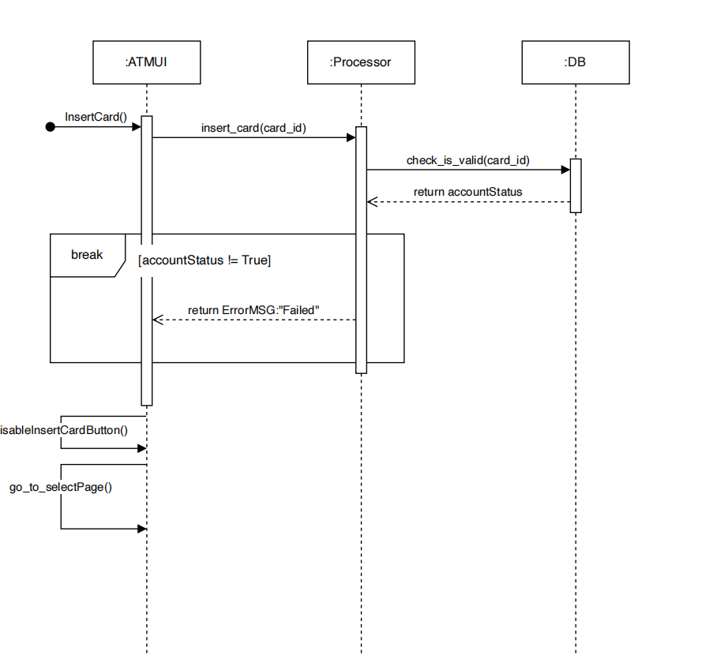

* S1.1.1: Insert Card

1. Insert Card button pressed
2. Verify the card
   1. If it is invalid, an ErrorMSG will be send from the processor and a warning will appear on the ATMUI
   2. Otherwise, continue the procedure.
3. Disable the Insert Card button, which means the ATM has a card in it
4. Go to the select Page

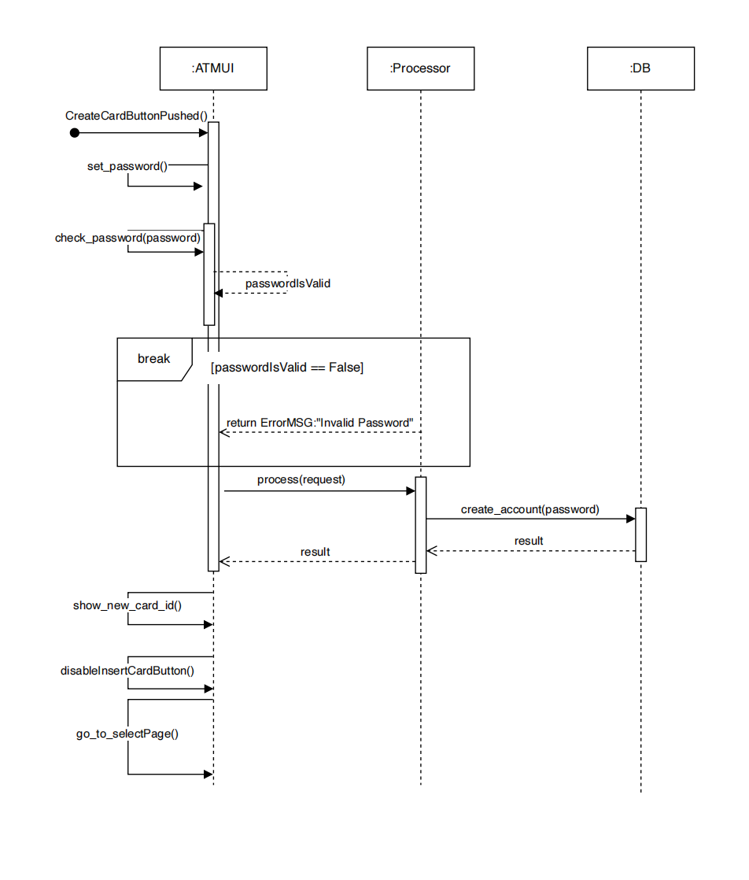

* S1.1.2: Create Card

1. Create Card button clicked
2. Get Password
   1. If the password obtained does not consist of more than 6 digits,break
   2. Otherwise,continue the procedure.
3. A new card id is created in the DB and was send to the processor
4. Disable the Insert Card button to preventing conflicts between different accounts
5. Go to the select Page

#### S1.2: Select Page

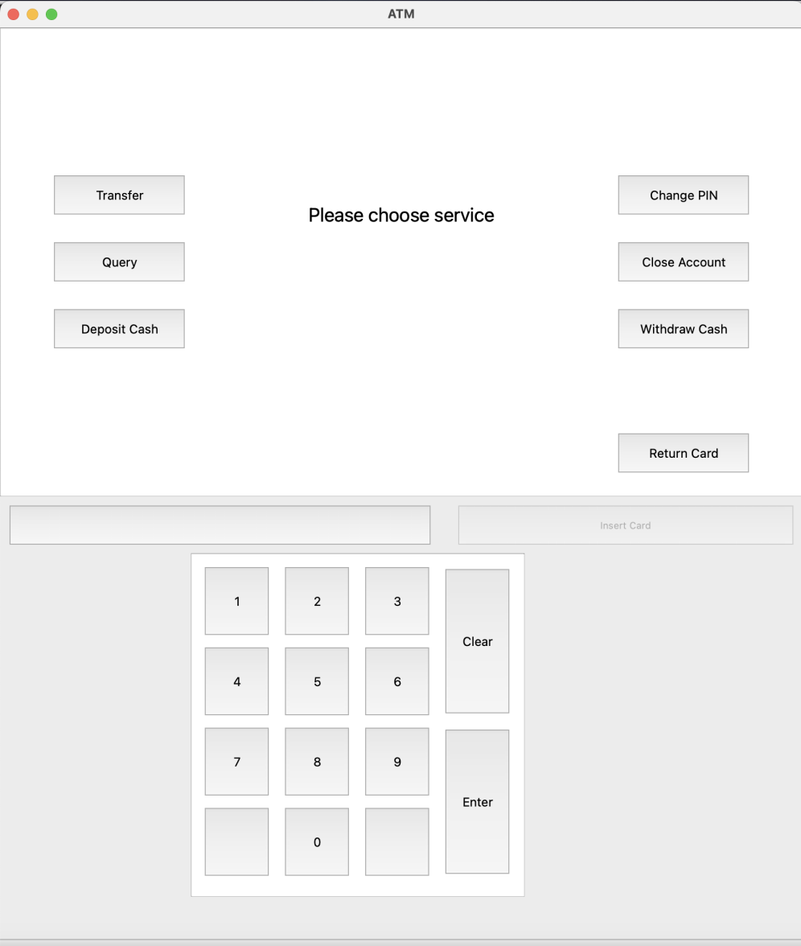

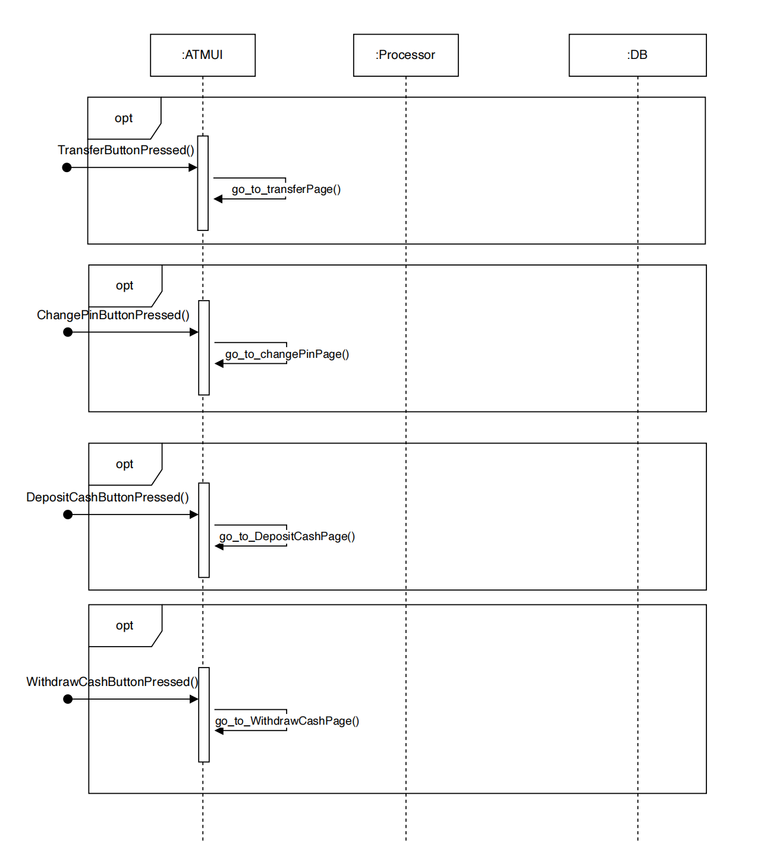

* S1.2.1: Transfer Button pressed

1. Go to the Transfer Page

* S1.2.2: ChangePin Button pressed

1. Go to the ChangePin Page

* S1.2.3: DepositCash Button pressed

1. Go to the DepositCash Page

* S1.2.4: WithdrawCash Button pressed

1. Go to the WithdrawCash Page

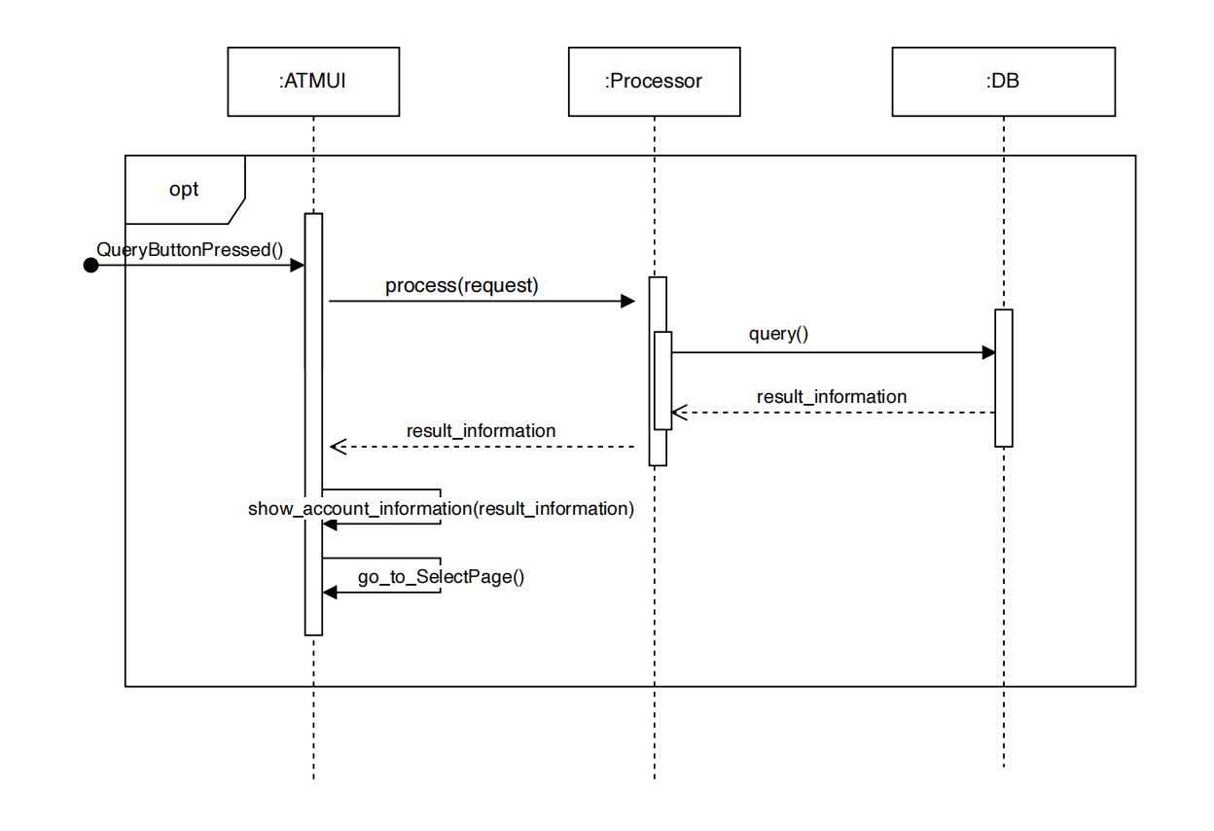

* S1.2.5: Query Button pressed

1. Send request to the processor
2. The processor handle the query request
   1. The DB return the account information
3. Write the account information to the Query Page
4. Go to the Query Page

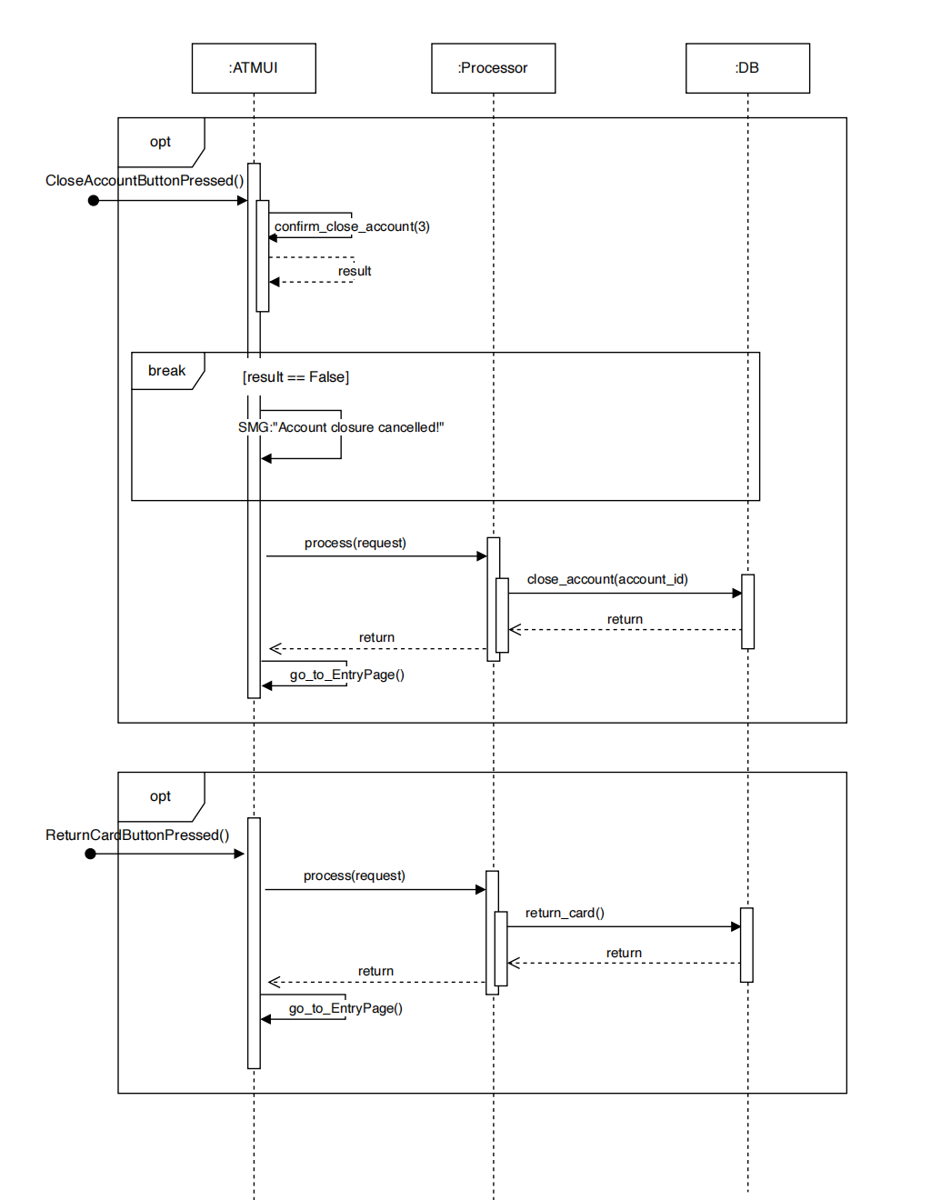

* S1.2.6: Press Return Card pressed

1. Enable the "Insert Card" button, which means there is no card in the ATM at that time
2. Go to the Entry Page

* S1.2.7: CloseAccount Button pressed

1. Confirm Close Account: The user is prompted three times to confirm the account closure.
   1. If the user cancels at any prompt: Display a message: "Account closure cancelled" and break
   2. If the user confirms all three prompts: The processor processes the close account request and continue the procedure.
2. Display a success message: "Close Account, Succeed!".
3. Enable the "Insert Card" button, when the account was closed, the corresponding card would be swallowed by the ATM and thus a user can insert a new card.
4. Go to the Entry page.

#### S1.3: Transfer Page

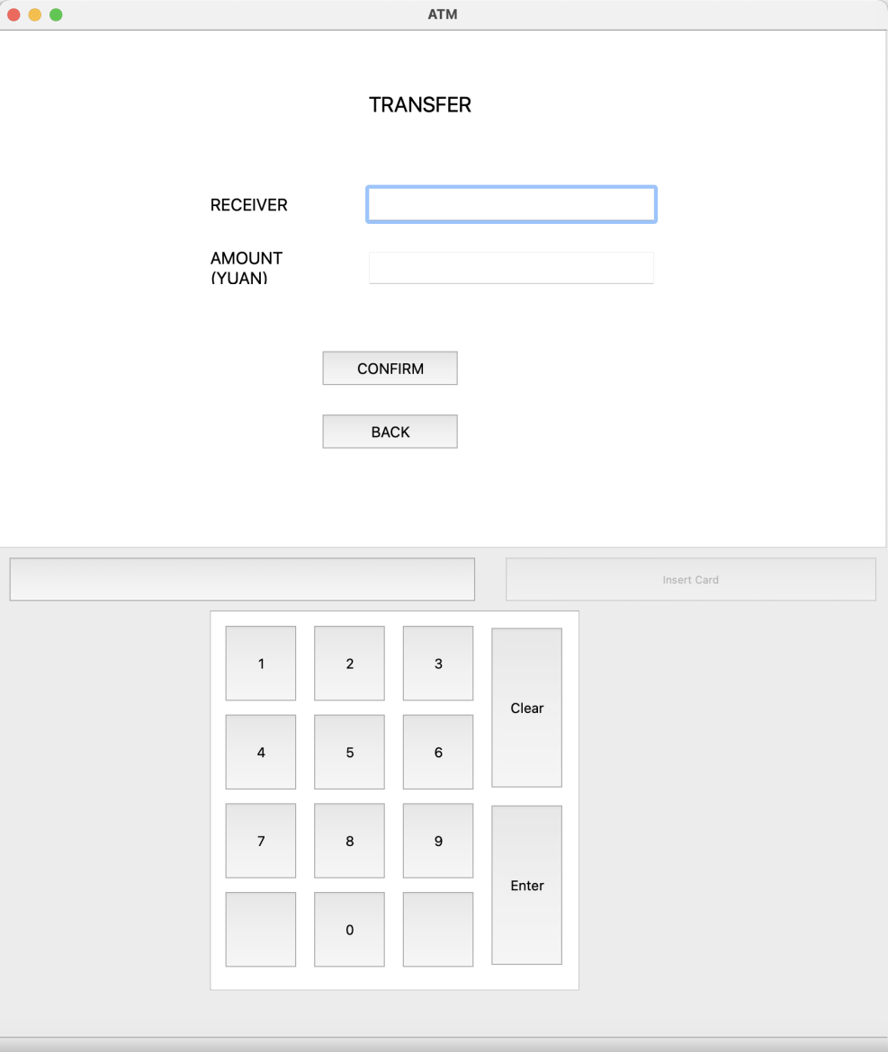

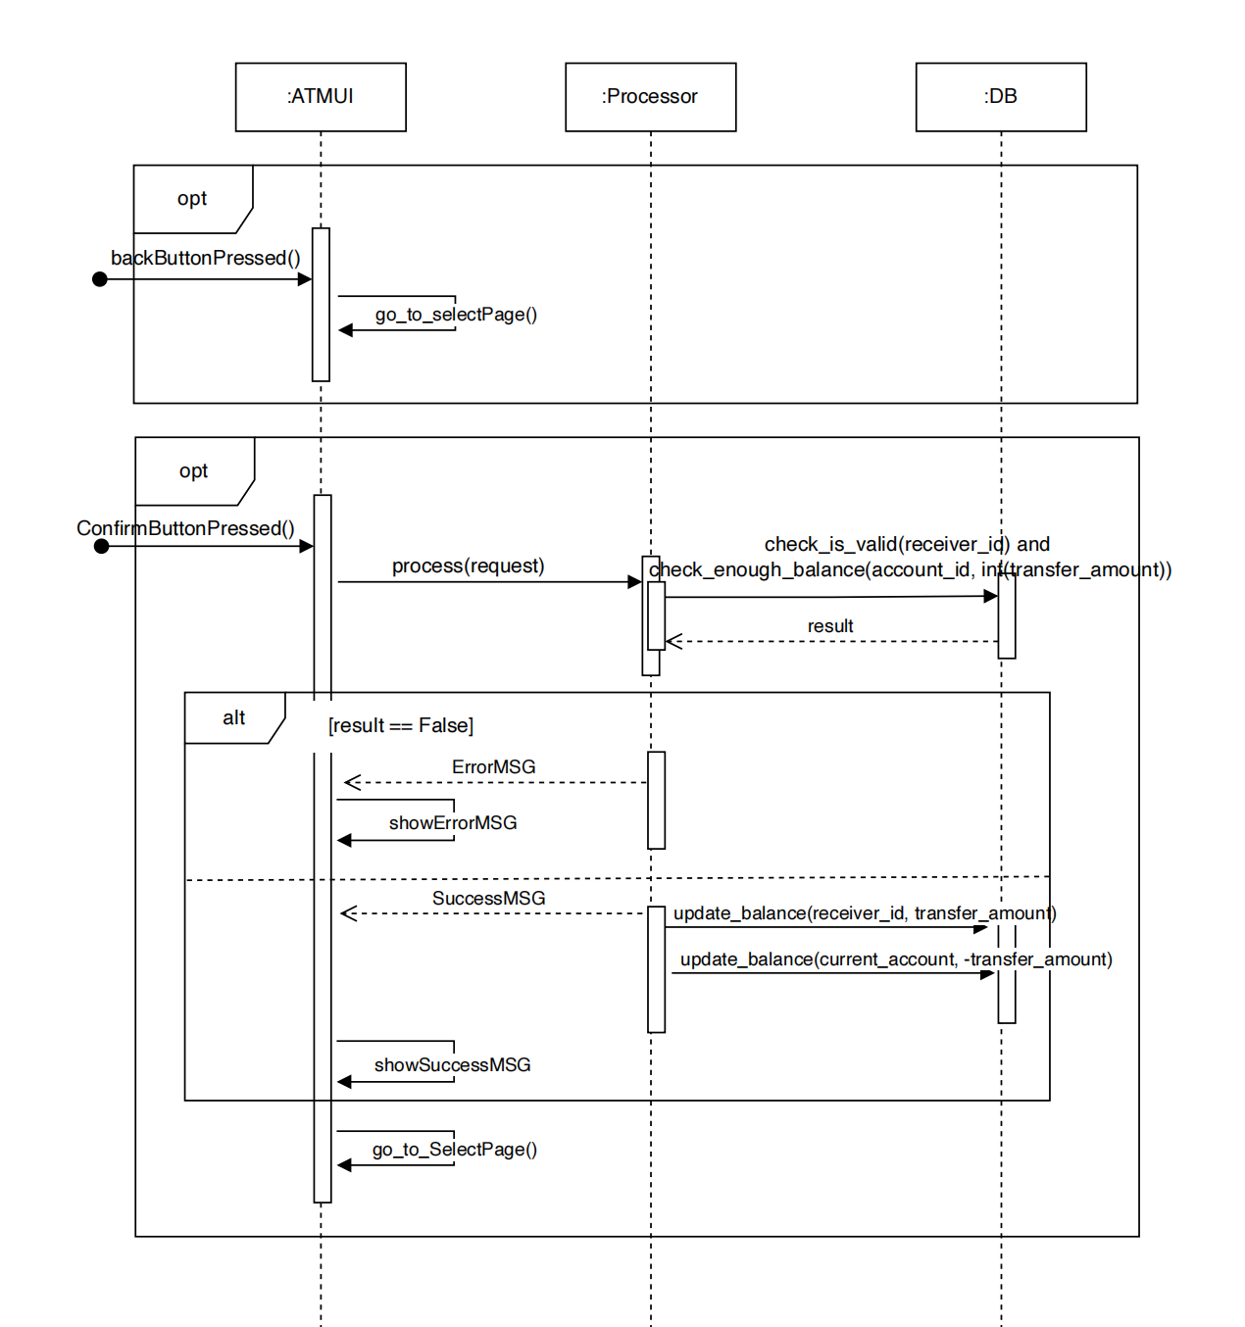

* S1.3.1 Back Button Pressed

1. Go to the Select page.

* S1.3.2 Confirm Button Pressed

1. Send request to the processor
2. The ATM UI reset the input line
3. Check request
   1. If the receiver ID is valid and there is sufficient balance in current account, continue the procedure.
   2. Otherwise, request failed the UI shows the Error Information and break
4. The DB handle the transfer request
   1. The balance in the receiver account increases the same amount as the transfer amount
   2. The balance in the current account decreases the same amount as the transfer amount
5. Go back to the Select Page

#### S1.4: ChangePin Page

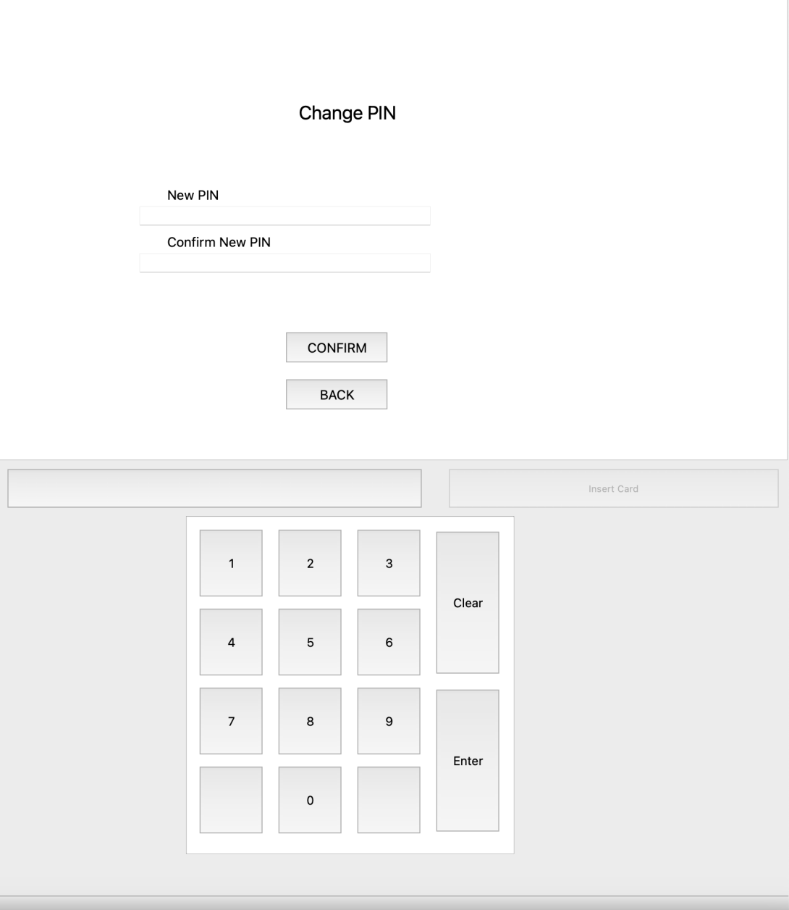

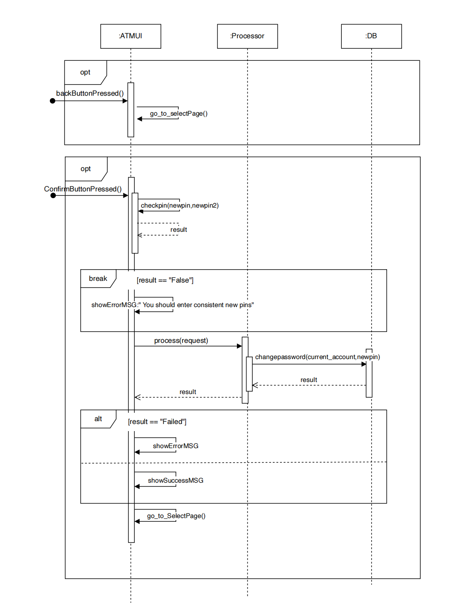

* S1.4.1 Back Button Pressed

1. Go to the Select page.

* S1.4.2 Confirm Button Pressed

1. Check if the two new pins are consistent with each other and valid
   1. If No, break
   2. Otherwise, continue the procedure.
2. Send request to the processor
3. The ATM UI reset the input line
4. The processor handle the changepin request
   1. The DB update the newpassword to the current account
5. Go back to the Select Page

#### S1.5: Query Page

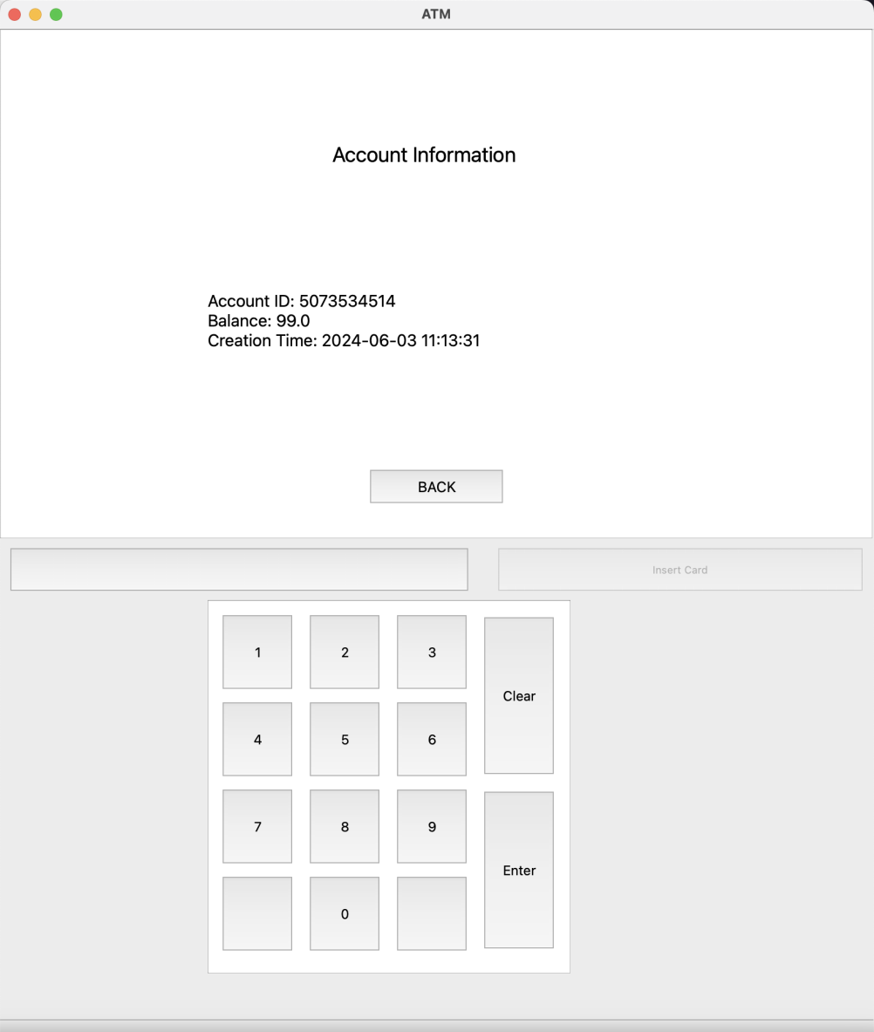

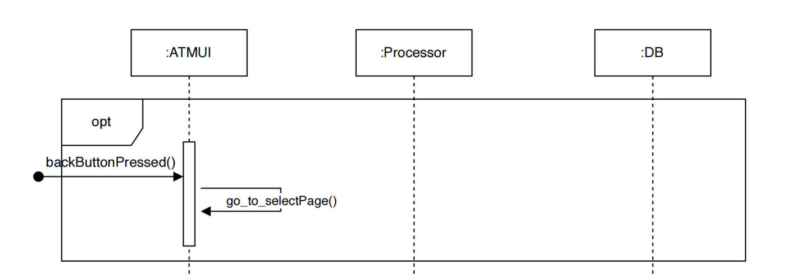

* S1.5.1 Back Button Pressed

1. Go to the Select page.

#### S1.6: Deposit Cash Page

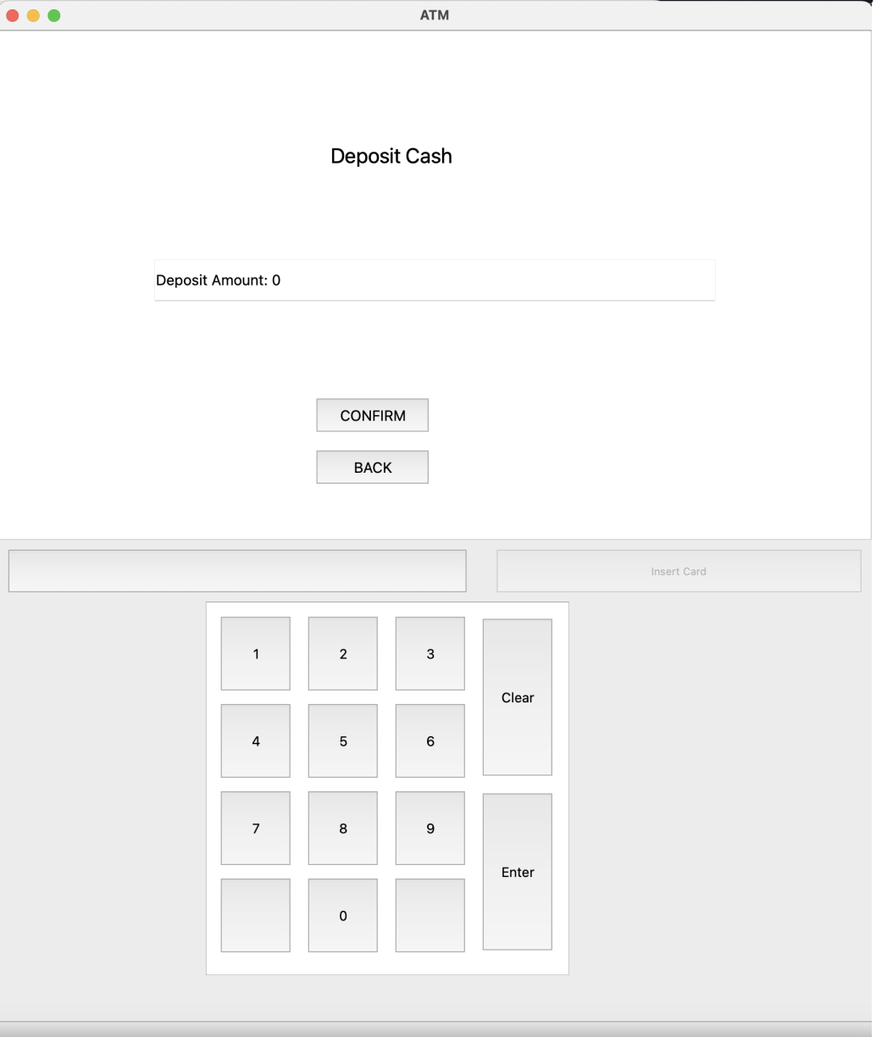

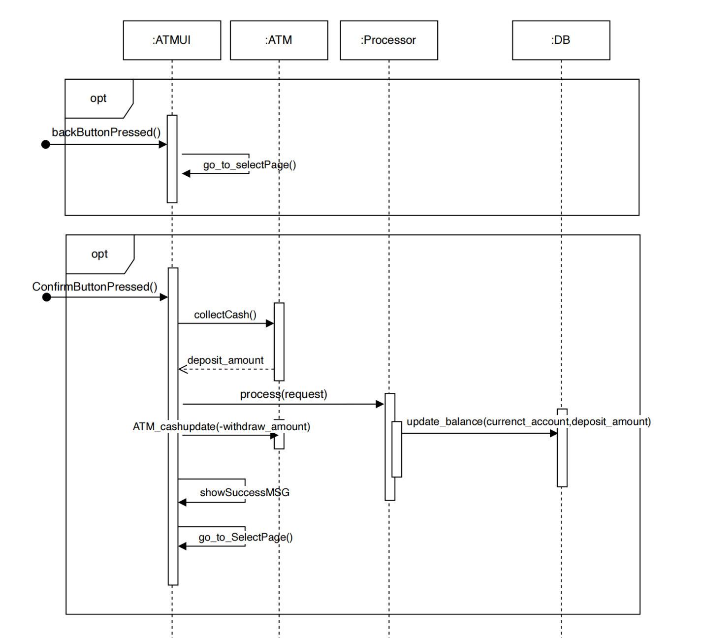

* S1.6.1 Back Button Pressed

1. Go to the Select page.

* S1.6.2 Confirm Button Pressed

1. Collect Cash from the ATM and get the deposit amount
2. Send request to the processor
3. The processor handle the deposit cash request
   1. The balance in the current account increases the same amount as the deposit amount
4. The cash in the ATM increases the same amount as the deposit amount (and the deposit amount in the casher box is set to 0)
5. Go back to the Select Page

#### S1.7: Withdraw Cash Page

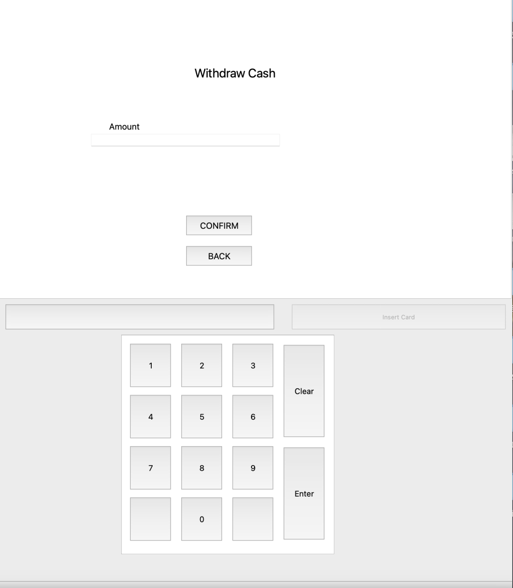

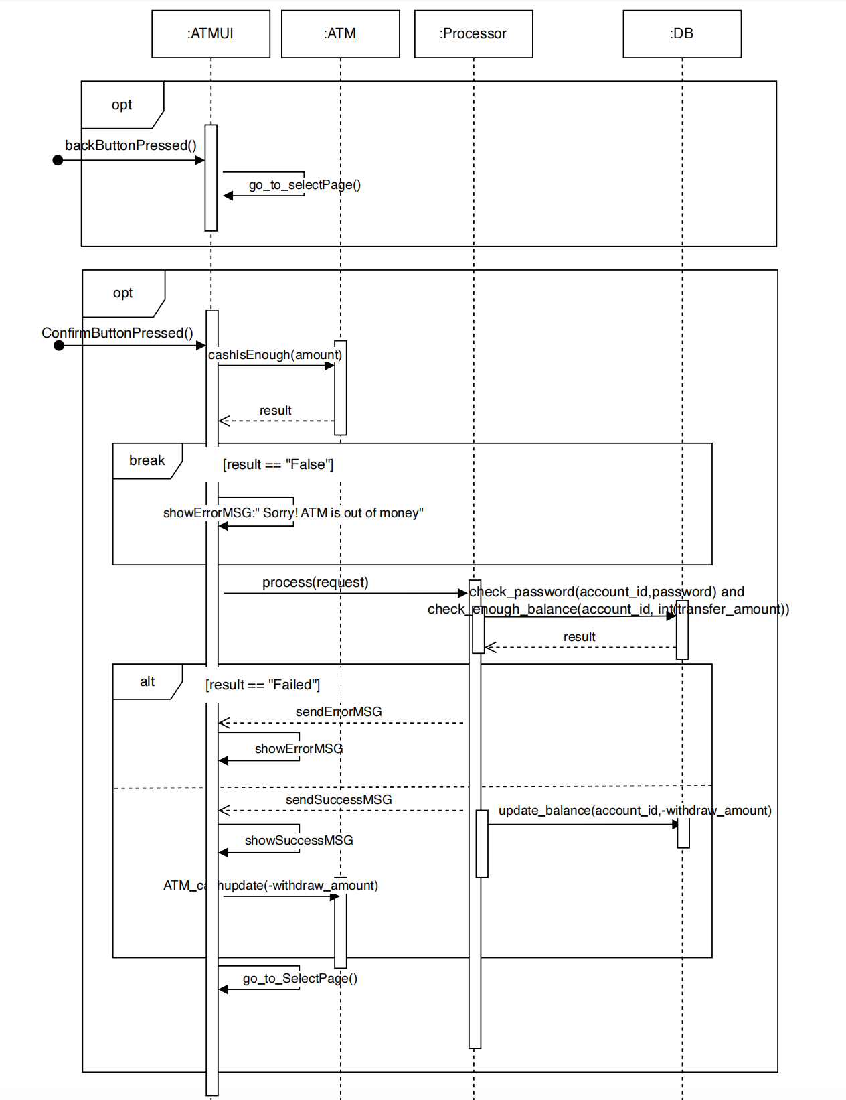

* S1.7.1 Back Button Pressed

1. Go to the Select page.

* S1.7.2 Confirm Button Pressed

1. Check the amount
   1. If the User does not enter amount or the amount is zero, a warning appears on the ATM UI: "You should enter the correct amount" and break
   2. Otherwise, continue the procedure.
2. Check whether the ATM has enough money
   1. If the ATM does not have enough money, a warning appears on the ATM UI: "Sorry! ATM is out of money", break
   2. Otherwise, continue the procedure.
3. After the User enter the password, send request to the processor
   1. If the password is incorrect, an error message is sent and displayed on the ATMUI, break
   2. Otherwise, the balance in the current account decreases the same amount as the withdraw amount and continue the procedure
4. The cash in the ATM decreases the same amount as the deposit amount
5. Go back to the Select Page

### S2: APPUI Implementation

#### S2.1: Log In Page

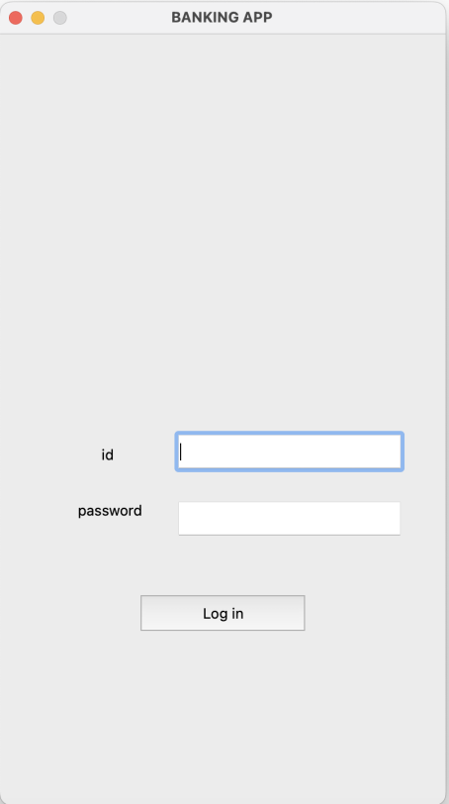

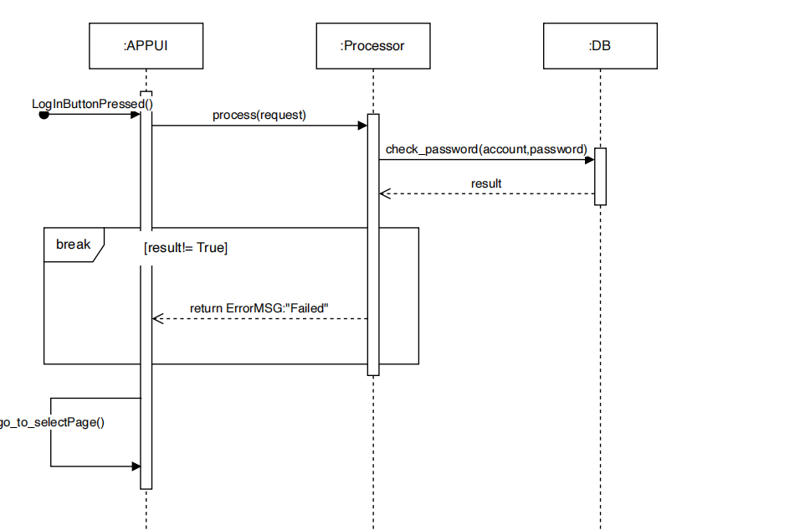

* S2.1.1: Log In Button Pressed

1. Verify
   1. If it is invalid account or the password is not matched, an ErrorMSG will be send from the processor and a warning will appear on the APPUI
   2. Otherwise, continue the procedure.
2. Go to the select Page

#### S2.2: Select Page

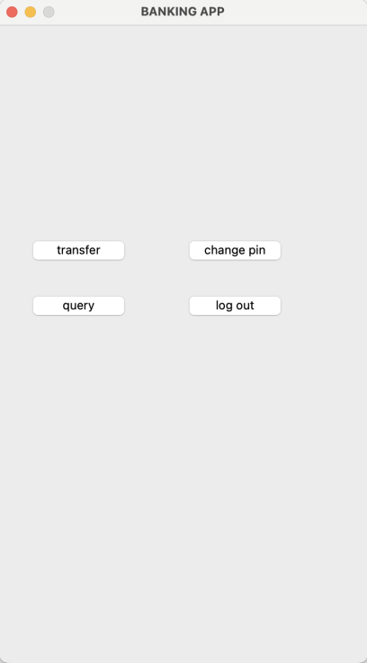

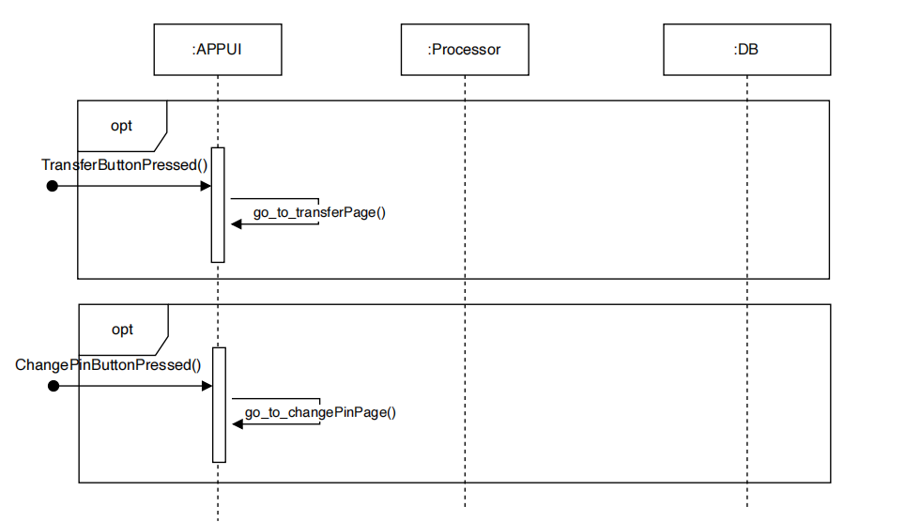

* S2.2.1: Transfer Button pressed

1. Go to the Transfer Page

* S2.2.2: ChangePin Button pressed

1. Go to the ChangePin Page

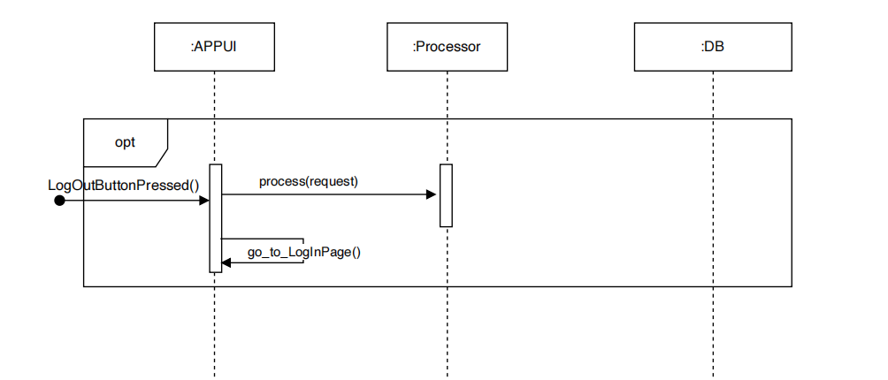

* S2.2.3: Log Out Button pressed

1. Send Log out message and app_id to the processor
2. Go to the Log In Page

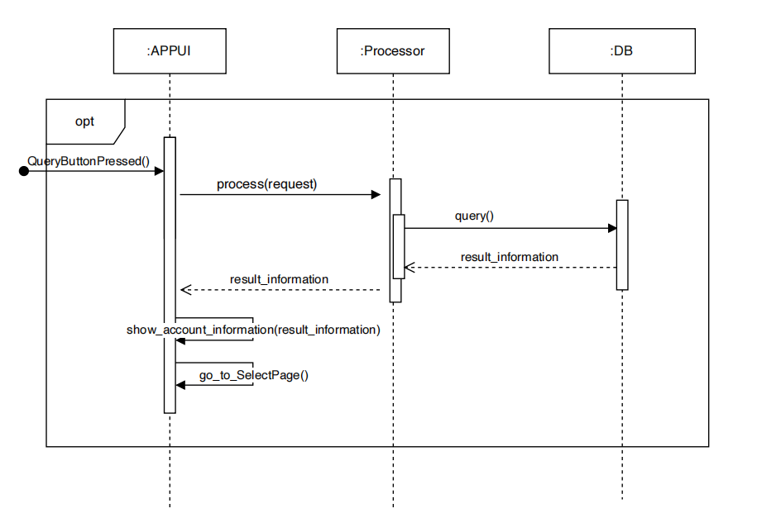

* S2.2.4: Quert Button pressed

1. Send request to the processor
2. The processor handle the query request
   1. The DB return the account information
3. Write the account information to the Query Page
4. Go to the Query Page

#### S2.3: Transfer Page

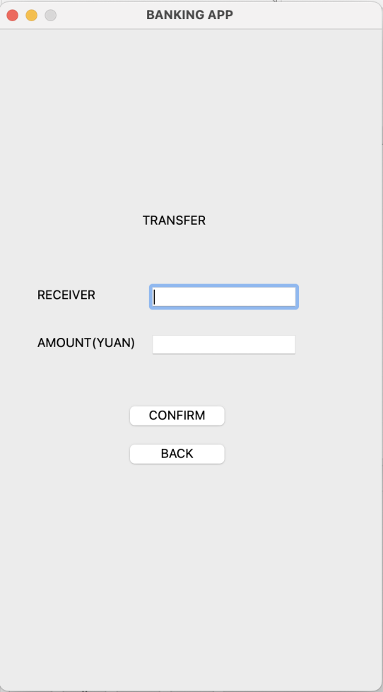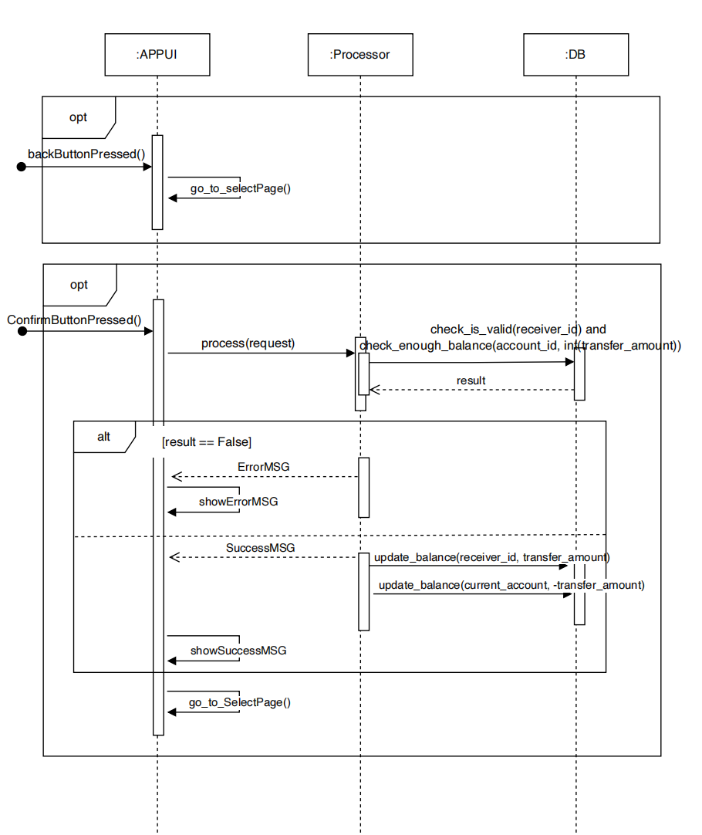

* S2.3.1 Back Button Pressed

1. Go to the Select page.

* S2.3.2 Confirm Button Pressed

1. Send request to the processor
2. The APP UI reset the input line
3. Check request
   1. If the receiver ID is valid and there is sufficient balance in current account, continue the procedure.
   2. Otherwise, request failed the UI shows the Error Information and break
4. The DB handle the transfer request
   1. The balance in the receiver account increases the same amount as the transfer amount
   2. The balance in the current account decreases the same amount as the transfer amount
5. Go back to the Select Page

#### S2.4: ChangePin Page

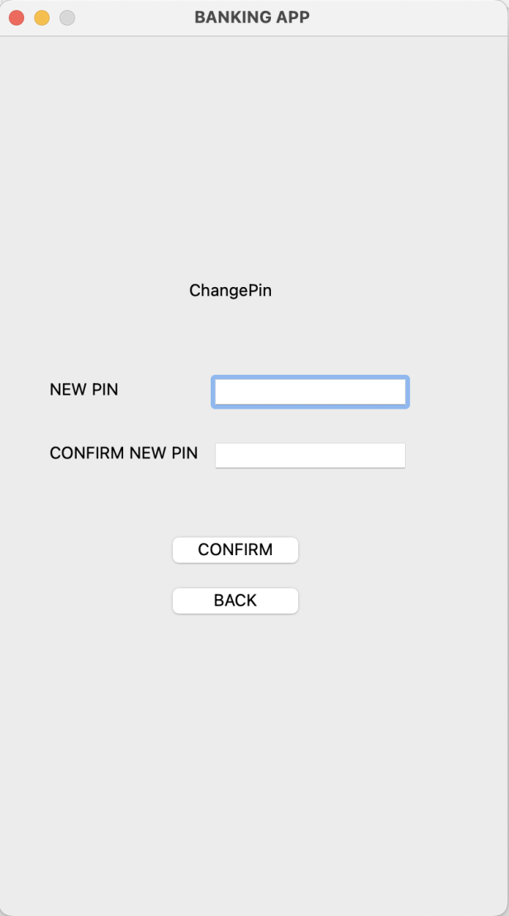

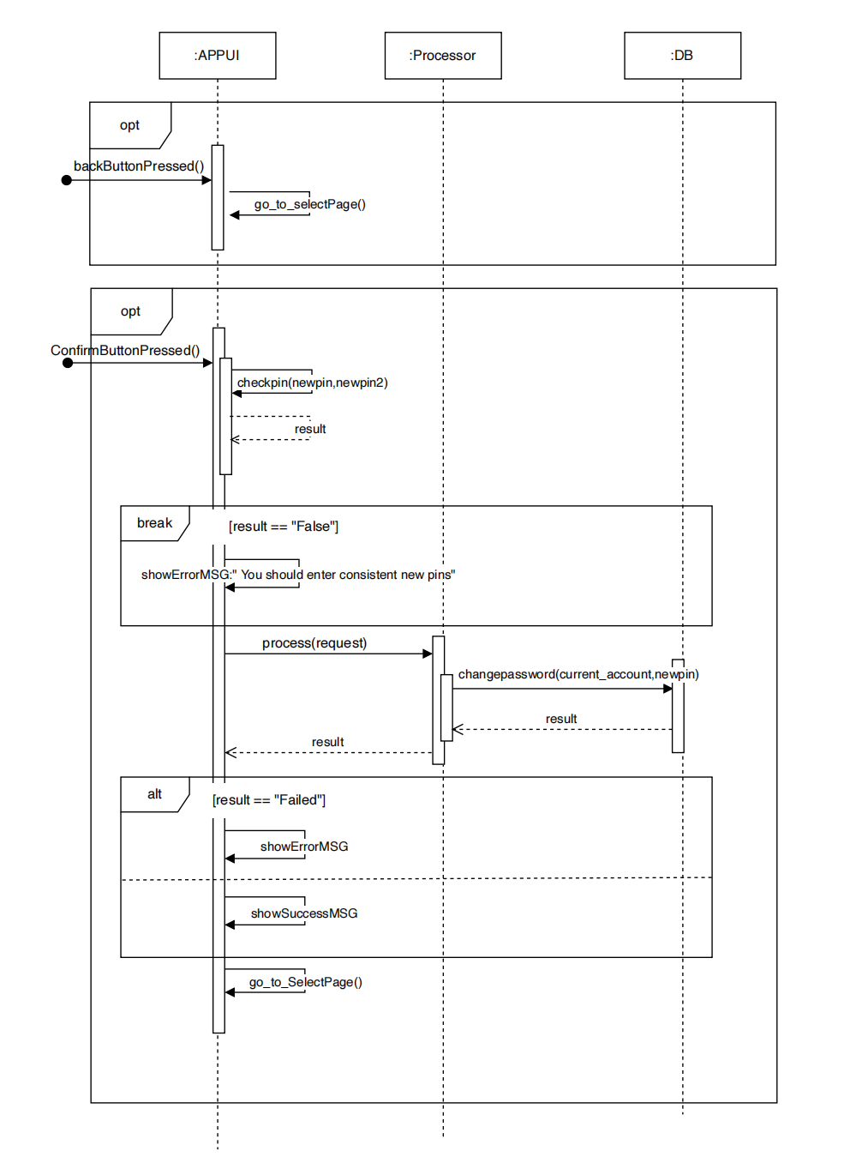

* S2.4.1 Back Button Pressed

1. Go to the Select page.

* S2.4.2 Confirm Button Pressed

1. The APPM UI reset the input line
2. Check if the two new pins are consistent with each other and valid
   1. If No, break
   2. Otherwise, continue the procedure.
3. Send request to the processor
4. The processor handle the changepin request
   1. The DB update the newpassword to the current account
5. Go back to the Select Page

#### S2.5: Query Page

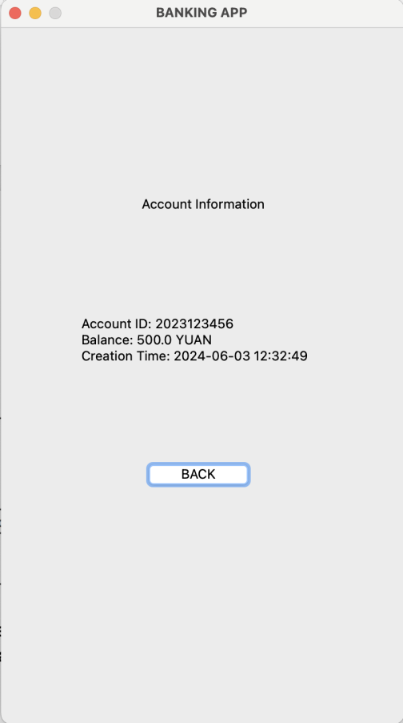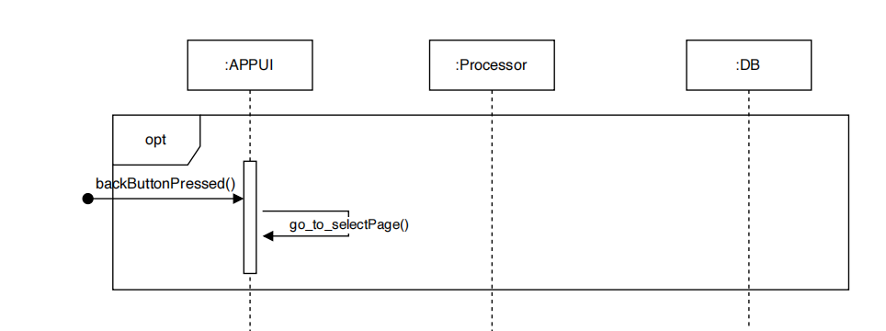

* S2.5.1 Back Button Pressed

1. Go to the Select page.