Group 7

Author: Jintong Luo,Xinyue Hu,Wenlin Zhu

Traceability Report

Banking System

Table of Contents

System Architecture 2

Software Traceability 2

## System Architecture

The system architecture is shown below:

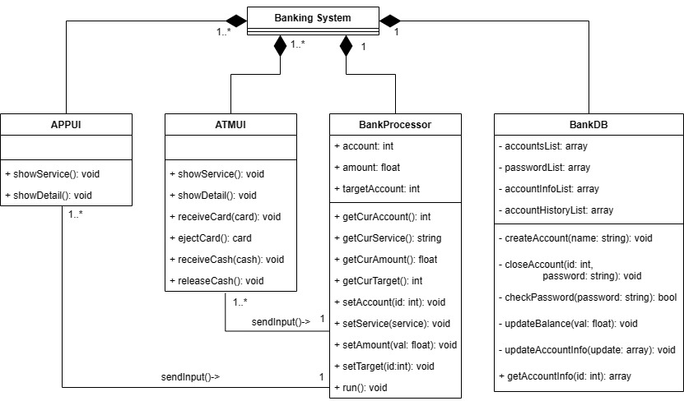

## Software Traceability

|  |  |  |
| --- | --- | --- |
|  | Is implemented by | Is validated by |
| R1 (APP UI) | S2 | T1.3 |
| R1.1 | S2.1 | T1.3 |
| R1.1.1 | S2.1.1 | T1.3.1 |
| R1.2 | S2.2 | T1.3 |
| R1.2.1 | S2.2.1 | T1.3.2 |
| R1.2.2 | S2.2.4 | T1.3.3 |
| R1.2.3 | S2.2.2 | T1.3.4 |
| R1.2.4 | S2.2.3 | T1.3.5 |
| R1.3 | S2.3 | T3.2.2 |
| R1.3.1 | S2.3.2 | T1.3.2 |
| R1.3.2 | S2.3.2 | T1.3.2 |
| R1.3.3 | S2.3.2 | T1.3.2 |
| R1.3.4 | S2.3.2 | T1.3.2 |
| R1.3.5 | S2.3.2 | T1.3.2 |
| R1.3.6 | S2.3.2 | T1.3.2 |
| R1.3.7 | S2.3.1 | T1.3.2 |
| R1.4 | S2.4 | T3.2.1 |
| R1.4.1 | S2.4.2 | T1.3.4 |
| R1.4.2 | S2.4.2 | T1.3.4 |
| R1.4.3 | S2.4.1 | T1.3.4 |
| R1.5 | S2.5 | T3.2.3 |
| R1.5.1 | S2.5 | T1.3.3 |
| R1.5.2 | S2.5 | T1.3.3 |
| R1.5.3 | S2.5 | T1.3.3 |
| R1.5.4 | S2.5 | T1.3.3 |
| R1.5.5 | S2.5.1 | T1.3.3 |
| R2 (ATM UI) | S1 | T1.4 |
| R2.1 | S1.1 | T1.4 |
| R2.1.1 | S1.1.1, S1.1.2 | T1.4.2 —T1.4.3, T1.4.11—T1.4.12 |
| R2.2 | S1.2 | T1.4 |
| R2.2.1 | S1.2.3 | T1.4.8 |
| R2.2.2 | S1.2.4 | T1.4.9—T1.4.10 |
| R2.2.3 | S1.2.1 | T1.4.7 |
| R2.2.4 | S1.2.5 | T1.4.6 |
| R2.2.5 | S1.2.2 | T1.4.5 |
| R2.2.6 | S1.2.7 | T1.4.11 |
| R2.3 | S1.6 | T3.1.1 |
| R2.3.1 | S1.6.2 | T1.4.8 |
| R2.3.2 | S1.6.2 | T1.4.8 |
| R2.3.3 | S1.6.2 | T1.4.8 |
| R2.3.4 | S1.6.2 | T1.4.8 |
| R2.3.5 | S1.6.1 | T1.4.8 |
| R2.4 | S1.7 | T3.1.2 |
| R2.4.1 | S1.7.2 | T1.4.9 |
| R2.4.2 | S1.7.2 | T1.4.9 |
| R2.4.3 | S1.7.2 | T1.4.9 |
| R2.4.4 | S1.7.2 | T1.4.9 |
| R2.4.5 | S1.7.1 | T1.4.9 |
| R2.5 | S1.3 | T3.1.3 |
| R2.5.1 | S1.3.2 | T1.4.7 |
| R2.5.2 | S1.3.2 | T1.4.7 |
| R2.5.3 | S1.3.2 | T1.4.7 |
| R2.5.4 | S1.3.2 | T1.4.7 |
| R2.5.5 | S1.3.2 | T1.4.7 |
| R2.5.6 | S1.3.2 | T1.4.7 |
| R2.5.7 | S1.3.1 | T1.4.7 |
| R2.6 | S1.5 | T3.1.4 |
| R2.6.1 | S1.5 | T1.4.6 |
| R2.6.2 | S1.5 | T1.4.6 |
| R2.6.3 | S1.5 | T1.4.6 |
| R2.6.4 | S1.5 | T1.4.6 |
| R2.6.5 | S1.5.1 | T1.4.6 |
| R2.7 | S1.4 | T2.2.1 |
| R2.7.1 | S1.4.2 | T1.4.5 |
| R2.7.2 | S1.4.2 | T1.4.5 |
| R2.7.3 | S1.4.1 | T1.4.5 |
| R2.8 | S1.2.6 | T1.4.4 |
| R2.8.1 | S1.2.6 | T1.4.4 |
| R3 (System Processor) | S1.1.2, S1.1.1, S1.6, S1.7, S1.3, S2.3, S2.1 | T1.1 |
| R3.1 | S1.1.2 | T1.1 |
| R3.1.1 | S1.1.2 | T1.1.12 |
| R3.1.2 | S1.1.2 | T1.1.12 |
| R3.1.3 | S1.1.2 | T1.1.1 |
| R3.1.4 | S1.1.2 | T1.1.1 |
| R3.2 | S1.1.1 | T1.1.13 |
| R3.2.1 | S1.1.1 | T1.1.13 |
| R3.2.2 | S1.1.1 | T1.1.13 |
| R3.2.3 | S1.1.1 | T1.1.13 |
| R3.3 | S1.6 | T1.1.3 |
| R3.3.1 | S1.6 | T1.1.3 |
| R3.3.2 | S1.6 | T1.1.3 |
| R3.3.3 | S1.6 | T1.1.3 |
| R3.4 | S1.7 | T1.1.4 |
| R3.4.1 | S1.7 | T1.1.4 |
| R3.4.2 | S1.7 | T1.1.4 |
| R3.4.3 | S1.7 | T1.1.4 |
| R3.5 | S1.3, S2.3 | T1.1.8 |
| R3.5.1 | S1.3, S2.3 | T1.1.8 |
| R3.5.2 | S1.3, S2.3 | T1.1.8 |
| R3.5.3 | S1.3, S2.3 | T1.1.8 |
| R3.5.4 | S1.3, S2.3 | T1.1.8 |
| R3.6 | S2.1 | T2.3 |
| R4 (System Database) | S1,S2 | T1.2 |
| R4.1 | S1,S2 | T1.2 |
| R4.1.1 | S1,S2 | T1.2.3, T1.2.5 |
| R4.1.2 | S1,S2 | T1.2.4 |
| R4.1.3 | S1,S2 | T1.2.9 |
| R4.1.4 | S1,S2 | T1.2.9 |
| R4.2 | S1,S2 | T1.2 |
| R4.2.1 | S1,S2 | T1.2.5 |
| R4.2.2 | S1,S2 | T1.2.3 |
| R4.2.3 | S1,S2 | T1.2.4 |