Group 7

Author: Jintong Luo

User Manual

Banking System

Table of Contents

1. Introduction 2

2. Technical Descriptions 2

2.1. System Architecture 2

2.2. Interface Overview 3

2.3. Installation 4

3. Operating Instructions 5

3.1. APP Operation 5

3.2. ATM Operation 9

## Introduction

This manual provides general information and procedures for using the Banking System.

Users could refer to this manual to learn how to use basic functions of this Banking system. Feel free to contact us Team 7 for more information if confused!

## Technical Descriptions

This section provides an overview of the different operation pages in the Banking System. Banking System could help people manage their money and transfer with other users. People could easily use this system via APP on their phones or using ATM on the road.

2.1. System Architecture

The system architecture of this banking system is shown below:

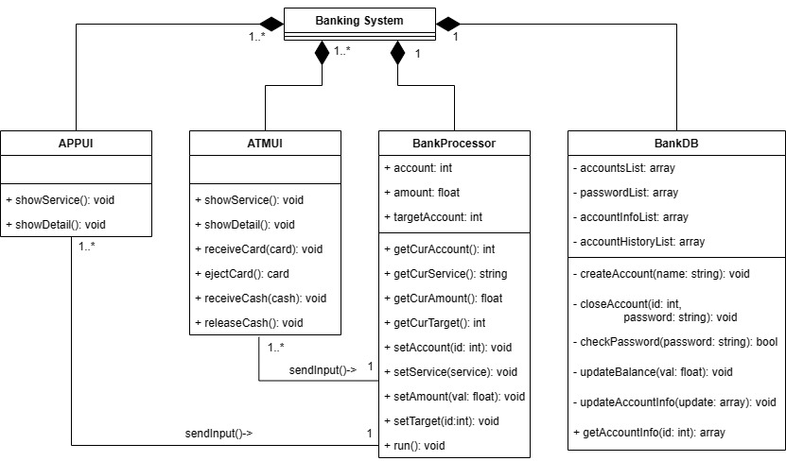

The Banking System consists of four major parts: ATM’s Interface, APP’s Interface, System Processor and System Database. The system processor and system database make up the backend, which could deal with multiple APPs and ATMs. For you sincerely users, you just need to learn how to interact with the two interfaces. This manual would introduce the usages carefully to you in following parts.

* 1. Interface Overview

*2.2.1. APP Interface*

The main interfaces of the APP and their relationships are as follows:

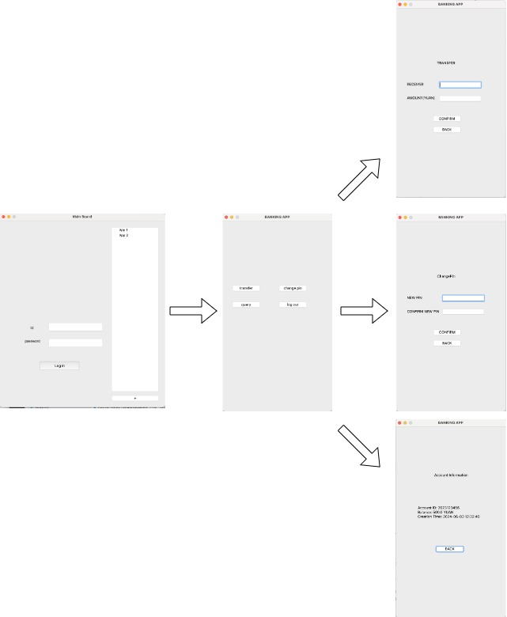

*2.2.2. ATM Interface*

The main interfaces of the ATM and their relationships are as follows:

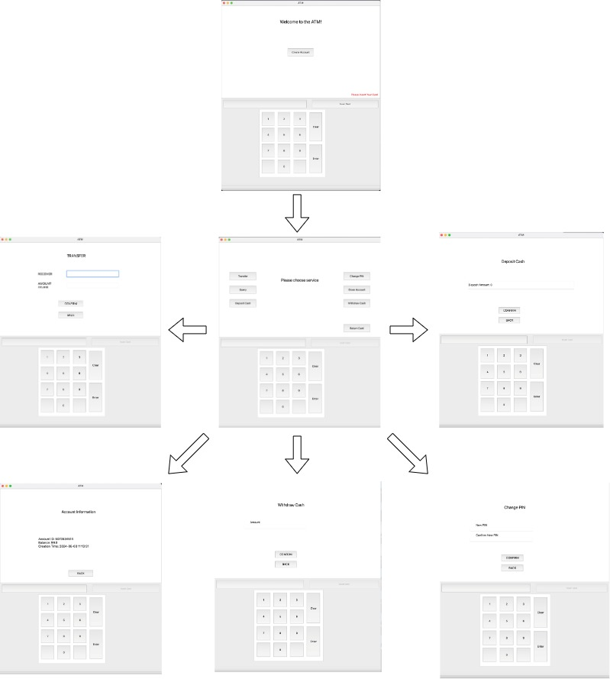

* 1. Installation

*2.3.1. Prerequisites*

* Your computer system should be macOS, e.g. Ventura 13.4 or newer. If you run the system on system like Windows or Linux, we could not guarantee that you could get the interfaces we presented.
* Install Python 3.12 or newer.
* Install PyQt5.
* For more details, please refer to the readme.txt.

*2.3.2. Run System*

* Run YourCodeExample/starter.py and you will see two Interfaces.
* Click the “+” on the mainboard and you could get more APPs.

## Operating Instructions

This section provides a detailed instruction of Banking System’s functionality and

operating procedure. You could use our Banking System easily after reading these instructions. Again, feel free to contact us Team 7 for more information if confused!

3.1. APP Operation

This section would introduce the usage of APP.

*3.1.1. Login*

When running our banking system, you could see this default interface for APP.

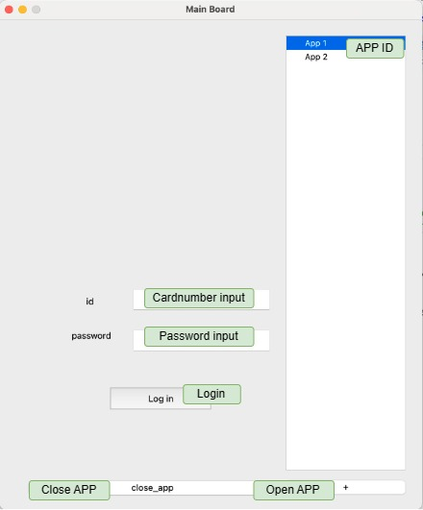

**Login Components**

* **APP ID**: Click on it to choose the APP you want from the existing APP there.
* **Open APP**: Click on it to open a new APP.
* **Close APP**: Click on it to close the APP you chosen.
* **Cardnumber Input**: Type in your card number there.
* **Password input**: Type in your password there.
* **Login**: Click on it to send login request.

**Operation Procedure for Login**

For a target APP, the procedures for Login are as follows:

1. Type in your card number.
2. Type in your password.
3. Clicking on “**Log in**” button.

If the account is valid and the password is correct, the system would change to the Main Interface.

*3.1.2. Main Interface*

This is the Main Interface for the APP. On this page, you could choose the service you want.

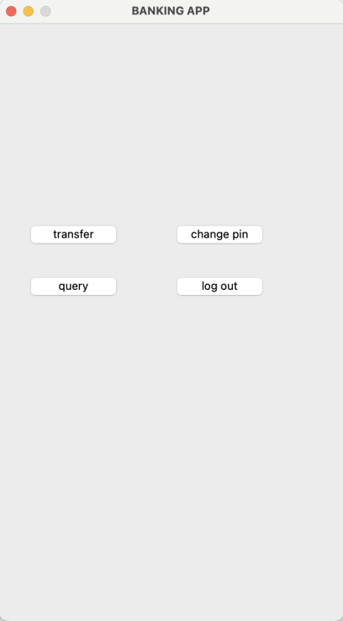

**Main Interface Components**

* **transfer**: Click on it to make transfer.
* **change PIN**: Click on it to change a new PIN.
* **query**: Click on it to check your account profile.
* **log out**: Click on it to logout.

*3.1.3. Transfer*

On this page, you could transfer to other users.

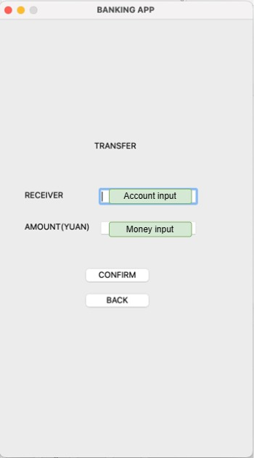

**Transfer Components**

* **Account input**: Type in the target account number there.
* **Money input**: Type in the amount of money you want to transfer.
* **CONFIRM**: Click on it to send transfer request.
* **BACK**: Click on it to cancel transfer request and return to the Main Interface.

**Operation Procedure for Transfer**

1. Type in the target account number.
2. Type in the amount of money you want to transfer.
3. Click on the “**CONFIRM**” button to send request, or click on the “**BACK**” to cancel the request and return to the Main Interface.

If the transfer is accepted, you would receive a message to inform you. Otherwise the system would warn you and give the reason for failure, then you could reconsider the account and amount and request again.

*3.1.4. Change PIN*

On this page, you could change your PIN.

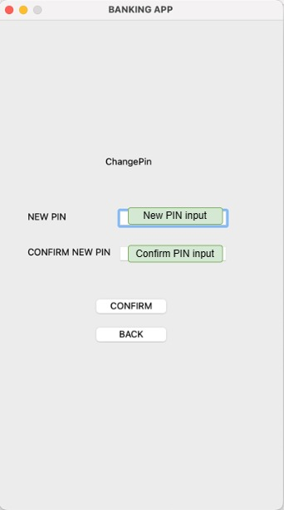

**Change PIN Components**

* **New PIN input**: Type in the new PIN there.
* **Confirm PIN input**: Type in the new PIN again to confirm.
* **CONFIRM**: Click on it to confirm the changes.
* **BACK**: Click on it to cancel and return to the Main Interface.

**Operation Procedure for Change PIN**

1. Type in the new PIN.
2. Type in the new PIN again to confirm.
3. Click on the “**CONFIRM**” button to confirm the changes, or click on the “**BACK**” to cancel and return to the Main Interface.

If the new PIN is valid, you would receive a message to inform you. Otherwise the system would warn you, then you could reconsider the new PIN and change them again.

*3.1.5. Query*

On this page, you could check your account profile.

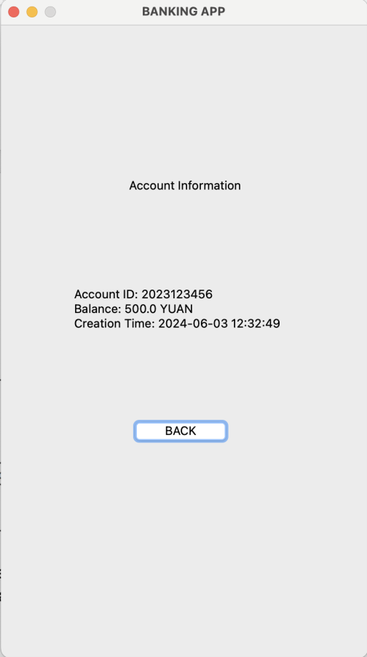

**Query Components**

* **BACK**: Click on it to return to the Main Interface.

**Operation Procedure for Query**

Click on the “**BACK**” button to return to the Main Interface, if you have checked your profile and would like to leave.

3.2. ATM Operation

This section would introduce the usage of ATM.

*3.2.1. Login*

When ATM start, you could see this interface.

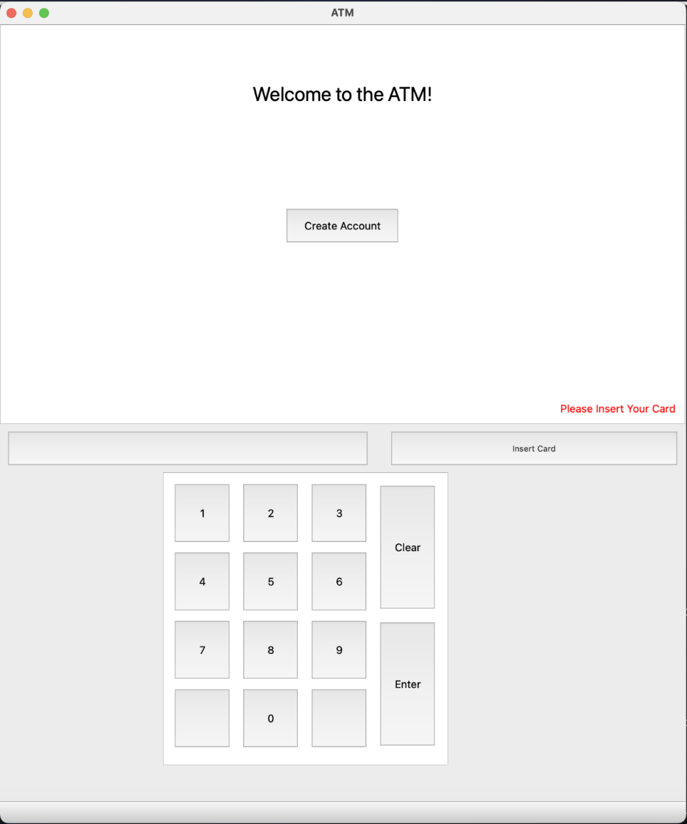

**Default Components**

* **Insert Card**: Clicking on this button would open a new window that ask you to input card number to simulate inserting a physical card. After entering the card number, there would be a page asking you to enter your PIN in order to ensure security.
* **Create Account**: Clicking on this button would open a new window that ask you to set the PIN for the new account and tell you the card number of the new account then.

**Operation Procedure for Default Login**

Click on the “**Insert Card**” button to login and pass the identification check, or click on the “**Create Account**” button to create a new account. Then it will change to Main Interface.

*3.2.2. Main Interface*

This is the Main Interface for the ATM. On this page, you could choose the service you want.

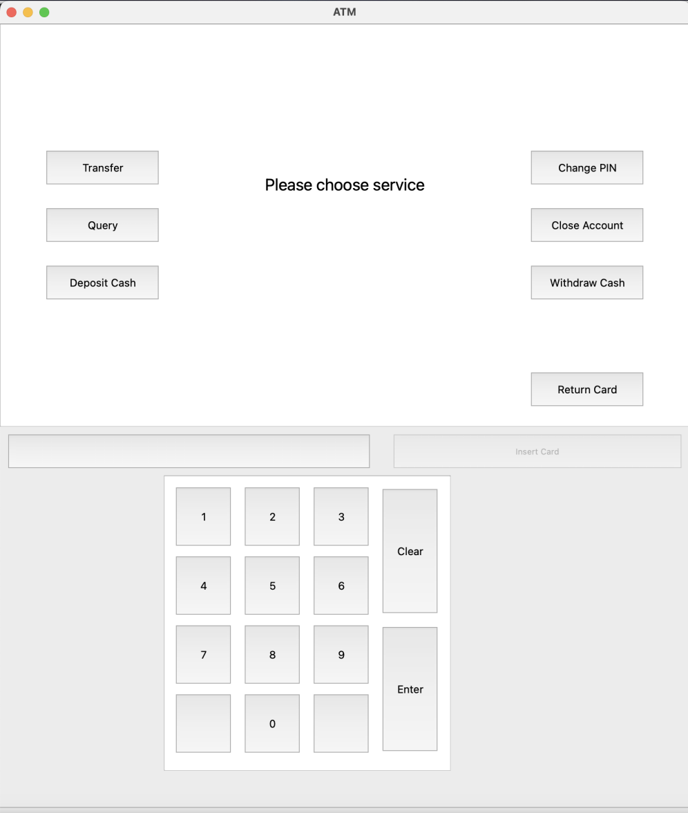

**Main Interface Components**

* **Transfer**: Click on it to make transfer.
* **Change PIN**: Click on it to change a new PIN.
* **Query**: Click on it to check your account profile.
* **Withdraw cash**: Click on it to withdraw cash from the balance.
* **Deposit cash**: Click on it to deposit cash into the balance.
* **Close Account**: Click on it to close current account.
* **Return Card**: Click on it to finish using the system and get your card back.

*3.2.3. Transfer*

On this page, you could transfer to other users.

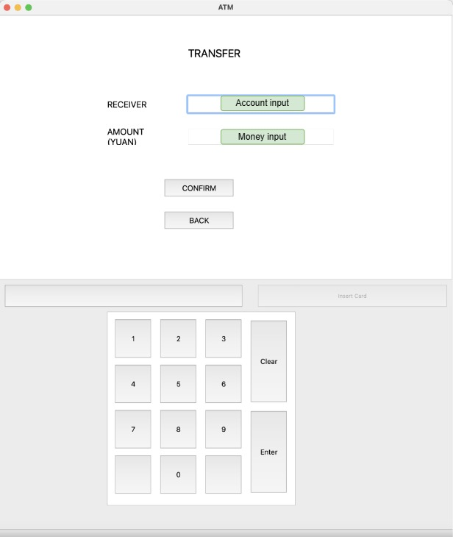

**Transfer Components**

* **Account input**: Insert the target account number there.
* **Money input**: Insert the amount of money you want to transfer.
* **CONFIRM**: Click on it to send transfer request.
* **Number Pad**: Use number pad to make input.
* **BACK**: Click on it to cancel transfer request and return to the Main Interface.

**Operation Procedure for Transfer**

1. Type in the target account number.
2. Type in the amount of money you want to transfer.
3. Click on the “**CONFIRM**” button to send request, or click on the “**BACK**” to cancel the request and return to the Main Interface.

If the transfer is accepted, you would receive a message to inform you. Otherwise the system would warn you and give the reason for failure, then you could reconsider the account and amount and request again.

*3.2.4. Query*

On this page, you could check your account profile.

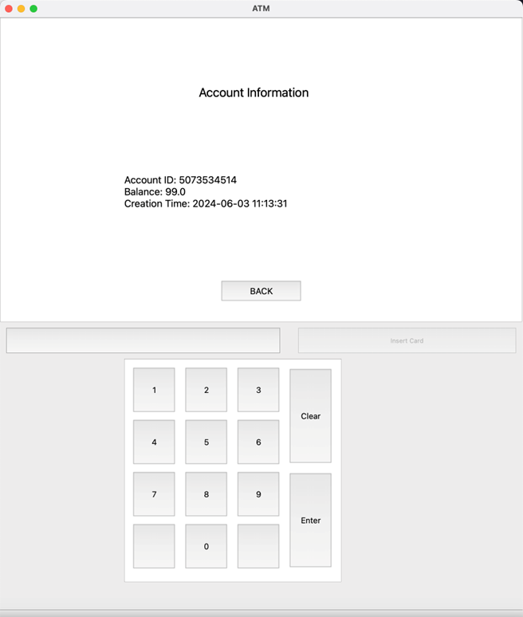

**Query Components**

* **BACK**: Click on it to return to the Main Interface.

**Operation Procedure for Query**

Click on the “**BACK**” button to return to the Main Interface, if you have checked your profile and would like to leave.

*3.2.5. Change PIN*

On this page, you could change your PIN.

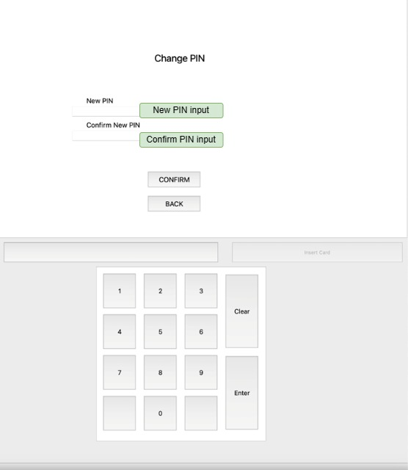

**Change PIN Components**

* **New PIN input**: Type in the new PIN there.
* **Confirm PIN input**: Type in the new PIN again to confirm.
* **CONFIRM**: Click on it to confirm the changes.
* **Number Pad**: Use number pad to make input.
* **BACK**: Click on it to cancel and return to the Main Interface.

**Operation Procedure for Change PIN**

1. Type in the new PIN.
2. Type in the new PIN again to confirm.
3. Click on the “**CONFIRM**” button to confirm the changes, or click on the “**BACK**” to cancel and return to the Main Interface.

If the new PIN is valid, you would receive a message to inform you. Otherwise the system would warn you, then you could reconsider your new PIN and change them.

*3.2.6. Deposit*

On this page, you could make deposits into your account’s balance.

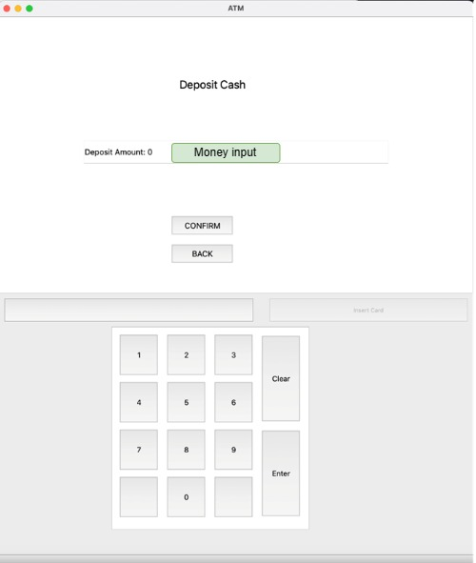

**Deposit Components**

* **Money input**: Insert the amount of cash you would like to deposit.
* **CONFIRM**: Click on it to confirm the transaction.
* **Number Pad**: Use number pad to make input.
* **BACK**: Click on it to cancel and return to the Main Interface.

**Operation Procedure for Deposit**

1. Type in expected deposit amount.
2. Click on the “**CONFIRM**” button to confirm the transaction, or click on the “**BACK**” to cancel and return to the Main Interface.

If the actual cashed ATM received aligns with the expected deposit amount, you would receive a message to inform you. Otherwise the system would warn you, then you could reconsider your deposit amount and change them.

*3.2.7. Withdraw*

On this page, you could withdraw cash from your account’s balance.

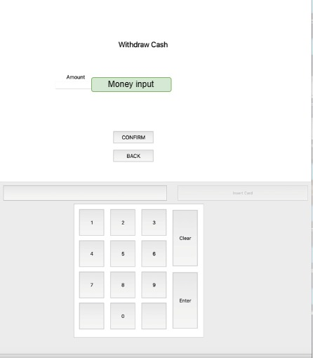

**Withdraw Components**

* **Money input**: Insert the amount of cash you would like to withdraw.
* **CONFIRM**: Click on it to confirm the transaction.
* **Number Pad**: Use number pad to make input.
* **BACK**: Click on it to cancel and return to the Main Interface.

**Operation Procedure for Withdraw**

1. Type in expected withdraw amount.
2. Click on the “**CONFIRM**” button to confirm the transaction, or click on the “**BACK**” to cancel and return to the Main Interface.

If the your expected withdraw amount is less than your account balance, you would receive the cash. Otherwise the system would warn you, then you could reconsider your withdraw amount and change them.