Group 7

Author: Wenlin Zhu, Jintong Luo, Xinyue Hu

Traceability Report

Painkiller Injection System

Table of Contents

System Architecture 2

Software Traceability 2

## System Architecture

The system architecture is shown below:

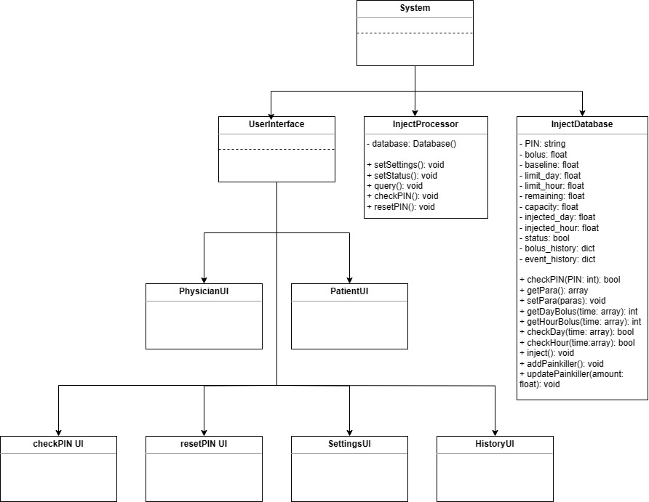

## Software Traceability

|  |  |  |
| --- | --- | --- |
|  | Is implemented by | Is validated by |
| R1 | S1, S3, S4 | T3.3, T3.1, T3.2, T1.3.6 |
| R1.1 | S1, S3, S4 | T3.3 |
| R1.1.1 | S1.2, S3 | T3.3 |
| R1.1.2 | S1.5, S4 | T3.3 |
| R1.1.3 | S1.5, S4 | T3.3 |
| R1.1.4 | S1.5, S4 | T3.3 |
| R1.1.5 | S1.5, S4 | T3.3 |
| R1.1.6 | S1.6 | T3.3 |
| R1.1.7 | S1.4 | T3.3 |
| R1.2 | S1.1 | T3.1 |
| R1.2.1 | S1.1.1, S1.1.2 | T3.1 |
| R1.2.2 | S1.1.1, S1.1.2 | T3.1 |
| R1.2.3 | S1.1.1, S1.1.2 | T3.1 |
| R1.2.4 | S1.1.1, S1.1.2 | T3.1 |
| R1.2.5 | S1.1.3 | T3.1 |
| R1.3 | S1 | T3.2 |
| R1.3.1 | S1.1.4 | T3.2 |
| R1.3.2 | S1.1.1, S1.1.2 | T3.2 |
| R1.3.3 | S1.1.1, S1.1.2 | T3.2 |
| R1.3.4 | S1.1.1, S1.1.2 | T3.2 |
| R1.3.5 | S1.1.1, S1.1.2 | T3.2 |
| R1.3.6 | S1.3 | T3.2 |
| R1.4 | S1.1.4 | T1.3.6 |
| R2 | S5 | T3.4 |
| R2.1 | S5 | T3.4 |
| R3 | S1, S2, S5 | T1.1.4, T1.1.1, T1.3.6, T1.1.2, T1.1.3 |
| R3.1 | S2 | T1.1.4 |
| R3.2 | S1.6 | T1.1.1, T1.3.6 |
| R3.3 | S5 | T1.1.2, T1.1.3 |
| R4 | S1, S3, S4 | T1.2.1,T1.2.5,T1.2.3,T1.2.7,T1.2.9, T1.2.22,T1.2.10,T1.2.13, T1.2.23, T1.2.24 |
| R4.1 | S3, S4 | T1.2.1,T1.2.5,T1.2.3,T1.2.7,T1.2.9 |
| R4.1.1 | S3 | T1.2.1 |
| R4.1.2 | S4 | T1.2.5 |
| R4.1.3 | S4 | T1.2.3 |
| R4.1.4 | S4 | T1.2.7 |
| R4.1.5 | S4 | T1.2.9 |
| R4.2 | S1.1.2 | T1.2.22,T1.2.10,T1.2.14 |
| R4.2.1 | S1.1.2 | T1.2.22 |
| R4.2.2 | S1.1.2 | T1.2.10 |
| R4.2.3 | S1.1.2 | T1.2.13 |
| R4.3 | S1.1.2 | T1.2.23,T1.2.23 |
| R4.3.1 | S1.1.2 | T1.2.23 |
| R4.3.1 | S1.1.2 | T1.2.24 |