Group 7

Author: Wenlin Zhu

User Manual

Painkiller Injection System

Table of Contents

System Architecture 2

Physician Manual 2

Injection Processor Board 2

Check PIN UI 2

Reset PIN UI 2

History Board 2

Setting Board 2

Patient Manual 3

Injection UI 2

## System Architecture

The system architecture is shown below:

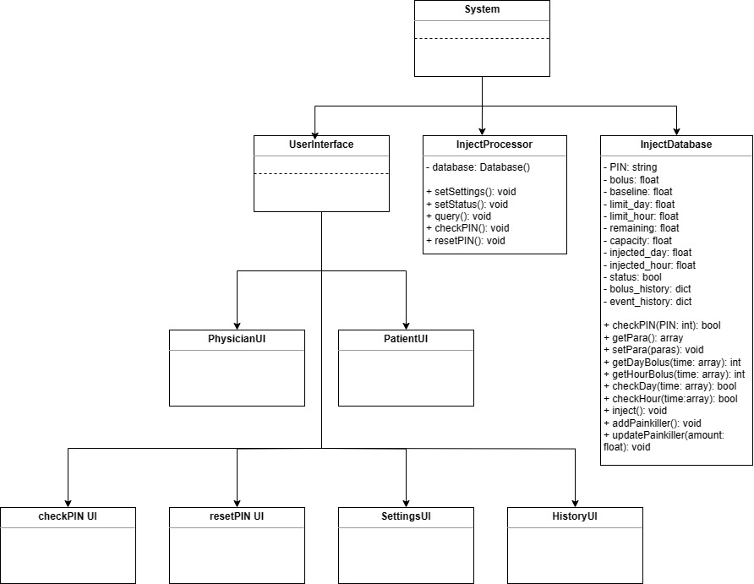

## Physician Manual

#### Injection Processor Board

The physician using painkiller system has a Injection Processor Board which is shown below (Figure 1):

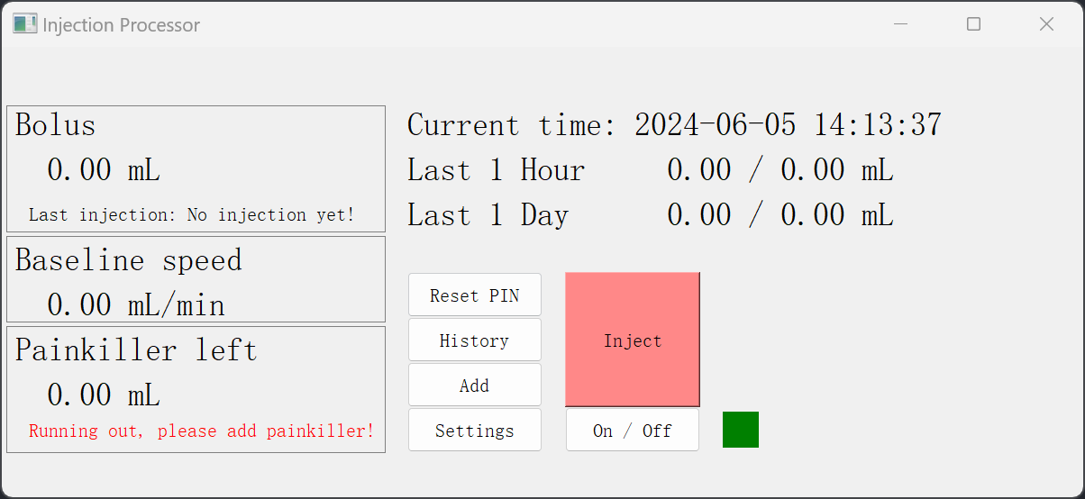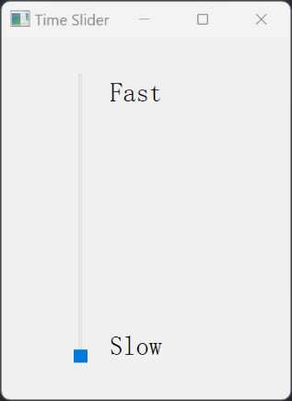

Figure 1

#### Injection Processor Components

1 “Bolus”. It shows how much bolus can be injected per shot.

2 “Last injection”. It shows the time of the last bolus injection.

3 “Baseline speed”. It shows how much baseline can be injected per second.

4 “Painkiller left”: It shows how mush painkiller left. A warning will be shown when painkiller is running out.

5 “Current time”: It shows the current time.

6 “Last 1 Hour”: On the left side of “/”, it is how much painkiller has been injected in the last one hour. On the right side of “/”, it is the maximum amount of painkiller that can be injected in one hour.

7 “Last 1 Day”: On the left side of “/”, it is how much painkiller has been injected in the last one day. On the right side of “/”, it is the maximum amount of painkiller that can be injected in one day.

8 “Reset PIN”: Clicking on this button will open Check PIN UI. After entering correct PIN, Check PIN UI will be closed and open Reset PIN UI. The default PIN is 000000.

9 “History”: Clicking on this button will open History Board.

10 “Add”: Clicking on this button will add the painkiller to 10ml.

11 “Settings”: Clicking on this button will open Check PIN UI. After entering correct PIN, Check PIN UI will be closed and open Setting Board.

12 “On/Off”: Clicking on this button will open Check PIN UI. After entering correct PIN, Check PIN UI will be closed and switch to another status. Green means the baseline status is “on”, and Red means the baseline status is “off”.

13 “Time Slider”: Moving this slider will change the speed of time, which is used in simulation.

#### Check PIN UI

After clicking “Reset”, ”Settings” or “On/Off” button on the Injection Processor Board, this Check PIN UI will be shown (Figure 2).

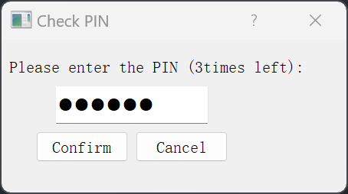

Figure 2

#### Check PIN Components

1 “PIN Input Box”: PIN should be entered in here.

2 “Cancel”: Clicking on this button will close Check PIN UI.

3 “Confirm”: Clicking on this button will check whether the PIN is correct. If correct, Check PIN UI will be closed and open the next UI. If wrong, a “Wrong PIN” message will be shown (Figure 3).

#### 

Figure 3

#### Reset PIN UI

After clicking “Reset” button on the Injection Processor Board, this Check PIN UI will be shown. If correct, Check PIN UI will be closed and open the Reset UI (Figure 4).

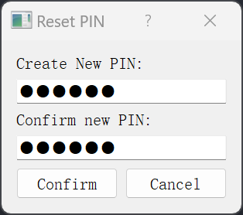

Figure 4

#### Reset PIN Components

1 “Create PIN Box”: New PIN should be entered in here.

2 “Confirm PIN box”: New PIN should be entered in here again.

3 “Cancel”: Clicking on this button will close Reset PIN UI.

4 “Confirm”: Clicking on this button will check whether the PINs match. If they match, a “success” message will be shown (Figure 5). If they don’t match, an “Invalid” message will be shown (Figure 6).

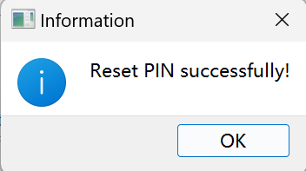

Figure 5

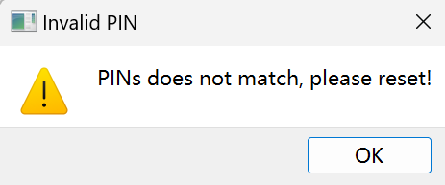

Figure 6

#### History Board

After clicking “History” button on the Injection Processor Board, this History Board will be shown (Figure 7).

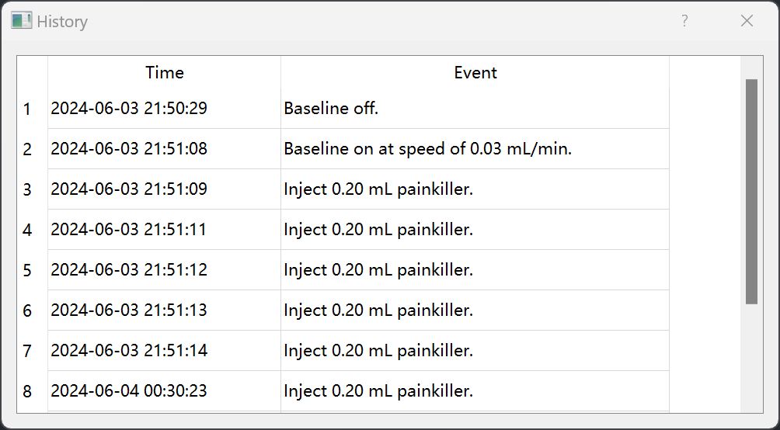

Figure 7

#### History Components

1 “Event Number”: It shows the index of Event.

2 “Time”: It shows when the event occurred.

3 “Event”: It shows the injection status, injection time and injected drugs.

#### Setting Board

After clicking “Settings” button on the Injection Processor Board, this Check PIN UI will be shown. If correct, Check PIN UI will be closed and open the Setting Board (Figure 8).

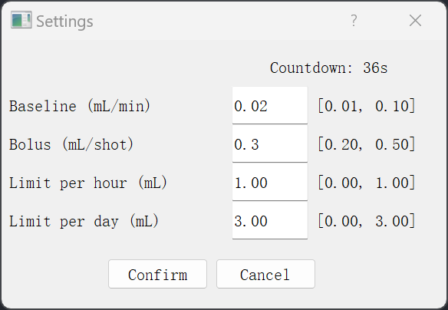

Figure 8

#### Setting Components

1 “Countdown”. It shows a one-minute countdown. Then the Setting Board will be closed automatically.

2 “Baseline”: The baseline injection speed should be entered in here. There is a limit between 0.01ml/min and 0.10ml/min.

3 “Bolus”: The amount of painkiller injected by one bolus should be entered in here. There is a limit between 0.20ml/shot and 0.50ml/shot.

4 “Limit per hour”: The maximum amount of painkiller injected in one hour should be entered in here.

5 “Limit per day”: The maximum amount of painkiller injected in one day should be entered in here.

6 “Cancel”: Clicking on this button will close Setting Board.

7 “Confirm”: Clicking on this button will check whether the PIN is correct. If correct and input is invalid, an “Invalid” message will be shown (Figure 9). If correct and input is valid, Check PIN UI will be closed and open the Injection Processor Board with new settings (Figure 10).

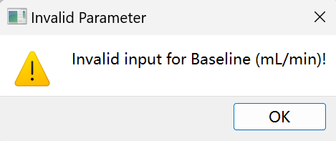

Figure 9

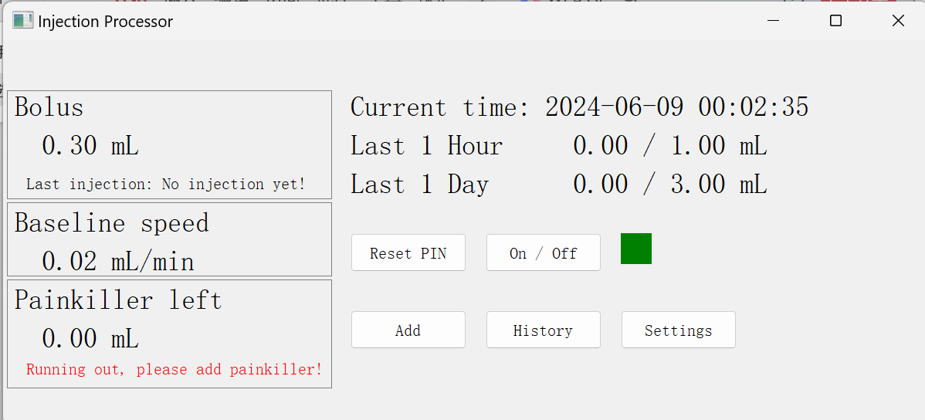

Figure 10

## Patient Manual

#### Injection UI

The patient using painkiller system has an Injection UI which is shown below (Figure 11):

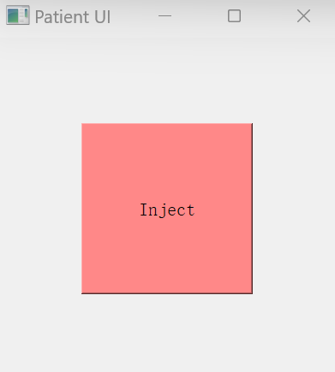

Figure 11

#### Injection Components

1 ”Inject”. Clicking on this button will inject a bolus.