Group X

Author: YourName

Software Specifications

Smart Restaurant System

Table of Contents

System Architecture 2

Software Specifications 2

S1: ServerUI implementation 2

S2: ChefUI Implementation 4

## System Architecture

The system architecture is shown below:



## Software Specifications

### S1: ServerUI implementation

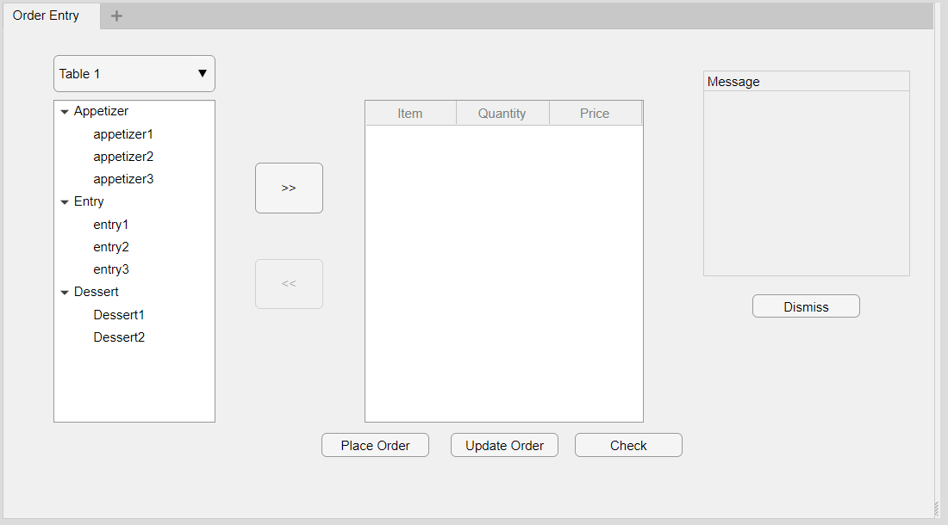

#### S1.1: Take order



* S1.1.1: Select food items

1. Select button clicked
2. For all selected food items
   1. If item not already in list, add the item to the list
   2. If item already in list, increase the quantity

* S1.1.2: Deselect food items

1. Deselect button clicked
2. For all selected food items
   1. If item quantity is equal to 1, remove the item
   2. If item quantity is larger than 1, decrease the quantity

#### S1.2: Change order



### S2: ChefUI Implementation

