Group X

Author: YourName

User Manual

Smart Restaurant System

Table of Contents

System Architecture 2

Server Manual 2

Chef Manual 3

## System Architecture

The system architecture is shown below:



## Server Manual

The server has a UI which is shown below:

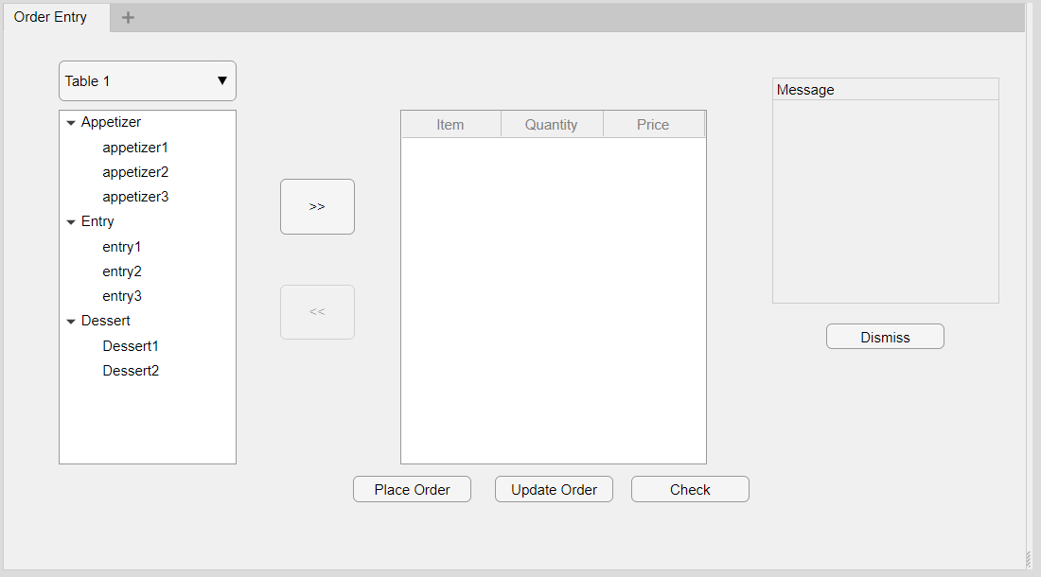

Explain how the server use the system

#### Placing an order

#### Update an order

#### Print check

## Chef Manual

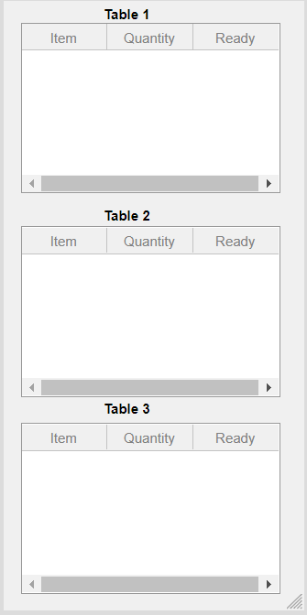

#### When an item is ready