Rebecca Hu

Prof. Powell

DSC 106

October 10, 2019

Homework 1

**Instructions for each tool:**

1) Create 3 sets of charts: bar chat, line chart, pie chart.

Take a screenshot for each chart and insert them into your submission.

2) Write a short analysis of each tool. Perform a short comparative analysis

focusing on the pros and cons of each.

3) When creating the charts, you do not need to use every single field in this

dataset when creating the visualizations. Pick the fields you think are

appropriate.

1. Google G Suite
   1. Bar chart

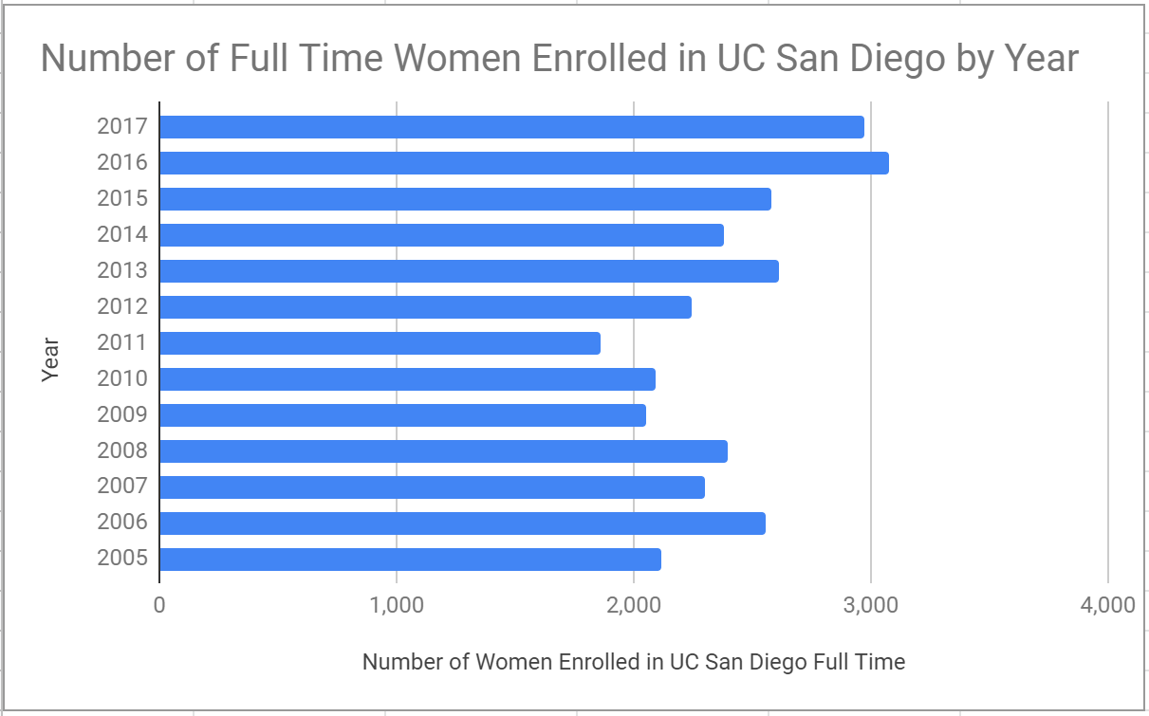

* 1. Line chart

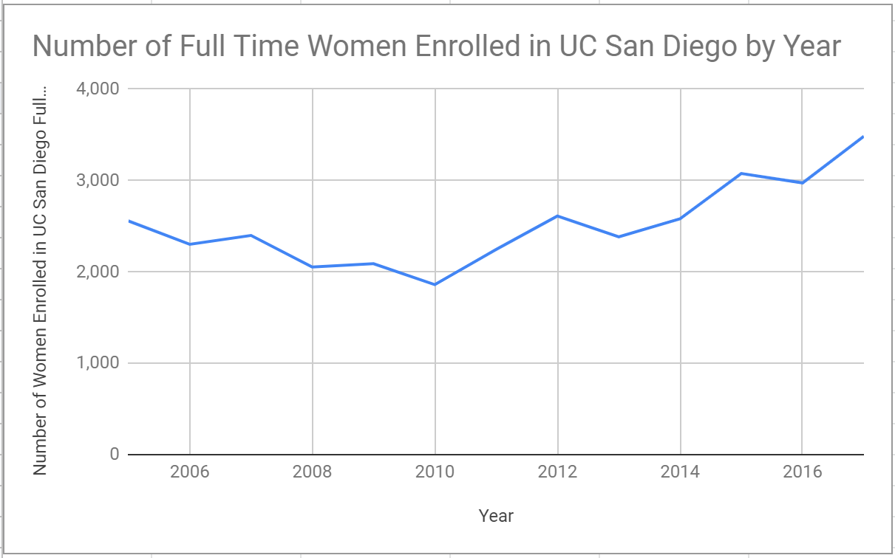

* 1. Pie chart

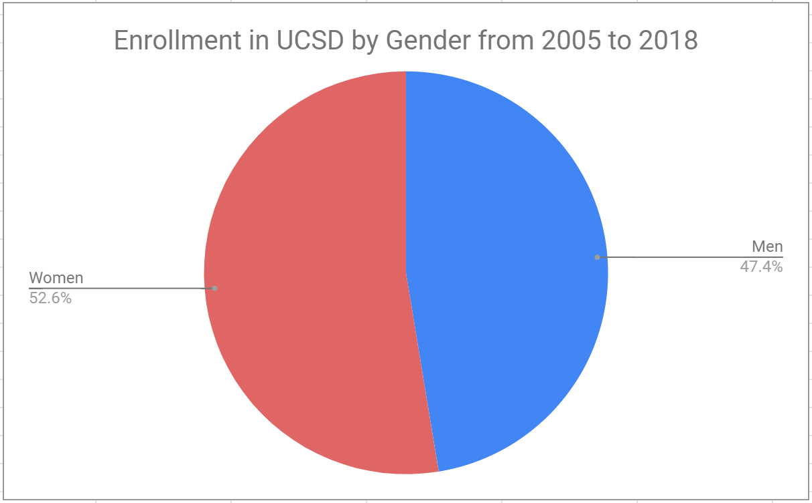

* 1. Analysis

Google sheets makes it very easy to create cookie cutter visualizations. Its relatively easy to use and add customize parts like labels of axes.

* + 1. Pros
    2. Cons

1. Infogram

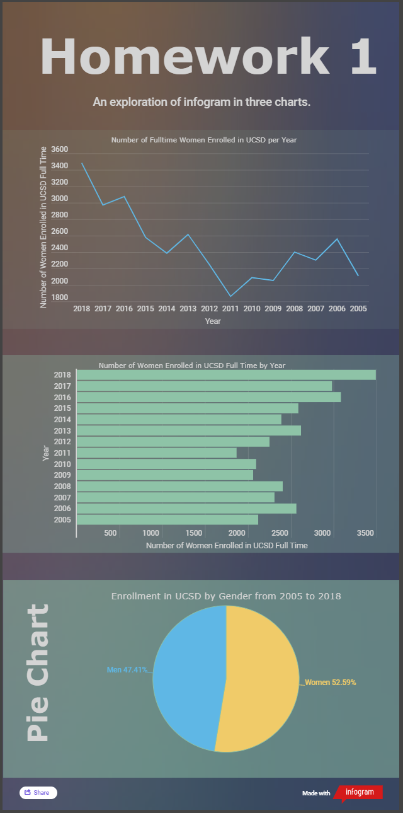

* 1. Bar chart
  2. Line chart
  3. Pie chart
  4. Analysis
     1. Pros
     2. Cons – Limited customizability. Switching the order of the years, no easy way to do it even thought google suite had a button for that. No way to get rid of lines between slices in pie chart. Data has to be in a specific format and theres no way to manipulate it in the webapp.

1. Tableau Desktop
   1. Bar chart

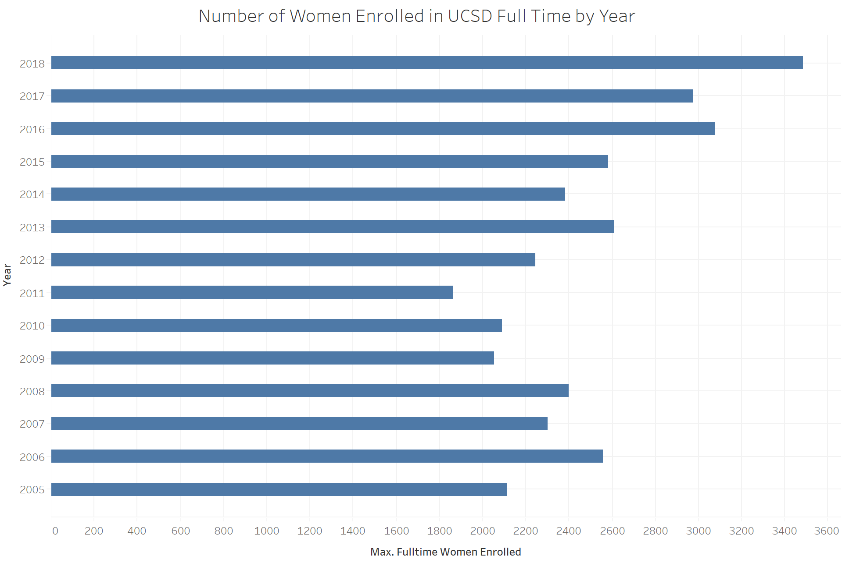

* 1. Line chart

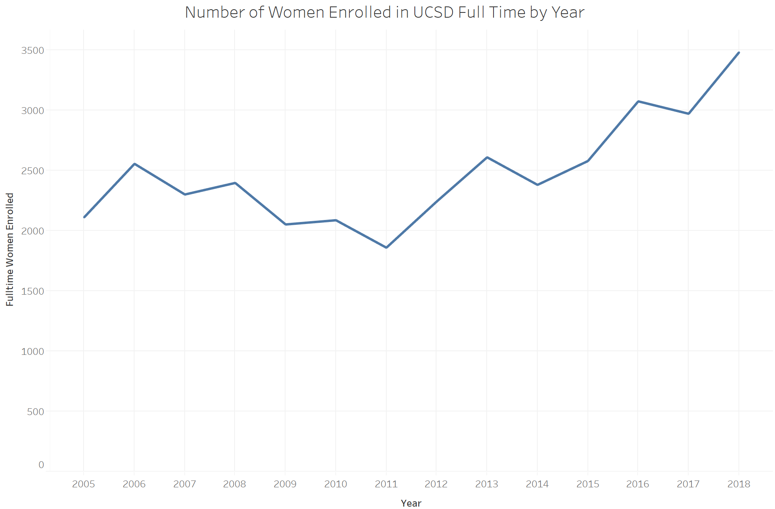

* 1. Pie chart

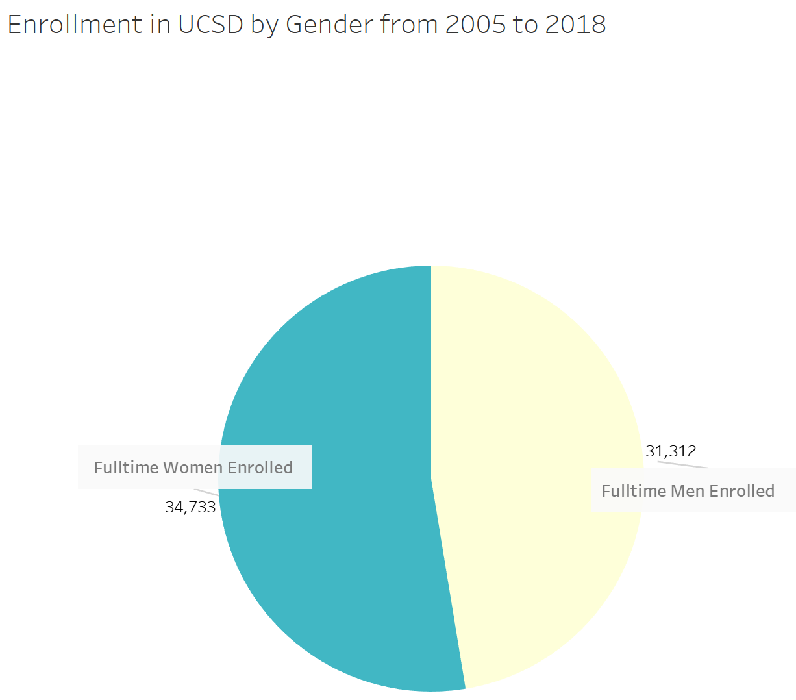

* 1. Analysis
     1. Pros
     2. Cons Have to have the data in a particular format and you cannot edit it easily in tableau.

1. D3.js
   1. Bar chart
   2. Line chart - <https://bl.ocks.org/gordlea/27370d1eea8464b04538e6d8ced39e89?fbclid=IwAR2Zfu3O5REBOj1dBpTClIuMA58MztuG1RlECUwk4zDaC1j5V4SJ_VO-lv0>

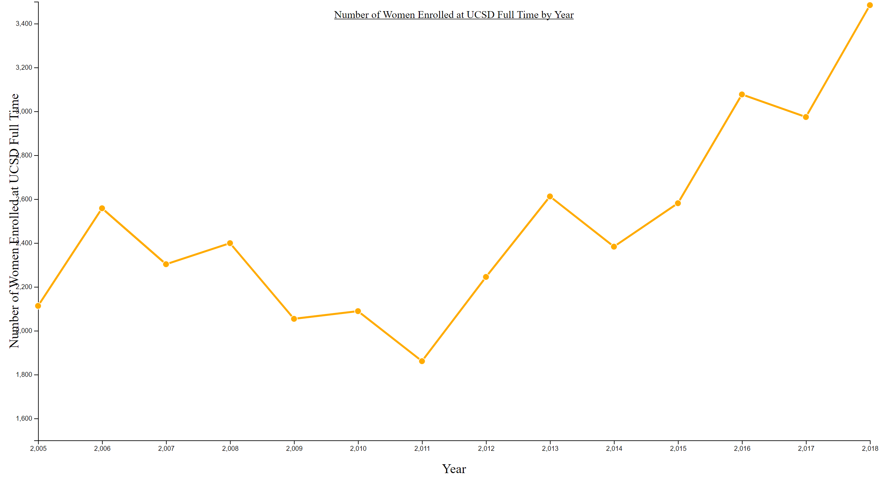

* 1. Pie chart
  2. Analysis
     1. Pros
     2. Cons

1. Highcharts
   1. Bar chart
   2. Line chart
   3. Pie chart
   4. Analysis
      1. Pros
      2. Cons