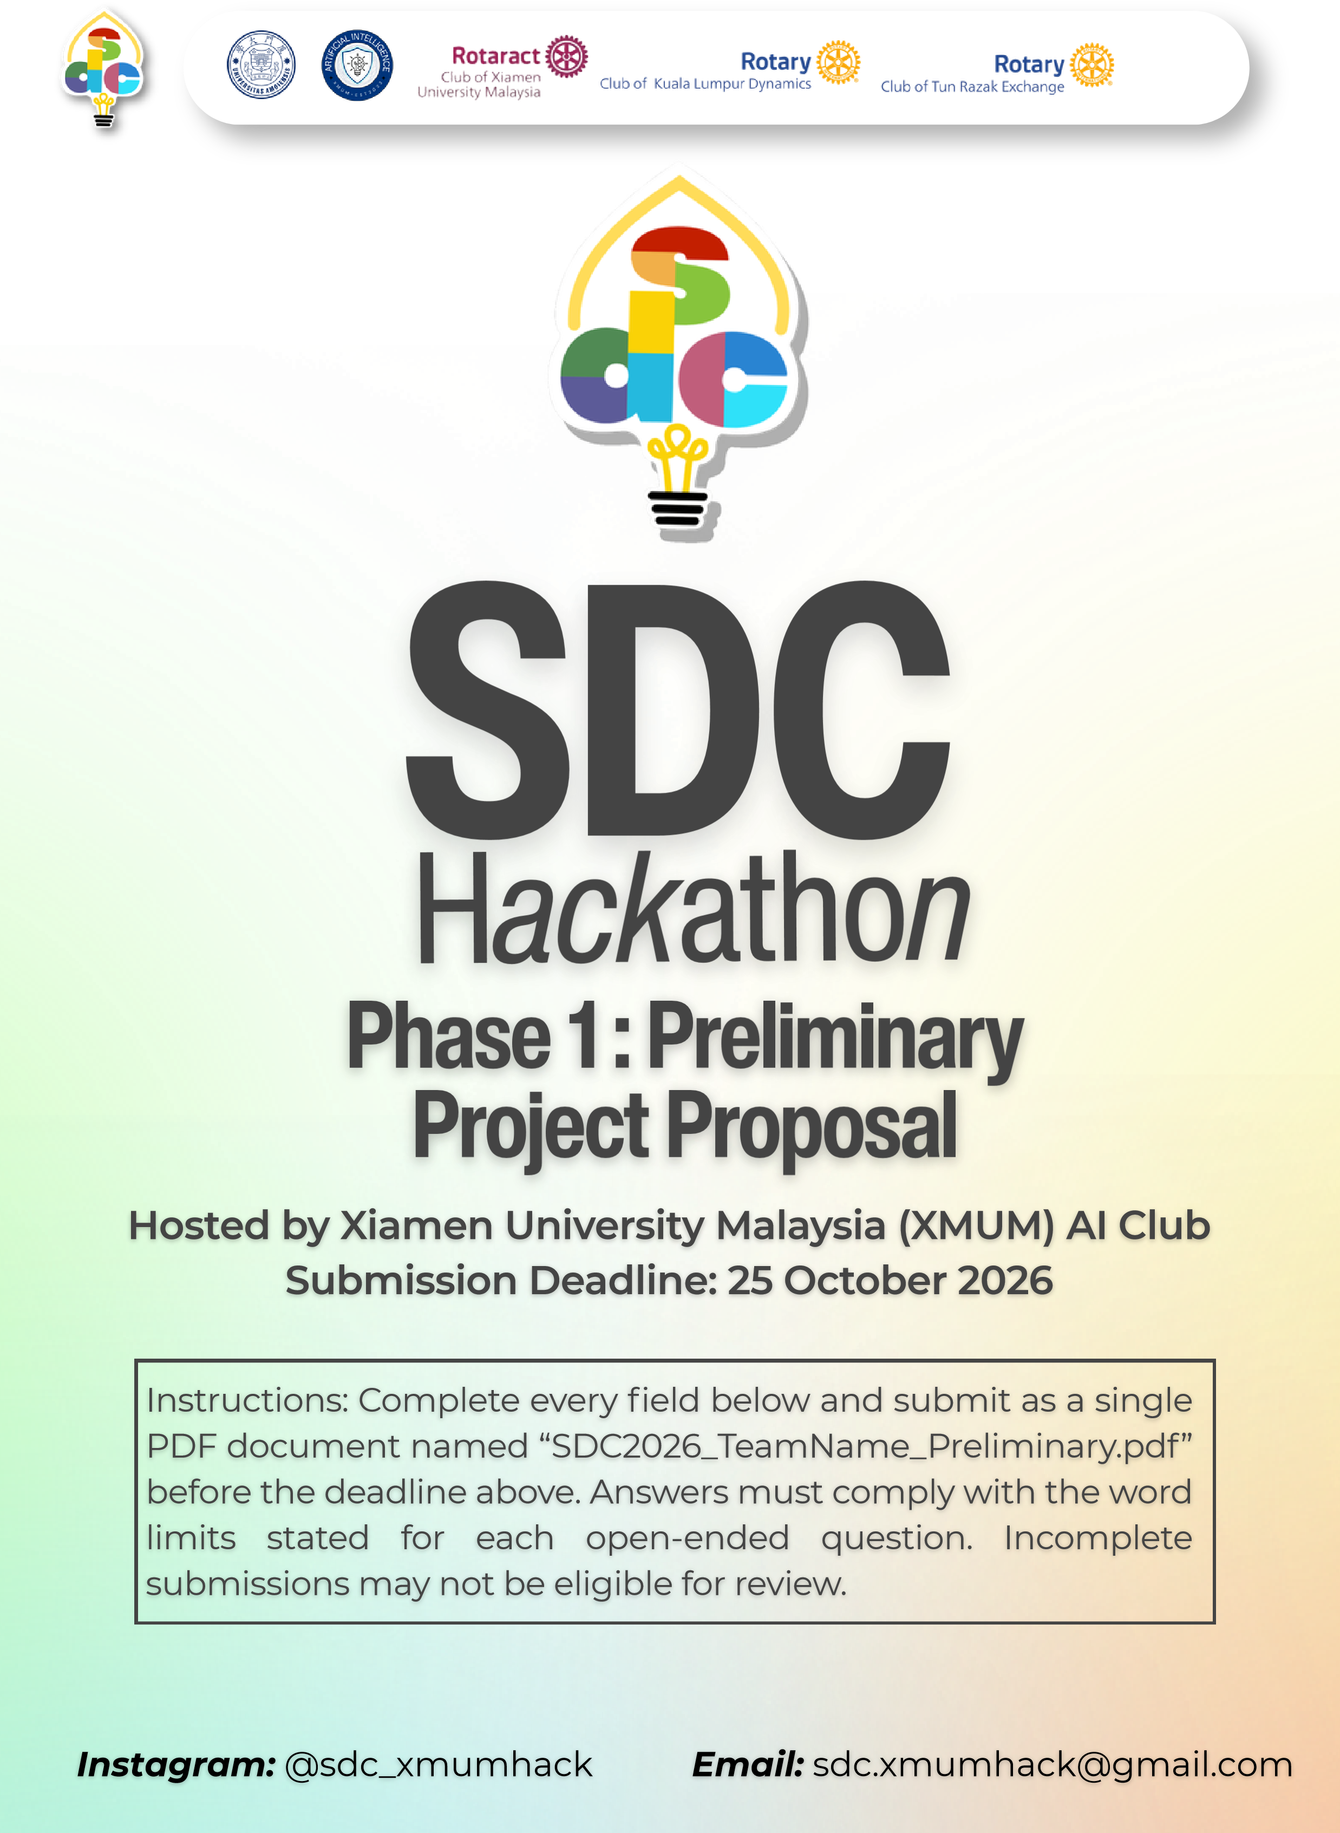
SDC HACKATHON 2026
Phase 1: Preliminary Project Proposal
Hosted by Xiamen University Malaysia (XMUM) AI Club
Submission Deadline: 25 October 2026
Instructions: Complete every field below and submit as a single PDF document named “SDC2026_TeamName_Preliminary.pdf” before the deadline above. Answers must comply with the word limits stated for each open-ended question. Incomplete submissions may not be eligible for review.

1. Team & Project Overview
Team Name | ONE ThirdWheel

Selected Domain | Domain 2

Selected SDG Track (1–17) | SDG – 8

Project / Solution Name

Name (Leader) | Hussein Al-manifi

Email & Phone (Leader) | halmanifi@gmail.com & 601140088061

University Affiliation(s) | University of Malaya

Number of Team Members | 3

2. Executive Summary & Problem Statement

2.1 The Problem Context
Describe the specific, real-world challenge your team is tackling. Who is affected by this problem, and why does it matter? Highlight the critical social, environmental, or economic issues involved.
[Maximum 250 words]

2.2 The Proposed AI Solution
Provide a high-level overview of your proposed application. How does it apply artificial intelligence to solve the problem stated above? Briefly mention the tools or technical skills gained from the SDC Phase 1 workshops (e.g., GenAI APIs, database architecture, cloud hosting) that you intend to leverage.
[Maximum 300 words]

3. Technical Architecture & Implementation Plan

3.1 Conceptual Tech Stack
List the technologies, frameworks, APIs, and databases you plan to use to build a functional, deployed prototype. Describe (or attach as an appendix) a simple system block diagram showing how the workshop elements connect into one architecture.
Did your project utilize any official SDC sponsor-provided GenAI API or Cloud Platform? If yes, specify which one and how it is used.

3.2 Design-Thinking & Deployment Strategy
Explain how your team applied design-thinking methodology to ensure this solution is technically viable, user-friendly, and ready for real deployment by Phase 2.
[Maximum 200 words]
While thinking about the concerns that employees face we put ourselves in their shoes, we all worked in internship before so we experienced how hard it is to keep track of tasks progress.
So to define the core issue, we looked at the issues separately.
1- Tasks communication is messy.
2- Tasks get created within private chats or some times within group chats although it gets lost with time.
3- Manual separate input of tasks progress is tedious and can be forgettable.
So the way to help solve these issues is actively help them while texting. Tasks can be generated while texting and approved within chats, updates can easily be recognized, and tracking between co-workers and superiors is much easier with the full overview of pending tasks for the teams and projects. Private conversations stay private until tasks generation time kicks in.
To make sure the experience isn’t cluttered, the TeamSync UI is none infringing, a simple line above the chat turn it on, and a simple popup between text messages to generate tasks.

“ADD MORE”

4. Preliminary Environmental & SDG Impact Framework
To align with SDC’s focus on meaningful global sustainability, establish your project’s impact baseline before building the prototype. Use estimated data, published research, or public benchmarks where exact figures are unavailable. Provide the citation of any sources used.
The target, baseline, and KPI you provide here will be used by judges during shortlisting to assess Innovation and Creativity as well as Feasibility of build. Vague or unsupported projections may weaken your case for advancing to Phase 2.

Metric Category | Your Response
Target SDG Sub-Target(s)  Identify the exact UN SDG sub-target your project addresses  e.g., Target 11.6 “Reduce the adverse per-capita environmental impact of cities, focusing on air quality and waste management.” | SDG 8: Decent Work and Economic Growth
Current Problem Baseline
What is the starting condition of the problem, expressed as a number?
e.g., “The target infrastructure currently experiences 35% energy inefficiency due to unoptimized scheduling.”
Core Measurable KPI
The specific unit you will track
e.g., % reduction in power consumption, processing-latency improvement, or kg of resource waste avoided.
Phase 2 Impact Target
Your realistic, percentage-based target by the final prototype presentation
e.g., “20% improvement in computational resource use.”

5. Eligibility & Readiness Checklist
Tick all boxes that apply before submitting.
All team members have completed the mandatory GenAI, Database, and Cloud Deployment upskilling workshops.

The project concept addresses a verified real-world problem mapped directly to one or more UN SDGs.

The proposed solution targets a functional, deployed application rather than a theoretical business case study.

All fields in this template have been completed within the word limits stated.

6. IP & Originality Declaration
6.1 Pre-Existing / Prior-Owned Work
Does this submission include any code, design, research, or other work that any team member created or owned before the start of this hackathon?
☐ Yes ☐ No
If yes, briefly describe what was pre-existing and which team member(s) owned it:

6.2 Third-Party Code, Datasets, or Models
Does your project use any third-party code libraries, open-source frameworks, public/private datasets, or pre-trained AI models that your team did not create?
☐ Yes ☐ No
If yes, list them below (open-source use is permitted provided it is declared and properly licensed/attributed):
Name | Type (code/dataset/model) | License

6.3 Employment-Related IP Conflicts
Is any team member currently bound by an employment, internship, or consulting agreement under which their employer could claim ownership of work they create during this hackathon?
☐ Yes ☐ No
If yes, please describe the nature of the agreement and which member it concerns:

7. Declaration
By submitting this proposal, the team leader confirms that the information provided is accurate to the best of the team’s knowledge and that the project will be original work created during the SDC 2026 hackathon period.

[Signature]
[Date]

