1.Files

(1).lib-------- The directory of library.

(2).include-------- The directory of header files.

(3).bin----- The directory of binary files.

(4).SampleClient.cpp-----The source code of client receiving program for reference.

(5).CMakeLists.txt-----The script of program build.

2.Demo test

(1).Set the PC IP address to 10.1.1.198 and subnet mask to 255.255.255.0. Disable the firewall and network blocking software.

(2).Run XINGYING motion capture software as an administrator.

(3).Select the data broadcast interface, select “NIC Address”, and then check “Setting”,“SDK Enabled”.XINGYING sends motion capture data, the local and other computers can receive data

(4).In live mode, click run;Or, in post-process mode, play back data.

(5). On Linux, copy dynamic library to library directory:

sudo cp libnokov_sdk.so /usr/lib

(6). Perform:

sudo ./SampleClient

Enter XINGYING broadcast IP to receive SDK data.

Note: In post-process mode, you need to close the client receiver before switching. If the connection fails, check the destination NIC name in “SampleClient.cpp” and ensure that the destination NIC Address is in the same network segment. You may need to disable Wireless Network Connection on some PC.

3.Version support

* 1. XINGYING 1.0.0.2910,2.x,3.x
  2. XING 1.0.0.2909
  3. CONG 1.2.0.2912

4.cmake build

Windows:

* + - 1. Create a new folder in the same level directory as CMakeLists.txt to store project files, as shown in the example：project

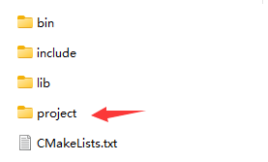

* + - 1. Open a command line window and enter the ‘project’ directory

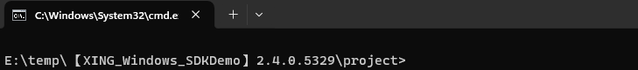

* + - 1. Run the command cmake to generate the project file. If there is an error here, please check if there are any illegal characters in the path. Do not use any special symbols, especially symbols, in the path &

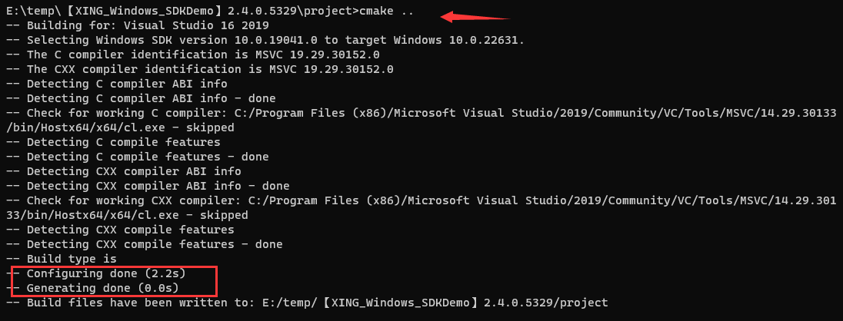

* + - 1. In File Explorer, double-click to open the project file

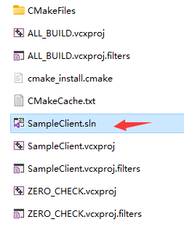

* + - 1. Directly compile and generate executable files

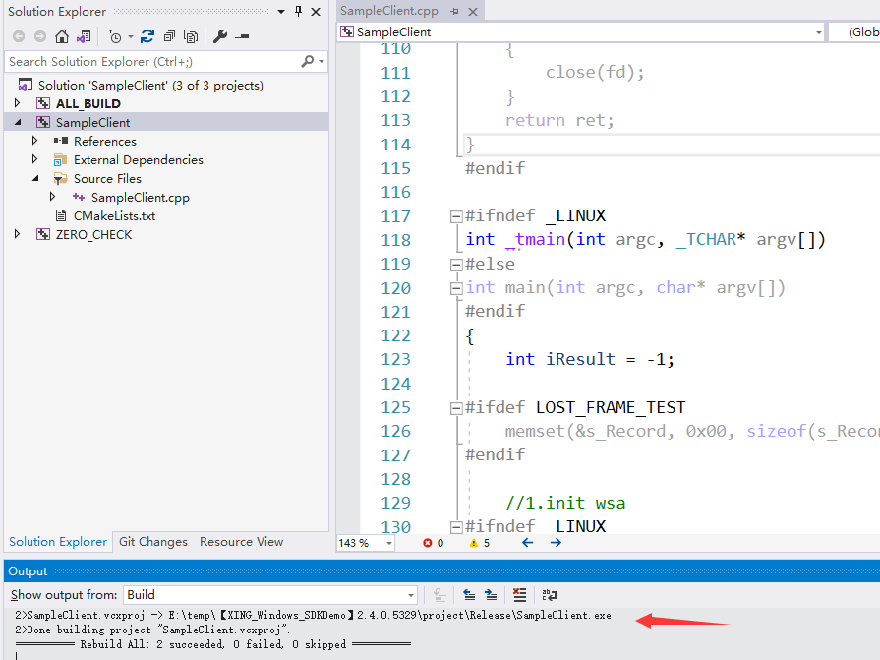

* + - 1. The executable file is located in the Debug or Release directory of the "project" directory

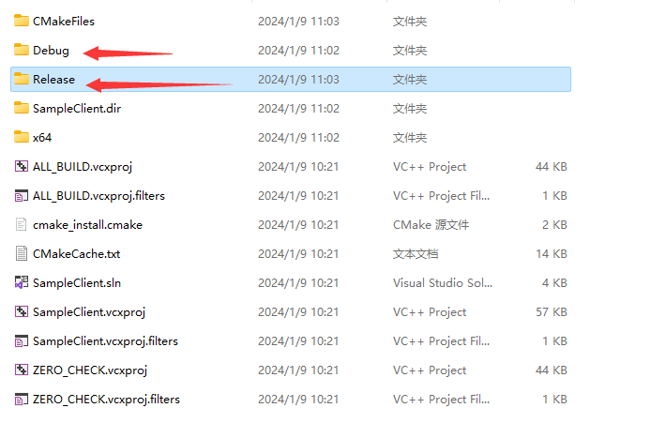

Linux:

In the same level directory as CMakeLists.txt, create a new folder to store project files. In the example, create:：project

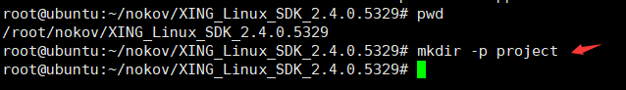

Run the command cmake, A Makefile will be generated. If there is an error here, please check if there are any illegal characters in the path and do not use special symbols

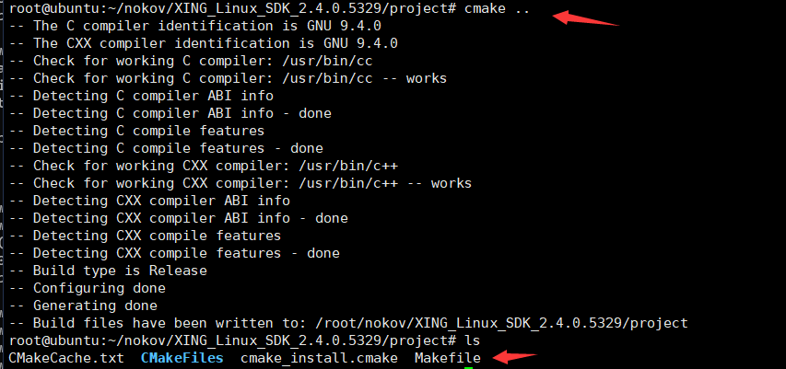

Run the make command to generate an executable file

