### MS6601: Homework 1

HU Yelong 57460513

WU Yi // TODO 填学号

###### Q1.1

A white noise process is a type of stochastic process, or a sequence of random variables, that has the following properties:

1. The mean of the process is constant over time.
2. The autocorrelation between any two points in the process is zero, meaning that the value of the process at any point in time is independent of its value at any other point in time.
3. The distribution of the process is Gaussian with a constant variance, meaning that the random variables in the process have a normal distribution with the same variance.

An i.i.d. process is a type of stochastic process where each observation is independent of all other observations and has the same probability distribution.

The main difference between white noise process and i.i.d. process is that white noise process is a type of stochastic process with specific properties, while i.i.d. process only states that all variables are independent and identically distributed. White noise process is also uncorrelated over time, while i.i.d. process does not necessarily have to be uncorrelated.

$$E(\overline{X})=E(\frac{1}{n}\sum_{t=1}^{n}{X_{t}})=\frac{1}{n}\sum_{t=1}^{n}{E(X_{t})}=\frac{1}{n}×nμ=μ$$

$$var(\overline{X})=var(\frac{1}{n}\sum_{t=1}^{n}{X_{t}})=\frac{1}{n^{2}}\sum_{t=1}^{n}{var(X_{t})}=\frac{1}{n^{2}}×nσ^{2}=\frac{σ^{2}}{n}$$

$$SE(\overline{X})=\sqrt{var(\overline{X})}=\sqrt{\frac{σ^{2}}{n}}$$

The standard error of the sample mean estimator for μ represents the level of precision of the estimator. It is a measure of the variability of the estimator based on the sample size and the variation of the underlying population. More specifically, it is a measure of the deviation of the sample mean from the true mean of the population. The smaller the standard error, the more likely it is that the sample mean is a close estimate of the true population mean.

###### Q1.2

A weakly stationary process is a type of stochastic process that satisfies the following conditions:

1. The mean of the process is constant over time.
2. The autocovariance of the process is a function of the lag alone, and not of the time at which the variables are measured.

In other words, a weakly stationary process is one in which the mean and the autocovariance structure do not change over time. It's called "weakly" stationary because the distribution of the random variables may change over time.

A time series is said to be strongly stationary if, in addition to being weakly stationary, the joint distribution of any set of observations at different times is the same. This means that the distribution of the time series does not change over time.

In summary, weakly stationary means the mean and variance are constant over time and strongly stationary means both mean, variance and the joint distribution are constant over time.

$$E(\overline{Y})=\frac{1}{n}\sum_{t=1}^{n}{E(Y_{t})}=\frac{1}{n}×nμ=μ$$

$$var(\overline{Y})=varvar(\frac{1}{n}\sum_{t=1}^{n}{Y_{t}})=\frac{1}{n^{2}}\sum_{t=1}^{n}{var(Y_{t})}=\frac{1}{n^{2}}×nσ^{2}=\frac{σ^{2}}{n}$$

$$SE(\overline{Y})=\sqrt{var(\overline{Y})}=\sqrt{\frac{σ^{2}}{n}}$$

###### Q1.3

In both white noise process and weakly stationary process, the variance of the sample mean estimator for the $\overline{X}$ and $\overline{Y}$ is both $\frac{σ^{2}}{n}$. The reason for this is that in both cases the observations are i.i.d. with mean $μ$ and variance $σ^{2}$. The result tells us that the sample mean estimator is an unbiased and consistent estimator for the mean $μ$ in both cases.

In both cases, the i.i.d. of the observations allow us to use the properties of the sample mean estimator to compute the variance of $\overline{X}$ and $\overline{Y}$ as $\frac{σ^{2}}{n}$.

It's also important to note that the weak stationarity does not imply that the mean and variance are time independent, it only require that they are constant over time and have a certain relationship between the covariance of different time lags.

###### Q1.4(Using Python3)

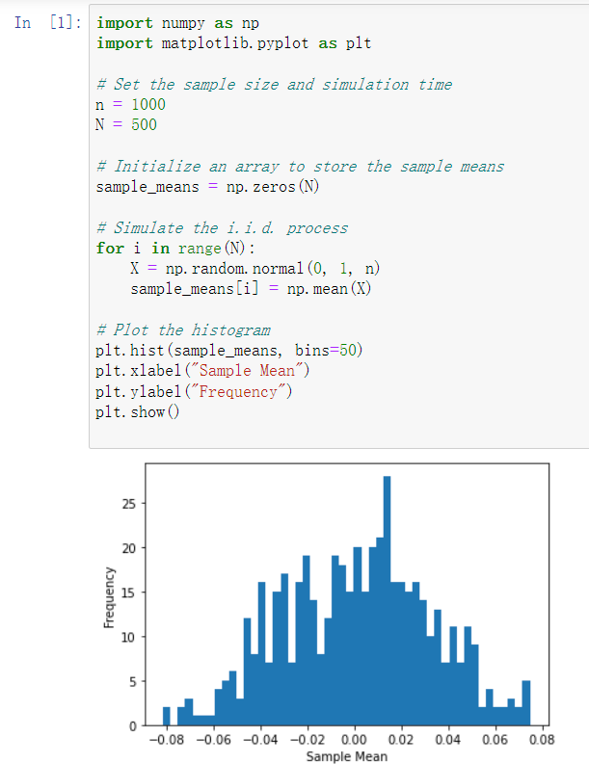

(b)

(i) This will calculate the expectation and variance of the AR(1) process X(t)=0.8X(t-1)+e(t), where e(t)~Normal(0, (sigma_e)^2), and also finds the value of (sigma_e)^2 to make variance of X(t) equals to 1. It will print out the expectation and variance of X(t) and the value of (sigma_e)^2 that makes the variance of X(t) equal to 1.

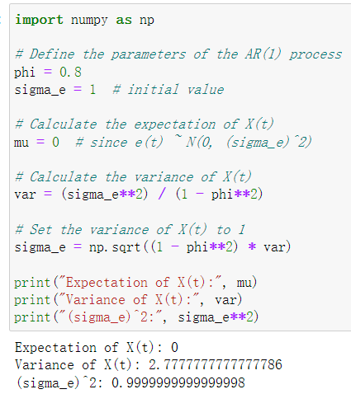

(ii)This will simulate data from the AR(1) process X(t)=0.8X(t-1)+e(t), where e(t)~Normal(0, (sigma_e)^2) with sample size n=1000(that is X1, ..., Xn) with initial value X0=0 and simulation time N=500. It will also compute the sample mean Xbar(1), ..., Xbar(N), where Xbar(i) is the sample mean from the i-th simulation. Finally, it will plot the histogram for Xbar(1), ..., Xbar(N) using matplotlib library.

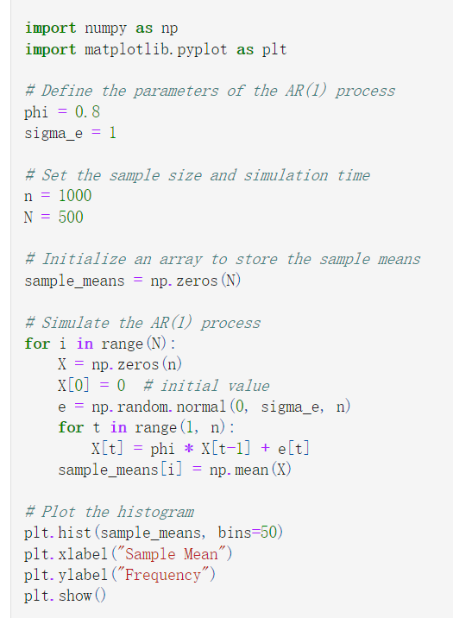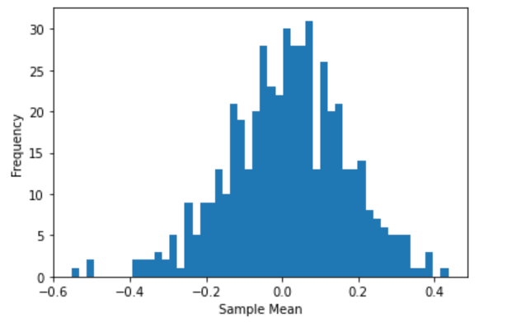

(c)

The two histograms above are for the sample means of two different processes: i.i.d. standard normal distribution and stationary autoregressive process AR(1).

The histogram for the i.i.d. standard normal distribution should be bell-shaped and centered around 0, since the sample means of i.i.d. standard normal distribution should converge to the population mean, which is 0.

The histogram for the stationary autoregressive process AR(1) will also be bell-shaped and centered around the population mean, which is 0 in this case, as the sample mean ${\overline{X}}^{(i)}$ will converge to the population mean of the $X_{t}$ which is 0, but it will be wider than the histogram of the i.i.d. standard normal distribution. This is because the sample means of the stationary autoregressive process AR(1) will have a larger variance than the sample means of the i.i.d. standard normal distribution.

In summary, the histograms of the sample means of the i.i.d. standard normal distribution and the stationary autoregressive process AR(1) are similar in that they are both bell-shaped and centered around 0, but the histogram of the sample means of the stationary autoregressive process AR(1) is wider than the histogram of the sample means of the i.i.d. standard normal distribution. This is due to the fact that the sample means of the stationary autoregressive process AR(1) have a larger variance than the sample means of the i.i.d. standard normal distribution.