《编译原理》实验报告
实验序号：4 实验项目：SLR语法分析
学 号 | 1910705127 | 姓 名 | 宋宇昕 | 专业、班级 |  | 19软件1班
实验地点 | 精工楼 | 指导教师 | 肖蕾 | 实验时间 |  | 11.14
- 实验目的
- 理解自下而上语法分析方法；
- 掌握LR(0)项目集规范族的构造方法；
- 掌握SLR分析表的构造算法；
4、理解LR分析法的非递归过程。
二、实验环境
建议使用Visual C++ 6.0；windows系列操作系统。
三、实验内容与要求
1、输入文法，构造并输出识别该文法所有活前缀的DFA；
2、构造该文法的SLR分析表并判断该文法是否是SLR文法；
3、对于SLR文法，进一步实现SLR文法的非递归自下而上分析过程，判断输入的串是否是可以接受的，并按栈、输入、输出列表打印分析过程。

四、实验过程与结果
1、算法的主要原理
先用推广文法重新定义开始符号得到了初始状态L(0)然后对开始符号求闭包，然后对初始状态输入字符，输入字符后，在对当前项进行闭包，依次可以得到所有的状态集合。
① 若项目A→α·aβ属于Ik且转换函数GO(Ik,a)= Ij，当a为终结符时则置ACTION[k,a]为Sj。
② 若项目A→α· 属于Ik，则对任何终结符a 和’#'号置ACTION[k,a]和ACTION[k,#]为”rj”，j为在文法G′中某产生式A→α的序号。
③ 若GO(Ik,A)＝Ij，则置GOTO[k,A]为”j”，其中A为非终结符。
④ 若项目S′→S·属于Ik，则置ACTION[k,#]为”acc”，表示接受。
⑤ 凡不能用上述方法填入的分析表的元素，均应填上”报错标志”。为了表的清晰我们仅用空白表示错误标志。
2、算法流程与设计思路（建议画图说明）

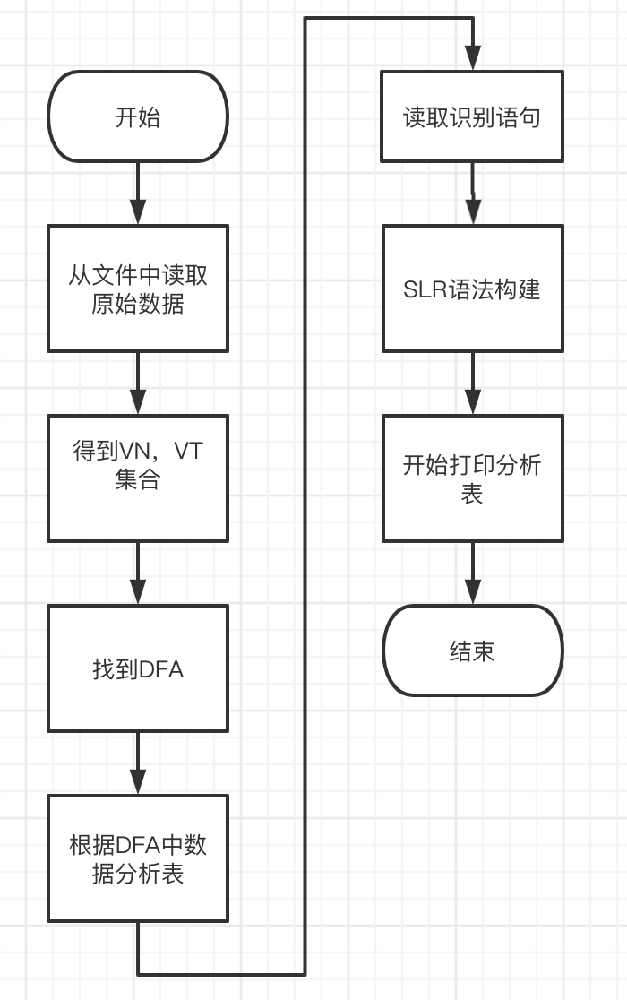
- 实验结果与分析（至少给出3组测试的截图，包括正确的输入与错误的输入示例，并给出结果正确性的验证说明）
输入 | 结果
7  S->E  E->E+T  E->T  T->T*F  T->F  F->(E)  F->i | 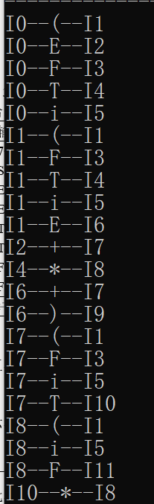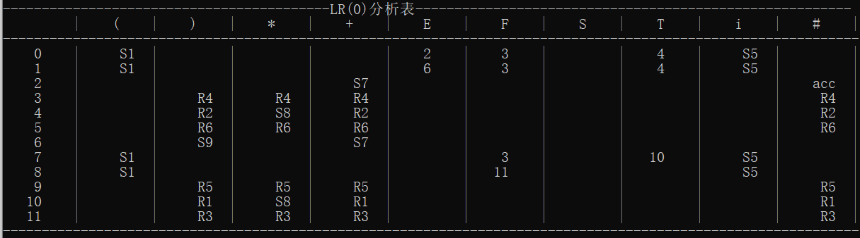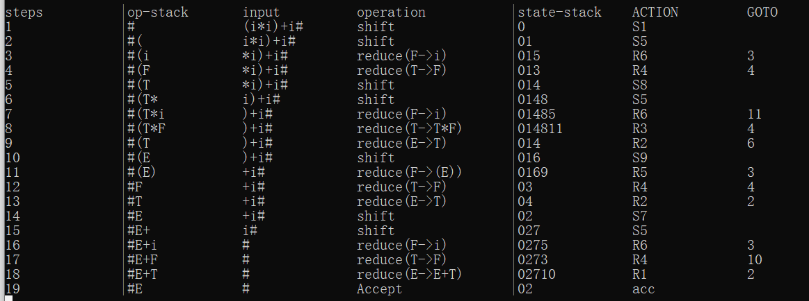
(错误示范)  3  E->E+T|T  T->*F|F  F->(E)|i | 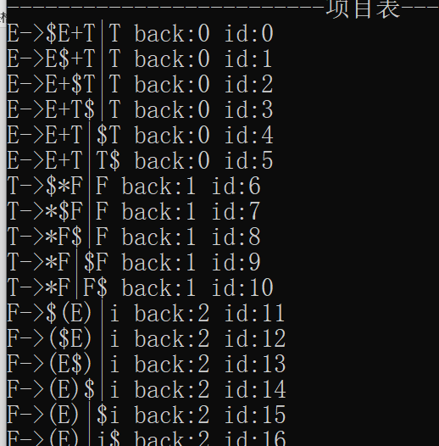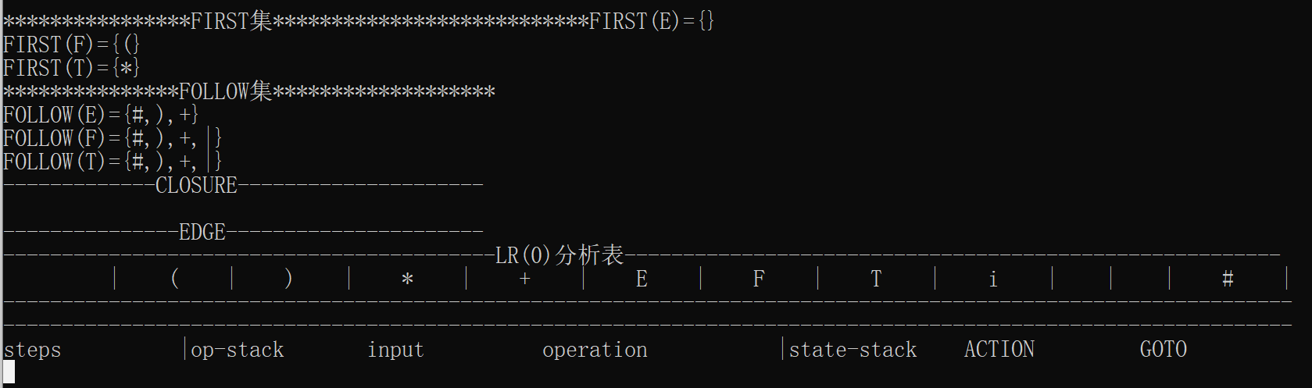
4  S->E  E->E+T  E->T  T->T*F  T->F | 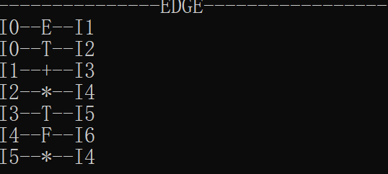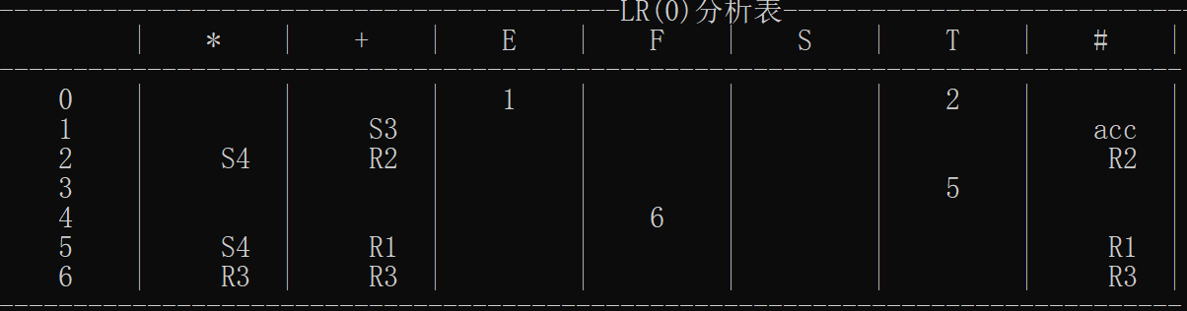
- 实验过程遇到的问题及解决方法（罗列2个以上遇到的问题）
- 数据结果存储问题
通过构建map类型，指定相应的key和value值，当value值有多个时，放入数组其中。
- LR（0）分析表的输出
通过对输出数据格式化为统一的长度，然后将每一个key所对应的数据都提前存储为map，遍历输出即可。
六、心得体会
LR（0）实际是就是最右推导的过程，当你构建分析表之后，对相应的语句进行入栈分析就会迎刃而解。

七、教师评语  签名：  日期： |  |  |  |  | 成绩
附源程序及核心代码注释：
import java.util.ArrayList;
import java.util.HashMap;
import java.util.HashSet;
import java.util.Set;
import java.util.Stack;
public class Demo {
public static void main(String[] args) {
Test test = new Test();
test.getNvNt();
test.Init();
test.createTable();
test.analyzeLL();
//test.analyzeSLR();
test.ouput();
}
}
class Test {
//单个符号first集
public HashMap<Character, HashSet<Character>> firstSet = new HashMap<>();
//符号串first集
public HashMap<String, HashSet<Character>> firstSetX = new HashMap<>();
//开始符
public static char S = 'S';
public HashMap<Character, HashSet<Character>> followSet = new HashMap<>();
//非终结符
public HashSet<Character> VnSet = new HashSet<>();
//终结符
public HashSet<Character> VtSet = new HashSet<>();
//非终结符-产生式集合
public HashMap<Character, ArrayList<String>> experssionSet = new HashMap<>();
// E: TK | K: +TK $ | T : FM | M: *FM $|F :i (E)
public String[][] table;
public String[][] tableSLR = {
{"", "i", "+", "*", "(", ")", "$", "E", "T", "F"},
{"0", "s5", "", "", "s4", "", "", "1", "2", "3"},
{"1", "", "s6", "", "", "", "acc", "", "", ""},
{"2", "", "r2", "s7", "", "r2", "r2", "", "", ""},
{"3", "", "r4", "r4", "", "r4", "r4", "", "", ""},
{"4", "s5", "", "", "s4", "", "", "8", "2", "3"},
{"5", "", "r6", "r6", "", "r6", "r6", "", "", ""},
{"6", "s5", "", "", "s4", "", "", "", "9", "3"},
{"7", "s5", "", "", "s4", "", "", "", "", "10"},
{"8", "", "s6", "", "", "s11", "", "", "", ""},
{"9", "", "r1", "s7", "", "r1", "r1", "", "", ""},
{"10", "", "r3", "r3", "", "r3", "r3", "", "", ""},
{"11", "", "r5", "r5", "", "r5", "r5", "", "", ""}};
public String[] inputExperssion = { "S->I", "S->o", "I->i(E)SL", "L->eS", "L->~", "E->a", "E->b"};
public Stack<Character> analyzeStatck = new Stack<>();
public Stack<String> stackState = new Stack<>();
public Stack<Character> stackSymbol = new Stack<>();
public String strInput = "i(a)i(b)oeo$";
public String action = "";
public String[] LRGS = {"E->E+T", "E->T", "T->T*F", "T->F", "F->(E)", "F->i"};
int index = 0;
public void Init() {
//获取生成式
for (String e : inputExperssion) {
String[] str = e.split("->");
char c = str[0].charAt(0);
ArrayList<String> list = experssionSet.containsKey(c) ? experssionSet.get(c) : new ArrayList<>();
list.add(str[1]);
experssionSet.put(c, list);
}
//构造非终结符的first集
for (char c : VnSet)
getFirst(c);
//构造开始符的follow集
getFollow(S);
//构造非终结符的follow集
for (char c : VnSet)
getFollow(c);
}
/**
* 先求非终结符，再求终结符
*/
public void getNvNt() {
for (String e : inputExperssion)
VnSet.add(e.split("->")[0].charAt(0));
for (String e : inputExperssion)
for (char c : e.split("->")[1].toCharArray())
if (!VnSet.contains(c))
VtSet.add(c);
}
public void getFirst(char c) {
if (firstSet.containsKey(c))
return;
HashSet<Character> set = new HashSet<>();
// 若c为终结符 直接添加
if (VtSet.contains(c)) {
set.add(c);
firstSet.put(c, set);
return;
}
// c为非终结符 处理其每条产生式
for (String s : experssionSet.get(c)) {
if ("~".equals(c)) {
set.add('~');
} else {
for (char cur : s.toCharArray()) {
if (!firstSet.containsKey(cur))
getFirst(cur);
HashSet<Character> curFirst = firstSet.get(cur);
set.addAll(curFirst);
if (!curFirst.contains('~'))
break;
}
}
}
firstSet.put(c, set);
}
public void getFirst(String s) {
if (firstSetX.containsKey(s))
return;
HashSet<Character> set = new HashSet<>();
// 从左往右扫描该式
int i = 0;
while (i < s.length()) {
char cur = s.charAt(i);
if (!firstSet.containsKey(cur))
getFirst(cur);
HashSet<Character> rightSet = firstSet.get(cur);
// 将其非空 first集加入左部
set.addAll(rightSet);
// 若包含空串 处理下一个符号
if (rightSet.contains('~'))
i++;
else
break;
// 若到了尾部 即所有符号的first集都包含空串 把空串加入fisrt集
if (i == s.length()) {
set.add('~');
}
}
firstSetX.put(s, set);
}
public void getFollow(char c) {
ArrayList<String> list = experssionSet.get(c);
HashSet<Character> leftFollowSet = followSet.containsKey(c) ? followSet.get(c) : new HashSet<>();
//如果是开始符 添加 $
if (c == S)
leftFollowSet.add('$');
//查找输入的所有产生式，添加c的后跟 终结符
for (char ch : VnSet)
for (String s : experssionSet.get(ch))
for (int i = 0; i < s.length(); i++)
if (c == s.charAt(i) && i + 1 < s.length() && VtSet.contains(s.charAt(i + 1)))
leftFollowSet.add(s.charAt(i + 1));
followSet.put(c, leftFollowSet);
//反向扫描处理c的每一条产生式
for (String s : list) {
int i = s.length() - 1;
while (i >= 0) {
char cur = s.charAt(i);
//只处理非终结符 I->i(E)SL
if (VnSet.contains(cur)) {
// 都按 A->αBβ 形式处理
//1.若β不存在 followA 加入 followB
//2.若β存在，把β的非空first集 加入followB
//3.若β存在 且first(β)包含空串 followA 加入 followB
String right = s.substring(i + 1);
HashSet<Character> rightFirstSet;
if(!followSet.containsKey(cur))
getFollow(cur);
HashSet<Character> curFollowSet = followSet.get(cur);
//先找出first(β),将非空的加入followB
if (0 == right.length()) {
curFollowSet.addAll(leftFollowSet);
} else {
if (1 == right.length()) {
if (!firstSet.containsKey(right.charAt(0)))
getFirst(right.charAt(0));
rightFirstSet = firstSet.get(right.charAt(0));
} else {
if (!firstSetX.containsKey(right))
getFirst(right);
rightFirstSet = firstSetX.get(right);
}
for (char var : rightFirstSet)
if (var != '~')
curFollowSet.add(var);
// 若first(β)包含空串,将followA加入followB
if (rightFirstSet.contains('~'))
curFollowSet.addAll(leftFollowSet);
}
followSet.put(cur, curFollowSet);
}
i--;
}
}
}
public void createTable() {
Object[] VtArray = VtSet.toArray();
Object[] VnArray = VnSet.toArray();
// 预测分析表初始化
table = new String[VnArray.length + 1][VtArray.length + 1];
table[0][0] = "Vn/Vt";
//初始化首行首列
for (int i = 0; i < VtArray.length; i++)
table[0][i + 1] = (VtArray[i].toString().charAt(0) == '~') ? "$" : VtArray[i].toString();
for (int i = 0; i < VnArray.length; i++)
table[i + 1][0] = VnArray[i] + "";
//全部置error
for (int i = 0; i < VnArray.length; i++)
for (int j = 0; j < VtArray.length; j++)
table[i + 1][j + 1] = "error";
//插入生成式
for (char A : VnSet) {
for (String s : experssionSet.get(A)) {
if (!firstSetX.containsKey(s))
getFirst(s);
HashSet<Character> set = firstSetX.get(s);
for (char a : set)
insert(A, a, s);
if (set.contains('~')) {
HashSet<Character> setFollow = followSet.get(A);
if (setFollow.contains('$'))
insert(A, '$', s);
for (char b : setFollow)
insert(A, b, s);
}
}
}
}
public void analyzeLL() {
System.out.println("****************LL分析过程**********");
System.out.println(" Stack Input Action");
analyzeStatck.push('$');
analyzeStatck.push(S);
displayLL();
char X = analyzeStatck.peek();
while (X != '$') {
char a = strInput.charAt(index);
if (X == a) {
action = "match " + analyzeStatck.peek();
analyzeStatck.pop();
index++;
} else if (VtSet.contains(X))
return;
else if (find(X, a).equals("error"))
return;
else if (find(X, a).equals("~")) {
analyzeStatck.pop();
action = X + "->~";
} else {
String str = find(X, a);
if (str != "") {
action = X + "->" + str;
analyzeStatck.pop();
int len = str.length();
for (int i = len - 1; i >= 0; i--)
analyzeStatck.push(str.charAt(i));
} else {
System.out.println("error at '" + strInput.charAt(index) + " in " + index);
return;
}
}
X = analyzeStatck.peek();
displayLL();
}
System.out.println("analyze LL1 successfully");
System.out.println("****************LL分析过程**********");
}
public void analyzeSLR() {
action = "";
index = 0;
stackState.push("0");
char a = strInput.charAt(index);
System.out.println("****************SLR分析过程**********");
System.out.println(" State Symbol Input Action");
this.displaySLR();
while (true) {
String s = stackState.peek();
// 查表为移进
if (Action(s, a).charAt(0) == 's') {
stackState.push(Action(s, a).substring(1));
stackSymbol.push(a);
a = strInput.charAt(++index);
action = "shift ";
displaySLR();
}
// 查表为归约
else if (Action(s, a).charAt(0) == 'r') {
// 获取文法串
String str = LRGS[Integer.parseInt(Action(s, a).substring(1)) - 1];
int len = str.substring(3).length();
// 弹出右部长度的符号和状态
for (int i = 0; i < len; i++) {
stackSymbol.pop();
stackState.pop();
}
// goto的值进栈
String t = stackState.peek();
stackState.push(Action(t, str.charAt(0)));
stackSymbol.push(str.charAt(0));
action = "reduce:" + str;
displaySLR();
} else if (Action(s, a) == "acc")
break;
else
return;
}
System.out.println("analyze SLR successfully");
System.out.println("****************SLR分析过程**********");
}
public String Action(String s, char a) {
for (int i = 1; i < 13; i++)
if (tableSLR[i][0].equals(s))
for (int j = 1; j < 10; j++)
if (tableSLR[0][j].charAt(0) == a)
return tableSLR[i][j];
return "";
}
public String find(char X, char a) {
for (int i = 0; i < VnSet.size() + 1; i++) {
if (table[i][0].charAt(0) == X)
for (int j = 0; j < VtSet.size() + 1; j++) {
if (table[0][j].charAt(0) == a)
return table[i][j];
}
}
return "";
}
public void insert(char X, char a, String s) {
if (a == '~') a = '$';
for (int i = 0; i < VnSet.size() + 1; i++) {
if (table[i][0].charAt(0) == X)
for (int j = 0; j < VtSet.size() + 1; j++) {
if (table[0][j].charAt(0) == a) {
table[i][j] = s;
return;
}
}
}
}
public void displayLL() {
// 输出 LL1
Stack<Character> s = analyzeStatck;
System.out.printf("%23s", s);
System.out.printf("%13s", strInput.substring(index));
System.out.printf("%10s", action);
System.out.println();
}
public void displaySLR() {
// 输出 SLR
System.out.printf("%25s", stackState);
System.out.printf("%15s", stackSymbol);
System.out.printf("%15s", strInput.substring(index));
System.out.printf("%15s", action);
System.out.println();
}
public void ouput() {
System.out.println("*********first集********");
for (Character c : VnSet) {
HashSet<Character> set = firstSet.get(c);
System.out.printf("%10s", c + " -> ");
for (Character var : set)
System.out.print(var);
System.out.println();
}
System.out.println("**********first集**********");
System.out.println("*********firstX集********");
Set<String> setStr = firstSetX.keySet();
for (String s : setStr) {
HashSet<Character> set = firstSetX.get(s);
System.out.printf("%10s", s + " -> ");
for (Character var : set)
System.out.print(var);
System.out.println();
}
System.out.println("**********firstX集**********");
System.out.println("**********follow集*********");
for (Character c : VnSet) {
HashSet<Character> set = followSet.get(c);
System.out.print("Follow " + c + ":");
for (Character var : set)
System.out.print(var);
System.out.println();
}
System.out.println("**********follow集**********");
System.out.println("**********LL1预测分析表********");
for (int i = 0; i < VnSet.size() + 1; i++) {
for (int j = 0; j < VtSet.size() + 1; j++) {
System.out.printf("%6s", table[i][j] + " ");
}
System.out.println();
}
System.out.println("**********LL1预测分析表********");
System.out.println("**********SLR语法分析表********");
for (int i = 0; i < 12 + 1; i++) {
for (int j = 0; j < 10; j++) {
System.out.printf("%6s", tableSLR[i][j] + " ");
}
System.out.println();
}
System.out.println("**********SLR语法分析表********");
}
}

