1 实验12 myBatis代码生成器的使用

|  |  |  |  |  |  |
| --- | --- | --- | --- | --- | --- |
| 学号 | 1910705127 | 姓名 | 宋宇昕 | 班级 | 19软件1班 |
| 上课地点 | 精工楼 | 教师 | 孟昭睿 | 上课时间 | 11.30 |

Book数据库文件

CREATE TABLE `book` (

`id` int(11) NOT NULL AUTO_INCREMENT,

`name` longtext NOT NULL,

`author` longtext NOT NULL,

`publisher` longtext NOT NULL,

`price` double NOT NULL,

`img` longtext NOT NULL,

`description` longtext NOT NULL,

`category` int(11) NOT NULL,

PRIMARY KEY (`id`),

KEY `category` (`category`),

CONSTRAINT `book_ibfk_1` FOREIGN KEY (`category`) REFERENCES `category` (`id`) ON DELETE NO ACTION ON UPDATE NO ACTION

) ENGINE=InnoDB AUTO_INCREMENT=61 DEFAULT CHARSET=utf8;

User数据库文件

CREATE TABLE `user` (

`id` int(11) NOT NULL AUTO_INCREMENT,

`username` longtext NOT NULL,

`passwd` longtext NOT NULL,

`privilege` int(11) NOT NULL,

PRIMARY KEY (`id`)

) ENGINE=InnoDB AUTO_INCREMENT=5 DEFAULT CHARSET=utf8;

Cart数据库文件

CREATE TABLE `shopping_cart` (

`id` int(11) NOT NULL AUTO_INCREMENT COMMENT '购物车id',

`user_id` int(11) DEFAULT NULL COMMENT '用户id',

`total` double(255,2) DEFAULT NULL COMMENT '购物车总金额',

PRIMARY KEY (`id`),

KEY `user_id` (`user_id`),

CONSTRAINT `user_id` FOREIGN KEY (`user_id`) REFERENCES `user` (`id`)

) ENGINE=InnoDB AUTO_INCREMENT=5 DEFAULT CHARSET=utf8;

生成的UserMapp文件

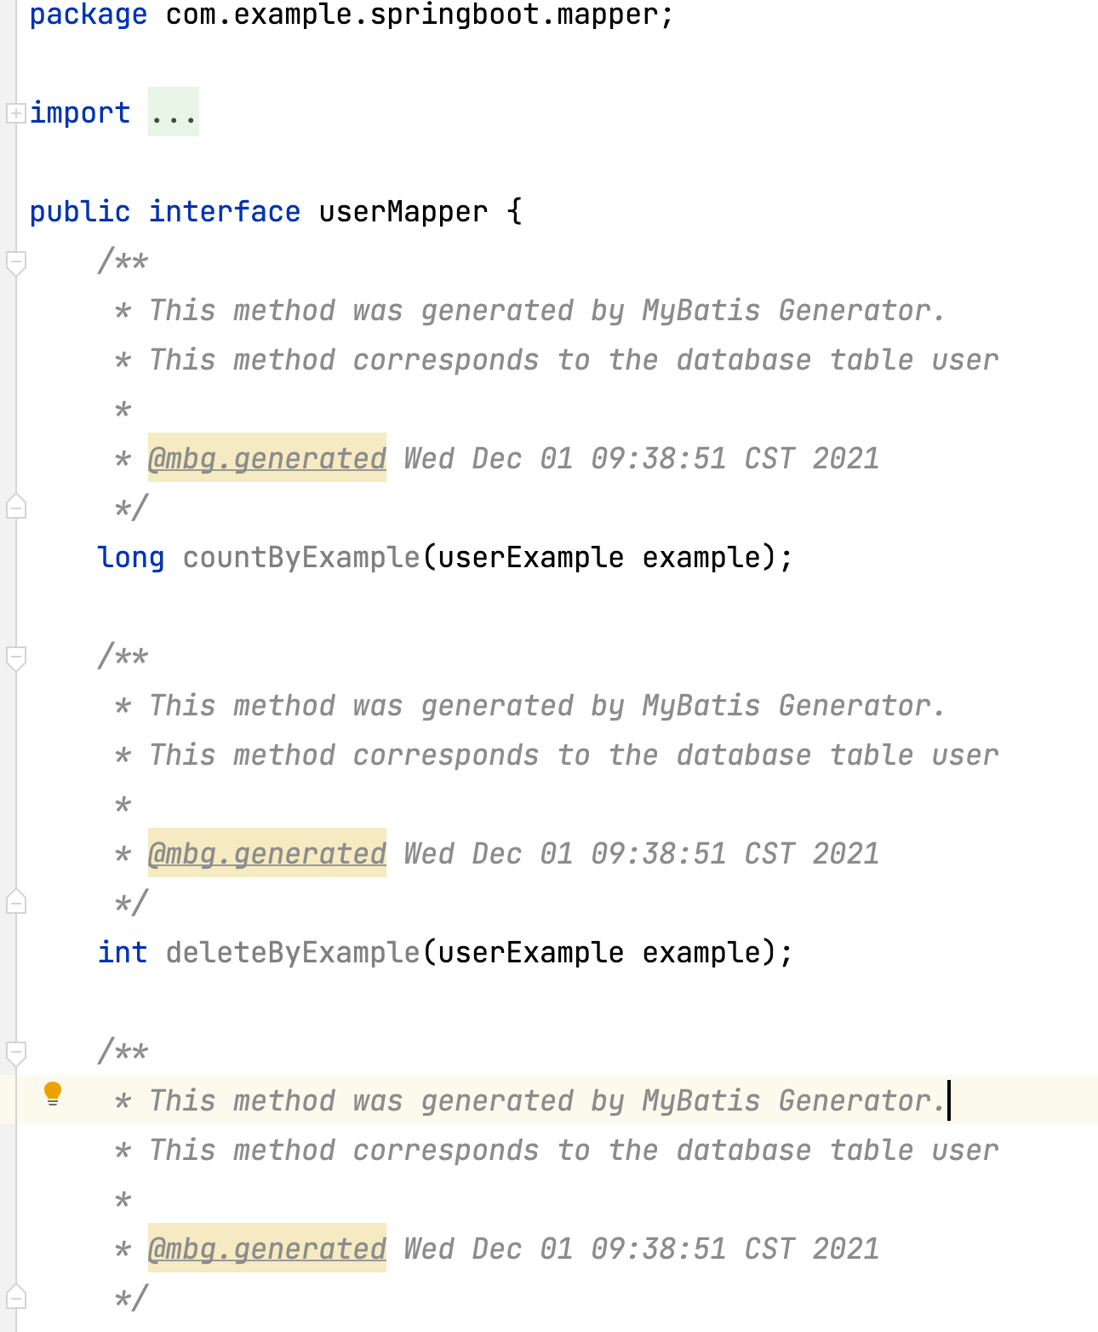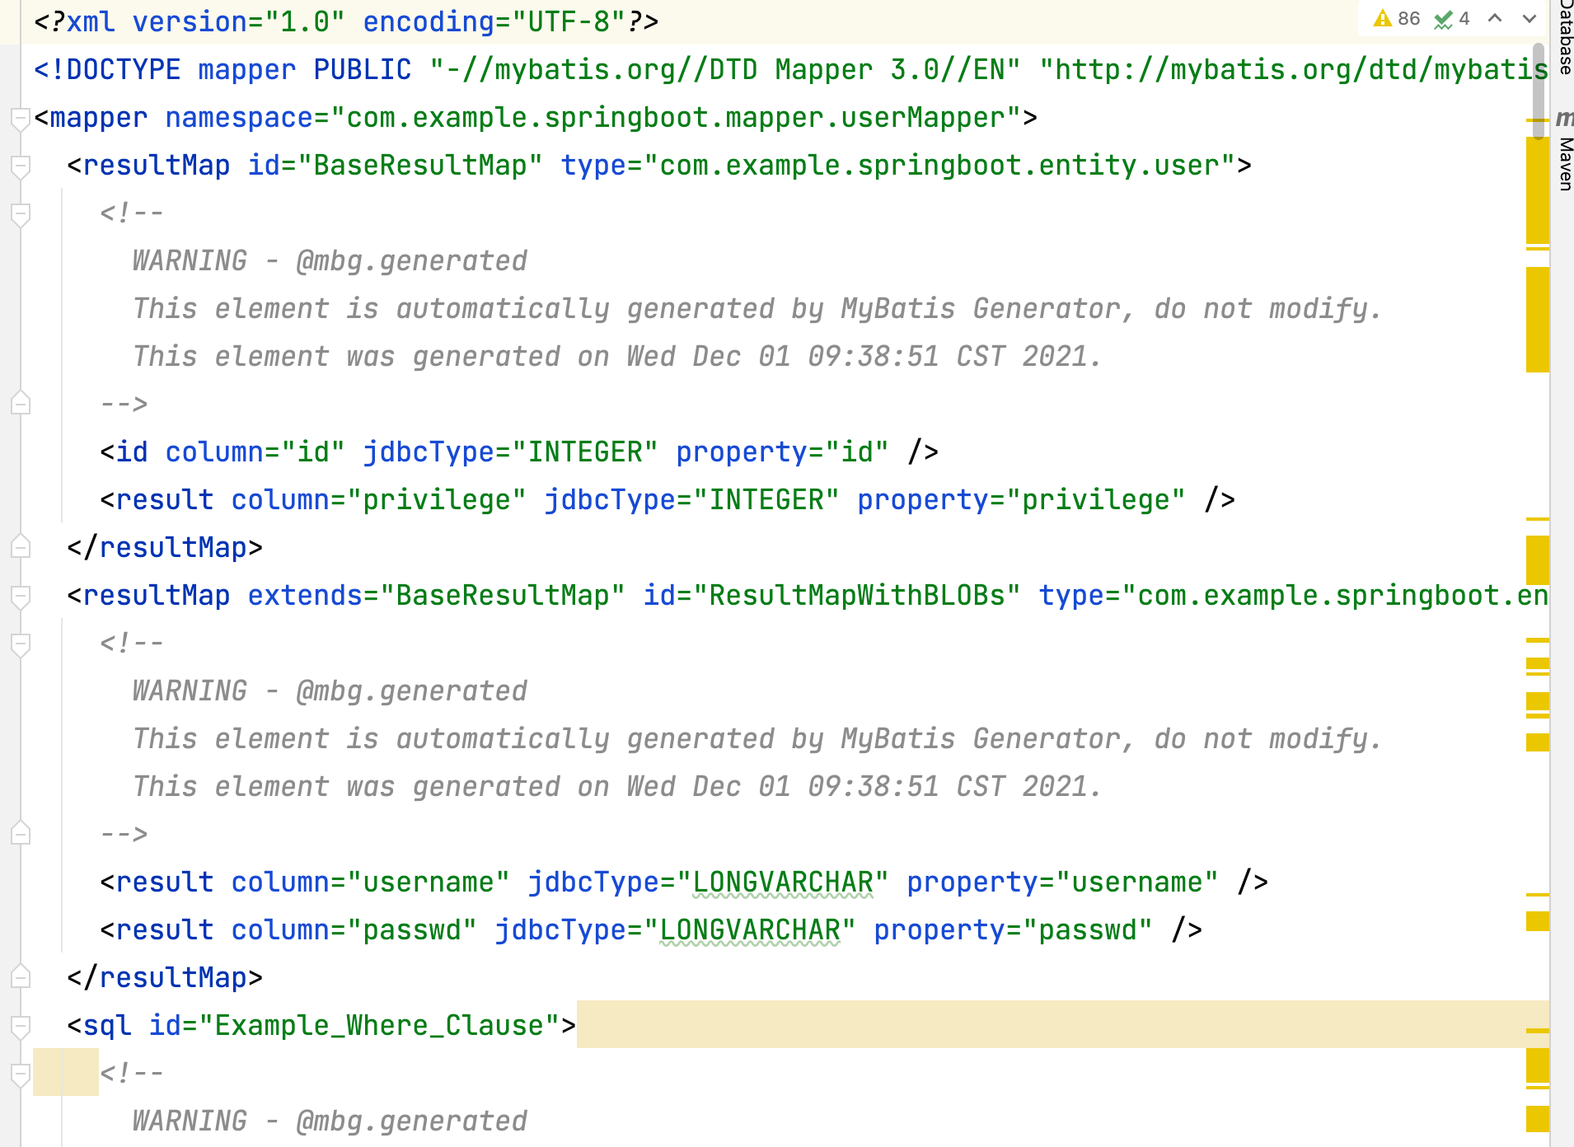

生成的BookMapper文件

