1 实验 Spring Boot Cache使用和Redis基本使用

|  |  |  |  |  |  |
| --- | --- | --- | --- | --- | --- |
| 学号 | 1910705127 | 姓名 | 宋宇昕 | 班级 | 19软件1班 |
| 上课地点 | 精工楼 | 教师 | 孟昭睿 | 上课时间 | 12.6 |

User数据库文件

CREATE TABLE `cache_user` (

`id` int(255) NOT NULL,

`name` varchar(255) DEFAULT NULL,

`age` int(255) DEFAULT NULL,

`date` datetime DEFAULT NULL,

`if_use` tinyint(1) DEFAULT '0',

PRIMARY KEY (`id`)

) ENGINE=InnoDB DEFAULT CHARSET=utf8;

User.java

**package com.example.code.entity;**

**import lombok.Data;**

**import java.util.Date;**

**@Data**

**public class User {**

**private Integer id;**

**private String name;**

**private Integer age;**

**private Date date;**

**private boolean if_use;**

**}**

UserService.java

package com.example.code.service;

import com.example.code.entity.User;

import com.example.code.mapper.UserMapper;

import org.springframework.beans.factory.annotation.Autowired;

import org.springframework.cache.annotation.CacheConfig;

import org.springframework.cache.annotation.CacheEvict;

import org.springframework.cache.annotation.Cacheable;

import org.springframework.stereotype.Service;

@Service

@CacheConfig(cacheNames = "users")

public class UserService {

@Autowired

UserMapper userMapper;

@Cacheable(key = "#p0")

public User selectUser(String id) {

System.out.println("select from datebase");

return userMapper.findById(id);

}

@CacheEvict(key = "#p0",allEntries = true)

public void deleteById(String id) {

System.out.println("delete");

userMapper.deleteById(id);

}

}

UserController文件

package com.example.code.controller;

import com.example.code.entity.User;

import com.example.code.service.UserService;

import org.springframework.beans.factory.annotation.Autowired;

import org.springframework.web.bind.annotation.PathVariable;

import org.springframework.web.bind.annotation.RequestMapping;

import org.springframework.web.bind.annotation.RestController;

@RestController

@RequestMapping("/user")

public class RedisController {

@Autowired

UserService userService;

@RequestMapping("/{id}")

public User ForTest(@PathVariable String id) {

User user = userService.selectUser(id);

if (user!=null) {

System.out.println("User Id:"+user.getName());

} else {

System.out.println("Can't find user");

}

return user;

}

@RequestMapping("/delete/{id}")

public String delete(@PathVariable String id) {

userService.deleteById(id);

return "delete success";

}

}

Redis常用操作

1. 设置变量 ，查找变量，删除变量

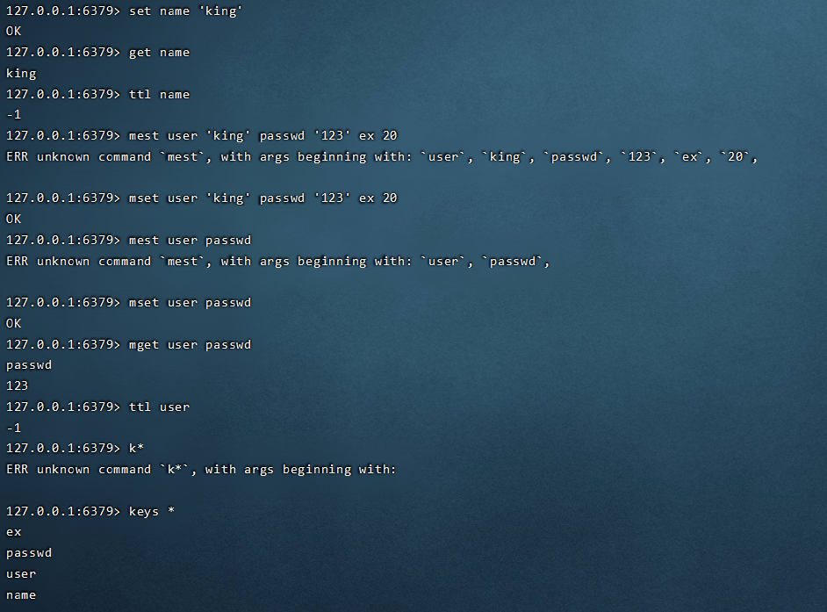

1. Set的使用

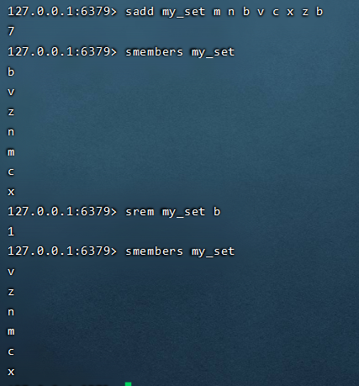

1. List的使用

