

Table of Contents
1. Identification of potential problem 3
1.1. Cell_Phone_Price_Prediction dataset 3
1.2. Wine dataset 3
2. Understandings of data characteristics 4
2.1 Cell_Phone_Price_Prediction dataset characteristics 5
2.2 Wine dataset characteristics 8
3. Data preparation 11
4. Implementing machine learning methods 12
4.1 Cell_Phone_Price_Prediction models 12
4.2 Wine models 13
5. Implementing the models in Azure Machine Learning 13
6. Analysis of model results 16
6.1 Cell_Phone_Price_Prediction results 16
6.1.1. Final validation 17
6.1.2. Analysis insight 18
6.2 Wine results 18
6.2.1. Final validation 19
6.1.2. Analysis insight 20
7. Conclusion 21
8. Reference 22

1. Identification of potential problem

1.1. Cell_Phone_Price_Prediction dataset
The business problem for the cell phone dataset is to classify phones into price categories based on their technical specifications such as RAM, battery capacity, screen size, processor-related features and camera capability. In a real business setting, this problem matters for smartphone manufacturers, retailers and e-commerce platforms. A reliable classifier can support new product positioning, competitor benchmarking, faster assortment planning and pricing strategy (Ahmed Mahoto et al. 2021). Instead of relying only on expert judgement, firms can use historical patterns to estimate which specification bundles are associated with low, medium or premium price segments. This improves pricing consistency and reduces the risk of launching products at the wrong value tier (Ahmed Mahoto et al. 2021).
Machine learning provides a data-driven solution because the relationship between technical features and final price category is multivariate. Customers do not respond to RAM, battery power or display resolution in isolation; they respond to a bundle of specifications that collectively signal quality. A supervised learning model can identify these patterns and learn decision boundaries between price classes more consistently than manual rules (Shetty et al. 2022). The output is actionable because it helps decision-makers answer practical questions such as: “If we increase RAM and camera quality but keep battery power constant, does the phone move into a higher segment?” This directly aligns with evidence-based pricing and product portfolio management.

1.2. Wine dataset
The wine dataset’s objective is not to predict a known target for future observations, but to discover natural groupings of wines based on chemical attributes such as alcohol, phenols, flavonoids and proline. In commercial terms, clustering can support product differentiation, inventory segmentation, targeted marketing and quality profiling (Kasem et al. 2024). For example, wineries, distributors or specialty retailers can use cluster profiles to separate wines into chemically distinct groups that may correspond to style, quality perception or production origin.
Machine learning, especially unsupervised learning, is suitable because clustering detects hidden structure in unlabelled data. Chaudhry et al. (2023) stated that even where class labels exist in the historical dataset, clustering remains useful because in real operational settings managers often do not know the “true” groups in advance. The technique can therefore reveal whether wines naturally separate into meaningful categories, and which variables are most influential in that separation (Chaudhry et al. 2023). This is valuable for market segmentation and product portfolio decisions by transforming complex chemical data into actionable insights.

2. Understandings of data characteristics
Table 3 summarises the key characteristics of the two datasets before the detailed analysis below.
Table 3: Overview of the two datasets.
Attribute | Cell_Phone_Price_Prediction | Wine
Source | Kaggle (2024) | UCI ML Repository
Observations | 2,000 train / 1,000 test | 178
Variables | 20 predictors + 1 target (price_range) | 13 continuous + 1 class
Task | Supervised classification (4 classes) | Unsupervised clustering (3 groups)
Missing values | 13 (4 in key predictors) | 4
Class balance | Balanced (~500 per class) | 3 natural groups
Strongest signal | RAM (corr ≈ 0.92) | Proline, flavanoids, colour intensity

2.1 Cell_Phone_Price_Prediction dataset characteristics
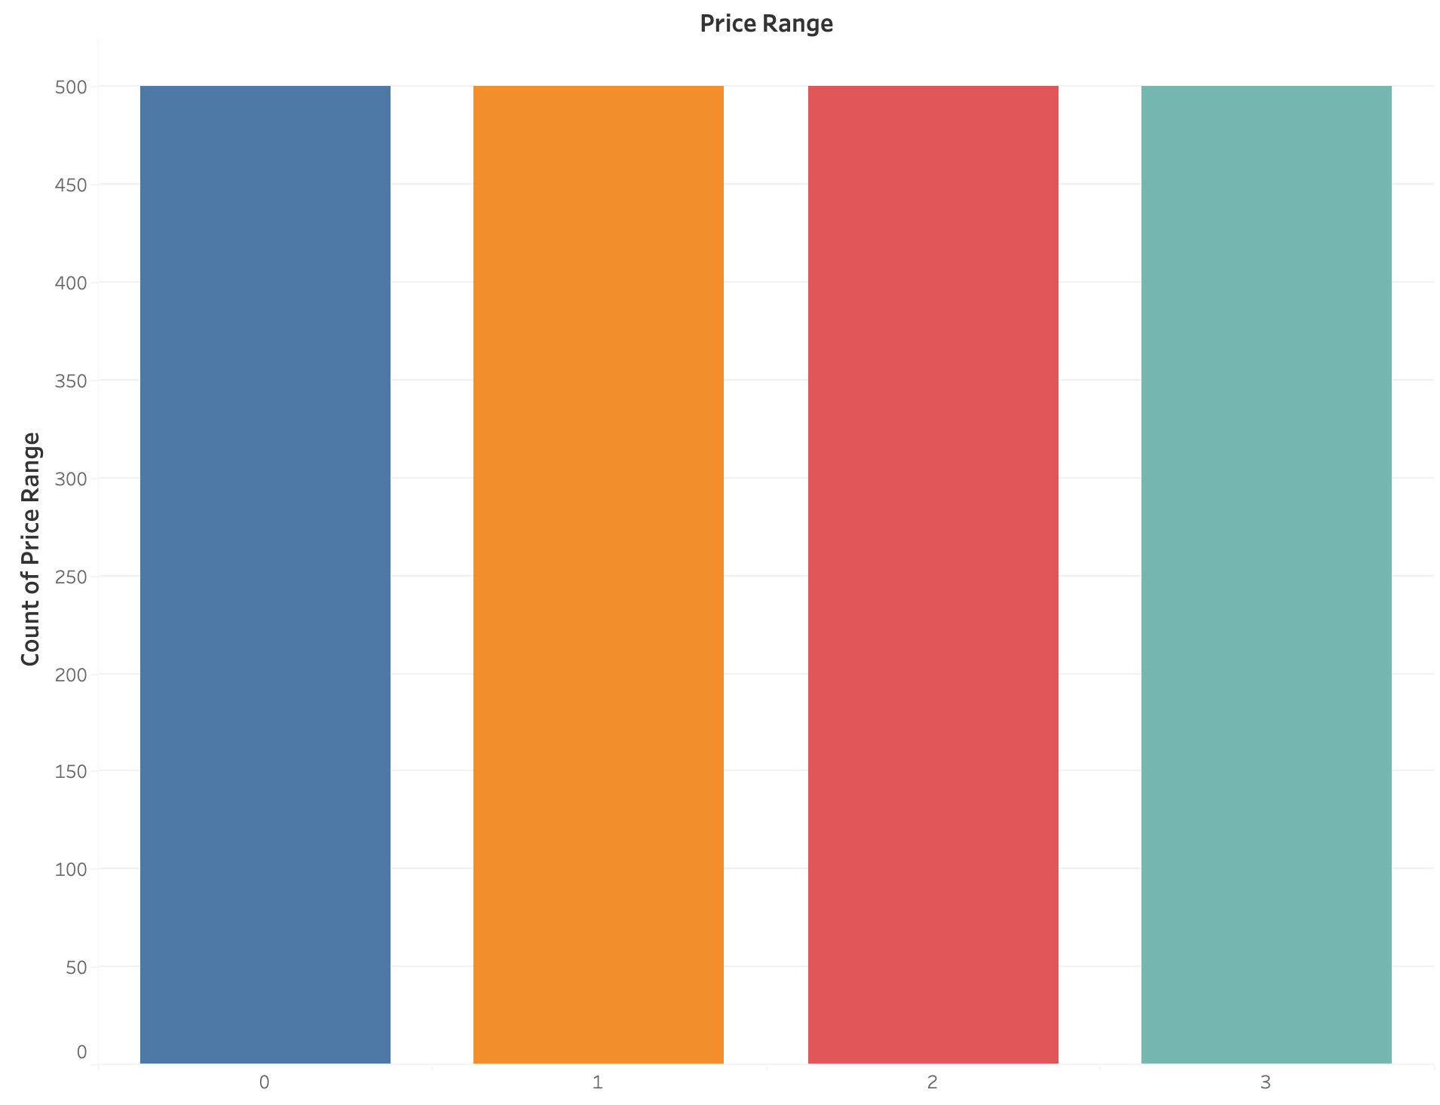
Figure 1: Histogram of price_range distribution.
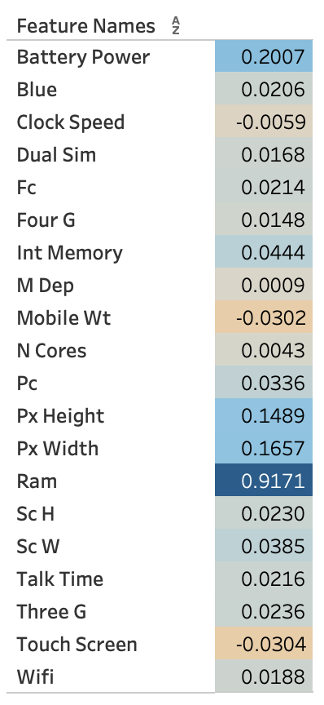
Figure 2: Correlation heatmap of price_range with other attributes.
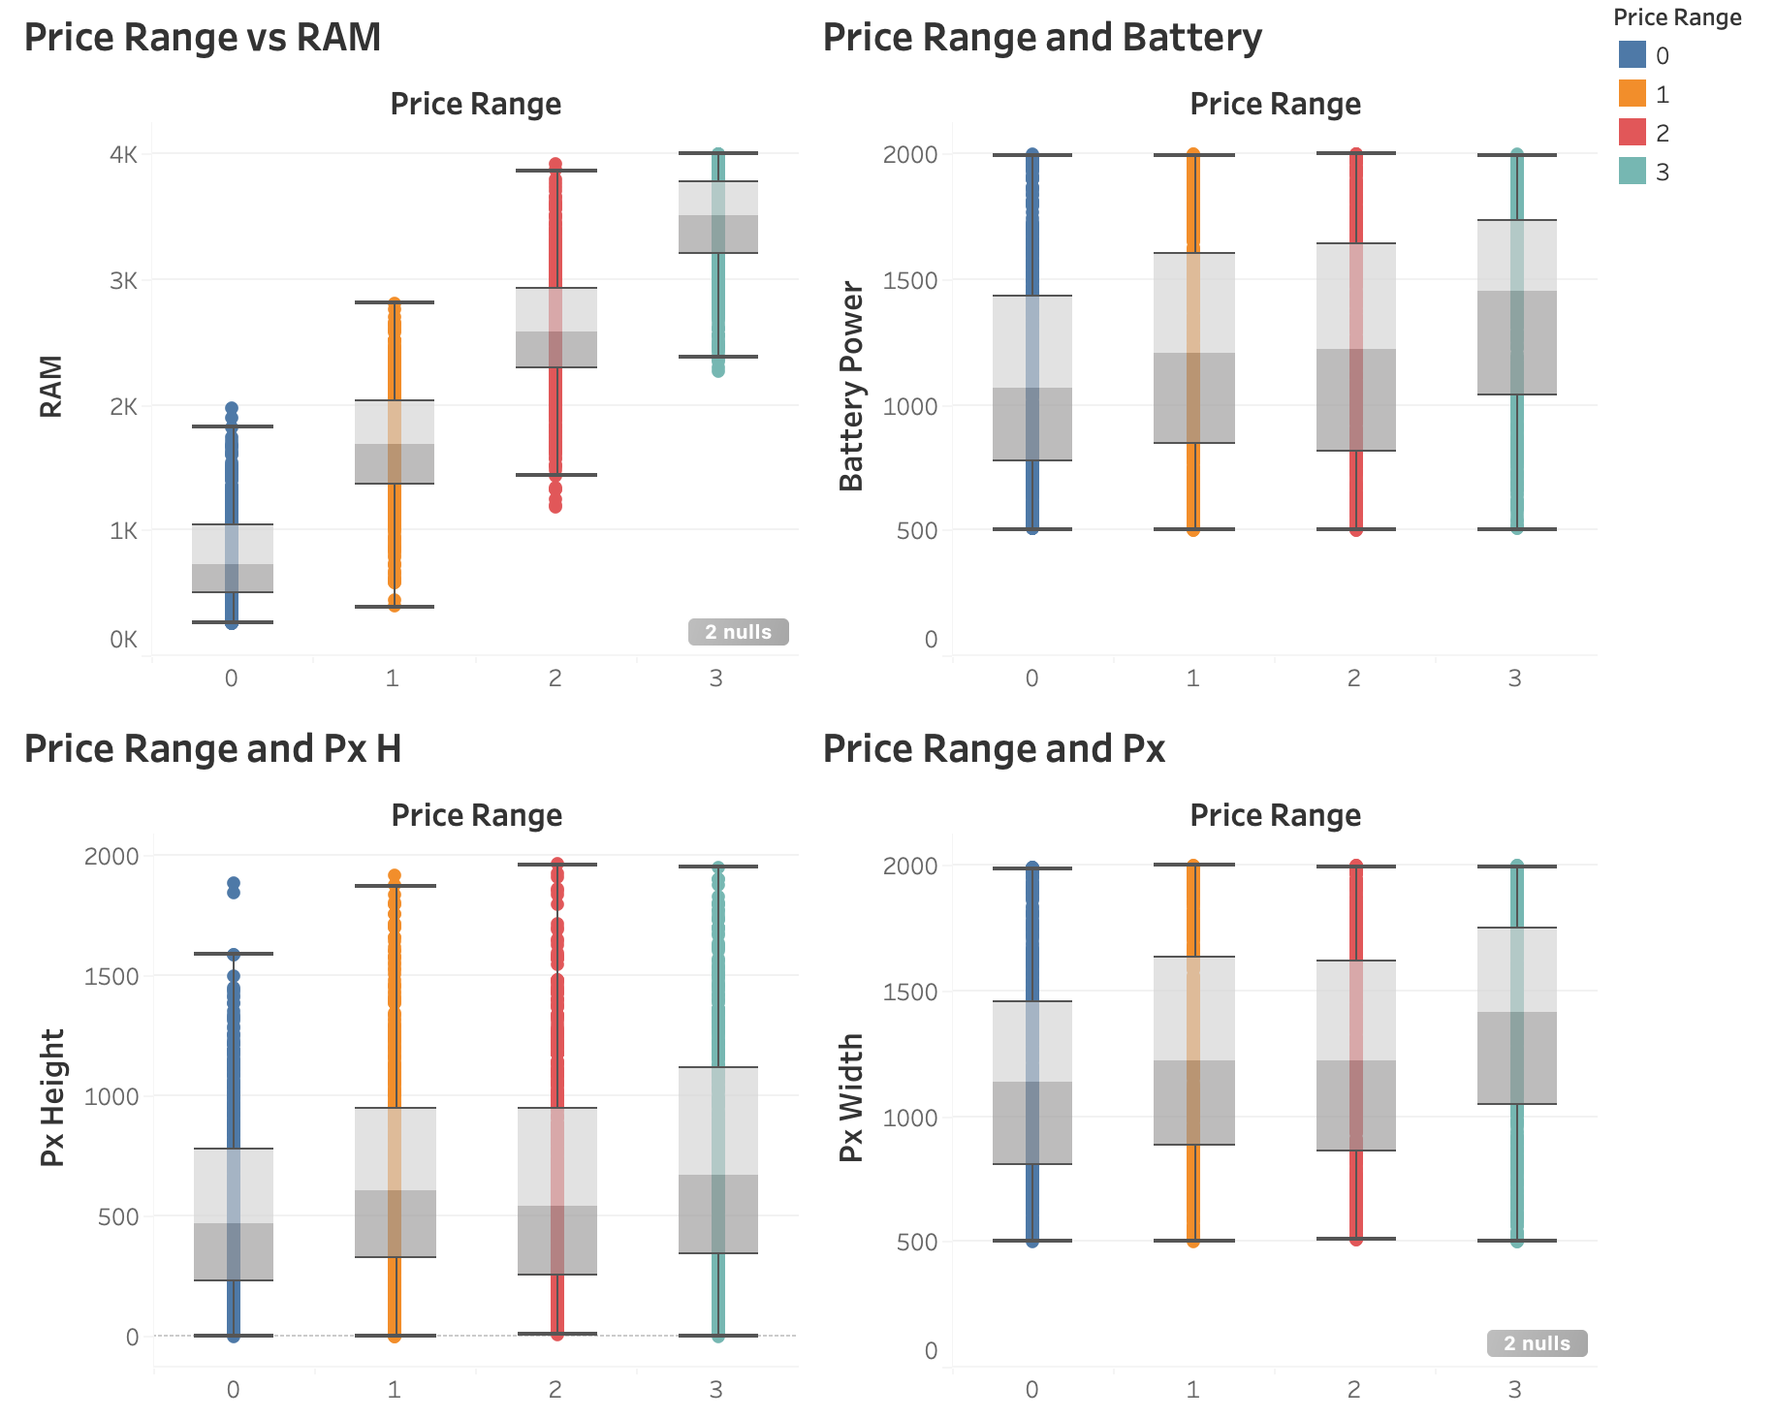Figure 3: Boxplots of price_range and 4 continuously numerical variables.
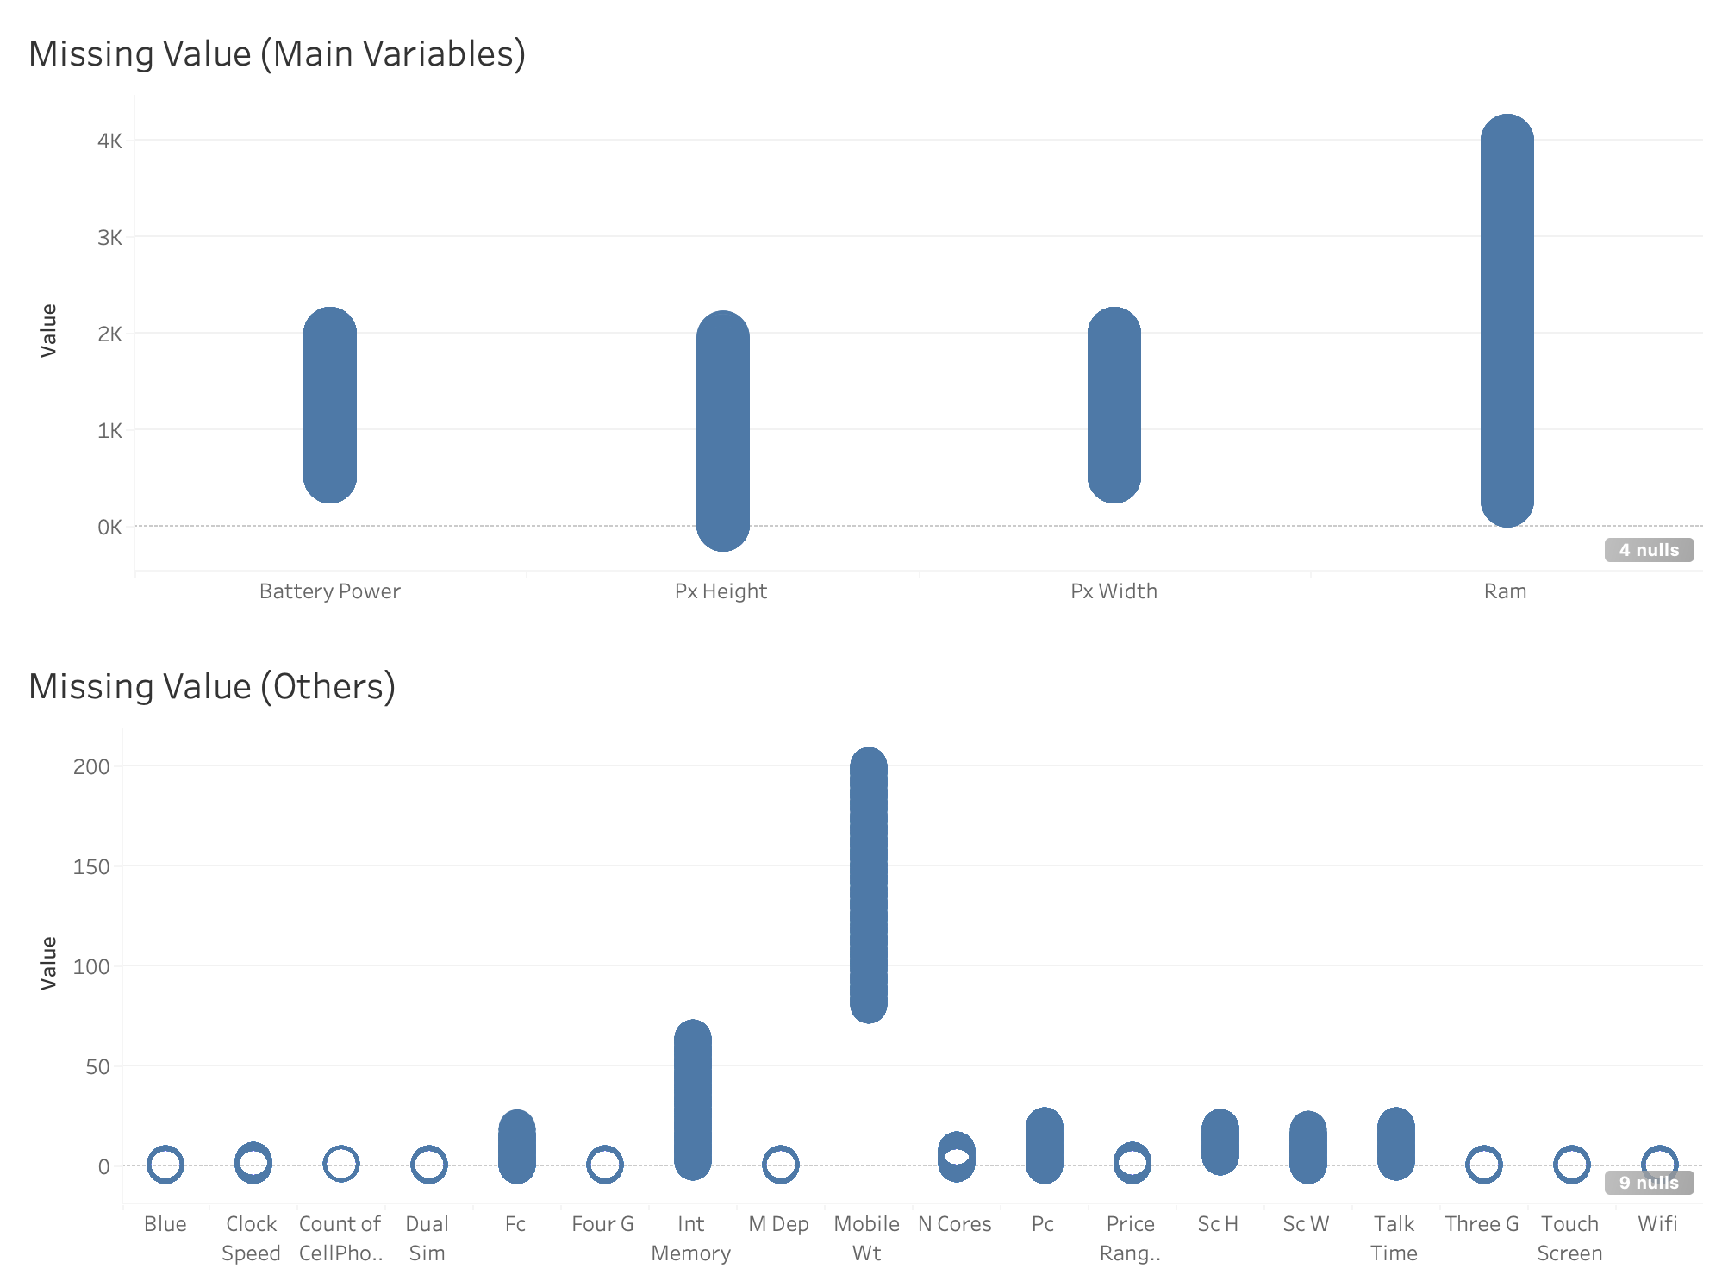
Figure 4: Missing values of Cell_Phone_Price_Prediction training dataset, due to 0 missing values in testing dataset, therefore, no visualisation is indicated.
The datasets are sourced from Kaggle (2024), consisting of a labelled training set with 2,000 observations and an unlabelled testing set of 1,000 observations including an id attribute. The training data includes 20 predictor variables and one target variable (price_range), enabling supervised classification. Most variables are numerical, including key continuous features such as ram, battery_power, px_height, and px_width, along with binary indicators (e.g., dual_sim, wifi), capturing both technical specifications and product characteristics.
Distribution analysis (Figure 1) shows that price_range is evenly distributed across four classes (0–3), indicating a balanced dataset that reduces bias and improves reliability (Dube and Verster 2023). Correlation analysis, commonly used to identify influential features (Kumar and Chong 2018), reveals that RAM has a strong positive relationship with price (~0.92), making it the most significant predictor (Figure 2). Other variables, such as battery power (~0.2), pixel width (~0.17), and pixel height (~0.15), show moderate correlations, while most features contribute minimally.
Boxplots (Figure 3) further confirm that RAM has strong discriminative power, with clear separation across price categories, whereas other variables show partial overlap. Data inspection (Figure 4) identifies only 13 missing values (including 4 in key predictors), which are addressed using median imputation due to its robustness and minimal distortion (Joel et al. 2024). Additionally, scale heterogeneity requires normalisation for models such as logistic regression, while tree-based models remain unaffected [1].
From a business perspective, features such as RAM and display quality are key drivers of price segmentation, supporting their importance in predictive modelling.

2.2 Wine dataset characteristics
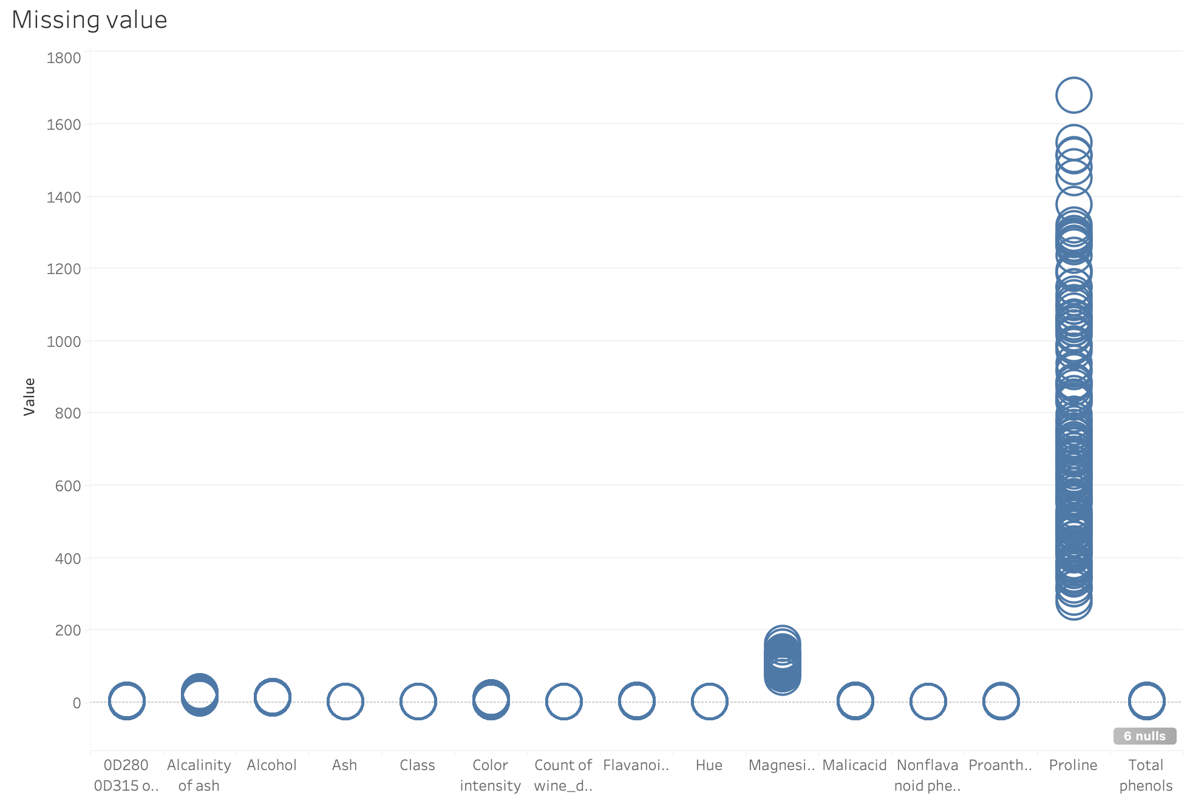
Figure 5: Missing values of Wine dataset.
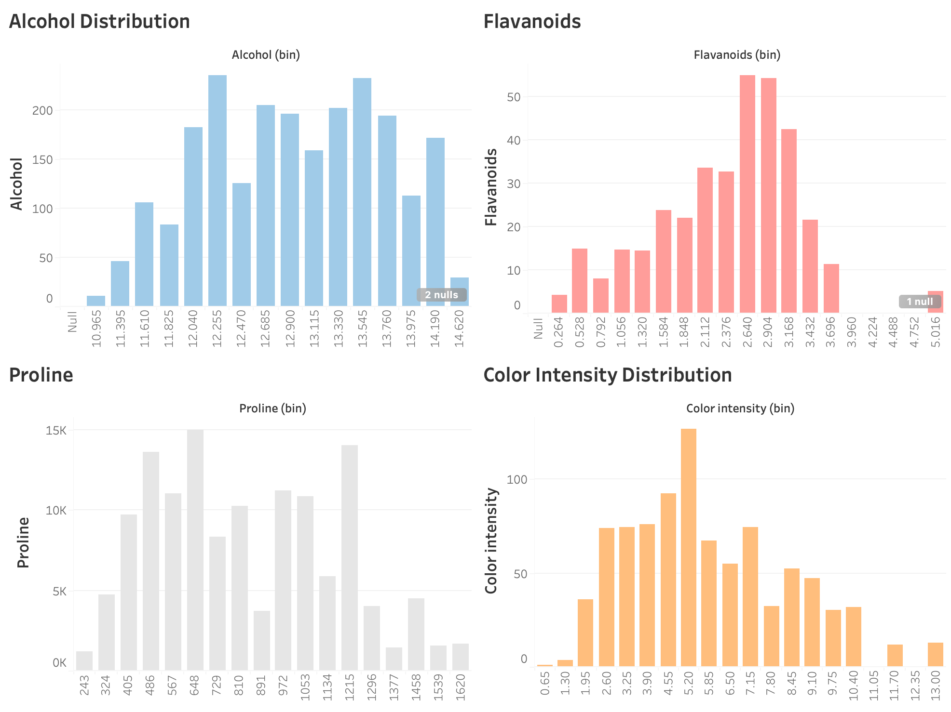Figure 6: Histograms of Alcohol, Proline, Flavanoids, and Color Intensity.
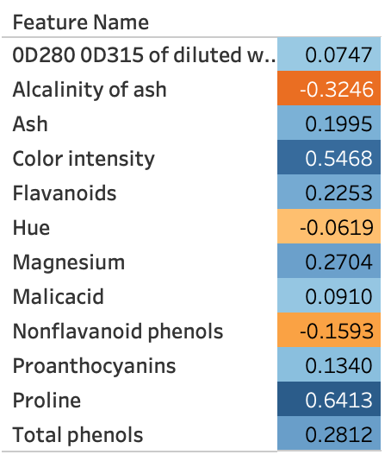
Figure 7: Correlation heatmap of Alcohol with other attributes.
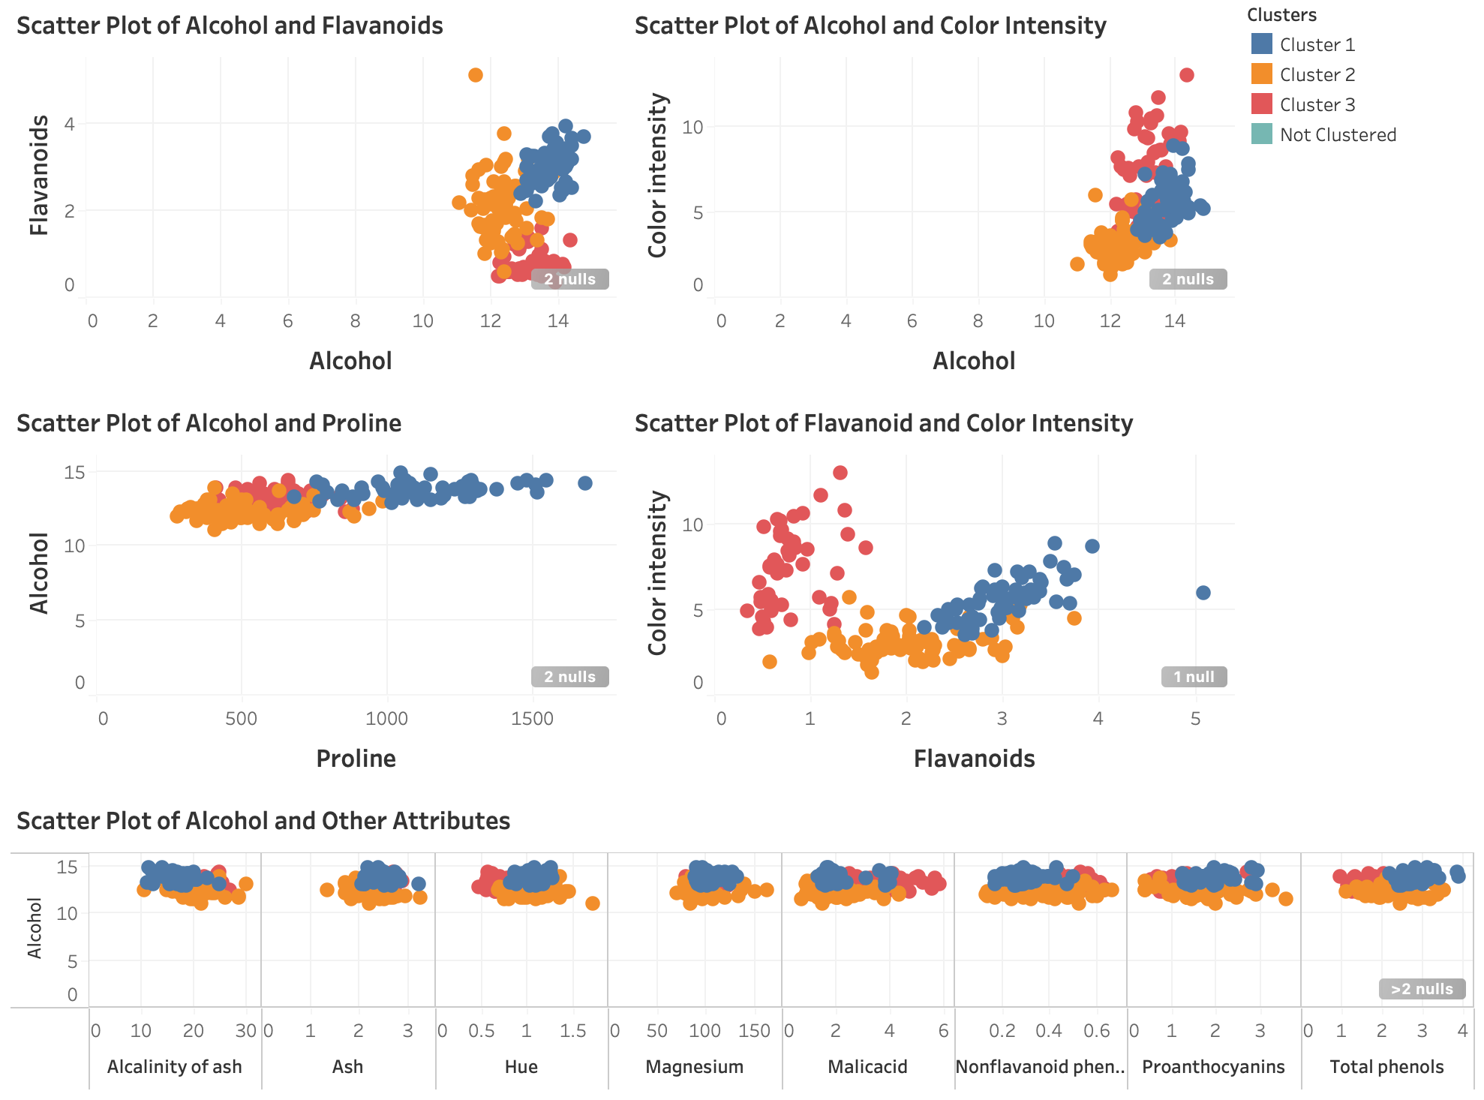Figure 8: Scatter Plot of Alcohol vs Flavanoids, Proline, Color Intensity, Other Attributes and Flavanoids vs Color Intensity.
The Wine dataset, sourced from the UCI Machine Learning Repository, contains 178 observations and 14 variables, including 13 continuous chemical attributes and a class variable with three categories. Key features include alcohol, flavanoids, proline, color intensity, and magnesium, making it a classic multivariate dataset well-suited for clustering, as distance-based methods perform effectively on numerical data (El Habib Kahla et al. 2024). Data inspection (Figure 5) identifies only 4 missing values, indicating high data quality and minimal need for complex imputation (Joel et al. 2024).
Distribution plots (Figure 6) show variability and mild skewness across key variables. Proline exhibits a wide range with potential outliers, while flavanoids and color intensity are more concentrated, suggesting stronger discriminatory power. Although correlation analysis (Figure 7) provides insight into linear relationships, clustering depends on distance and structure. Variables such as lavanoids remain important due to their strong cluster separation, highlighting the limitation of correlation-based evaluation in unsupervised learning (Rickert et al. 2023).
Beyond individual distributions, the relationships between variables are more informative for clustering. The correlation heatmap (Figure 7) shows that proline (≈ 0.64) and colour intensity (≈ 0.55) are most strongly associated with alcohol, whereas hue and non-flavanoid phenols are weak or negative. These pairings indicate that alcohol, proline, flavanoids, and colour intensity tend to move together and jointly define wine style, while low-correlation variables contribute little to group separation. This co-movement, rather than any single distribution, is what allows the three wine groups to emerge as chemically distinct segments.
Scatter plots (Figure 8) further confirm clear cluster structure. Strong separation is observed in alcohol vs flavanoids and color intensity, as well as flavanoids vs color intensity, while alcohol vs proline also shows distinct grouping. Other variables exhibit greater overlap and lower discriminative ability.
From a business standpoint, this separation is directly actionable: the high-alcohol, high-flavanoid, high-proline group (Cluster 1) maps onto a premium segment that can justify higher price positioning and targeted marketing, while the low-value group (Cluster 3) suits volume or entry-level assortment. Because these boundaries are driven by measurable chemical attributes, wineries and distributors can assign new wines to a segment automatically rather than relying on manual tasting judgement.
Based on these patterns, clusters can be meaningfully interpreted: Cluster 1 represents wines with higher alcohol, flavanoids, and proline (premium wines), Cluster 2 reflects moderate attributes (mid-range), and Cluster 3 captures lower values, particularly in flavanoids and proline (lower-quality wines).

3. Data preparation
The data preparation was performed in Microsoft Azure Machine Learning. For the Cell_Phone_Price_Prediction dataset, six sequential steps were applied, summarised in Table 1.
Table 1: Data preparation steps applied in Azure ML for the Cell_Phone_Price_Prediction dataset.
Step | Azure module | Configuration | Rationale
1 | Select Columns in Dataset | All predictor columns | Retain all features for training
2 | Clean Missing Data | Replace with median; exclude Price_Range; remove all-missing columns | Robust to outliers; preserves the distribution
3 | Normalize Data | Z-score; exclude price_range | Standardise heterogeneous scales for scale-sensitive models
4 | Split Data | 80/20 split; randomised; seed 123 | Unbiased holdout evaluation; reproducible
5 | Select Columns (test set) | Exclude Id column | No predictive value; avoids noise
6 | Apply Transformation | Reuse Step 3 transform on test set | Prevent data leakage; consistent scaling

Median imputation was chosen for missing values because of its robustness to outliers and minimal distortion of the underlying distribution; given the low proportion of missing data, no indicator variables were added and any entirely empty columns were removed (Josse et al. 2024). Z-score normalisation was then applied to place all features on a common scale with zero mean and unit variance, which is essential for scale-sensitive models such as logistic regression; compared with min-max scaling it is more robust to outliers and better preserves the distribution (Pranolo et al. 2024). The target variable was excluded from normalisation to avoid distorting the class boundaries. A fixed random seed was used when splitting the data 80/20 to ensure a reproducible and unbiased holdout evaluation (Larcher and Barbosa 2022).
The Apply Transformation step requires particular justification. The normalisation parameters (the mean and standard deviation used for Z-score scaling) are learned only from the training data and then reused on the testing data. If the test set were scaled using its own statistics, information from the test set would leak into preprocessing and produce an over-optimistic, unrealistic evaluation. Reusing the training transformation also reflects real deployment, where a model receives new records individually and cannot recompute scaling from future data (Bouke and Abdullah 2023). This guarantees that the training and testing features share an identical scale, keeping the model comparison fair and the evaluation valid.
For the Wine dataset, the same first four steps were applied: selecting all columns, median imputation, Z-score standardisation excluding the class label, and an 80/20 split. Following Chaudhry et al. (2023), the class variable was withheld from the clustering model because clustering is unsupervised and using target labels would bias the result and artificially inflate performance; the class was retained only for post-hoc evaluation and interpretation of the resulting clusters.

4. Implementing machine learning methods

4.1 Cell_Phone_Price_Prediction models
Two supervised learning models were applied to predict the target variable price_range: Multiclass (Multinomial) Logistic Regression (MLR) and Multiclass Decision Forest (MDF).
MLR was selected as a baseline for its simplicity, interpretability, and effectiveness when relationships between features and the target are approximately linear (Abramovich et al. [2]). Because the dataset is largely numerical and has been standardised, MLR is well-suited to capturing global linear patterns and producing stable, interpretable results, although its assumption of linear decision boundaries may limit its ability to model complex interactions.
In contrast, MDF is an ensemble method equivalent to Random Forest that captures nonlinear relationships and complex feature interactions (Talla et al. 2019; Wang et al. 2023). By aggregating multiple decision trees it reduces variance and improves generalisation while remaining less sensitive to feature scaling (Fulazzaky et al. 2024), making it a useful complement to MLR and enabling a balanced comparison between interpretability and predictive power.
To improve performance, the hyperparameters of each model were tuned, as summarised in Table 2. MLR used L2 regularisation to control complexity and ensure stable convergence (Wen et al. 2023), while MDF was configured with more trees, a controlled depth, and a minimum leaf size to prevent overfitting and improve stability (Becker et al. 2023).
Table 2: Model hyperparameters configured in Azure ML.
Model | Key hyperparameters | Reason
Multiclass Logistic Regression (MLR) | L2 regularisation = 1.0; optimisation tolerance = 1e-07; seed = 123 | Controls complexity; ensures stable convergence
Multiclass Decision Forest (MDF) | Trees = 100; max depth = 10; min leaf = 5; bagging resampling | Reduces variance; prevents overfitting
K-Means Clustering | Centroids = 3 (and 4 for comparison); K-Means++ init; Euclidean distance; normalise = True; iterations = 100; seed = 123 | Stable convergence; fair distance calculation; reproducible

4.2 Wine models
A single clustering model, K-Means, was applied to the Wine dataset because of its effectiveness in identifying inherent group structures in numerical data and minimising within-cluster variance; K-Means partitions data into a predefined number of clusters, with silhouette analysis commonly used to determine the optimal value (Ikotun et al. 2023).
The model was configured with K-Means++ initialisation to improve convergence stability and Euclidean distance as the similarity metric (Coates et al. 2012). Feature normalisation ensured fair distance calculations across variables of different scales, and a fixed random seed (123) ensured reproducibility; the full settings are listed in Table 2.
Two K-Means models were built deliberately as a validation strategy rather than out of redundancy. Because the optimal number of clusters is unknown in a genuine unsupervised setting, K = 3 (matching the dataset's three known classes) was compared against an over-segmented K = 4. Running both configurations makes it possible to demonstrate empirically, through the separation and cohesion metrics reported in Section 6, that K = 3 yields more meaningful, stable, and well-separated clusters rather than simply assuming it. This comparison provides the evidence that justifies selecting K = 3 as the final model.

5. Implementing the models in Azure Machine Learning

For the Cell_Phone_Price_Prediction workflow in Azure, the applied pipeline below (Figure 9).
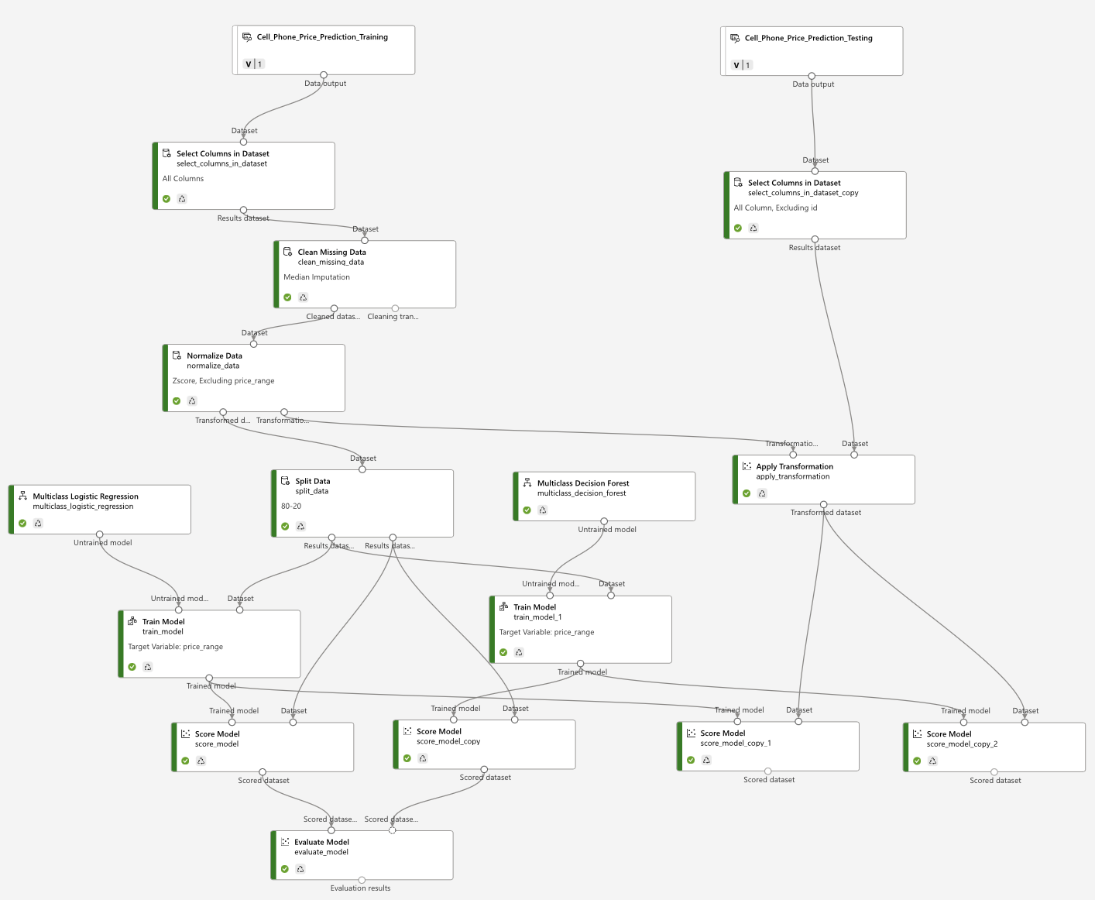Figure 9: Successfully configured pipeline for Cell_Phone_Price_Prediction datasets in Azure.

For the wine workflow in Azure, the applied pipeline below (Figure 10).
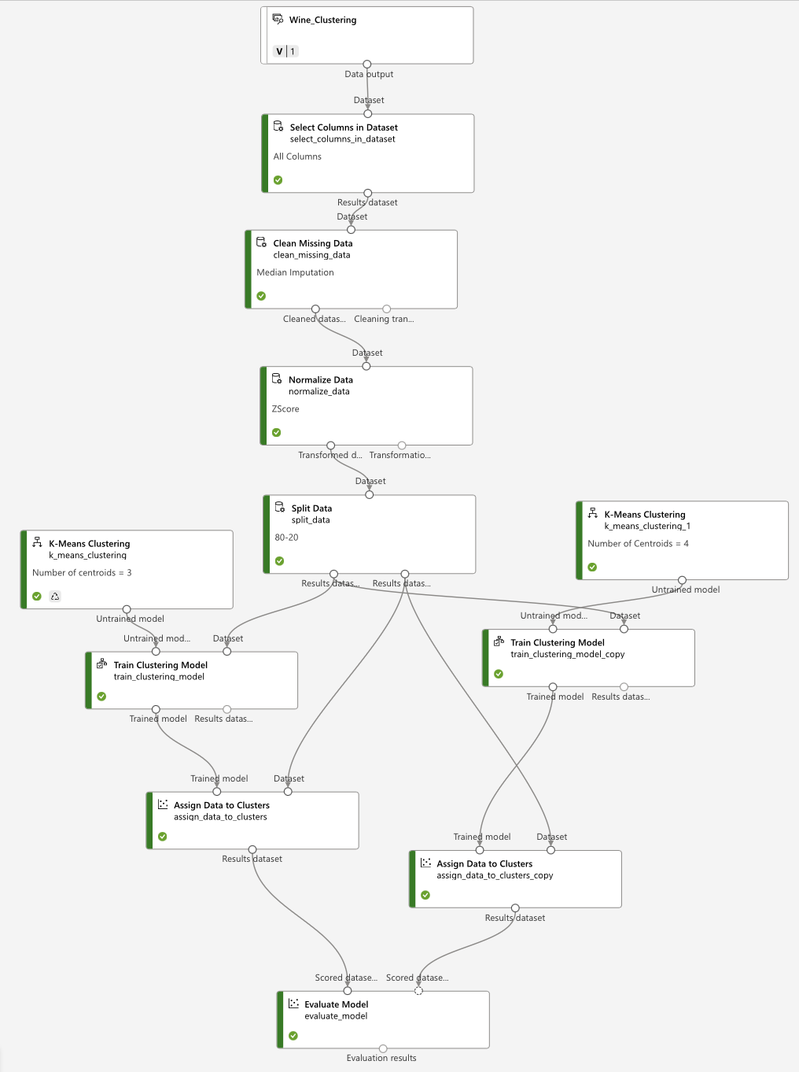
Figure 10: Succesfully configured pipeline for Wine datasets in Azure.

6. Analysis of model results

6.1 Cell_Phone_Price_Prediction results
For the cell phone dataset, the key evaluation metrics are accuracy, precision, and recall.
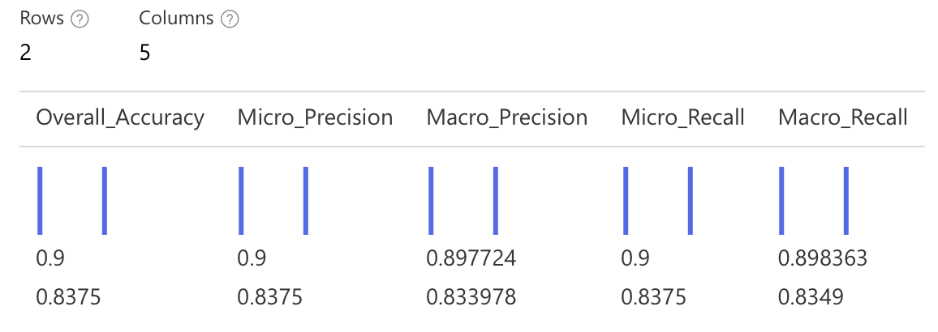Figure 11: Evaluation result for MLR (Row Above) and MDF (Row Below).
Evaluation metrics such as accuracy, precision, and recall are derived from the confusion matrix, which summarises the relationship between predicted and actual labels. Although only aggregated metrics are displayed, these values are internally computed from the confusion matrix (Riehl et al. 2023).
According to Figure 11, MLR consistently outperforms MDF across all metrics, achieving an accuracy of 0.90 compared to 0.8375. It also records higher micro and macro precision and recall, indicating stronger predictive performance and more balanced classification across price categories. This suggests that MLR generalises more effectively and reduces class-specific bias.
The superior performance of MLR indicates that the relationship between technical specifications and price_range is largely linear. As a linear model, MLR effectively captures these relationships through weighted feature combinations after normalisation, producing stable and consistent predictions (Nieus et al. 2022).
In contrast, MDF’s lower performance suggests that complex non-linear interactions are less critical in this dataset or may lead to overfitting. Despite its ability to model complexity, this does not translate into improved performance (Vallée et al. 2023). Therefore, MLR is selected as the best-fit model, offering higher accuracy, consistency, and practical interpretability.

6.1.1. Final validation
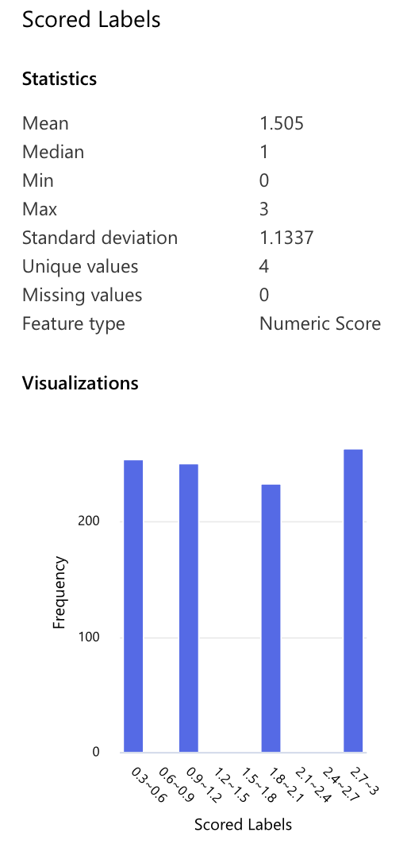
Figure 12: MDF’s score label of trained model transformed into testing dataset.
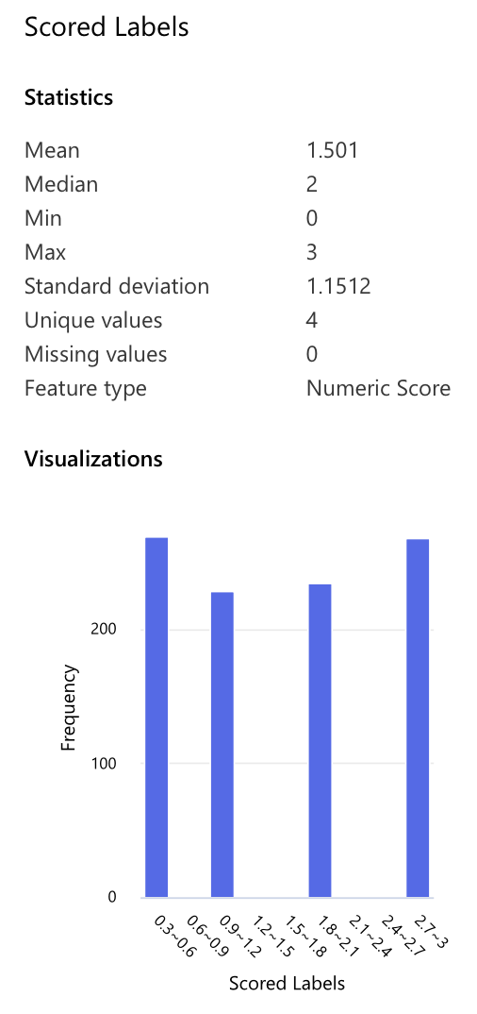
Figure 13: MLR’s score label of trained model transformed into testing dataset.
For MDF, the scored labels show a relatively balanced distribution across all price categories, with a mean of 1.505 and median of 1 (Figure 12). The standard deviation of 1.1337 indicates moderate variability, suggesting the model can differentiate across classes without collapsing predictions into a narrow range.
In contrast, MLR produces a distribution with a mean of 1.501 and median of 2 (Figure 13), indicating a slight shift towards higher price categories. Its slightly higher standard deviation (1.1512) suggests more dispersed and less balanced predictions (Figure 13).
However, despite MDF’s more balanced output, MLR achieves significantly higher accuracy and more consistent precision and recall (Owusu-Adjei et al. 2023). This indicates stronger alignment with true class labels, while MDF’s balanced distribution does not translate into higher predictive correctness.

6.1.2. Analysis insight
Overall, the results confirm that MLR provides more reliable performance on unseen data. Although MDF produces a more balanced prediction distribution, this does not lead to higher accuracy or better alignment with true labels. In contrast, MLR achieves superior accuracy, precision, and recall, indicating stronger generalisation and more consistent class discrimination. This aligns with the dataset’s characteristics, which exhibit largely linear relationships, particularly the strong correlation between RAM and price (~0.92), making MLR more effective in capturing underlying patterns and delivering accurate predictions.

6.2 Wine results
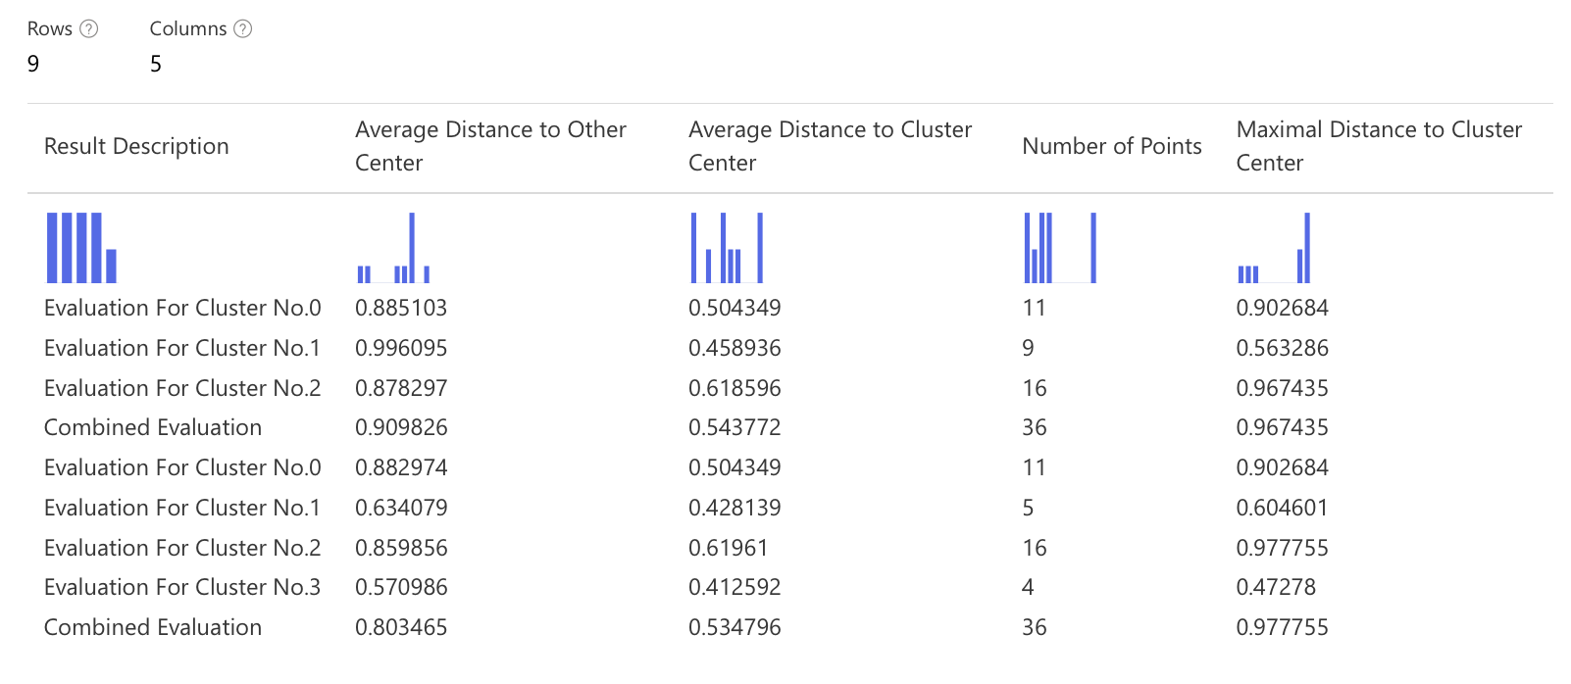Figure 14: Evaluation result for K-mean Clustering with K=3 (the first 4 rows) and K=4 (the rest rows below).
Figure 14 presents the evaluation results for K-Means clustering with K=3 and K=4. The results indicate that the model with K=3 provides superior clustering performance compared to K=4. Specifically, K=3 achieves a higher average distance to other cluster centres (0.9098 against 0.8035), indicating stronger separation between clusters. At the same time, the average distance to cluster centre remains comparable between the two models (~0.54), suggesting that both configurations maintain a similar level of cohesion.
From a data perspective, this result is highly consistent with the structure of the wine dataset, where the true labels (class) are naturally divided into three distinct groups. Therefore, setting K=3 allows the model to align closely with the inherent data structure, resulting in more meaningful and well-defined clusters. In contrast, increasing K to 4 forces the model to artificially split existing groups, leading to weaker separation and less stable clustering patterns.

6.2.1. Final validation
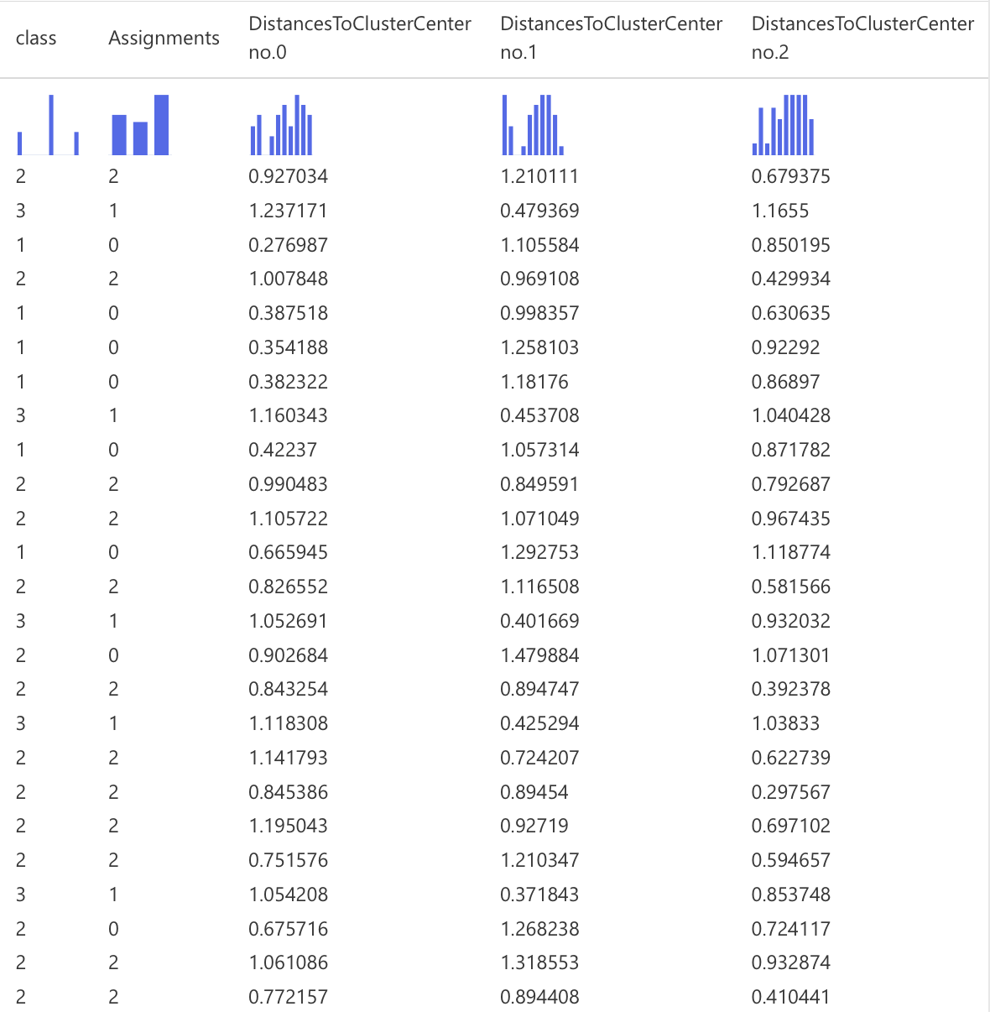
Figure 15: Results for K=3 in Assign Data to Cluster in Azure.
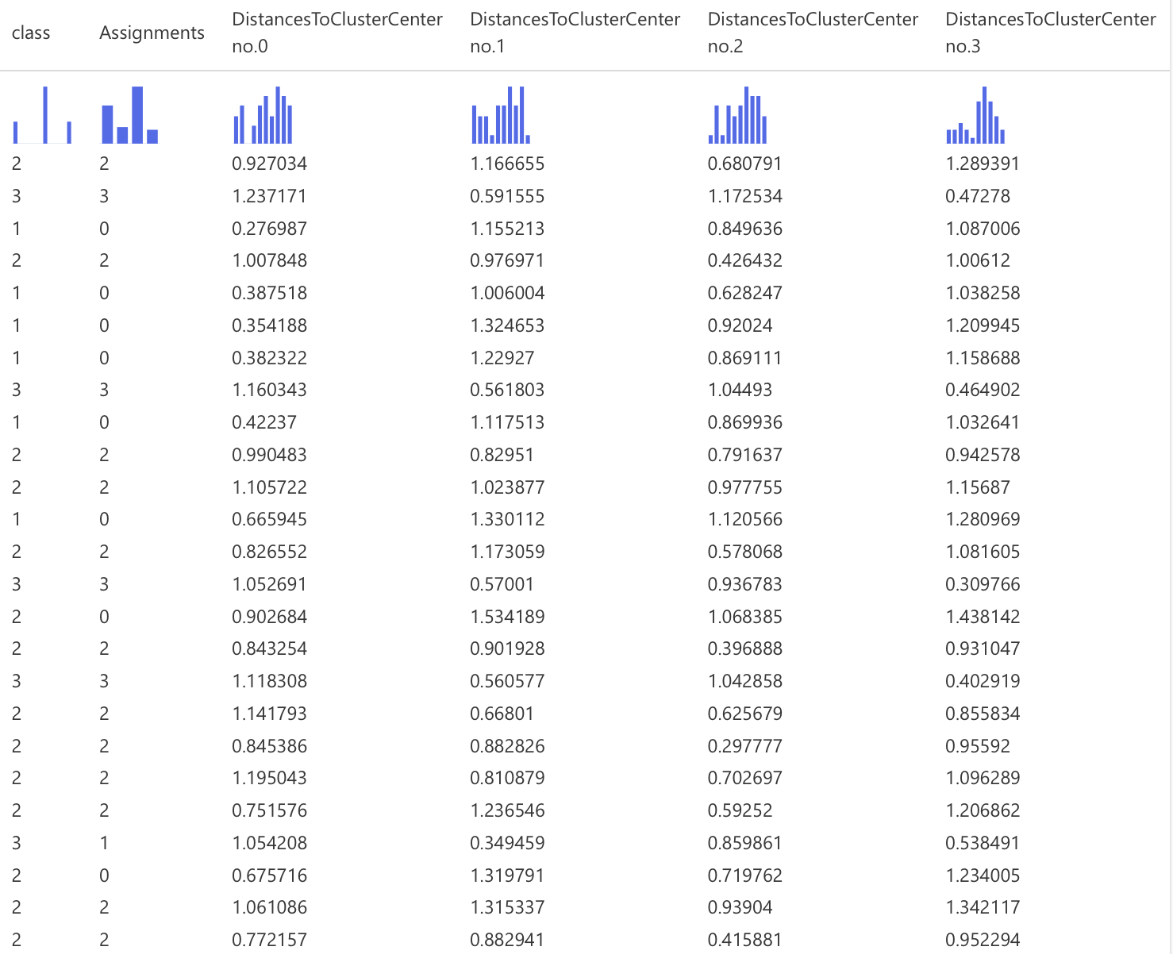
Figure 16: Result for K=4 in Assign Data to Cluster in Azure.
The clustering results for K=3 provide strong validation of model effectiveness. The Assign Data to Clusters output shows a clear alignment between cluster assignments and true class labels, where each cluster predominantly corresponds to a single class with minimal overlap (Figure 15). This indicates well-defined and compact clusters. Distance measures further support this, with smaller intra-cluster distances and larger inter-cluster distances, confirming strong cohesion and separation.
In contrast, K=4 shows weaker alignment, as observations from the same class are split across multiple clusters—for example, Class 2 across Clusters 2 and 0, and Class 3 across Clusters 3 and 1 (Figure 16). This fragmentation indicates over-segmentation, reduces interpretability, and introduces small, unstable clusters with limited practical value (Figure 16).

6.1.2. Analysis insight
The evaluation results and final validation confirm that K-Means with K=3 is the optimal clustering model for the wine dataset. It demonstrates strong cluster separation and cohesion, with cluster assignments closely aligned to true class labels, indicating high cluster purity and meaningful segmentation. In contrast, K=4 results in over-segmentation, where observations from the same class are split across multiple clusters, reducing interpretability and stability. From a business perspective, K-Means with an appropriate number of centroids effectively supports wine categorisation for differentiation and decision-making. This outcome is also consistent with the dataset’s structure, which naturally forms three distinct groups, showing that K-Means can successfully recover underlying patterns without label information. Therefore, K=3 provides a robust, interpretable, and practically relevant clustering solution.

7. Conclusion
This report demonstrates how machine learning can effectively address different business problems by aligning model choice with data characteristics and objectives. For the cell phone dataset, the analysis shows that MLR performs best, achieving higher accuracy and more consistent predictions than MDF. This indicates that phone price categories are largely driven by stable relationships between technical features such as RAM and battery capacity. As a result, MLR is recommended to support pricing decisions, product positioning, and portfolio planning. For the wine dataset, K-Means clustering with K = 3 is identified as the optimal solution, producing clear and well-separated clusters that align closely with the natural grouping of the data and enable meaningful segmentation.
Importantly, Azure Machine Learning played a key role in this analysis by enabling an end-to-end, visual workflow for data preparation, model building, and evaluation. This not only improved efficiency but also ensured transparency and reproducibility of results. Overall, the findings highlight that with appropriate tools and model selection, machine learning can deliver reliable and actionable insights for business decision-making.

8. Reference
[1] Mahmud Sujon K, Binti Hassan R, Tusnia Towshi Z, Othman MA, Abdus Samad M and Choi K, “When to Use Standardization and Normalization: Empirical Evidence From Machine Learning Models and XAI”, IEEE access, 12: 135300-135314, Oct 2024 doi: 10.1109/ACCESS.2024.3462434
[2] Abramovich F, Grinshtein V and Levy T, “Multiclass Classification by Sparse Multinomial Logistic Regression”, IEEE transactions on information theory, 67 (7): 4637-4646, Apr 2021, doi: 10.1109/TIT.2021.3075137
Ahmed Mahoto N, Iftikhar R, Shaikh A, Asiri Y, Alghamdi A and Rajab K (2021) ‘An Intelligent Business Model for Product Price Prediction Using Machine Learning Approach’, Intelligent automation and soft computing, 29 (3): 147-159, doi: 10.32604/iasc.2021.018944
Becker T, Rousseau AJ, Geubbelmans M, Burzykowski T and Valkenborg D (2023) ‘Decision trees and random forests’, American journal of orthodontics and dentofacial orthopedics, 164 (6): 894-897, doi: 10.1016/j.ajodo.2023.09.011
Bouke MA and Abdullah A (2023) ‘An empirical study of pattern leakage impact during data preprocessing on machine learning-based intrusion detection models reliability’, Expert systems with applications, 230: 120715, Science Direct Open Access Journal Website, accessed 26 March 2026, doi: 10.1016/j.eswa.2023.120715
Chaudhry M, Shafi I, Mahnoor M, Vargas DLR, Thompson EB and Ashraf I (2023) ‘A Systematic Literature Review on Identifying Patterns Using Unsupervised Clustering Algorithms: A Data Mining Perspective’, Symmetry (Basel), 15 (9): 1679, MPDI Open Access Journal Website, accessed 26 March 2026, doi: 10.3390/sym15091679
Coates A, Ng AY, Montavon G, Orr GB and Müller KR (2012) ‘Learning Feature Representations with K-Means', Neural Networks: Tricks of the Trade, 561-580, doi: 10.1007/978-3-642-35289-8_30
Dube L and Verster T (2023) ‘Enhancing classification performance in imbalanced datasets: A comparative analysis of machine learning models’, Data science in finance and economics, 3 (4): 354-379, doi: 10.3934/DSFE.2023021
El Habib Kahla M, Beggas M, Laouid A and Hammoudeh M (2024) ‘A Nature-Inspired Partial Distance-Based Clustering Algorithm’, Journal of sensor and actuator networks, 13 (4): 36, MPDI Open Access Journal Website, accessed 26 March 2026, doi: 10.3390/jsan13040036
Fulazzaky T, Saefuddin A and Soleh AM (2024) ‘Evaluating Ensemble Learning Techniques for Class Imbalance in Machine Learning: A Comparative Analysis of Balanced Random Forest, SMOTE-RF, SMOTEBoost, and RUSBoost’, Scientific journal of informatics (Semarang), 11 (4): 969-980, doi: 10.15294/sji.v11i4.15937
Ho SY, Phua K, Wong L and Bin Goh WW (2020) ‘Extensions of the External Validation for Checking Learned Model Interpretability and Generalizability’, Patterns, 1 (8): 100129, doi: 10.1016/j.patter.2020.100129
Ikotun AM, Ezugwu AE, Abualigah L, Abuhaija B and Heming J (2023) ‘K-means clustering algorithms: A comprehensive review, variants analysis, and advances in the era of big data’, Information sciences, 622: 178-210, doi: 10.1016/j.ins.2022.11.139
Joel LO, Doorsamy W and Paul BS (2024) On the Performance of Imputation Techniques for Missing Values on Healthcare Datasets, arXiv Open Access Journal Website, accessed 26 March 2026, doi: https://doi.org/10.48550/arXiv.2403.14687
Josse J, Chen JM, Prost N, Varoquaux G and Scornet E (2024) ‘On the consistency of supervised learning with missing values’, Statistical papers (Berlin, Germany), 65 (9): 5447-5479, Springer Nature Link Open Access Journal Website, accessed 26 March 2026, doi: 10.1007/s00362-024-01550-4
Kaggle (2024), Cell Phone Price [dataset], Kaggle website, accessed 26 March 2026, https://www.kaggle.com/datasets/atefehmirnaseri/cell-phone-price
Kasem MS, Hamada M and Taj-Eddin I (2024) ‘Customer profiling, segmentation, and sales prediction using AI in direct marketing’, Neural computing & applications, 36 (9): 4995-5005, doi: 10.1007/s00521-023-09339-6
Kumar S and Chong I (2018) ‘Correlation Analysis to Identify the Effective Data in Machine Learning: Prediction of Depressive Disorder and Emotion States’, International journal of environmental research and public health, 15 (12): 2907, MDPI Open Access Journal Website, accessed 26 March 2026, doi: 10.3390/ijerph15122907
Larcher CHN and Barbosa HJC (2022) ‘Evaluating Models with Dynamic Sampling Holdout in Auto-ML', SN computer science, 3 (6): 506, Springer Nature Link Open Access Journal Website, accessed 26 March 2026, doi: 10.1007/s42979-022-01406-4
Nieus T, Borgonovo D, Diwakar S, Aletti G and Naldi G (2022) ‘A multi-class logistic regression algorithm to reliably infer network connectivity from cell membrane potentials’, Frontiers in applied mathematics and statistics, Vol. 8, Frontier Open Access Journal Website, accessed 27 March 2026, doi: https://doi.org/10.3389/fams.2022.1023310
Owusu-Adjei M, Ben Hayfron-Acquah J, Frimpong T and Abdul-Salaam G (2023) ‘Imbalanced class distribution and performance evaluation metrics: A systematic review of prediction accuracy for determining model performance in healthcare systems’, PLOS digital health, 2 (11): e0000290, PLOS digital health Open Access Journal Website, accessed 27 March 2026, doi: 10.1371/journal.pdig.0000290
Pranolo A, Setyaputri FU, Paramarta AKI, Triono APP, Fadhilla AF, Akbari AKG, Utama ABP, Wibawa AP and Uriu W (2024) ‘Enhanced Multivariate Time Series Analysis Using LSTM: A Comparative Study of Min-Max and Z-Score Normalization Techniques’, Ilkom Jurnal Ilmiah, 16 (2): 210-220, DOAJ Open Access Journal Website, accessed 26 March 2026, doi: 10.33096/ilkom.v16i2.2333.210-220
Rickert CA, Henkel M and Lieleg O (2023) ‘An efficiency-driven, correlation-based feature elimination strategy for small datasets’, APL machine learning, 1 (1): 016105, AIP Publising Open Access Journal Website, accessed 26 March 2026, doi: 10.1063/5.0118207
Riehl K, Neunteufel M and Hemberg M (2023) ‘Hierarchical confusion matrix for classification performance evaluation’, Journal of the Royal Statistical Society Series C: Applied Statistics, 72 (5): 1394-1412, doi: 10.1093/jrsssc/qlad057
Shetty SH, Shetty S, Singh C, Rao A and Singh P (2022) ‘Supervised Machine Learning: Algorithms and Applications’, Fundamentals and Methods of Machine and Deep Learning: Algorithms, Tools and Applications, 1-16, doi: 10.1002/9781119821908.ch1
Talla S, Venigalla P, Shaik A and Vuyyuru M (2019) ‘Multiclass Classification Using Random Forest Classifier’, International Journal of Scientific Research in Computer Science, Engineering and Information Technology (IJSRCSEIT), 5 (2): 493-496, doi: https://doi.org/10.32628/CSEIT183821
Vallée R, Vallée JN, Guillevin C, Lallouette A, Thomas C, Rittano G, Wager M, Guillevin R and Vallée A (2023) ‘Machine learning decision tree models for multiclass classification of common malignant brain tumors using perfusion and spectroscopy MRI data’, Frontiers in oncology, 13: 1089998, Frontiers Open Access Journal Website, accessed 27 March 2026, doi: 10.3389/fonc.2023.1089998
Wang Z, Cai Y, Liu D, Qiu F, Sun F and Zhou Y (2023) ‘Intelligent classification of coal structure using multinomial logistic regression, random forest and fully connected neural network with multisource geophysical logging data’, International journal of coal geology, 268: 104208, Science Direct Open Access Journal Website, accessed 26 March 2026, 10.1016/j.coal.2023.104208
Wen C, Li Z, Dong R, Ni Y and Pan W (2023) ' Simultaneous Dimension Reduction and Variable Selection for Multinomial Logistic Regression’, INFORMS journal on computing, 35 (5): 1044-1060, doi: 10.1287/ijoc.2022.0132

