/home/amov/Prometheus/Modules/planning/global_planning/src/global_planner.cpp

1. 参数

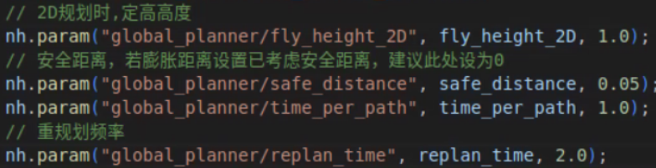

fly_height_2D：1.0 👉 0.4

time_per_path：1.0 👉 1.5