Plots for Hybrid Wannier Centers in Hopf Insulator

*Parameters:*

*h=1; t=1*

*Nx = Ny = Nz = 101*

**As a function of ky**

kz = 0

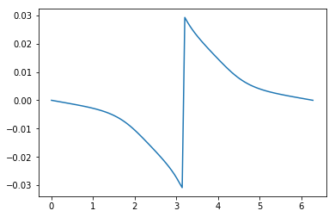

kz = pi/10 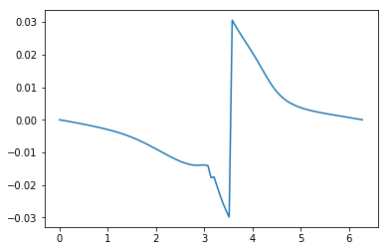

kz = pi/2 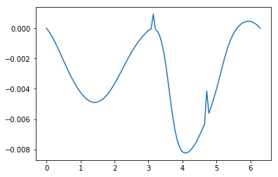

**As a function of kz**

ky = 0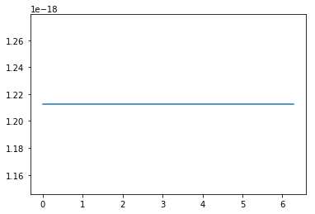

ky = pi/10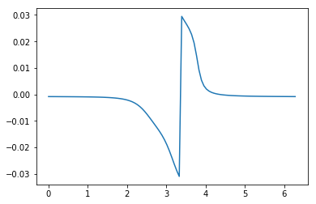

kz = pi/2 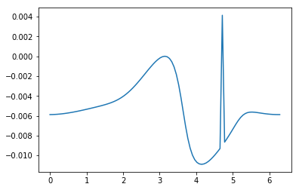

kz = 2pi*0.49 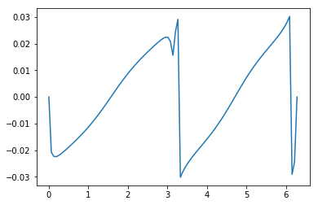

kz = pi 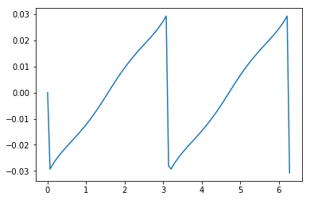

kz = 2pi*0.51 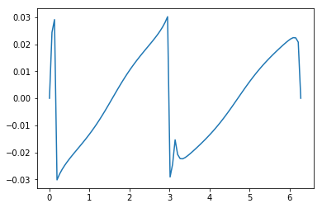

ky = 2pi*0.49 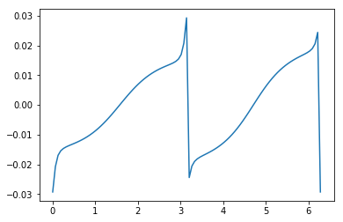

ky = pi 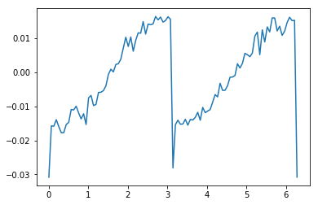

ky = 2pi*0.51 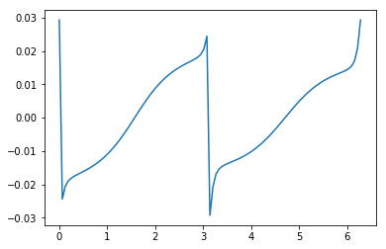

kz = 2pi*0.74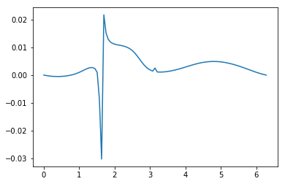

kz = 3pi/2 = 2pi*0.75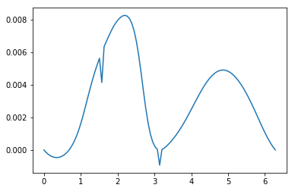

kz = 2pi*0.76 

ky = 2pi*0.74 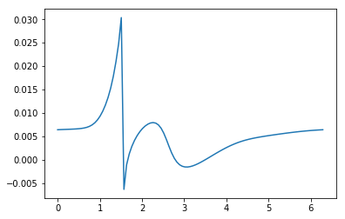

ky = 3pi/2 = 2pi*0.75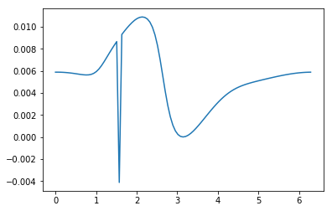

ky = 2p*0.76 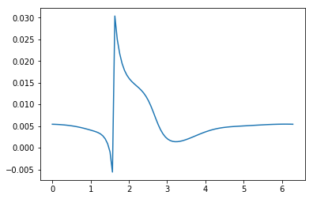

kz = 2pi 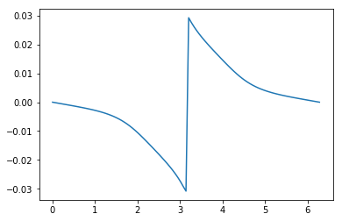

ky = 2pi 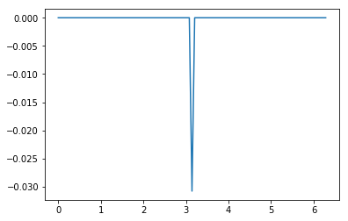

Description

For the function of ky

* At kz = 0 behavior is fine.
* At kz in vicinity of 0 some small artefacts appear
* At kz = pi/2 generally the behavior is good but two artefacts appear (in details the situation is considered for kz = 3pi/2)
* In the vicinity of pi there are some problems
* At kz = 2pi*0.49 it isn’t clear if function returns to its initial value or not
* At kz = pi the function isn’t periodical, but the artifacts vanish
* At kz = 2pi*0.51 the function is reflected function at kz = 2pi*0.49
* In the vicinity of kz = 3pi/2 one artefact vanishes another transforms into passing through the whole zone.
* At kz = 2pi behavior is the same as at kz = 0

For the function of kz (differences from ky function)

* In vicinity of 0 there’s no artefacts
* At ky = pi/2 and 3pi/2 there’s only one artefact which transforms into zone passing
* At ky = pi the function is periodic but noisy
* At ky = 2pi an artefact appears

Conclusion

It seems that the behavior looks like the right one, but some questions appear.

The program is written in two different ways and the results coincide.

The method of calculation: parallel transport along kx direction.