影像處理

作業XX書面報告

學號： 姓名：

1. 本次作業
2. Input a color image *C*(*R*,*G*,*B*)
3. Output the color image *C*
4. Transform the color image *C* into a grayscale image *I* by *I* = (*R+G+B*)/3
5. Show the grayscale image *I.*

(Read image files: including JPG files, BMP files, and PNG files.)

1. 測試結果(請附至少程式畫面截圖，並附相關說明)

Input File

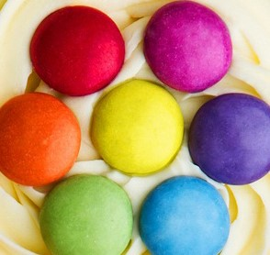

範例一為XX之測試結果。左圖為XX檔案，右圖為XX結果。由上圖可觀察到…

檔案

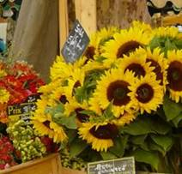

範例二為XX之測試結果。左圖為XX檔案，右圖為XX結果。由上圖可觀察到…

範例三為XX之測試結果。左圖為XX檔案，右圖為XX結果。由上圖可觀察到…

檔案



1. 程式撰寫心得(至少100字)
2. 程式碼

Advance Image Processing

Homework No. XX

Student No: Name:

1. Project topic:
2. Test results (please attach at least screenshots of the program with relevant instructions)

Input File



The first example shows that … One can observe that …

檔案



The second example shows that … One can observe that …

The third example shows that … One can observe that …

檔案



1. What you have learned in this homework? (at least 100 words)
2. Source Code