**Task 1: Project Preliminary**  
  
**Team Discussion Proof**  
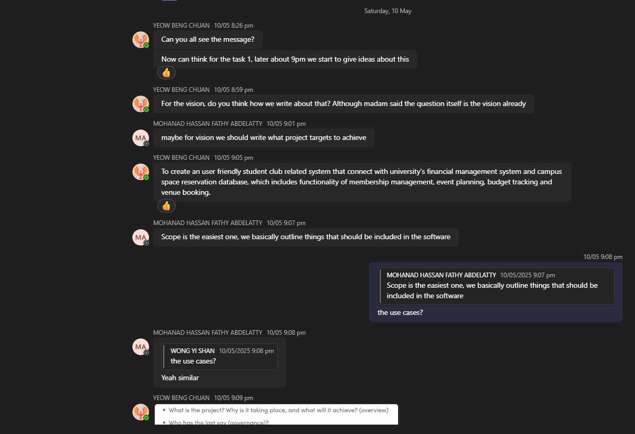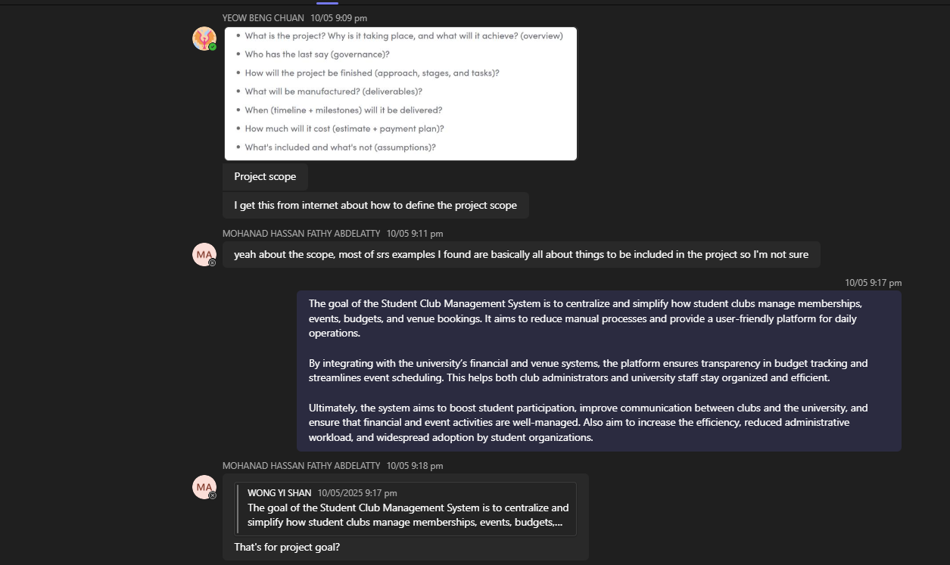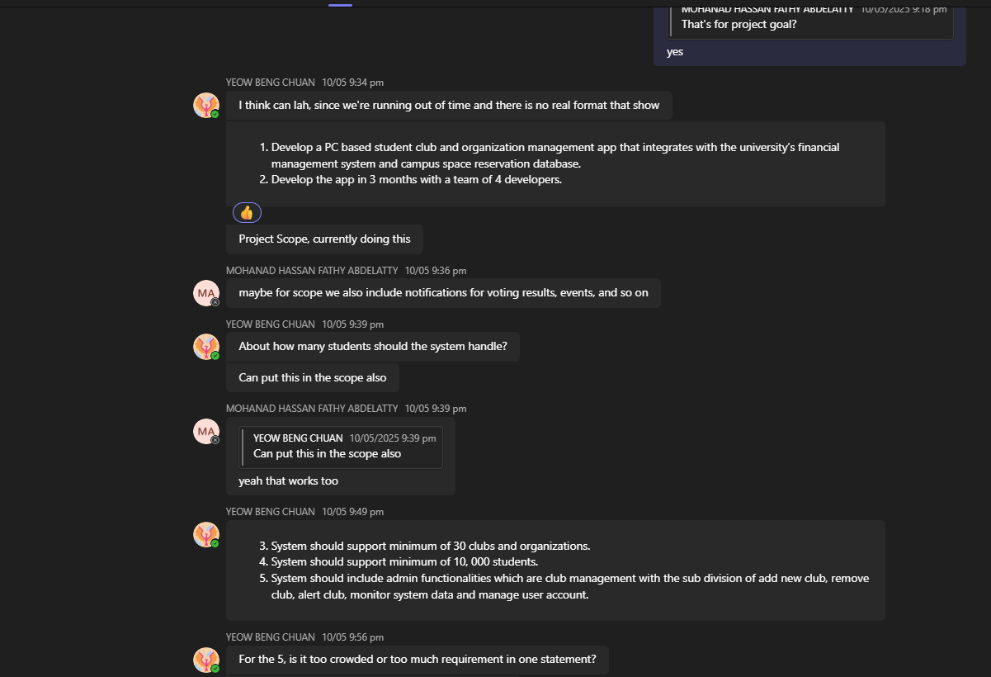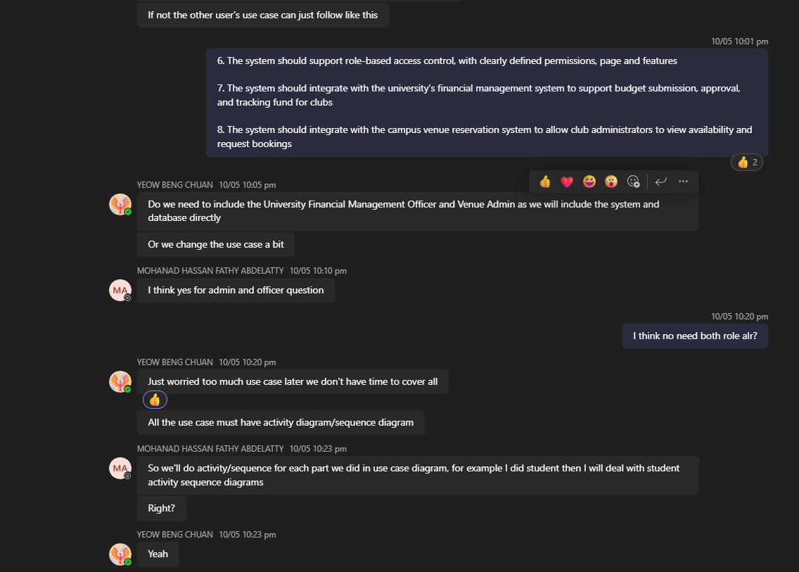

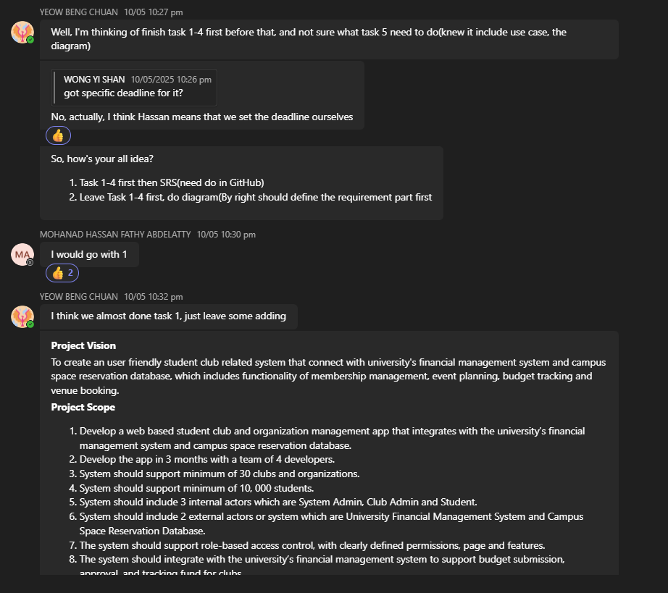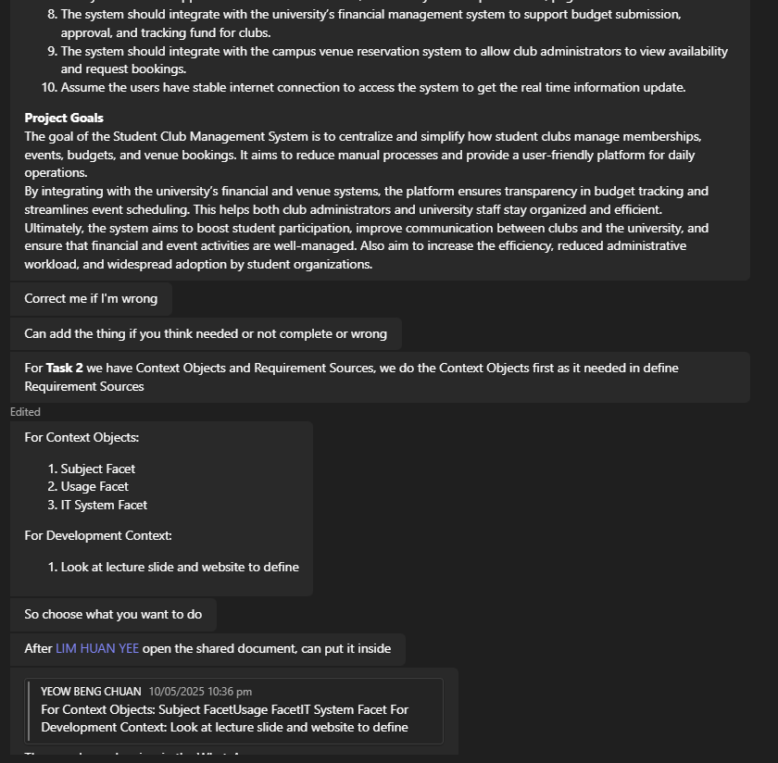

## **Project Vision**

To create a user-friendly student club related system that connect with university's financial management system and campus space reservation database, which includes functionality of membership management, event planning, budget tracking and venue booking.

## **Project Scope**

1. Develop a web-based student club and organization management app.
2. Develop the app in 3 months with a team of 4 developers.
3. The system should support a minimum of 30 clubs and organizations.
4. The system should support a minimum of 10, 000 students.
5. System should include 3 internal actors which are System Admin, Club Admin and Student.
6. The system should include 2 external actors or system which are the University Financial Management System and Campus Space Reservation Database.
7. The system should support role-based access control, with clearly defined permissions, pages and features.
8. The system should integrate with the university’s financial management system to support budget submission, approval, and tracking fund for clubs.
9. The system should integrate with the campus venue reservation system to allow club administrators to view availability and request bookings.
10. Assume the users have stable internet connection to access the system to get the real time information update.

## **Project Goals**

The goal of the Student Club Management System is to centralize and simplify how student clubs manage memberships, events, budgets, and venue bookings. It aims to reduce manual processes and provide a user-friendly platform for daily operations.

By integrating with the university’s financial and venue systems, the platform ensures transparency in budget tracking and streamlines event scheduling. This helps both club administrators and university staff stay organized and efficient.

Ultimately, the system aims to boost student participation, improve communication between clubs and the university, and ensure that financial and event activities are well-managed. It also aims to increase efficiency, reduce administrative workload, and widespread adoption by student organizations.