**Task 2: Context Object & Requirements Source**

**Team Discussion Proof**

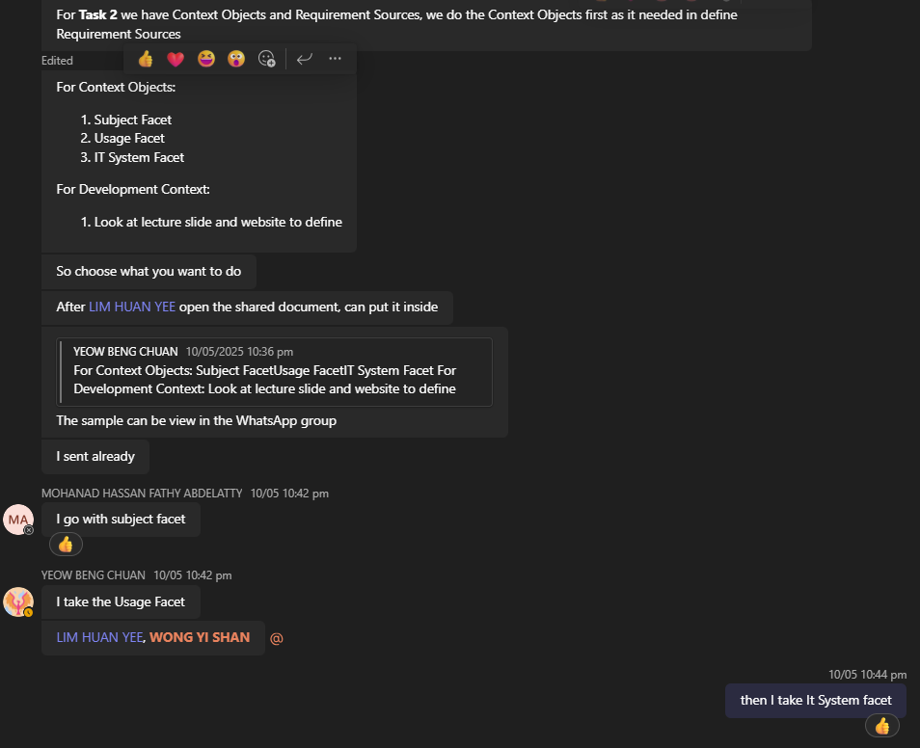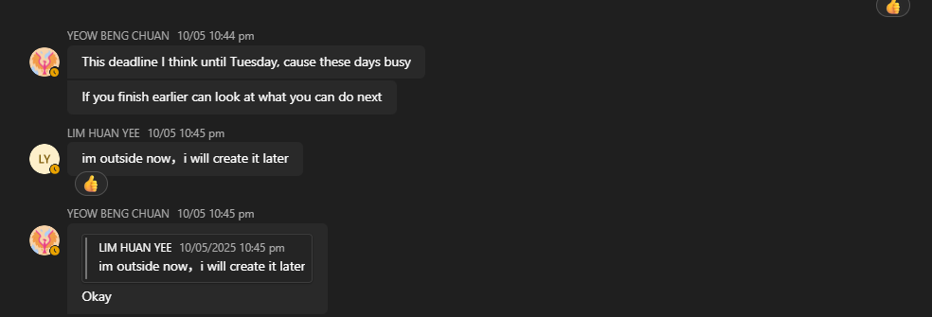

## **Context Objects**

**System Context**

**Subject Facet**

|  |  |
| --- | --- |
| System Context Object | Properties |
| Members | -Member ID  -Name  -E-mail  -Role  -Status |
| Club | - Club ID  - Name  - Description  - Category  - Member List |
| Event | - Date/Time  - Location  - Budget |
| Venue | - Name  - Capacity  - Location |
| Budget | - Amount |

**Usage Facet**

|  |  |
| --- | --- |
| System Context Object | Properties |
| Student (User Group) | - Maximum 12, 000 of active users - Required information of club to know what a club do - Required information of club event to know details about event - Right to join and leave a club - Right to vote for the event |
| Club Admin (User Group) | - Maximum 1000 club members can be added - Access to view club member status - Access to add and remove a club member - Access to manage vote related activity - Interaction with University Financial Management System to process financial related issue - Interaction with Campus Space Reservation Database to know the availability of venue - Communication with System Admin to have the reservation of venue |
| System Admin (User Group) | - Access to manage user account - Maximum 50 clubs can be created - Access to create and remove a club - Approve or reject club venue reservation - Communication with Club Admin to notify if club violates the rule |

**IT System Facet**

|  |  |
| --- | --- |
| **System Context Object** |  |
| Web Server | * Maximum downtime: 2 hours per 24h * HTTPS enabled; |
| Database Server | * Daily backup at 12 AM * Max response time < 300ms * Supports 10,000+ users |
| Client Browser (User Device) | * Must support modern browsers (Chrome, Firefox, Edge) * JavaScript enabled |
| Financial System API | * Real-time sync * JSON data format * Response time < 1s * Available 24h with maximum 2 hours downtime * Requires API key authentication |
| Venue Booking API | * Real-time sync * JSON data format * Response time < 1s * Available 24h with maximum 2 hours downtime * Requires API key authentication |
| Authentication System | * All content access with only corresponding roles * Enable 2 Authentication * Sessioning authentication with 15 minutes idle expire |
| System Administrator Console | * Role-based access only * Logs all changes * Manage all system data |

|  |  |
| --- | --- |
| University Financial Management (Interaction Models) | - Approve club financial proposal - Required financial proposal and report from Club Admin for record purpose |
| Campus Space Reservation (Interaction Models) | - Provide venue that are still available - Interaction with System Admin to confirm venue reservation for club event |

**Development Context**

|  |  |  |
| --- | --- | --- |
| **Development Context Object** | **Source** | **Explanation** |
| ​​Python Django​​ | IT System Facet (Web Server) | Full-stack framework for club/event management; combines front-end templates and back-end APIs. |
| ​​Microsoft Azure App Service​​ | IT System Facet (Web Server) | Hosts Django app with auto-scaling; guarantees 99.9% uptime for 12k+ users. |
| ​​IBM DB2​​ | IT System Facet (Database Server) | Production database for member lists, budgets, and venue bookings; ACID-compliant and GDPR-aligned. |
| ​​Microsoft Outlook API​​ | Usage Facet (Students) | Sends event reminders and booking confirmations via university Outlook emails. |
| ​​Microsoft Entra ID​​ | IT System Facet (Authentication) | Manages role-based access (Students/Admins) with 2FA and session timeouts. |
| ​​Azure SQL Database​​ | IT System Facet (Database Server) | Handles staging/testing workflows and real-time voting data; mirrors production. |
| ​​Django REST Framework​​ | Usage Facet (University Financial) | REST APIs for budget tracking and integration with financial systems (JSON sync). |
| ​​Azure DevOps​​ | IT System Facet (System Admin) | CI/CD pipelines enforce system limits (50 clubs max, 1k members/club). |
| ​​Microsoft Power BI​​ | Subject Facet (Budget) | Generates visual reports for Club Admins to monitor expenses and remaining funds. |
| ​​Azure Load Balancer​​ | IT System Facet (Web Server) | Distributes traffic during voting peaks to maintain <300ms response times. |
| ​​Postman​​ | IT System Facet (Venue Booking API) | Tests real-time sync with Campus Space Reservation Database and Entra ID auth. |
| ​​pytest​​ | IT System Facet (Web Server) | Validates Django APIs for budget/venue modules (ensures <1s response time). |
| ​​Microsoft Defender for Cloud​​ | Subject Facet (Members) | Monitors GDPR/FERPA compliance; anonymizes student emails and enforces retention. |

## **Requirements Sources**

|  |  |
| --- | --- |
| **Requirements Sources** | **System Context Objects** |
| Stakeholders | Student |
| Club Admin |
| System Admin |

|  |  |
| --- | --- |
| **Requirements Sources** | **System Context Objects** |
| Systems | University Financial Management System |
| Campus Space Reservation Database |
| Authentication System |

|  |  |
| --- | --- |
| **Requirements Sources** | **System Context Objects** |
| Documents | Club |
| Venue |
| Budget |
| Web Server |
| Database Server |
| Client Browser |