**Task 3: Elicitation Plan & Potential Requirements Classification**

**Team Discussion Proof**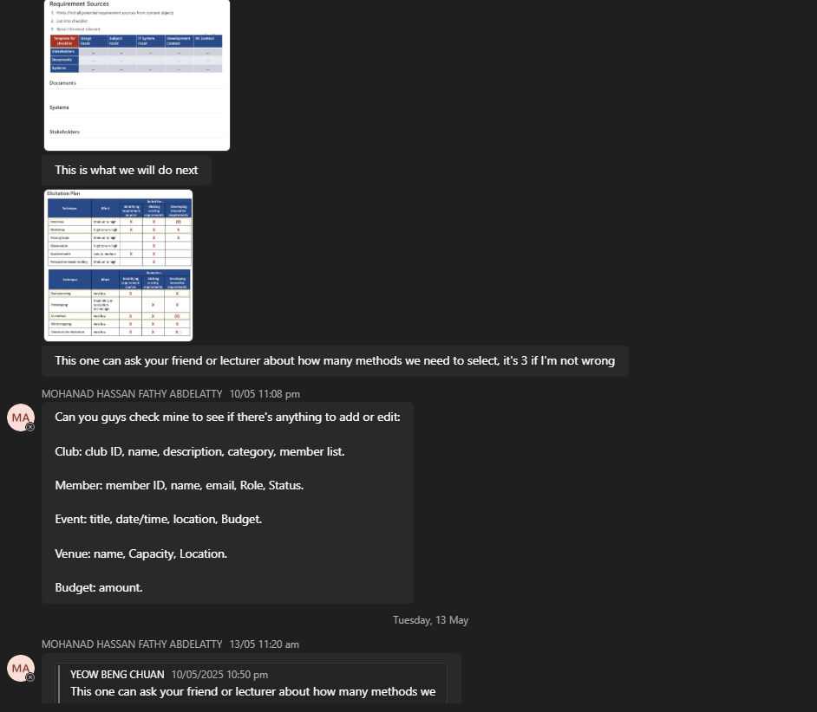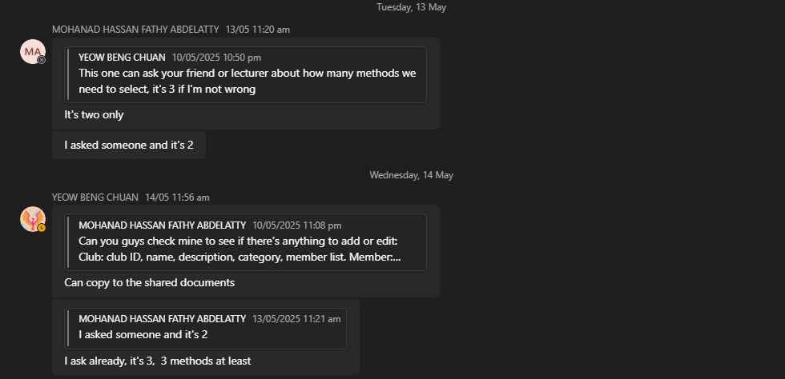

## **Elicitation Plan**

1. **Brainstorming**

|  |  |
| --- | --- |
| Purpose | To get an idea of the overall system from developers. This can define the users of the system and their behaviors for implementing the features that need to be added and belong to different users. Thus, the draft of the system structure can be clarified, and stakeholders have a better idea on the outcome of the project. |
| People Involve | All group members (Developer/Student) |
| Venue/Platform | Microsoft Teams (Online based) -Solve the physical area constraint -Save times |
| Time/Duration | Preparation Period: 1 day Execution Period: 1-2 hours Result Processing Periods: 1 hour |
| Object Should be Discuss | 1. How many users(actors) are in the system? 2. What are the behaviors (use cases) of each user (actors)? 3. What is the relationship between each user (actor)? 4. Do any other considerations need to be considered during development?  Requirements type: Dissatisfiers, satisfiers and delighters |
| Step to be Performed | 1. Announce the time and the platform used to hold the meeting 2. Prepare for the topic earlier before the meeting held 3. Held the meeting 4. Discuss about each object that needs to be discussed 5. From the discussion, ensure all objects have been discussed 6. From the chat, list out all the result of discussion, which are the requirements that need to be added 7. Produce the result which has classify the requirements |

1. **Questionnaire**

|  |  |
| --- | --- |
| Purpose | To gather stakeholders’ thoughts and ideas from a structured query. By this to elicit the existing requirements to get the satisfiers and dissatisfiers of the system from the perspective of end user, who is a student. With a low effort but high response method to shorten time in elicitation session. |
| People Involve | Prepare by: Yeow Beng Chuan Target audience: Students (50 students) |
| Venue/Platform | Google Form (Online Based) -Solve the physical area constraint |
| Time/Duration | Preparation Period: 1 day Execution Period: 7 days Result Processing Periods: 1 day |
| Object Should be Discuss | 1. Question Form: i. In a student club management system, are (Potential Requirements) important for you as a normal user? (1 is least important, 5 is very important) ii. In a student club management system, are (Potential Requirements) important for you as a club admin? (1 is least important, 5 is very important) ii. In a student club management system, what would you feel if (Potential Requirements) were not included? (1 is it makes no difference for me, 3 is it is better to have it, 5 is it must be included) 2. Potential Requirements: a. Students i. Ability to view list of clubs and their descriptions ii. Ability to view upcoming club events iii. Ability to join or leave a club iv. Ability to vote for club events v. Ability to filter or search for clubs/events b. Club Admin i. Can add or remove club members ii. Can view member participation or status iii. Can submit event proposals iv. Can initiate budget requests v. Can request venue reservation for events vi. Can view financial approval status vii. Can view venue availability c. Quality Requirements i. System should be available 99.9% of the time ii. Response time for user actions must be under 3 seconds iii. Data should be backed up daily iv. Only authorized users can access certain features v. Interface must be accessible via desktop and mobile browsers vi. System should have large scalability  Requirements type: Dissatisfiers, satisfiers and delighters |
| Step to be Performed | 1. Define potential requirements and classify them 2. Create Google form 3. Add ranked questions which ask responders to rate from 1 to 5, which requirements are the most wanted and the least 4. Send out the Google form through social media like WhatsApp and Instagram 5. Wait for response 6. View the result and elicit the requirements based on the result 7. Produce the result which has classify the requirements |

1. **Mind Mapping**

|  |  |
| --- | --- |
| Purpose | From the mind-mapping, define the relevant requirements from the center which is the Student Club Management System. This can define the overall system visually and give the stakeholders a better understanding of the software that will be developed. Thus, they can mention which requirement is missing and which requirement is not necessary. |
| People Involve | Any of the members (Developers) |
| Venue/Platform | [Draw.io](http://draw.io/) (web-based chart drawing program) - Free to use - Well known - Sufficient features for the requirements |
| Time/Duration | Execution Periods: 3 days Result Processing Periods: 1 day |
| Object Should be Discuss | 1. Users of the system 2. Functions of the system 3. Interface of the system 4. Constraint of the system  Requirements type: Dissatisfiers, satisfiers and delighters |
| Step to be Performed | 1. Open [Draw.io](http://draw.io/) program in website 2. Open a new document 3. Draw the center of the mind map, which is the Student Club Management System 4. Draw other relevant objects point from the center 5. From each branch, draw the requirements 6. Finalize the mind map with other developers 7. Produce the result which has classify the requirements |

## **Classification of Potential Requirements Using Kano Model**

|  |  |
| --- | --- |
|  | Requirements |
| Delighters | * Student can vote for club events * Student can filter or search for clubs and events * Club admin can view financial approval status * Club admin can view venue availability * Interface must be accessible via desktop and mobile browsers * System should have large scalability |
| Satisfiers | * Student can view list of clubs and their descriptions * Student can view upcoming club events * Club admin can view member participation or status * Club admin can submit event proposal * Club admin can initiate budget request * Club admin can request venue reservation for events * System should be available 99.9% of the time * Response time for user actions must be under 3 seconds |
| Dissatisfiers | * Student can join or leave a club * Club admin can add or remove club member * Data should be backed up daily * Only authorized users can access certain features |