**Task 4: Elicitation Session & Requirements Classification**

**Team Discussion Proof**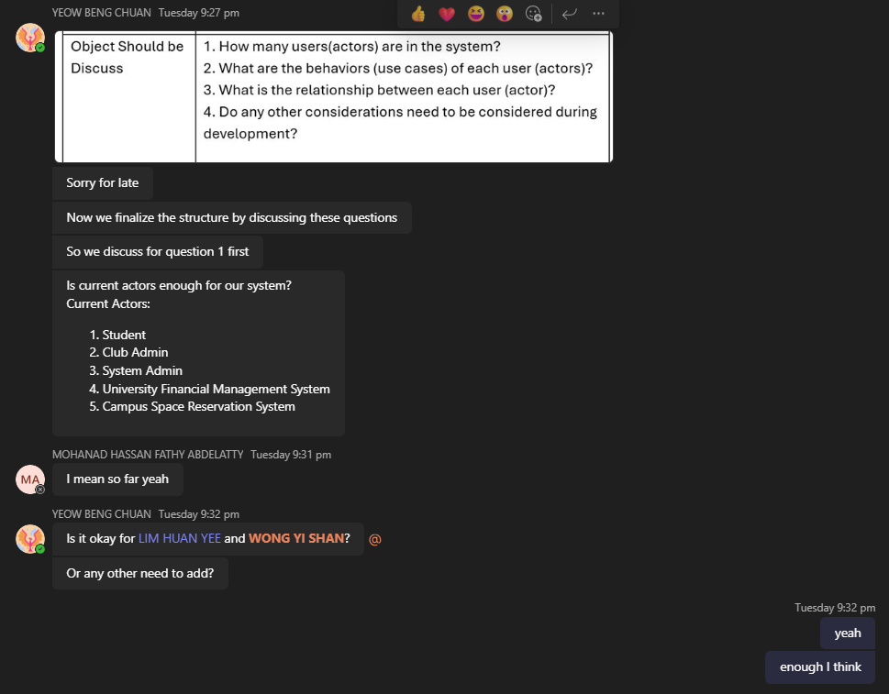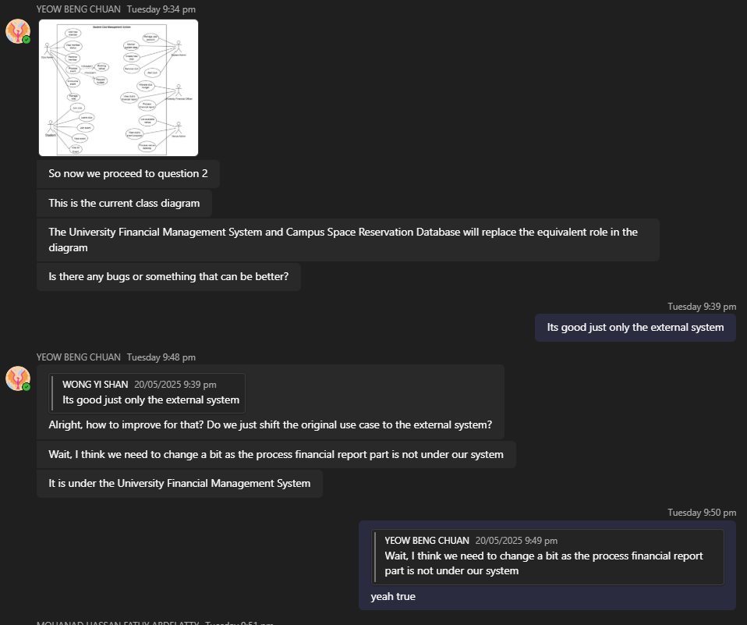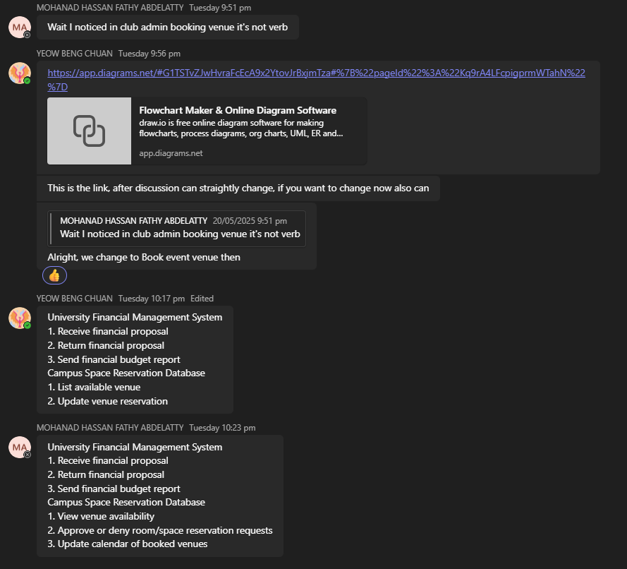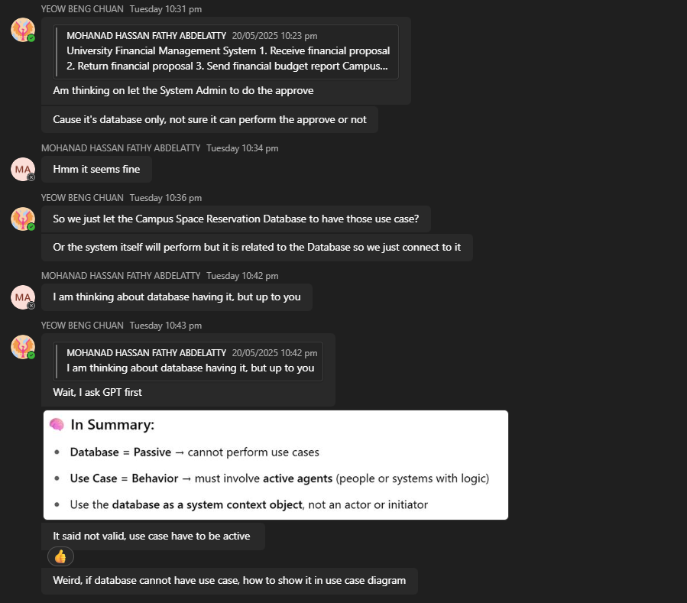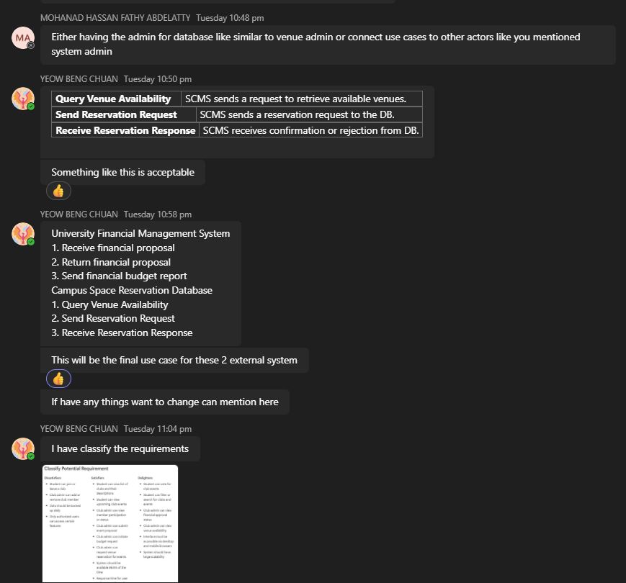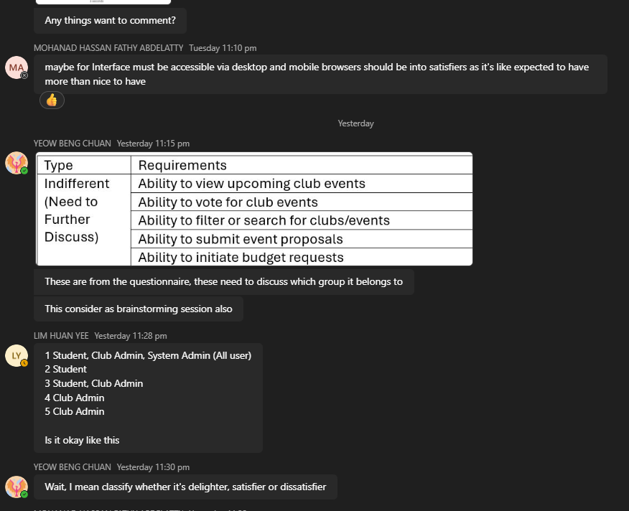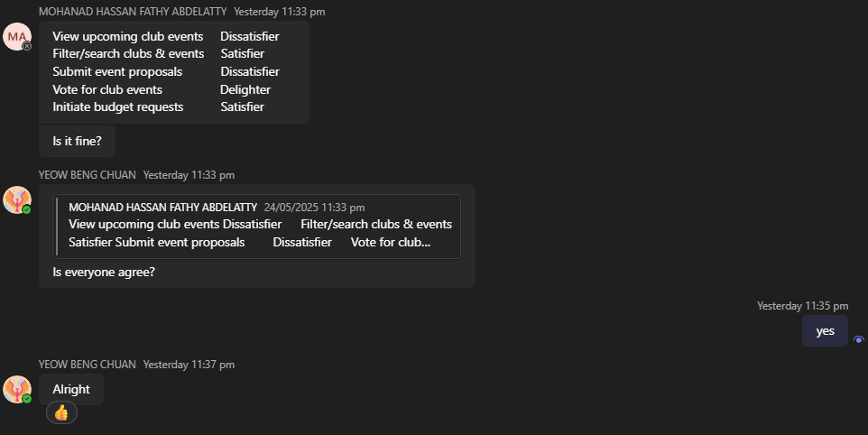

## **Elicitation Session**

1. **Brainstorming**

Total Session: 4

|  |  |
| --- | --- |
| Date | 30th April 2025 |
| Time | 12.20pm – 2.00pm (1 hour 40 minutes) |
| Venue/Platform | Microsoft Teams Chat |
| Participants | All members |
| Purpose | Define the core of the system: i. Actors of the system  ii. Use cases of the actors |
| Discussed Object | i. Actors of the system  Club, University Financial Management System, Campus Space Reservation Database (mentioned by Yeow and Lim)  ->  Club Admin, Club Member, University Financial Officer, Venue Admin (mentioned by Wong)  ->  Club Admin, Club Member, University Financial Officer, Venue Admin, System Admin (mentioned by Yeow)  The actor of the system is agreed by all members and proceeded with the use case for each actor  ii. Use cases of the actors  *with ‘+’ means will be included in Use Case Diagram   * System Admin   + Manage club     - Add new club+     - Remove club+     - Alert club+   + Manage user account+   + Monitor system data+ * Club Admin   + Manage membership     - Add new member+     - View member status+     - Remove member+   + Manage event     - Propose event+       * Booking venue+       * Request budget+     - Announce event+   + Manage vote+ * Student   + Join club+   + Leave club+   + View event+   + Join event+   + Voting+ * University Financial Officer   + Allocate club budget+   + View club’s financial report+   + Process financial report(Approve/Reject)+ * Venue Admin   + List available venue+   + View club’s event proposal+   + Process venue booking(Approve/Reject) |
| Result | 5 main actors: System Admin, Club Admin, Student, University Financial Officer and Venue Admin  Requirements from brainstorming: - System Admin can add new club  - System Admin can remove club  - System Admin can alert club  - System Admin can manage user account  - System Admin can monitor system data  - Club Admin can add new member  - Club Admin can view member status  - Club Admin can remove member  - Club Admin can propose event  - Club Admin can book venue  - Club Admin can request budget  - Club Admin can announce event  - Club Admin can manage vote  - Student can join club  - Student can leave club  - Student can view event  - Student can join event  - Student can vote  - University Financial Officer can allocate club budget  - University Financial Officer can view club’s financial report  - University Financial Officer can process financial report  - Venue Admin can list available venue  - Venue Admin can view club’s event proposal  - Venue Admin can process venue booking |

Table 1- Brainstorming Session 1 Table

|  |  |
| --- | --- |
| Date | 10th May 2025 |
| Time | 9.00pm – 11.00pm (2 hours) |
| Venue/Platform | Microsoft Teams Chat |
| Participants | All members |
| Purpose | Define the project preliminary: i. Project goals  ii. Project scope (constraint) |
| Discussed Object | i. Project goals  • Simplify and centralize club management (memberships, events, budgets, venues)  • Reduce manual work through a user-friendly digital platform  • Integrate with university systems for financial and venue coordination  • Improve communication between clubs and universities  • Boost student participation and streamline administrative tasks  • Ensure transparency, efficiency, and wide adoption by student organizations  (all above mentioned by Wong)  ii. Project scope   1. Develop a web based student club and organization management app that integrates with the university’s financial management system and campus space reservation database. (mentioned by Yeow) 2. Develop the app in 3 months with a team of 4 developers. (mentioned by Yeow) 3. System should support minimum of 30 clubs and organizations. (mentioned by Yeow) 4. System should support minimum of 10, 000 students. (mentioned by Yeow) 5. System should include 3 internal actors which are System Admin, Club Admin and Student. (mentioned by Yeow) 6. System should include 2 external actors or system which are University Financial Management System and Campus Space Reservation Database. (mentioned by Yeow) 7. The system should support role-based access control, with clearly defined permissions, page and features. (mentioned by Wong) 8. The system should integrate with the university’s financial management system to support budget submission, approval, and tracking fund for clubs. (mentioned by Wong) 9. The system should integrate with the campus venue reservation system to allow club administrators to view availability and request bookings. (mentioned by Wong) 10. Assume the users have stable internet connection to access the system to get the real time information update. (mentioned by Yeow) |
| Result | Requirements from brainstorming:  Functional Requirement:   * The system shall provide a web interface to manage student clubs and organizations. * The system shall support role-based access control for System Admin, Club Admin, and Student roles. * The system shall allow Club Admins to submit budget proposals to the University Financial Management System. * The system shall allow the university financial system to approve or reject budget submissions. * The system shall allow Club Admins to view venue availability and request bookings via integration with the Campus Space Reservation Database. * The system shall support interaction with two external systems: Financial Management System and Campus Space Reservation Database. * The system shall allow the creation and management of at least 30 clubs and organizations.   Quality Requirement:   * The system shall be a web-based application accessible via modern browsers. * The system shall define and enforce access permissions for each user role (System Admin, Club Admin, Student). * The system shall support concurrent access by a minimum of 10,000 student users. * The system shall provide real-time information updates under stable internet conditions.   Constraint:   * The system shall be developed within 3 months.  |  | | --- | | * The development team will consist of 4 developers. |  |  | | --- | |  | |

Table 2- Brainstorming Session 2 Table

|  |  |
| --- | --- |
| Date | 20th May 2025 |
| Time | 9.30pm – 11.00pm (1 hour 30 minutes) |
| Venue/Platform | Microsoft Teams Chat |
| Participants | All members |
| Purpose | Checked current Use Case Diagram and made changes: i. Finalized Use Case Diagram |
| Discussed Object | i. Finalized Use Case Diagram  The actors are finalized as 5, which are Student, Club Admin, System Admin, University Financial Management System and Campus Space Reservation. Some changes have been made to fulfil the more complete system.  Club Admin  - Add new member  - View member status  - Remove member  - Propose event  - Announce event  - Manage vote  - Submit financial budget report  - Book venue  - Request budget  System Admin  - Manage user account  - Monitor system data  - Create new club  - Remove club  - Alert club  Student  - Request to join club  - Leave club  - Join event  - View event  - Vote for event |
| Result | Requirements from brainstorming:  - Club Admin can add new members  - Club Admin can view member status  - Club Admin can remove members  - Club Admin can propose event  - Club Admin can announce events  - Club Admin can manage vote  - Club Admin can submit financial budget report  - Club Admin can book venue  - Club Admin can request budget  - System Admin can manage user account  - System Admin can monitor system data  - System Admin can create new club  - System Admin can remove club  - System Admin can alert club  - Student can request to join club  - Student can leave club  - Student can join event  - Student can view event  - Student can vote for event |

Table 3- Brainstorming Session 3 Table

|  |  |
| --- | --- |
| Date | 22nd May 2025 |
| Time | 11.15pm – 11.30pm (15 minutes) |
| Venue/Platform | Microsoft Teams Chat |
| Participants | All members |
| Purpose | Discussed indifferent requirements from the questionnaire |
| Discussed Object | |  |  | | --- | --- | | View upcoming club events | Dissatisfier | | Filter/search clubs & events | Satisfier | | Submit event proposals | Dissatisfier | | Vote for club events | Delighter | | Initiate budget requests | Satisfier |   Suggested by Hassan, agreed by all members |
| Result | The indifferent requirements from the questionnaire have been classified.   |  |  | | --- | --- | | View upcoming club events | Dissatisfier | | Filter/search clubs & events | Satisfier | | Submit event proposals | Dissatisfier | | Vote for club events | Delighter | | Initiate budget requests | Satisfier | |

Table 4- Brainstorming Session 4 Table

|  |  |
| --- | --- |
| Session | Requirements |
| 1 | - System Admin can add new club  - System Admin can remove club  - System Admin can alert club  - System Admin can manage user account  - System Admin can monitor system data  - Club Admin can add new member  - Club Admin can view member status  - Club Admin can remove member  - Club Admin can propose event  - Club Admin can book venue  - Club Admin can request budget  - Club Admin can announce event  - Club Admin can manage vote  - Student can join club  - Student can leave club  - Student can view event  - Student can join event  - Student can vote  - University Financial Officer can allocate club budget  - University Financial Officer can view club’s financial report  - University Financial Officer can process financial report  - Venue Admin can list available venues  - Venue Admin can view club’s event proposal  - Venue Admin can process venue booking |
| 2 | - The system should provide a web interface to manage student clubs and organizations.  - The system should support role-based access control for System Admin, Club Admin, and Student roles.  - The system shall allow Club Admins to submit budget proposals to the University Financial Management System.  - The system shall allow the university financial system to approve or reject budget submissions.  - The system shall allow Club Admins to view venue availability and request bookings via integration with the Campus Space Reservation Database.  - The system shall support interaction with two external systems: Financial Management System and Campus Space Reservation Database.  - The system shall allow the creation and management of at least 30 clubs and organizations.  - The system shall be a web-based application accessible via modern browsers.  - The system should define and enforce access permissions for each user role (System Admin, Club Admin, Student).  - The system shall support concurrent access by a minimum of 10,000 student users.  - The system shall provide real-time information updates under stable internet conditions.  - The system shall be developed within 3 months.   |  | | --- | | - The development team will consist of 4 developers. | |
| 3 | - Club Admin can add new members  - Club Admin can view member status  - Club Admin can remove members  - Club Admin can propose event  - Club Admin can announce events  - Club Admin can manage vote  - Club Admin can submit financial budget report  - Club Admin can book venue  - Club Admin can request budget  - System Admin can manage user account  - System Admin can monitor system data  - System Admin can create new club  - System Admin can remove club  - System Admin can alert club  - Student can request to join club  - Student can leave club  - Student can join event  - Student can view event  - Student can vote for event |
| 4 | Classify requirements from questionnaire |

Table 5 – Brainstorming Session by Session Requirement Table

Conclusion:

All session 1’s requirements are replaced by session 3’s requirements as session 3 component is an update of session 1 component. All session 3’s requirements are classified through questionnaire. Only sessions 2 and 4 will be classified.

|  |  |  |
| --- | --- | --- |
| Session | Requirements | Type |
| 2 | The system should provide a web interface to manage student clubs and organizations | Dissatisfier |
| The system should support role-based access control for System Admin, Club Admin, and Student roles | Dissatisfier |
| The system shall allow Club Admins to submit budget proposals to the University Financial Management System | Satisfier |
| The system shall allow the university financial system to approve or reject budget submissions | Satisfier |
| The system shall allow Club Admins to view venue availability and request bookings via integration with the Campus Space Reservation Database | Satisfier |
| The system shall support interaction with two external systems: Financial Management System and Campus Space Reservation Database | Dissatisfier |
| The system shall allow the creation and management of at least 30 clubs and organizations | Dissatisfier |
| The system shall be a web-based application accessible via modern browsers | Dissatisfier |
| The system should define and enforce access permissions for each user role (System Admin, Club Admin, Student) | Dissatisfier |
| |  | | --- | |  |  |  | | --- | | The system shall support concurrent access by a minimum of 10,000 student users | | Satisfier |
| The system shall provide real-time information updates under stable internet conditions | Satisfier |
| The system shall be developed within 3 months | Indifferent (For end user) |
| The development team will consist of 4 developers | Indifferent (For end user) |
| 4 | Students can view upcoming club events | Dissatisfier |
| Students can filter/search clubs & events | Satisfier |
| Club Admin can submit event proposals | Dissatisfier |
| Students can vote for club events | Delighter |
| Club Admin can initiate budget requests | Satisfier |

Table 6 - Brainstorming Requirements Classification Table

1. **Questionnaire**

|  |  |
| --- | --- |
| Time/Duration | Released on 19th May 2025, Closed on 22nd May 2025 (3 days) |
| Venue/Platform | Google Form sent through WhatsApp group chat |
| Respondents | 6 |
| Results | Question 1a:  *Is the ability to view list of clubs and their descriptions important for you as a normal user? (1 is least important, 5 is very important)*   |  |  |  |  |  |  | | --- | --- | --- | --- | --- | --- | | Selection | 1 | 2 | 3 | 4 | 5 | | Distribution | 0 | 0 | 0 | 3 | 3 | | Percentage (%) | 0.0 | 0.0 | 0.0 | 50.0 | 50.0 |   Question 1b:  *What would you feel if this feature does not included? (1 is it is not needed for me, 5 is very disappointed)*   |  |  |  |  |  |  | | --- | --- | --- | --- | --- | --- | | Selection | 1 | 2 | 3 | 4 | 5 | | Distribution | 0 | 0 | 0 | 4 | 2 | | Percentage (%) | 0.0 | 0.0 | 0.0 | 66.7 | 33.3 | |
| Question 2a: *Is the ability to view upcoming club events important for you as a normal user? (1 is least important, 5 is very important)*   |  |  |  |  |  |  | | --- | --- | --- | --- | --- | --- | | Selection | 1 | 2 | 3 | 4 | 5 | | Distribution | 0 | 1 | 2 | 2 | 1 | | Percentage (%) | 0.0 | 16.7 | 33.3 | 33.3 | 16.7 |   Question 2b:  *What would you feel if this feature does not included? (1 is it is not needed for me, 5 is very disappointed)*   |  |  |  |  |  |  | | --- | --- | --- | --- | --- | --- | | Selection | 1 | 2 | 3 | 4 | 5 | | Distribution | 1 | 1 | 2 | 1 | 1 | | Percentage (%) | 16.7 | 16.7 | 33.3 | 16.7 | 16.7 | |
| Question 3a:  *Is the ability to join or leave a club important for you as a normal user? (1 is least important, 5 is very important)*   |  |  |  |  |  |  | | --- | --- | --- | --- | --- | --- | | Selection | 1 | 2 | 3 | 4 | 5 | | Distribution | 0 | 0 | 0 | 2 | 4 | | Percentage (%) | 0.0 | 0.0 | 0.0 | 33.3 | 66.7 |   Question 3b:  *What would you feel if this feature does not included? (1 is it is not needed for me, 5 is very disappointed)*   |  |  |  |  |  |  | | --- | --- | --- | --- | --- | --- | | Selection | 1 | 2 | 3 | 4 | 5 | | Distribution | 0 | 0 | 0 | 1 | 5 | | Percentage (%) | 0.0 | 0.0 | 0.0 | 16.7 | 83.3 | |
| Question 4a:  *Is the ability to vote for club events important for you as a normal user? (1 is least important, 5 is very important)*   |  |  |  |  |  |  | | --- | --- | --- | --- | --- | --- | | Selection | 1 | 2 | 3 | 4 | 5 | | Distribution | 1 | 0 | 1 | 2 | 2 | | Percentage (%) | 16.7 | 0.0 | 16.7 | 33.3 | 33.3 |   Question 4b:  *What would you feel if this feature does not included? (1 is it is not needed for me, 5 is very disappointed)*   |  |  |  |  |  |  | | --- | --- | --- | --- | --- | --- | | Selection | 1 | 2 | 3 | 4 | 5 | | Distribution | 1 | 0 | 2 | 1 | 2 | | Percentage (%) | 16.7 | 0.0 | 33.3 | 16.7 | 33.3 | |
| Question 5a:  *Is the ability to filter or search for clubs/events important for you as a normal user? (1 is least important, 5 is very important)*   |  |  |  |  |  |  | | --- | --- | --- | --- | --- | --- | | Selection | 1 | 2 | 3 | 4 | 5 | | Distribution | 0 | 1 | 1 | 3 | 1 | | Percentage (%) | 0.0 | 16.7 | 16.7 | 50.0 | 16.7 |   Question 5b:  *What would you feel if this feature does not included? (1 is it is not needed for me, 5 is very disappointed)*   |  |  |  |  |  |  | | --- | --- | --- | --- | --- | --- | | Selection | 1 | 2 | 3 | 4 | 5 | | Distribution | 0 | 1 | 2 | 2 | 1 | | Percentage (%) | 0.0 | 16.7 | 33.3 | 33.3 | 16.7 |   Question 6a:  *Is the ability to add or remove club members important for you as a club admin? (1 is least important, 5 is very important)*   |  |  |  |  |  |  | | --- | --- | --- | --- | --- | --- | | Selection | 1 | 2 | 3 | 4 | 5 | | Distribution | 0 | 0 | 0 | 1 | 5 | | Percentage (%) | 0.0 | 0.0 | 0.0 | 16.7 | 83.3 |   Question 6b:  *What would you feel if this feature does not included? (1 is it is not needed for me, 5 is very disappointed)*   |  |  |  |  |  |  | | --- | --- | --- | --- | --- | --- | | Selection | 1 | 2 | 3 | 4 | 5 | | Distribution | 0 | 0 | 0 | 1 | 5 | | Percentage (%) | 0.0 | 0.0 | 0.0 | 16.7 | 83.3 | |
| Question 7a:  *Is the ability to view member participation or status important for you as a club admin? (1 is least important, 5 is very important)*   |  |  |  |  |  |  | | --- | --- | --- | --- | --- | --- | | Selection | 1 | 2 | 3 | 4 | 5 | | Distribution | 0 | 0 | 0 | 5 | 1 | | Percentage (%) | 0.0 | 0.0 | 0.0 | 83.3 | 16.7 |   Question 7b:  *What would you feel if this feature does not included? (1 is it is not needed for me, 5 is very disappointed)*   |  |  |  |  |  |  | | --- | --- | --- | --- | --- | --- | | Selection | 1 | 2 | 3 | 4 | 5 | | Distribution | 0 | 0 | 2 | 3 | 1 | | Percentage (%) | 0.0 | 0.0 | 33.3 | 50.0 | 16.7 | |
| Question 8a:  *Is the ability to submit event proposals important for you as a club admin? (1 is least important, 5 is very important)*   |  |  |  |  |  |  | | --- | --- | --- | --- | --- | --- | | Selection | 1 | 2 | 3 | 4 | 5 | | Distribution | 0 | 1 | 1 | 2 | 2 | | Percentage (%) | 0.0 | 16.7 | 16.7 | 33.3 | 33.3 |   Question 8b:  *What would you feel if this feature does not included? (1 is it is not needed for me, 5 is very disappointed)*   |  |  |  |  |  |  | | --- | --- | --- | --- | --- | --- | | Selection | 1 | 2 | 3 | 4 | 5 | | Distribution | 0 | 1 | 2 | 1 | 2 | | Percentage (%) | 0.0 | 16.7 | 33.3 | 16.7 | 33.3 | |
| Question 9a:  *Is the* *ability to initiate budget requests important for you as a club admin? (1 is least important, 5 is very important)*   |  |  |  |  |  |  | | --- | --- | --- | --- | --- | --- | | Selection | 1 | 2 | 3 | 4 | 5 | | Distribution | 1 | 0 | 1 | 2 | 2 | | Percentage (%) | 16.7 | 0.0 | 16.7 | 33.3 | 33.3 |   Question 9b:  *What would you feel if this feature does not included? (1 is it is not needed for me, 5 is very disappointed)*   |  |  |  |  |  |  | | --- | --- | --- | --- | --- | --- | | Selection | 1 | 2 | 3 | 4 | 5 | | Distribution | 1 | 1 | 1 | 1 | 2 | | Percentage (%) | 16.7 | 16.7 | 16.7 | 16.7 | 33.3 | |
| Question 10a:  *Is the ability to request venue reservation for events important for you as a club admin? (1 is least important, 5 is very important)*   |  |  |  |  |  |  | | --- | --- | --- | --- | --- | --- | | Selection | 1 | 2 | 3 | 4 | 5 | | Distribution | 0 | 0 | 1 | 3 | 2 | | Percentage (%) | 0.0 | 0.0 | 16.7 | 50.0 | 33.3 |   Question10b:  *What would you feel if this feature does not included? (1 is it is not needed for me, 5 is very disappointed)*   |  |  |  |  |  |  | | --- | --- | --- | --- | --- | --- | | Selection | 1 | 2 | 3 | 4 | 5 | | Distribution | 0 | 0 | 1 | 3 | 2 | | Percentage (%) | 0.0 | 0.0 | 16.7 | 50.0 | 33.3 | |
| Question 11a:  *Is the ability to view financial approval status you submitted important for you as a club admin? (1 is least important, 5 is very important)*   |  |  |  |  |  |  | | --- | --- | --- | --- | --- | --- | | Selection | 1 | 2 | 3 | 4 | 5 | | Distribution | 0 | 0 | 3 | 1 | 2 | | Percentage (%) | 0.0 | 0.0 | 50.0 | 16.7 | 33.3 |   Question 11b:  *What would you feel if this feature does not included? (1 is it is not needed for me, 5 is very disappointed)*   |  |  |  |  |  |  | | --- | --- | --- | --- | --- | --- | | Selection | 1 | 2 | 3 | 4 | 5 | | Distribution | 0 | 0 | 3 | 1 | 2 | | Percentage (%) | 0.0 | 0.0 | 50.0 | 16.7 | 33.3 | |
| Question 12a:  *Is the ability to view venue availability for the event important for you as a club admin? (1 is least important, 5 is very important)*   |  |  |  |  |  |  | | --- | --- | --- | --- | --- | --- | | Selection | 1 | 2 | 3 | 4 | 5 | | Distribution | 0 | 0 | 1 | 2 | 3 | | Percentage (%) | 0.0 | 0.0 | 16.7 | 33.3 | 50.0 |   Question 12b:  *What would you feel if this feature does not included? (1 is it is not needed for me, 5 is very disappointed)*   |  |  |  |  |  |  | | --- | --- | --- | --- | --- | --- | | Selection | 1 | 2 | 3 | 4 | 5 | | Distribution | 0 | 0 | 1 | 2 | 3 | | Percentage (%) | 0.0 | 0.0 | 16.7 | 33.3 | 50.0 | |
| Question 13:  *What would you feel if the system will be available 99.9% of the time? (1 is I do not like it, 3 if you think it is basic requirement, 5 is very satisfied)*   |  |  |  |  |  |  | | --- | --- | --- | --- | --- | --- | | Selection | 1 | 2 | 3 | 4 | 5 | | Distribution | 0 | 0 | 1 | 1 | 4 | | Percentage (%) | 0.0 | 0.0 | 16.7 | 16.7 | 66.7 | |
| Question 14:  *What would you feel if the response time for user actions is under 3 seconds? (1 is I do not like it, 3 if you think it is basic requirement, 5 is very satisfied)*   |  |  |  |  |  |  | | --- | --- | --- | --- | --- | --- | | Selection | 1 | 2 | 3 | 4 | 5 | | Distribution | 0 | 0 | 1 | 2 | 3 | | Percentage (%) | 0.0 | 0.0 | 16.7 | 33.3 | 50.0 | |
| Question 15:  *What would you feel if the data is backed up daily? (1 is I do not like it, 3 if you think it is basic requirement, 5 is very satisfied)*   |  |  |  |  |  |  | | --- | --- | --- | --- | --- | --- | | Selection | 1 | 2 | 3 | 4 | 5 | | Distribution | 0 | 0 | 1 | 2 | 3 | | Percentage (%) | 0.0 | 0.0 | 16.7 | 33.3 | 50.0 | |
| Question 16:  *What would you feel if only the authorized users can access certain features? (1 is I do not like it, 3 if you think it is basic requirement, 5 is very satisfied)*   |  |  |  |  |  |  | | --- | --- | --- | --- | --- | --- | | Selection | 1 | 2 | 3 | 4 | 5 | | Distribution | 0 | 0 | 0 | 2 | 4 | | Percentage (%) | 0.0 | 0.0 | 0.0 | 33.3 | 66.7 | |
| Question 17:  *What would you feel if the system can be access via desktop and mobile browsers? (1 is I do not like it, 3 if you think it is basic requirement, 5 is very satisfied)*   |  |  |  |  |  |  | | --- | --- | --- | --- | --- | --- | | Selection | 1 | 2 | 3 | 4 | 5 | | Distribution | 0 | 0 | 1 | 0 | 5 | | Percentage (%) | 0.0 | 0.0 | 16.7 | 0.0 | 83.3 | |
| Question 18:  *What would you feel if the system can handle large amount of user and do not crash? (1 is I do not like it, 3 if you think it is basic requirement, 5 is very satisfied)*   |  |  |  |  |  |  | | --- | --- | --- | --- | --- | --- | | Selection | 1 | 2 | 3 | 4 | 5 | | Distribution | 0 | 0 | 0 | 0 | 6 | | Percentage (%) | 0.0 | 0.0 | 0.0 | 0.0 | 100.0 | |
| Analysis | To analyze the result from the questionnaire, we must know each of the questions and the criteria to classify each requirement from it.    From question 1 to question 12, the form of question separated to two parts, which are part a, asks about importance of a requirement and part b, asks about feeling if it is not included. Here are the criteria to classify the requirements:   |  |  |  | | --- | --- | --- | | Question a | Question b | Result | | High | High | Satisfier | | High | Medium | Likely satisfier/delighter | | High | Low | Delighter | | Medium | High | Dissatisfier | | Medium | Medium | Indifferent (Need discussion) | | Medium | Low | Indifferent | | Low | High | Dissatisfier | | Low | Medium | Indifferent | | Low | Low | Indifferent |   Table: Classify Criteria for Question 1-12   |  |  |  |  | | --- | --- | --- | --- | | Score | <3 | >=3 && <4 | >=4 | | Result | Low | Medium | High |   Table: Rating Scale Breakdown  For questions 13 to 18, the questions asked about what stakeholder would feel if the requirement implemented. Here are the criteria to classify the requirements:  *Average = sum of all/num of respondents   |  |  |  |  |  | | --- | --- | --- | --- | --- | | Average scope | < 2.5 | 2.5 - 3.4 | 3.5 - 4.4 | 4.5 - 5.0 | | Result | Indifferent | Dissatisfier | Satisfier | Delighter |   Analysis Result:  Question 1-12  *ND= Need Discussion/Need Further Consideration   |  |  |  |  | | --- | --- | --- | --- | | Question | Average (a) | Average (b) | Classified Result | | 1 | 4.5 (High) | 4.33 (High) | Satisfier | | 2 | 3.5 (Medium) | 3 (Medium) | Indifferent (*ND) | | 3 | 4.67 (High) | 4.83 (High) | Satisfier | | 4 | 3.66 (Medium) | 3.5 (Medium) | Indifferent (*ND) | | 5 | 3.66 (Medium) | 3.5 (Medium) | Indifferent (*ND) | | 6 | 4.83 (High) | 4.83 (High) | Satisfier | | 7 | 4.17 (High) | 3.83 (Medium) | Satisfier/Delighter | | 8 | 3.83 (Medium) | 3.67 (Medium) | Indifferent (*ND) | | 9 | 3.67 (Medium) | 3.33 (Medium) | Indifferent (*ND) | | 10 | 4.17 (High) | 4.17 (High) | Satisfier | | 11 | 3.83 (High) | 3.83 (Medium) | Satisfier/Delighter | | 12 | 4.33 (High) | 4.5 (High) | Satisfier |   Question 13-18   |  |  |  | | --- | --- | --- | | Question | Average | Classified Result | | 13 | 4.5 | Delighter | | 14 | 4.33 | Satisfier | | 15 | 4.33 | Satisfier | | 16 | 4.67 | Delighter | | 17 | 4.67 | Delighter | | 18 | 5.0 | Delighter | |
| Conclusion | A diagram of a venn diagram  AI-generated content may be incorrect.From the analysis, we got **7 Satisfiers**, **4 Delighters**, **2 possible Satisfiers/Delighters**, **5 Indifferent**, which needs to be considered later to decide which class of requirements it is.  Questionnaire Result Set Diagram   |  |  | | --- | --- | | Type | Requirements | | Delighter | The system will be available 99.9% of the time | | Only the authorized users can access certain features | | The system can be accessed via desktop and mobile browsers | | The system can handle large numbers of users and do not crash |  |  |  | | --- | --- | | Type | Requirements | | Satisfier | Ability to view list of clubs and their descriptions (Student) | | Ability to join or leave a club (Student) | | Ability to add or remove club members (Student) | | Ability to request venue reservation for events (Club Admin) | | Ability to view venue availability for the event (Club Admin) | | The response time for user actions is under 3 seconds | | The data is backed up daily |  |  |  | | --- | --- | | Type | Requirements | | Dissatisfier | - |  |  |  | | --- | --- | | Type | Requirements | | Indifferent (Need to Further Discuss) | Ability to view upcoming club events (Student) | | Ability to vote for club events (Student) | | Ability to filter or search for clubs/events (Student) | | Ability to submit event proposals (Club Admin) | | Ability to initiate budget requests (Club Admin) | |

Sample question from 1-12:

Sample question from 13-18:

## **Classification of Requirements Using Kano Model**

|  |  |
| --- | --- |
| Categories | Requirements |
| Delighters | The system will be available 99.9% of the time |
| Only the authorized users can access certain features |
| The system can be accessed via desktop and mobile browsers |
| The system can handle large numbers of users and do not crash |
| Students can vote for club events |
| Satisfiers | Students can view the list of clubs and their descriptions |
| Students can join or leave a club |
| Students can add or remove club members |
| Club Admin can request venue reservation for events |
| Club Admin can view venue availability for the event |
| The response time for user actions is under 3 seconds |
| The data is backed up daily |
| Club Admin can initiate budget requests |
| Students can filter/search clubs & events |
| |  | | --- | |  |  |  | | --- | | The system shall support concurrent access by a minimum of 10,000 student users | |
| The system shall provide real-time information updates under stable internet conditions |
| The system shall allow Club Admins to submit budget proposals to the University Financial Management System |
| The system shall allow the university financial system to approve or reject budget submissions |
| The system shall allow Club Admins to view venue availability and request bookings via integration with the Campus Space Reservation Database |
| Dissatisfiers | Club Admin can submit event proposals |
| Students can view upcoming club events |
| The system shall support interaction with two external systems: Financial Management System and Campus Space Reservation Database |
| The system shall allow the creation and management of at least 30 clubs and organizations |
| The system shall be a web-based application accessible via modern browsers |
| The system should define and enforce access permissions for each user role (System Admin, Club Admin, Student) |
| The system should provide a web interface to manage student clubs and organizations |
| The system should support role-based access control for System Admin, Club Admin, and Student roles |